Economics 390 Name ________________________________
Spring 2020
April 7, 2020

First Midterm
Version 1

There are multiple versions of this exam. You will be given a scantron to fill out. It is important that you:

- Fill out this scantron accurately and completely using a #2 pencil
- In “Special Codes” put your exam version number in column “A”

During the exam it is expected that you will always keep your answers for the exam covered. A failure to cover your answers may be grounds for an academic misconduct violation.

During the exam it is expected that you will always keeps your eyes solely on your own exam. Violation of this expectation may be grounds for academic misconduct violation.

This exam is 19 pages long!

Binary Choice Questions (20 points) __________________

Multiple Choice Questions (60 points) __________________

Problem One (10 points) __________________

Problem Two (10 points) __________________

TOTAL out of 100 points __________________

I. Binary Choice Questions (2 points each)

1. A natural monopoly occurs when:

a. It is cheaper for a single firm to provide the good to the entire market than it is for two or more firms to serve the entire market.
b. There are significant barriers to entry that make it prohibitively expensive for competing firms to enter an industry.

2. Consider a market where production can be described by the following graph where LRATC is the long run average total cost curve:

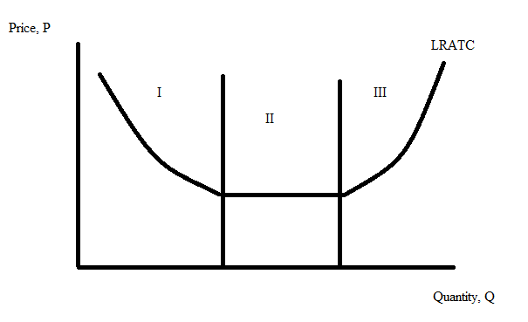
A natural monopoly operates in:

a. the area of production designated as “III” in the above graph.
b. the area of production designated as “I” in the above graph.

3. The presence of economies of scale or increasing returns to scale for a business suggests that the business will benefit from producing a:

a. larger quantity of the good.
b. smaller quantity of the good.

4. When the production of a good involves the use of a “lumpy input” (for example, a piece of equipment that can be very efficiently produce a very large quantity of the good), the business is likely to experience:

a. decreasing costs as output increases over the range of output that the machinery can produce.
b. increasing costs as output increases over the range of output that the machinery can produce.

5. For a city bus system that is not overcrowded, the:

a. marginal cost of an additional rider is always greater than the average total cost of providing a bus ride.
b. marginal cost of an additional rider approaches zero dollars.

6. If a utility is regulated to produce the socially optimal amount of the good, then:

a. a subsidy will need to also be paid to the utility.
b. the area of deadweight loss will be smaller than if the utility is unregulated, but there will still be an area of deadweight loss.

7. The “Platinum Rule” can be summarized as:

a. Do unto others as you would have them do unto you.
b. Do unto others as they would have you do unto them.

8. The medical community for many years has been concerned about the overuse of antibiotics since this excess usage potentially leads to faster mutation of the bacteria and a growing lack of efficacy with regard to the antibiotic (that is, the antibiotic loses its effectiveness against the strain of bacteria it once effectively targeted). This is an example:

a. a negative externality resulting from the overuse of the antibiotic.
b. a positive externality resulting from people positively using the antibiotic.

9. Public goods are non-rival and non-excludable. This means that:

a. Since the good is non-rival, the marginal cost of providing an additional unit of the good is $0 and suppliers will be unlikely to be willing to provide the good since if price equals marginal cost the price of the good will be $0 per unit.
b. Since the good is non-excludable it will be difficult to discern what the true supply curve for the good is since producers know that anyone can enjoy the good even if they have not paid to consume the good.

10. Josey’s daily chore at her house is to check if the trash needs to be taken out to the garbage can and, if so, to take the garbage out. Often Josey walks right past a full trash container and does not stop to do her chore. She reasons that if she waits long enough her mother will likely take the trash out. This is an example of Josey:

a. acting as a free rider.
b. recognizing that trash collection and removal is a non-rival good.

II. Multiple Choice Questions (4 points each)

Use the following graph to answer the next two (2) questions.

Consider the following cost curves for an industry:
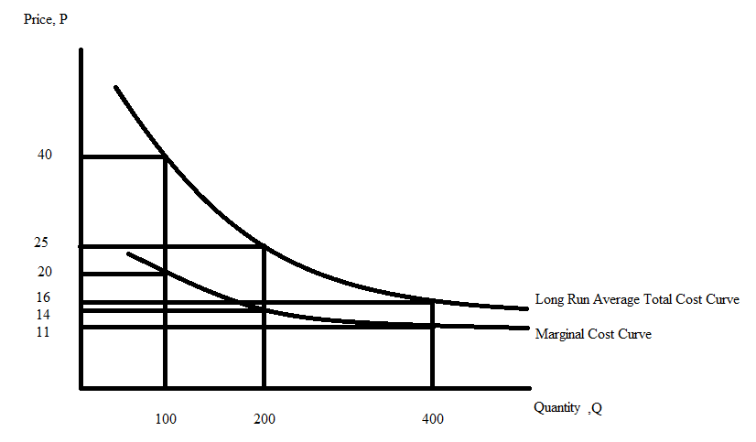

11. Given the above graph if 400 units of the good must be produced in this market, how many of the following statements are true?

- If four identical firms produce the good, then the total cost of producing the 400 units will be $16,000.
- If two identical firms produce the good, then the average total cost of producing the good will be $25 per unit.
- If a single firm produces all 400 units of the good, then the marginal cost of producing the last unit will be $5 lower than the average total cost of producing the good.
- If the industry is served by a single firm rather than two identical firms, then the average cost of producing this good will decrease by $9 per unit of the good.

a. One statement is true.
b. Two statements are true.
c. Three statements are true.
d. Four statements are true.

12. Suppose that two identical firms produce a combined total of 200 units and they sell each unit of the good they produce at $25 per unit. Given the above graph, calculate the value of total profits for the two firms (sum the profits made by each firm together to get a total profit). Total combined profit for the two firms equals:

a. $0
b. -$3000
c. $1000
d. $2200

13. Consider the following graph depicting a natural monopoly.

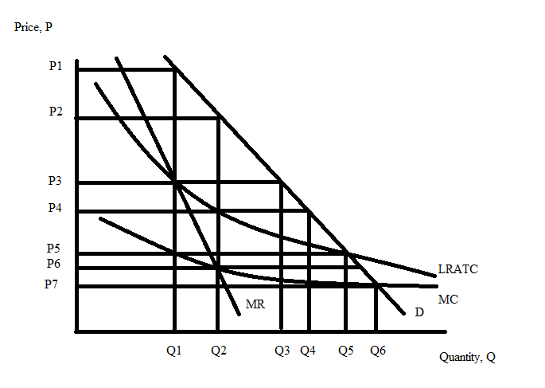
If this firm is regulated to so that its economic profit is equal to zero, then:

a. The firm will produce Q2 units and sell these units for a price of P3.
b. The firm will produce Q5 units and sell these units for a price of P5.
c. The firm will produce Q6 units and sell these units for a price of P7.
d. The firm will produce Q1 units and sell these units for a price of P1.

Use the following information to answer the next two (2) questions.

Consider the following graph that depicts the market for a good. In the graph MSB is the marginal social benefit curve, MPB is the marginal private benefit curve, and MSC is the marginal social curve.

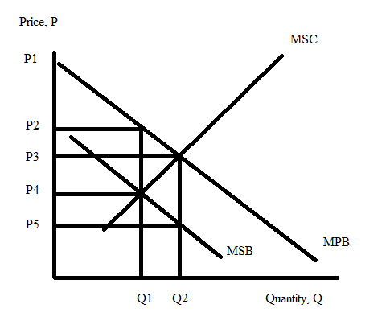
14. Which of the following would represent a good example that “fits” this graph?

a. Q is the amount of education that individuals decide to get.
b. Q is the number of alcoholic drinks an individual consumes per week.
c. Q is the number of units of pollution emitted by production plants when producing their products.
d. Q is the number of fish harvested by commercial fishermen.

15. Given the above graph and holding everything else constant, if the market does not correct for the externality, then the market will produce ______ units of the good and there will be a deadweight loss of ________.

a. Q2; (1/2)(Q2 – Q1)(P3 – P4)
b. Q1; (1/2)(Q2 – Q1)(P3 – P5)
c. Q1; (1/2)(Q1 – Q2)(P3 – P5)
d. Q2; (1/2)(Q2 – Q1)(P3 – P5)

16. Consider a market in which there is a production externality that is not currently being corrected for in the market (that is, the externality is not being internalized). Given this information and holding everything else constant, how many of the following statements are true?

- The market, without correction for this externality, will produce too much of the good.
- If this externality is internalized, then more of this good will be provided.
- At the current level of production, the marginal social benefit from consuming the good exceeds the marginal social cost of producing the good.
- If this externality is internalized, this will eliminate the deadweight loss that arises from this externality.

a. One statement is true.
b. Two statements are true.
c. Three statements are true.
d. Four statements are true.

Use the following information to answer the next two (2) questions.

You are provided the following information about a market where Q is the quantity of the good:

Marginal Private Cost of Providing the Good: MPC = 20 + 2Q
Marginal Social Cost of Providing the Good: MSC = 40 + 2Q
Marginal Private Benefit of Consuming the Good: MPB = 200 – (1/2)Q
Marginal Social Benefit of Consuming the Good: MSB = 200 – (1/2)Q

17. Given the above information and holding everything else constant, this problem is an example of:

a. A positive consumption externality.
b. A negative consumption externality.
c. A positive production externality.
d. A negative production externality.

18. Given the above information and holding everything else constant, what is the value of the deadweight loss from this externality?

a. DWL = $160
b. DWL = $80
c. DWL = $40
d. DWL = $320

Use the following information to answer the next two (2) questions.

Gary and Yoshi share an office. They both like to listen to music while they are working and given they can both listen to music played by each other, music is a public good for them. They stream music from an online radio and they have to pay for every hour of music that they listen to. The demand and the marginal cost for music is described by the following equations where P represents the price and Q represent the number of hours:

Yoshi’s Demand: P = 6 – Q
Gary’s Demand: P = 7 – Q
Marginal Cost: MC = 3

19. Given this information, what is the joint demand curve for music for Gary and Yoshi?
Multiple Choice Answer to Bubble In
a. | P = 13 – 2Q for 0 ≤ Q ≤ 6 | P = 7 – Q for 6 ≤ Q ≤ 7
b. | P = 7 – Q for 0 ≤ Q ≤ 1 | P = (13/2) – (Q/2) for 1 ≤ Q ≤ 13
c. | P = 13 – Q for 0 ≤ Q ≤ 6 | P = 7/2 – (Q/2) for 6 ≤ Q ≤ 14
d. | P = 7 – 2Q for 0 ≤ Q ≤ 1 | P = 13 – Q for 1 ≤ Q ≤ 13

20. Given the above information, what is the efficient number of hours of music (the social optimum amount of music) for Yoshi and Gary?

- 2 hours of music
- 3 hours of music
- 4 hours of music
- 5 hours of music

Use the following information to answer the next two (2) questions.

Consider a market for a public good. In this market, there are only two buyers, Sam and Annie, of the public good and both buyers are willing to reveal their preferences for the public good. Suppose that the individual demand for the public good can be expressed by the following equations where P is the price the individual is willing to pay per unit of the public good and Q is the number of units of the public good:

Sam's Demand Curve for the Public Good: P = 5 – (1/2)Q
Annie's Demand Curve for the Public Good: P = 10 – Q

You are also told that the marginal social cost of providing this public good is constant and equal to $3 per unit of the public good provided.

21. If this market provides the allocatively efficient amount of the public good, it will provide:

a. 4 units since this is the amount Sam is willing to demand at a price of $3 per unit.
b. 7 units since this is the amount Annie is willing to demand at a price of $3 per unit.
c. 5.5 units since this is the average of the amount that Sam and Annie are willing to demand at a price of $3 per unit.
d. 8 units since this is where price equals marginal social cost in the market for this public good.

22. At the allocatively efficient amount of the public good, Annie will pay per unit of the public good.

a. $1
b. $2
c. $3
d. $4

23. The health care program in the United States that provides for health care to poor people is called:

a. the National Health Expenditure (NHE).
b. Medicaid.
c. Medicare.
d. Health Maintenance Organization (HMO).

24. How many of the following statements are true?

- The infant mortality rate in the United States gives us a ranking in the top ten for countries with the lowest infant mortality rate.
- The obesity rate in the United States is lower than the rate in our comparison countries (i.e., countries that have similar standard of living as the US).
- The United States has a higher life expectancy than ten other peer countries that we use for comparison of health outcomes.
- The administrative costs of health care in the United States is a lower percentage than the health care costs as a percentage for the ten other peer countries that we use for comparison on health outcomes.

a. One statement is true.
b. Two statements are true.
c. Three statements are true.
d. None of the statements are true.

25. Consider a market for health care services where there are two types of consumers: poor consumers and non-poor consumers. The demand for health care services are given by the following equations where P is the price of unit of a health care service and Q is the number of units of health care services:

Demand by the Poor for Health Care Services: P = 500 – (1/2)Q
Demand by the Non-poor for Health Care Services: P = 1000 – (1/2)Q

You are also told that the supply curve for providing health care services is given by the following equation:

Supply of Health Care Services: P = 250 + (1/6)Q

Given this information and holding everything else constant, how many of the following statements are true?

- The market demand curve for health care services will have a “kink” point.
- The equilibrium quantity of health care services will be 1200 units of health care services and the poor will get 100 units of these health care services if there is no special program to provide services to the poor.
- The non-poor will end up consuming all the units of health care services if there is no special program to provide services to the poor.
- The equilibrium price for a unit of health care services will be greater than $500 per unit of health care services.

a. One statement is true.
b. Two statements are true.
c. Three statements are true.
d. Four statements are true.

Part III. Problems and Short Answers (10 points per question)

1. Consider a market that can be described by the following equations where Q is the quantity of the good:

Marginal Private Cost: MPC = 20 + 2Q
Marginal Social Benefit: MSB = 200 – (1/2)Q
Externality Cost of Producing the good = $40 per unit of the good produced

a. (2 points) Suppose this externality is not internalized in the market. Given this information and holding everything else constant, what quantity will the market produce? Show your work to get full credit.

Answer:
To find the quantity the market will produce if the externality is not internalized in the market set MPC = MSB. Thus:
20 + 2Q = 200 – (1/2)Q
(5/2)Q = 180
Qmarket = 72 units of the good

Additional Commentary:

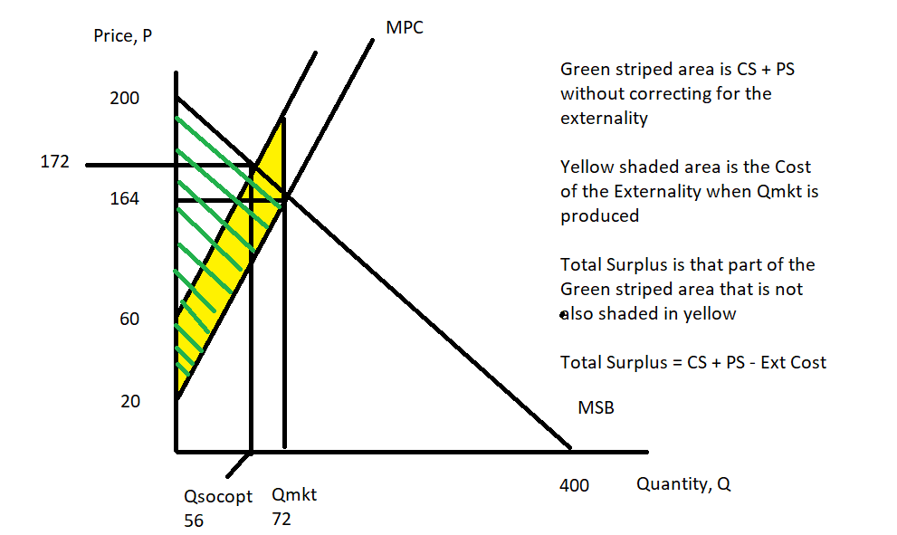

b. (4 points) Given this information and holding everything else constant, provide the value of consumer surplus, producer surplus, the externality cost, and the value of deadweight loss if this externality is not internalized. Show your work to get full credit. ]

Answer:
CS if externality is not internalized = (1/2)(200 – 164)(72) = $1296
PS if externality is not internalized = (1/2)(164- 20)(72) = $5184
Externality cost = ($40 per unit)(72 units) = $2880
DWL if externality is not internalized = (1/2)(40)(72 – 56) = $320

c. (4 points) Given this information and holding everything else constant, provide the value of consumer surplus, producer surplus, the externality cost, and the value of deadweight loss if this externality is internalized in the market. Show your work to get full credit.

Answer:
CS if externality is internalized = (1/2)(200 – 172)(56) = (1/2)(28)(72) = (14)(56) = $784
PS if externality is internalized = (172- 132)(56) + (1/2)(132 – 20)(56) = $5376
Externality cost = ($40 per unit)(56 units) = $2240
DWL if externality is internalized = $0

2. (10 points) In class we discussed externalities and market failure related to externalities. In a brief essay identify three separate methods of dealing with an externality. Describe each method and how each method would effectively reduce the problem represented by externalities.

Answer:
Answers here will vary, but here is a partial list of possible answers!

Tax on the activity to reduce the activity
Subsidies of the activity to increase the activity
Direct Regulation by the government
Social sanctions where we follow rules and norms of behavior that reduce the occurrence of externalities
Restrictive covenants
Tradeable permits

Grading:
3 points for each method and its explanation
1 point for overall quality of essay.

