Economics 390

Spring 2020

Answers to Homework #3

Due 3/12/20

Homework is due at the beginning of lecture. The professor reserves the right to not accept homework if it is late. The expectation is that the homework will be done in a professional manner: it should be stapled, it should be neat, well organized, and complete. You cannot receive full credit if you omit questions and do not follow the provided instructions. There is no need to submit the questions: you need to simply submit your answers. You will not be able to get full credit for the homework if you do not show your work in an organized, easy-to-follow manner. Make sure your name is clearly and legibly written on the homework. Illegible answers will not get full credit.

**Externalities**

**Externalities:**

1. Consider the production of a good. At the market provided quantity of the good you are told that the marginal social benefit from consuming this good is less than the marginal social cost of producing this good.

a. Draw a graph that represents this provided information. In your graph be sure to include the marginal private benefit (MPB) curve, the marginal social benefit curve (MSB), and the marginal social cost (MSC) curve. Label the market quantity, Qmarket, as well as the socially optimal quantity, Qsocial optimum, in your graph. If there is an area of deadweight loss label this area as well.

b. Given the above information, does the market left to itself, produce too much or too little of the good? Explain your answer.

Answer:

a.

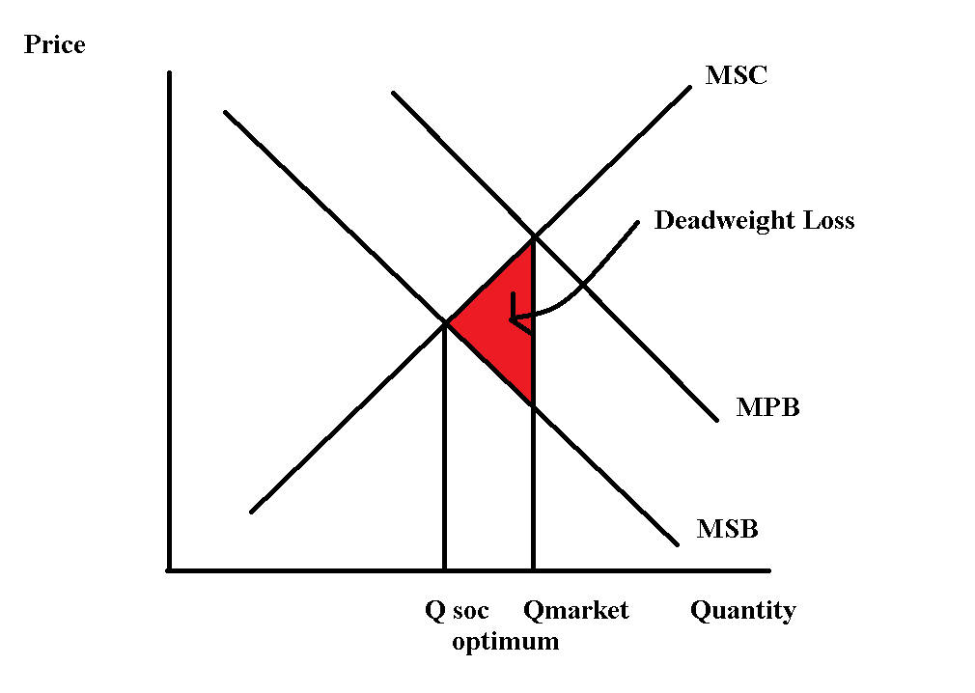

b. The market produces too much of the good since MSC > MSB at the market quantity. At the market quantity the value to the consumer of the last unit consumed is less than the cost to society of producing this last unit. The market, failing to internalize the externality, produces too much of the good.

2. The marginal social cost of providing a good is given by the following equation where Q is the market quantity and P is the price per unit:

Marginal Social Cost: MSC = 10 + 2Q

The marginal private benefit of providing this good is given by the following equation:

Marginal Private Benefit: MPB = 100 – Q

You are also told that this good generates negative consumption benefits of $9 per unit of the good consumed.

a. Given this information what is the quantity produced by the market?

b. Given this information what is the socially optimum amount of the good. Show how you found your answer.

c. What is the deadweight loss when this market fails to internalize (to correct for) the externality? Show how you found your answer.

Answer:

a. The market will produce where MPB = MSC:

100 – Q = 10 + 2Q

90 = 3Q

Qmarket = 30 units

b. The socially optimum amount of the good is where MSB = MSC. We need to find the MSB curve. We know that there is a negative externality of $9 per unit. This means that the MSB curve is shifted down from the MPB curve by $9 at every quantity. The MSB can be written as:

MSB = 91 – Q

Set the MSB = MSC:

91 - Q = 10 + 2Q

3Q = 81

Qsocial optimum = 27 units

c. DWL is calculated as follows:

DWL = (1/2)($9 per unit)(30 units – 27 units) = $13.50

3. We live in a world confronted with a large array of challenges. A recent challenge is the level of plastics and plastic particles that have been found in the world’s oceans and ingested by the many sea animals that have contact with this plastic. Discuss the issue of this plastic and how it represents an externality that the market is failing to identify and correct. Then suggest some options that might be implemented to help remedy this problem.

Answer:

Answers here will vary but the key concept here is that an externality occurs when there is a benefit or a cost from consuming or producing the good that is not incorporated in the transaction. For instance, there is a societal benefit from individuals getting an education. Yet, most individuals decide how much education they will get based upon the private benefits they will receive from the education. The social benefit from the education is not included in the transaction: there is a positive externality that is not internalized by the market. When a producer produces their product and creates a pollution by-product that they fail to clean up, then that producer is creating a negative externality that reflects a cost that they are inflicting on society. Failure to include this cost of their production generates the negative externality. When there is a positive externality, the market will under produce the good; when there is a negative externality, the market will produce too much of the good.

With regard to plastics in our water supply and oceans: the plastics are toxic to life, difficult to remove once they are in the water, and they represent a negative externality. The environmental impact of these plastics in our waterways is still being analyzed, but there is already plenty of evidence that this is not a good situation.

Here are some simple solutions for negative externalities: regulation, taxes, moral codes and social sanctions, contracts that limit or prohibit behaviors. With plastics some regulations might prove very helpful: for example, to regulate or simply outlaw plastic wrappers might be very effective. Working to educate people as to the impact of widespread use of plastic would also be helpful: with education you might really impact consumer behavior and you might see consumers demanding that producers find ecologically better packaging solutions.

Here are some simple solutions for positive externalities: regulation (for instance, mandatory education through age 16), subsidies, moral codes and social sanctions, contracts that mandate behaviors.

4. Consider the market for plastic in the country of Seaview. The market for plastic in this country is currently described by the following demand and supply equations:

Demand: Q = 100,000 – 10000P

Supply: Q = 40,000P

where P is the price per unit of plastic and Q is units of plastic. Although the good citizens of Seaview are aware that consuming plastic creates externality costs on their society the current plastic market does not incorporate any of these externalities.

a. Describe at least four possible externality costs associated with the consumption of plastic.

b. Given the externality costs you delineated in (a), where do you think the marginal social cost of plastic curve is relative to the given supply curve? That is, are the two curves the same, is the marginal social cost of plastic curve to the right of the market supply curve, or is the marginal social cost of plastic curve to the left of the market supply curve?

c. Given the above information, what is the current market equilibrium quantity and price?

d. Suppose that the government analyzes the externality costs in this market and concludes that the market should ideally result in 40,000 units of plastic being consumed if all the externalities associated with plastic consumption were internalized in the market. Assuming the externality costs are per unit of usage of plastic and are constant, what is the externality cost per unit of plastic consumed?

e. Suppose the government elects to impose a tax to internalize the externality. How big an excise tax would the government need to impose in order to address the externality that you measured in (d)?

Answer:

a. The answers will vary here, but here is at least a starting list of things you might have thought of: loss of wildlife due to the ingestion of plastic, health costs due to the consumption of plastic, environmental costs arising from the use of petroleum products to produce plastic, air pollution from the production of plastic, cost of military expenditures to secure low price petroleum products needed to produce plastic, the visual ugliness of plastic litter, etc.

b. The marginal social cost of plastic includes many costs that are currently not included in the market supply curve. This implies that the marginal social cost of plastic curve will be located to the left of the market supply curve.

c. To find the current equilibrium price and equilibrium quantity use the given demand and supply curves: thus, 100,000 – 10000P = 40,000P or P = $2 per unit of plastic. Q = 100,000 – 10000(2) = 80,000 units of plastic.

d. If the market should ideally result in the consumption of 40,000 units of plastic, we can use this information to compute the externality cost per unit of plastic. Using the supply equation, we find that producers are willing to supply 40,000 units of plastic for a price of $1 per unit. Using the demand equation, we find that demanders are willing to demand 40,000 units of plastic for a price of $6 per unit. The externality cost per unit of plastic is therefore $5 per unit.

e. If the government imposed an excise tax of $5 per unit of plastic this would cause the market supply curve to shift to the left by the amount of the externality cost per unit of plastic. The market with this tax would then provide the socially optimal amount of the good: 40,000 units of plastic sold for a price of $6 per unit.

**Public Goods:**

5. Imagine a community that has only two residents: Paul and Sally. Paul and Sally both realize that their community would benefit from the installation of streetlights, and they are trying to figure out the optimal number of streetlights for their community. Paul and Sally are both willing to reveal their preferences for streetlights:

Paul’s preferences for streetlights are given by the equation: MPB = 20 – 2Q

Sally’s preferences for streetlights are given by the equation: MPB = 10 – (1/2)Q

where MPB is the marginal private benefit for the individual and Q is the number of streetlights. Both Paul and Sally know that the marginal social cost of installing a streetlight is given by the equation:

Cost of installing streetlights: MSC = 3.5Q

a. Given this information, start by constructing three graphs that are vertically drawn one under the other. In the top graph depict the MPB for Paul; in the second stacked graph depict the MPB for Sally; and in the final stacked graph depict the MSB (marginal social benefit) from streetlights assuming that Paul and Sally are the only two individuals in this community. Label all axis, and any “kink” points clearly and completely.

b. Given your graphs in (a), write an equation(s) for the MSB curve you found. Make sure you also indicate any relevant range for the MSB equation(s) you provide.

c. Calculate the optimal number of streetlights in this community and then determine the total price per streetlight and the amount of this price that will be paid by Paul and the amount that will be paid by Sally. Show your work and explain how you found your answers.

Answers:

a.

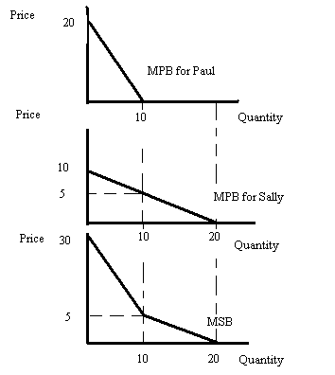

b. From the bottom graph in (a) we can see that there are two linear segments to the MSB curve. The top segment can be written as P = 30 – (5/2)Q for prices greater than or equal to $5 per unit. The bottom segment is P = 10 – (1/2)Q (this is just Sally’s MPB curve since at quantities greater than or equal to 10 units, Paul has no MPB from streetlights) for prices less than or equal to $5 per unit.

c. To find the optimal number of streetlights for the community, we first need to recognize that streetlights are a public good: non-rival and non-excludable. In this example, Paul and Sally have revealed their preferences and are not free riding. We can find the optimal amount of streetlights by equating MSC = MSB. But, this is a bit challenging for us since we have two MSB curves to consider. Let’s start with MSB = 30 – (5/2)Q. Setting this equal to MSC we have 30 – (5/2)Q = 3.5Q or 60 – 5Q = 7Q or Q = 5. Looking at the bottom graph in (a) we see that Q = 5 is in the range of quantities for this MSB curve. If 5 streetlights are produced then the MSC tells us that the price per streetlight will be equal to 3.5Q or 3.5(5) = $17.50 per streetlight. How much will Paul pay? Plug Q = 5 into his MPB curve to find out: MPB = 20 – 2Q = 20 – 2(5) = $10.00 per streetlight that Paul will play. (This implies that Sally will be paying $7.50 per streetlight-let’s check!).

How much will Sally pay? Plug Q = 5 into her MPB curve to find out: MPB = 10 – (1/2)Q = 10 – (1/2)(5) = $7.50.

6. Consider a community that has two residents, Leslie and Ron. Leslie and Ron would both like to have some public parks in their community and they are trying to decide on the optimal number of parks to build, and what price they should each contribute for each park. Luckily they are both willing to reveal their preferences and so we do not have to worry about the free rider problem. You are provided the following equations describing these individuals demand curves for public parks where P is the price per park and Q is the quantity of parks:

Leslie’s demand for parks: Q = 6 – 2P

Ron’s demand for parks: P = 3/2 – (1/4)Q.

You are also told that the marginal social cost of providing a park is given by the equations:

Marginal Social Cost: MSC = $3

a. On your homework paper draw three graphs vertically one above the other. The first graph should be labeled “Leslie’s demand”; the second graph should be labeled “Ron’s demand”; and the third graph should be labeled “Market demand”. On each graph the horizontal axis should be labeled “Quantity of Parks” while the vertical axis should be labeled “Price of Parks”. Now in each graph draw in the demand curve corresponding to your label. Remember that the market demand curve will be a vertical summation of the individual demand curves since a public good is non-rival.

b. Write an equation for the market demand curve for the public good.

c. Given the above information, what is the optimal number of parks for the community? Show how you found this number.

d. Since Leslie and Ron each get benefits from the parks, they will each contribute towards the cost. Given her demand, how much will Leslie contribute per park? How much will Ron contribute per park? Why do Leslie and Ron contribute different amounts?

e. Now think about what would happen if Leslie and Ron were unable to share the same parks. Now each of them would have to build their own private park, and pay the full cost. How many parks are Leslie and Ron willing to pay for individually? How many total parks would be built? *(Remember: we can’t build negative parks.)*

Answers:

a.

Macintosh HD:Users:Tom:Dropbox:Teaching:Econ 101 TA Fall 2014:Homeworks:Hw6graph1.pdf

Macintosh HD:Users:Tom:Dropbox:Teaching:Econ 101 TA Fall 2014:Homeworks:hw6graph2.pdf

Macintosh HD:Users:Tom:Dropbox:Teaching:Econ 101 TA Fall 2014:Homeworks:Hw6graph3.pdf

b.

Leslie: P = 3 – (1/2)Q

Ron: P = 3/2 – (1/4)Q

Market Demand Curve for the Public Good: P = 9/2 – (3/4)Q

c. To find the optimal number, find the market demand when the price equals marginal cost.

MC = 3

P = 9/2 – (3/4)Q

3 = 9/2 – (3/4)Q

Q = 2 parks

d. The marginal social cost of each park is $3, which must be paid by Leslie and Ron. From part (c), we know that the optimal number of parks is Q = 2. We can plug Q = 2 into the individual demand curves to find each person’s willingness to pay for 2 parks.

Leslie: P = 3 – (1/2)(2)

P = $2 per park

Ron: P = 3/2 – (1/4)(2)

P = $1 per park

So Leslie is willing to contribute $2 per park when 2 parks are built, and Ron is willing to contribute $1 per park. $2 + $1 = $3 = MSC, so together they cover the full cost of the parks. Because Leslie and Ron have different demand curves, or willingness to pay for parks, their contributions are different. This only works because both of them are honestly reporting their individual demand for parks.

e. If Leslie has to pay the full cost of $3 per park, she would be willing to pay for:

3 = 3 – (1/2)Q

Q = 0 parks

If Ron has to pay $3 per park, he would be willing to pay for:

3 = 3/2 – (1/4)Q

Which gives Q less than zero, so he wouldn’t pay for any parks either.

So if Leslie and Ron cannot share the benefits and costs of the parks, none will be built in the community.

7. Consider the following matrix that represents Mary and Sam’s costs and benefits from contributing to the provision of a public good.

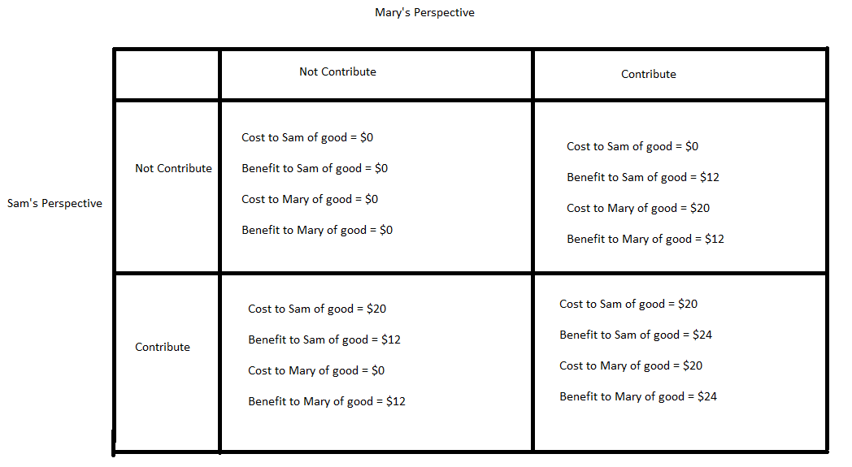

a. Given the above information, what is Mary’s dominant strategy? Explain how you found your answer.

b. Given the above information, what is Sam’s dominant strategy? Explain how you found your answer.

c. Given the above information, what do you predict will be the outcome of this simple game? Explain your answer.

Suppose we alter the matrix so that it reflects the marginal social cost and the marginal social benefit. Here is the new matrix:

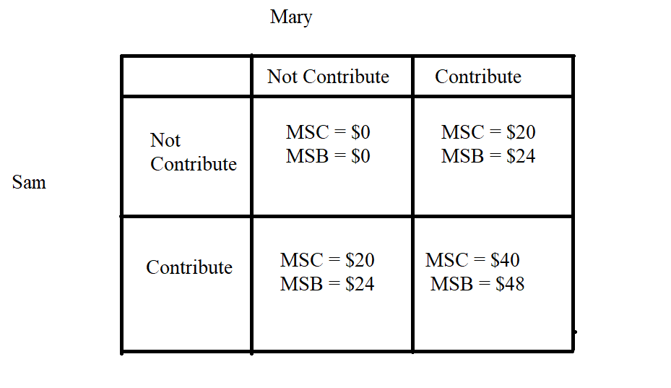

d. Suppose Sam and Mary want to maximize the net social benefit they get from the good (or minimize the net social cost of the good) where net social benefit is defined as the MSB – MSC. Given this assumption and the information you have been provided, find the optimal strategy for Sam and the optimal strategy for Mary. Explain your answer. Provide a matrix that gives the net marginal social benefit as part of the explanation for your answer.

Answers:

a. Mary’s dominant strategy is “Not Contribute”. To see this result imagine that Mary is viewing this game as a two row game: initially she assumes that Sam is not contributing and she evaluates what her best strategy is given this assumption: she finds that when Sam is not contributing she is better off with the strategy of “Not Contribute”. Then she moves to the second row where she assumes that Sam is contributing and she evaluates what her best strategy is given this assumption: she finds that when Sam is contributing she is better off with the strategy of “Not Contribute” (she would be free riding on Sam’s contribution). No matter what Sam does, Mary’s better strategy is “Not Contribute”: it is her dominant strategy.

b. Sam’s dominant strategy is “Not Contribute”. To see this result imagine that Sam is viewing this game as a two column game: initially he assumes that Mary is not contributing and he evaluates what his best strategy is given this assumption: he finds that when Mary is not contributing he is better off with the strategy of “Not Contribute”. Then he moves to the second column where he assumes that Mary is contributing and he evaluates what his best strategy is given this assumption: he finds that when Mary is contributing he is better off with the strategy of “Not Contribute” (he would be free riding on Mary’s contribution). No matter what Mary does, Sam’s better strategy is “Not Contribute”: it is his dominant strategy.

c. The outcome of this game will be that both Sam and Mary do not contribute to the provision of the public good.

d. To see the outcome let’s first change the matrix so that it reflects the net MSB. Thus:

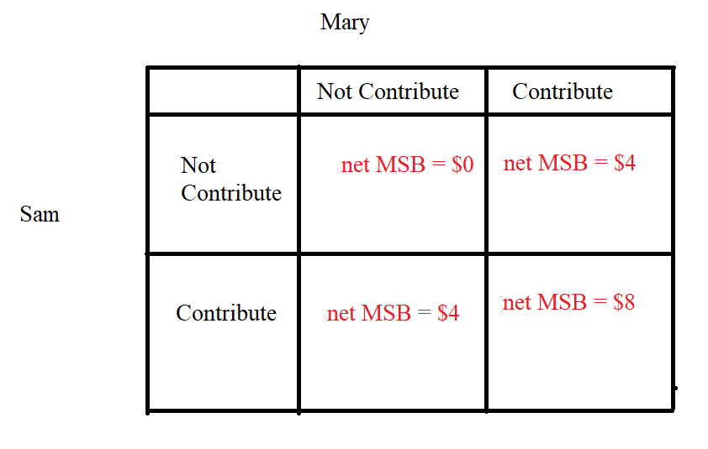

Now, the dominant strategy for Sam and for Mary is to contribute for the provision of the public good. If we can get people to look at the net marginal social benefit we are likely to get a better societal outcome when it comes to the provision of the public good.

8. Amanda and Robert are the only residents in a community. Amanda and Robert are debating the installation of streetlights in their community. They both know each other’s preferences for streetlights and Amanda knows that Robert values having more streetlights than does Amanda. Both Robert and Amanda have linear demand curves for streetlights. The graph below depicts the marginal social benefit of streetlights for these two individuals:

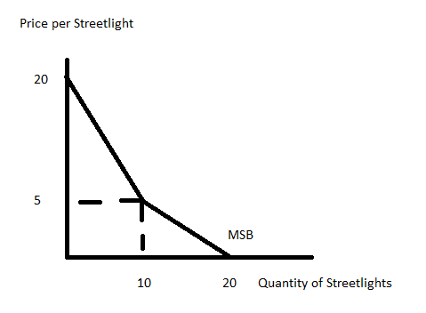

Suppose you are also told that the marginal social cost of producing a streetlight is given by the equation:

Marginal Social Cost of Streetlight: MSC = 4 + (5/2)Q

Assume that neither of these individuals free ride. Given this information and holding everything else constant, answer the following questions. Provide your reasoning behind your answers to get full credit.

a. Amanda’s demand curve for streetlights.

b. Robert’s demand curve for streetlights.

c. The socially optimal amount of streetlights given the above information.

d. The amount that Robert will contribute per streetlight if the socially optimal amount of streetlights is produced.

e. The amount that Amanda will contribute per streetlight if the socially optimal amount of streetlights is produced.

Answers:

a. From the graph we can see the kink point at (10, 5). This kink point tells us that above the kink point that both Amanda and Robert have a demand for the public good and below the kink point only one of them is demanding the public good. The information provided tells us that Robert wants more streetlights than Amanda: so the lower segment must represent just Robert. So, start by constructing Robert’s demand curve: we know that it contains the point (Q, P) = (10, 5) and (20, 0). From these two points we can calculate the slope of Robert’s demand curve for streetlights as (-1/2).So the demand for Robert is given by the equation: P = 10 – (1/2)Q.

From this we can “back out” Amanda’s demand curve: when Q = 10, she is not willing to pay anything for that many streetlights, so P = 0 at that quantity. We also know that the MSB curve has the point (0, 20) and when Q = 0, Robert’s y-intercept is 10: this implies that the y-intercept for Amanda’s demand curve must also be 10. Thus, Amanda’s demand curve for streetlights contains the points (Q, P) = (0, 10) and (10, 0). Her demand curve for streetlights is therefore given by the equation: P = 10 – Q.

b. See the explanation in (a): Robert’s demand curve for streetlight is P = 10 – (1/2)Q.

c. To find the socially optimal amount of streetlights equate the MSB to the MSC. Thus:

MSB = MSC

20 – (3/2)Q = 4 + (5/2)Q

40 – 3Q = 8 + 5Q

32 = 8Q

Qsocially optimal = 4 units

d. To see what Robert will contribute per streetlight, plug the Qsocially optimal into Robert’s demand curve for streetlights:

P = 10 – (1/2)Q

P = 10 – (1/2)(4)

P = $8 per streetlight

e. To see what Amanda will contribute per streetlight, plug the Qsocially optimal into Amanda’s demand curve for streetlights:

P = 10 – Q

P = 10 – 4

P = $6 per streetlight

Note: that the sum of what Robert and Amanda are willing to pay is equal to the MSC of providing 4 streetlights. To see this:

MSC = 4 + (5/2)Q

When Q = 4

MSC = 4 + (5/2)(4)

MSC = $14 per streetlight