Economics 302 Name _____________________________
4 Week Summer Session 2006
Answers to Quiz 3 Student ID Number __________________
6/13/06

The following quiz is worth a total of 12.5 points. In addition, 0 to 2.5 points will be subtracted from your final score if your work is illegible and hard to follow (1 points for marginally illegible work, 2 points for illegible work, and 2.5 points for unbearably difficult-to-read work).

- You are given the following information about an economy.

Y = C + I
Y = F(K, L)
The aggregate production function for this economy exhibits constant returns to scale and the marginal products of labor and capital are both subject to diminishing returns.
s = saving rate (assume this is constant) per year
δ= depreciation rate (assume this is a constant) per year
y = Y/L
k = K/L
k* = steady state of capital per worker (K/L)

You are also told that sf(k) < δk.

  - (1 point) What is sf(k)? sf(k) is the total amount of investment per unit of labor. This level of investment depends on the saving rate and the production function.
  - (1 point) What is δk? δk is the amount of capital per worker that depreciates or wears out during the year.
  - (2 points) Interpret the meaning of sf(k) < δk? When sf(k) < δk, this implies that the level of investment per worker is less than the amount of depreciating capital per worker during the time period under consideration. This implies that the change in the capital stock from one period to the next is a negative number.
  - (2 points) Draw a graph illustrating both sf(k), δk, and k*. Indicate on your graph where sf(k) < δk. Be sure to label your graph completely.
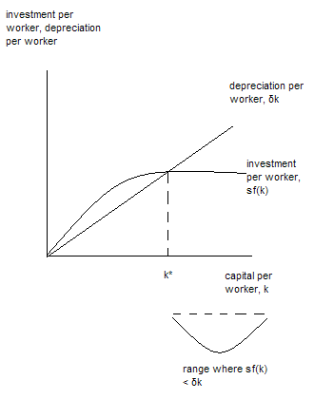
  - (2 points) Using the Solow Growth Model discussed in class, explain what happens in this economy when sf(k) < δk. The capital stock per worker will decrease from one period to the next and over time the economy will return to k* where sf(k), the amount of investment per worker, will equal δk, the amount of depreciating capital per worker. That is, the capital stock per worker will diminish until the economy returns to the steady state level of k*.

- You are given the following aggregate production function for an economy:

Y = 10K^{1/2}L^{1/2}

You are also told that K equals 400 units of capital and L equals 625 units of labor. In addition, the money supply equals 10,000 and the velocity of money is constant and equal to 1.

  - (1 point) What is an equation for the long-run aggregate supply curve (LRAS) for this economy? Y = 10 (400)^{1/2}(625)^{1/2} = 10(20)(25) = 5000. Thus, the LRAS curve is Y = 5000.
  - (1 point) Draw a graph depicting this long-run aggregate supply curve with real GDP. Y, on the horizontal axis and the aggregate price level, P, on the vertical axis. Label your graph thoroughly.
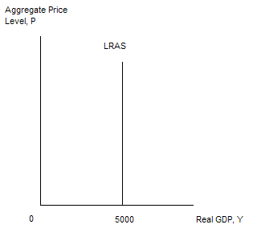
  - (2 points) Using the given information, fill in the missing values in the table below which describe points lying on this economy’s aggregate demand curve.
P | Y
1 | 10000
8 | 1250
500 | 20

  - (2 points) What is the long-run equilibrium aggregate price level for this economy? We know MV = PY and that Y = 5000 in the long-run. Since M = 10,000 and V = 1, we can solve this equation for the equilibrium aggregate price level. P = 2.

- (1/2 point) The U.S. unemployment rate is currently
.
Correct answer: 5.1% is the most recent estimate. In grading this we did not count any answers between 4 to 7% wrong.

