Economics 302 Name _________________________________
Spring2008
Monday/Wednesday Lecture
Answers to Quiz #1 Student ID Number ______________________

- This question is designed to evaluate your recall of basic supply and demand principles. For each of the following sketch a diagram of supply and demand. Assume each market is initially in equilibrium before the stated event occurs. Draw this initial equilibrium and the subsequent equilibrium after the market adjusts. Provide a summary statement about the effect of the stated event on the equilibrium price and quantity. Label your graphs with the following notation where appropriate:

D₁ = the initial demand curve
D₂ = the new demand curve
S₁ = the initial supply curve
S₂ = the new supply curve
P₁ = the initial equilibrium price
P₂ = the new equilibrium price
Q₁ = the initial equilibrium quantity
Q₂ = the new equilibrium quantity

- (.25 points) The cost of labor increases for all firms in an industry. At the same time income increases for consumers. Assume this good is a normal good.

- (.25 points) The price of steak increases. What is the effect of this price change on the market for chicken?

- (.25 points) The government taxes producers of the good with an excise tax that is an amount levied on each unit of the good sold. On your graph label the price paid by consumers as P₂, and the price received by producers (this price excludes the excise tax they pay the government) as P₃.

- Suppose that the production function for an economy is given by
Y = F(K,L) = AK^{1/2}L^{1/2}
Where Y is output, A is the level of technology, K is capital and L is labor.

  - (.25 points) If the value of L is 100, the value of K is 400, and the value of A is 2, what is the value of output in this economy? Show your work.

  - (.25 points) Given the values in part (a), calculate labor productivity. Show your work. Be sure to show the relevant units of measurement in your answer.

  - (.25 points) If capital and technology are held constant, but labor is decreased to 81 units, what happens to labor productivity? Verbally describe the effect of this change on labor productivity.

  - (.25 points) In the space below sketch a picture that shows the aggregate production function drawn with respect to labor. In your drawing indicate both the initial situation where labor equals 100 and the new situation where labor equals 81. Label your graph carefully and completely. On your drawing indicate what is happening to labor productivity as you move from using 100 units of labor to using 81 units of labor.

- This is just a quick review of some terms I think you should be familiar with before we start the course. The diagram below illustrates an aggregate production function showing the relationship between the amount of capital utilized in a year by an economy and the level of real GDP this economy produces in a year from that capital. The aggregate production function that is represented is drawn holding the level of labor and technology constant.

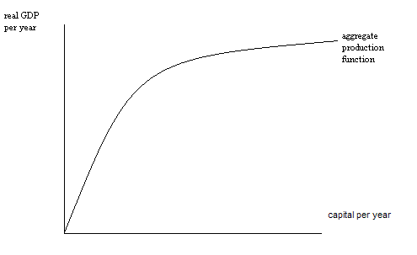
  - (.25 points) Using the graph as a reference, what is the marginal product of capital?

  - (.25 points) Using the graph as a reference, what is capital productivity?

  - (.25 points) Suppose the level of technology changes in this economy. In the space below sketch a graph of the aggregate production function and how it is affected by this change.

