Economics 302
Spring 2008
Homework #5

Homework will be graded for content as well as neatness, sloppy or illegible work will not receive full credit. This homework requires the use of Microsoft Excel.

- Keynesian Cross
Consider a closed economy with consumption given by the following equation.
In addition, suppose that planned investment expenditure is 300 and that the government runs a balanced budget with 200 in government spending. Use the Keynesian cross as a starting point to answer the following questions.

  - If Y is 1,100, what is planned expenditure? What is the change in inventory level? Given your answer to the last question, would you expect equilibrium Y be higher or lower than 1,100? If you expect equilibrium Y to be different, explain the mechanism by which you would expect Y to change in this economy.
The change in inventory level is the output less planned expenditure, this is equal to Y – E which is equal to 1,100 – 1,200 = -100. As inventory levels are decreasing we expect that the equilibrium level of output should be higher than 1,100. Firms will take the change in inventory as a sign to hire more workers and increase production, increasing the level of output and moving toward the equilibrium level.

  - What is equilibrium Y?

  - What are the equilibrium levels of consumption, private saving, public saving, and national saving, based on the equilibrium level of output you just found?

  - Compared to the answer you found in part (b), what is the new equilibrium income when Investment is reduced by 50? What is the Keynesian multiplier for investment spending?
The Keynesian Multiplier on investment spending is equal to 1 / (1-MPC) = 3, thus we know that a 50 unit decrease in investment will result in a 150 unit decrease in output.

  - Compared to the answer you found in part (b), what is the new equilibrium income if taxes are increased by 75? What is the Keynesian multiplier for taxes?
The Keynesian Multiplier on taxes is equal to –MPC / (1-MPC) = -2, thus we know that a 75 unit increase in taxes will also result in a 150 unit decrease in output.

- IS-LM Model
Consider a closed economy described by the following equations.

  - Solve for the IS curve. [Hint: Use the Keynesian Cross equilibrium condition and solve for Y as a function of r.]

  - Solve for the LM curve.
  - Rearrange the equations you found in the previous two parts, solving for r, and fill in the table below pertaining to the IS and LM curves. (When appropriate round to the nearest unit, i.e. 3.6 is rounded to 4.) Graph the two curves on one graph using the completed table.

Y | IS | LM
0 | 22.0 | 0.0
100 | 20.3 | 1.0
200 | 18.6 | 2.0
300 | 16.9 | 3.0
400 | 15.1 | 4.0
500 | 13.4 | 5.0
600 | 11.7 | 6.0
700 | 10.0 | 7.0
800 | 8.3 | 8.0
900 | 6.6 | 9.0
1000 | 4.9 | 10.0
1100 | 3.1 | 11.0
1200 | 1.4 | 12.0
1300 | -0.3 | 13.0
1400 | -2.0 | 14.0
1500 | -3.7 | 15.0

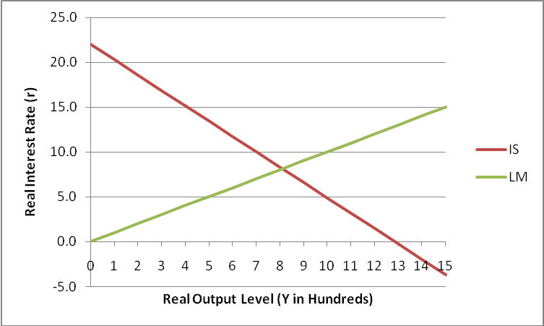

  - Find the equilibrium output level using Goal Seek within Excel, and report the equilibrium interest rate. [Hint: Add another column to your created table, finding the difference in the IS and LM values. In Excel 2007, use the Data tab, Data Tools, What-If Analysis to find Goal Seek. In older versions of Excel, Goal Seek is under Tools. Once you have Goal Seek open, “set cell” is the cell containing the difference “to value” of zero (the equilibrium condition that IS = LM) “by changing” the output level cell for that line.]

Y | IS | LM | Difference
0 | IS₀ | LM₀ | IS₀ - LM₀

810.526315789474 (Goal Seek Output)

  - Solve for the equilibrium interest rate and output level by hand. Your equilibrium output level should agree with that found in the previous part of the problem.

  - Use the IS and LM curves that you found earlier to derive the aggregate demand equation. [Hint: The IS curve describes all combinations of output levels Y and real interest rate levels r in which the goods market is in equilibrium. Rearrange the IS curve to solve for r. The LM curve describes all combinations of output levels Y, real interest rate levels r, and aggregate price levels P in which the money market is in equilibrium. Rearrange the LM curve to solve for r also, leaving price level as a variable P. Set the two equations equal to each other and solve for P to arrive at the aggregate demand curve.]

  - Use Excel to graph the aggregate demand equation, allowing output to range from 200 to 1,000 in 100 unit increments. Does your aggregate demand curve look correct? Graphically verify that the previously found equilibrium output level and price level are on the AD curve.
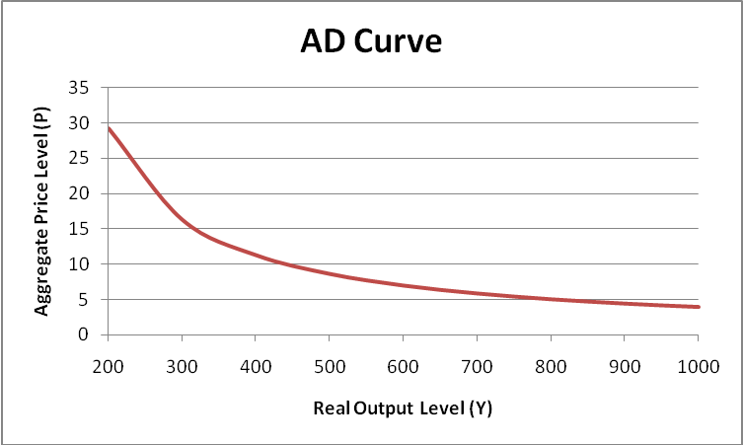

  - Suppose that government purchases are raised from 150 to 200. How much does the IS curve shift? Using the original LM curve, what are the new equilibrium interest rate and the new equilibrium level of income? Why does the shift in the IS curve not equal the change in the equilibrium level of income? Describe what happens to the AD curve when you make this change in the IS curve, and graph the new AD curve with the old one.

Increasing G shifts the IS curve to the right and leaves the LM curve the same, using the Keynesian Multiplier we know that he 50 unit increase in G causes a 200 unit increase in Y at a given interest rate on the IS curve.
The IS curve shifts to the right, resulting in a higher equilibrium interest rate and higher equilibrium level of income. The new equilibrium level of income is 74 higher than before, which is a much smaller change than the 200 unit increase caused by the IS curve shift. This smaller IS/LM equilibrium income shift compared to the IS shift is caused by having a LM curve that is positive sloping. The new equilibrium allows the interest rate will fluctuate and the entire IS curve shift is not manifested in only a change in the equilibrium level of income but also in the equilibrium interest rate.

The AD curve shifts to the right when the IS curve shifts right.
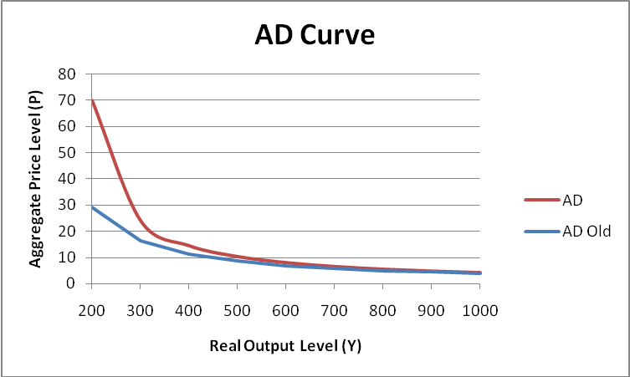

  - Suppose instead that the fed increases the money supply from 1,000 to 1,200, leaving government spending at 150. Do we move along or shift the IS and LM curves? What is the new equilibrium interest rate and what is the new level of income? Describe what happens to the AD curve when you make this change in the money supply, and graph the new AD curve with the old one.

Increasing M^{S} shifts the LM curve to the right and leaves the IS curve the same.

The AD curve shifts to the right when the LM curve shifts right.
