Economics 302 Name ________________________________
Answers to Second Midterm
June 14, 2007 Student ID Number _____________________

Version 1

This midterm consists of 25 multiple choice questions (some with just two answers and some with up to five answers) worth 2 points each for a total of 50 points and 3 problems worth a total of 50 points. Please answer all multiple choice questions on the scantron provided.

Pleases show all your work on the exam booklet: if any questions arise as to the integrity of your exam, we will NOT give full credit unless suitable work is shown in the exam booklet.

For all questions please pick the BEST answer.

SCANTRON DIRECTIONS
Please fill out your scantron sheet carefully. You need to use a number 2 pencil and you need to bubble in your
- Name
- Student Identification Number (and NOT your social security number)
- Your exam version number in special codes column “A”

PROBLEM DIRECTIONS:
Please answer these questions on your test booklet. Please write legibly and please take some time to organize your answer before your write it.

If you have questions about any question on the exam please make a note of that question on your exam booklet and then draw the proctor’s attention to this question at the end of the exam. Please do not ask the proctor any questions during the exam: no questions will be answered during the exam period.

You have 75 minutes to complete the exam. Please use your exam booklet margins for any calculations you need to do.

Calculators are fine to use.

Problem #1 (12 points) _____________________

Problem #2 (22 Points) ______________________

Problem #3 (16 Points) ______________________

TOTAL _______________________

Multiple Choice:

- For a small, open economy when spending exceeds production then
I. This country will run a trade deficit
II. This country will be a net lender
III. This country will export less than it imports

  - Statements I, II and III are true
  - Statements I and II are true
  - Statements I and III are true
  - Statements II and III are true.

Answer: C.

- The national accounts identity for a small open economy can be written as
  - Y = C + I + G + X
  - Y = C^{d} + I^{d} + G^{d} + NX
  - NX = NS – I
  - All of the above answers accurately express the national accounts identity

Answer: C.

- For a small, open economy, if there is an increase in the level of national savings for a given level of investment, then the Classical Model suggests that this economy will
  - Find that its net exports are diminished
  - Find that its net exports are increased

Answer: B.

- In a model of a small, open economy the expression Y – C – G is equivalent to
  - National Saving
  - Private Saving
  - Government Saving
  - Investment

Answer: A.

- When the trade balance is negative, then it must be the case that
I. Exports are greater than imports
II. Imports are greater than exports
III. Net capital outflow are negative
IV. National savings is less than investment

  - Statements I, III and IV are true.
  - Statements II, III and IV are true.
  - Statements II and IV are true
  - Statements I and III are true

Answer: B.

- For a small, open economy when investment exceeds national saving then
I. The trade balance is negative
II. The trade balance is positive
III. The world real interest rate is higher than the real interest rate in the small, open economy

- Statements I and III are true.
- Statements II and III are true.
- Statement I is true.
- Statement II is true.

Answer: C.

- A small, open economy is initially in a long run equilibrium situation where the real interest rate in this economy equals the world real interest rate. Assume that this economy has full capital mobility. Then, this small, open economy reduces their level of government spending, holding everything else constant. This will
a. Result in national saving being less than investment for this economy at the world real interest rate.
b. Result in this country becoming a net lender to foreign economies.
c. Result in net capital outflows being negative.
d. Answers (a) and (c) are both true for this economy.

Answer: B.

- When a large country increases their level of government spending this leads to
  - Increases in the world real interest rate and therefore decreases in the level of worldwide spending.
  - Reductions in world savings and therefore an increase in the world real interest rate.
  - Reductions in world savings which are offset by reductions in the level of investment, so that government spending crowds out investment and has no impact on the world real interest rate.
  - Decreases in the world real interest rate and therefore an increase in economic production.

Answer: B.

- Which of the following statements is true?
I. The nominal exchange rate expresses the relative price of the currency of two countries
II. The real exchange rate is equal to the nominal exchange rate plus the rate of inflation.
III. The real exchange rate expresses the rate at which the goods of one country trade for the goods of another country.

  - Statements I, II and III are true.
  - Statements I and II are true.
  - Statements I and III are true.
  - Statement I is true.
  - Statement II is true.

Answer: C.

- Based on the model we used in class, the real exchange rate from country A’s perspective will increase if the price level in country B increases, holding everything else constant.
  - True
  - False

Answer: B. If the price level in country B increases this will make the price ratio for the price level in country A to the price level in Country B get smaller and therefore lead to decreases in the real exchange rate in Country A.

- While holding everything else constant, Country A finds that the nominal exchange rate for country B’s currency to country A’s currency increases. This will cause the real exchange rate from Country A’s perspective to decrease.
  - True
  - False

Answer: B. If the nominal exchange rate increases, this causes the numerator of the real exchange rate to increase and therefore the real exchange rate to increase.

- When the real exchange rate is relatively low, then
  - Foreign goods are relatively cheap and domestic goods are relatively expensive.
  - Foreign goods are relatively cheap and domestic goods are relatively cheap.
  - Foreign goods are relatively expensive and domestic goods are relatively expensive.
  - Foreign goods are relatively expensive and domestic goods are relatively cheap.

Answer: D. When the real exchange rate is relatively cheap this makes the country’s exports more attractive: hence, domestic goods are relatively cheap and foreign goods are relatively expensive.

- Starting at a point of trade balance and holding everything else constant, if the real exchange rate falls then this country will
  - Import less than it exports and it will therefore run a trade surplus.
  - Import less than it exports and it will therefore run a trade deficit.
  - Import more than it exports and it will therefore run a trade surplus.
  - Import more than it exports and it will therefore run a trade deficit.

Answer: A.

- A decrease in government spending, holding everything else constant, will result in
  - An increase in S – I and an increase in the real exchange rate.
  - An increase in S – I and a decrease in the real exchange rate.
  - A decrease in S – I and an increase in the real exchange rate.
  - A decrease in S – I and a decrease in the real exchange rate.

Answer: B

- If the Law of One Price holds then
I. Changes in national saving do not effect the real exchange rate
II. Changes in investment spending do effect the real exchange rate
III. When the real exchange rate is fixed, then any change in the nominal exchange rate must be due to changes in the price levels in either of the two countries
  - Statements I, II and III are true.
  - Statements I and II are true.
  - Statements I and III are true.
  - Statement I is true.
  - Statement III is true.

Answer: C.

- Holding everything else constant, when the rate of job separation increases this
  - Results in the unemployment rate decreasing.
  - Results in the unemployment rate increasing.
  - Causes no change in the unemployment rate since the rate of job finding has not changed.

Answer: B.

- When the rate of job finding decreases, holding everything else constant, this results in
  - Results in the unemployment rate decreasing.
  - Results in the unemployment rate increasing.
  - Causes no change in the unemployment rate since the rate of job separation has not changed.

Answer: B.

- In the Solow Growth Model holding everything else constant, an increase in the rate of depreciation will
  - Decrease the level of steady state capital per worker.
  - Increase the level of steady state capital per worker.
  - Have no effect on the level of steady state capital per worker.

Answer: A.

- The Golden Rule of Capital in the Solow Growth Model is that level of steady state capital per worker where
I. Output per worker is maximized.
II. Consumption per worker is maximized.
III. The economy has the optimal saving rate, s_{gold}.
  - Statements I, II and III are correct.
  - Statements I and II are correct.
  - Statements I and III are correct.
  - Statements II and III are correct.
  - Statement II is correct.

Answer: D.

- In the Solow Growth Model, the steady state level of capital per worker occurs when
  - Output per worker is maximized and constant.
  - Consumption per worker is maximized and constant.
  - The level of investment per worker equals the amount of capital per worker that depreciates during the particular time period.
  - All of the above statements are true for the steady state level of capital per worker in the Solow Growth Model.

Answer: C.

- In the Solow Growth Model and assuming the steady state, the larger the savings rate, holding everything else constant, the
  - Higher the consumption per worker.
  - Higher the steady state level of output per worker.
  - The greater the change in capital.
  - The lower the depreciation rate since this economy is investing heavily in new capital and will therefore have little capital that depreciates over time.

Answer: B.
- In a Solow Growth Model with no population growth and no technological change, consumption per worker will be maximized in the steady state when
  - Output per worker is maximized.
  - Investment per worker is maximized.
  - The marginal product of capital per worker is equal to the depreciation rate.
  - The marginal product of labor is equal to the depreciation rate.

Answer: C.

- When investment per worker is greater than the amount of capital per worker that depreciates during the same period of time, then it must be the case that
  - The steady state level of capital per worker is larger than the current level of capital per worker.
  - The steady state level of capital per worker is smaller than the current level of capital per worker.

Answer: A.

- In the Solow Growth Model it is impossible to have too high a savings rate since a higher savings rate is always more beneficial than a lower savings rate.
  - True
  - False

Answer: B.

- If the steady state rate of savings is too low, then the policymaker who successfully raises the saving rate will enact a policy that
  - Causes consumers in this economy to reduce their consumption per worker initially due the higher savings rate.
  - Causes investment spending to fall initially since the level of savings is too low for this economy.
  - Alters the marginal product of capital per worker for this economy.
  - Alters the steady state level of depreciation schedule for this economy.

Answer: A.

Problems:

- (12 points total) You are given the following information about an economy’s employment and unemployment situation for the past year. For this problem assume that all individuals in this economy are either employed or unemployed.

 | Employed | Unemployed | Total Labor Force
Initial Levels at Beginning of Year | 100,000 | 40,000 | C.
Change due to finding a job | +2000 | -2000 | XXXX
Sub-total | A. | B.
Change due to losing a job | -20,000 | +20,000 | XXXX
End of Year Levels | D. | E.

  - (2 points) What is the value of “C” in the above table? Explain your answer.

Answer: 140,000. The labor force is equal to the sum of the employed plus the unemployed or in this case 100,000+ 40,000 = 140,000.

  - (2 points) Given the above information, what is the value of the job finding rate, f, for this economy? Explain your answer.

Answer: 5%. The number of unemployed who find a job during this year is 2000. There are initially 40,000 unemployed, so 2000 of 40,000 represents 5% of that group. So, 5% of the unemployed find work during the year.

  - (2 points) What is the value of “D” in the above table? Explain you calculated this value.

Answer: 82,000. Initially there were 100,000 employed people in this economy. 2000 more people found work so that the number of employed rose to 102,000. But, during the year 20,000 employed people lost their jobs resulting in the total number of employed people at the end of the year equaling 82,000.

  - (2 points) Given the above information, what is the value of the job separation rate, s, for this economy? Explain your answer.

Answer: 20%. The job separation rate is the number of employed people who lost their jobs relative to the initial level of employment in the economy at the beginning of the year. 20,000 people lost their jobs out of the initial 100,000 that were employed, so the job separation rate, s, is equal to 20%.

  - (2 points) What is the steady state level of unemployment for this economy? Show your work and identify any symbols or equations that you are using.

Answer: 80%. The steady state level of unemployment for this economy is equal to s/(s + f) or 80%.

  - (2 points) Fill in the following table with your steady state values for the beginning of the year and the end of the year. Assume this economy starts the year at the steady state level of unemployment and ends the year in the steady state level of unemployment.

 | Employed | Unemployed | Total Labor Force
Initial Levels at Beginning of Year when in Steady State of Unemployment | 28,000 | 112,000 | 140,000
Change due to finding a job | +5600 | -5600 | XXXX
Sub-total | 33,600 | 106,400 | 140,000
Change due to losing a job | -5600 | +5600 | XXXX
End of Year Levels when in Steady State of Unemployment | 28,000 | 112,000 | 140,000

- (22 points total) Use the Solow Growth Model to answer this question. Suppose an economy can be characterized by the following Cobb-Douglas aggregate production function.
Y = F(K, L) = AK^{α}L^{1-α} = AK^{.5}L^{.5}

  - (2 points) Rewrite this aggregate production function in terms of output per worker, Y/L. Use y as the symbol for output per worker (Y/L) and k as the symbol for capital per worker (K/L).

Answer: Y = AK^{.5}L^{.5}
Y/L = (AK^{.5}L^{.5} )/L
y = AK^{.5}/L^{.5}
y = Ak^{.5}

  - (2 points) As k increases holding the amount of labor constant, what happens to y? Explain your answer and use a well-labeled graph to illustrate your answer.

Answer:
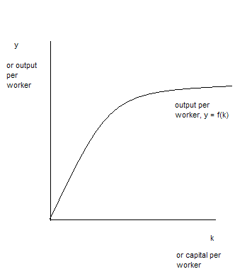

As capital per worker, k, increases for a given level of labor, output per worker, y, increases but eventually it increases at a diminishing rate due to decreases in the MPk.

  - (2 points) Suppose the fraction of income that is saved each year in this economy can be written as s where the value of s is between 0 and 1 (or 0 ≤ s ≤ 1). Suppose output in this economy can be broken down into two components: consumption and investment and that consumption per worker can be written as c = (1 – s)y. Provide an equation for investment per worker, i, that you develop from the information you have been given. (Hint” provide a step-by-step derivation of your equation for investment per worker.)

Answer: Y = C + I
Y/L = C/L + I/L
y = c + i
c= (1 – s)y
y = (1 – s)y + i
y = y – sy + i
i = sy

  - (2 points) Draw a well-labeled graph of your investment per worker equation.
Answer:

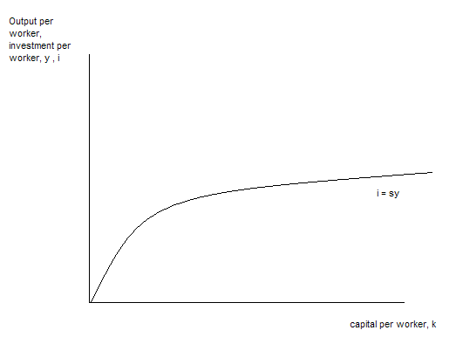

  - (2 points) Is the slope of the investment per worker function constant? Explain your answer.

Answer: No-the slope diminishes as the level of capital per worker increases due to diminishing marginal returns to k.

  - (2 points) Suppose that δ represents the fraction of the capital stock that wears out each year, or the depreciation rate. Draw a graph illustrating y, i, and δk: label your graph carefully and fully. Indicate on your graph the steady state level of k (k*); the steady state level of investment per worker (i*); the steady state level of consumption per worker (c*); and the steady state level of output per worker (y*).

Answer:

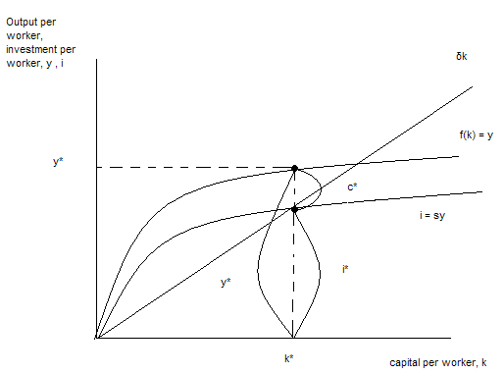

  - (6 points) Suppose the depreciation rate, δ, increases while holding all other exogenous variables constant. Briefly describe the effect of the change on the investment per worker function, the aggregate production per worker function, c*, i* and y*. Use a graph to illustrate your answer and then summarize your findings in a neat, organized table that recaps the effect of this change on the investment per worker function, the aggregate production per worker function, c*, i* and y*.

Answer:
In the answer there should be a description (2 points), a graph (2 points), and a table (2 points).

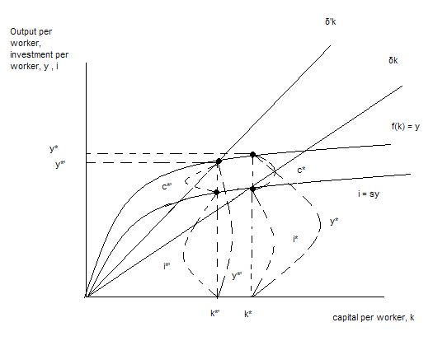

Investment per worker function | Aggregate Production per Worker function | c* | i* | y*
No change | No change | Decreases | Decreases | Decreases

  - (2 points) Draw a representation of the golden rule of capital for the Solow Growth Model. In your graph make sure you include y = f(k*), s_{gold}f(k*), δk*, c*_{gold}, i*_{gold}, and y*. In this drawing k*_{gold} refers to the level of steady state capital per worker that maximizes consumption per worker (c*_{gold}) and k* refers to a steady state level of capital per worker. Label all axes carefully.

Answer:

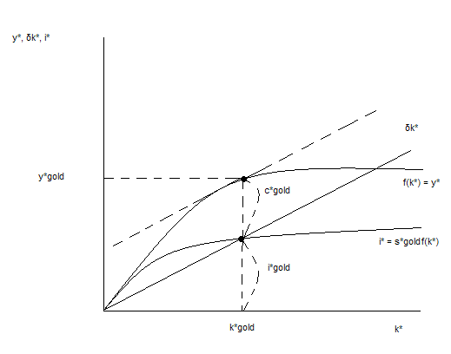

  - (2 point) What is special about c*_{gold} in the Solow Growth Model?

Answer: In the Solow Growth Model, c*_{gold} is where steady state consumption per worker is maximized. Given this economy’s aggregate production function and its depreciation rate, the savings rate associated with k*_{gold} is the savings rate that results in the steady state level of capital per worker that will maximize consumption per worker.

- The following information describes a small, open economy using a Classical long run Model. In this economy there are 400 units of capital and 625 units of labor. The aggregate production function is a Cobb Douglas Production Function where the parameter measuring technology has a value of 2. The production function exhibits constant returns to scale, all firms in the economy are competitive and price takers, and all input markets are competitive. Labor’s share of aggregate output is 50%.
  - ( 2 points) What is aggregate output, Y, for this economy? Show your work.

Answer: Y = AK^{α}L^{1-α}
Y = (2)(400)^{.5}(625)^{.5}
Y = (2)(20)(25)
Y = 1000
  - (2 points) What is capital’s income in this economy? Provide a derivation for your answer based on the model. Make sure you identify any symbols you use and where appropriate identify any units of measurement.

Answer:
Capital’s share of income = MPK * K
MPK = αAK^{α-1}L^{1-α}
MPK = (αAK^{α-1}L^{1-α} )(K/K)
MPK = αAK^{α}L^{1-α} /(K)
MPK = αY/K
MPK = (.5)(1000)/(400) = 1.25 units of output per unit of capital
Capital’s share of income = (1.25 units of output per unit of capital)(400 units of capital) = 500 units of output

You are also told that autonomous consumption equals 75 in this economy and that the marginal propensity to consume equals .5. Taxes are constant and equal to 150 and government spending is constant and equal to 100. Investment is a function of the real interest rate. When the real interest rate is zero, then the level of investment is 1000 and when the real interest rate is 10% (or .1), then the level of investment is 0.

  - (2 points) Suppose the world real interest rate is 5%. What is the value of investment, I, in this economy? Assume that the real interest rate in this economy equals the world real interest rate. Show your work.

Answer:
I = 1000 – 10000r
So, if r = .05, then
I = 1000 – 10000(.05)
I = 1000 – 500 = 500

  - (2 points) Given the information you have, what is the value of net exports, NX, for this country? Show your work.

Answer:
Y = C + I + G + NX
Y = 1000
I = 500
G = 100
1000 = C + 500 + 100 + NX
400 = C + NX
To find NX, we first need to calculate C:
C = a + b(Y – T)
C = 75 + .5(Y – 150)
C = 75 + .5(1000 – 150)
C = 75 + .5(850)
C = 75 + 425
C = 500
So, to find NX we substitute 500 for C to get
400 = C + NX
400 = 500 + NX
NX = -100

  - (2 points) Describe this country’s trade balance.

Answer:
This country is currently running a trade deficit since NX < 0. Alternatively, this country is spending more than it is producing and this leads to a trade deficit.

  - (2 points) What is the level of government saving, S_{G}, for this economy? What is the level of private saving, S_{P}, for this economy? What is the level of national saving for this economy? Show your work.

Answer:
S_{G} = T – G
S_{G} = 150 – 100 = 50
S_{P} = Y – C – T
S_{P} = 1000 – 500 – 150
S_{P} = 350
NS = S = S_{P} + S_{G}
NS = S = 350 + 50
NS = S = 400

  - (2 points) Holding everything else constant, suppose government spending increases by 100 in this economy. What is the level of net exports, NX, equal to in this economy given this change?

Answer:
G’ = 200
S_{G} = T – G = 150 – 200 = -50
S_{P} = 350
NS = S = 350 + (-50) = 300
I = 500
S – I = NX
300 – 500 = NX
NX = -200

  - (2 points) Draw a sketch illustrating the relationship between net exports, the real exchange rate (Є), and the initial level of government spending versus the new level of government spending. Label your graph clearly and carefully.

Answer:

