Economics 302** Name _______________________________
Fall 2009
Answers to Second Midterm Student ID Number ____________________
November 18, 2009 Section Number _______________________

This 75 point midterm consists of three parts: a binary choice section with 10 binary choice questions worth 2 points each for a total of 20 points; a short answer/graphing questions section with 5 questions each worth 5 points for a total of 25 points; and a problem section with two parts worth a total of 30 points.

You will want to write legibly since illegible answers will be graded as wrong answers.

You will want to present your work in an orderly fashion since a lack of organization will be interpreted as a lack of mental clarity and competent expression.

You will want to make sure your answers are clear and easy to find on the test.

All work should be done on the exam booklet and all answers should provide work and any formulas you used in answering the question. A lack of work for any answer will be penalized by a lower grade on that section.

Calculators are fine to use.

SCORE:

Binary Choice 20 points __________________

Short Answer/Graphing 25 points

1.__________________
2.__________________
3.__________________
4.__________________ 5.__________________

Problems 30 points

1. 20 points __________________

2. 10 points __________________

TOTAL 75 points __________________
Binary Choice (worth 2 points each or 20 points total)

Please circle legibly the letter that corresponds to your answer.

- According to the Fisher equation, the nominal interest rate is
- Equal to the real interest rate plus the expected inflation rate.
- Equal to the real interest rate minus the expected inflation rate.

- During periods of unexpected inflation, lenders are hurt while borrowers gain because the
  - Ex post real interest rate exceeds the ex ante real interest rate.
  - Ex post real interest rate is lower than the ex ante real interest rate.

- The Solow growth model predicts that countries with higher population growth rates will have
  - Lower steady-state levels of output per worker.
  - Lower steady-state growth rates of output per worker.

- If inflation falls from 6 percent to 4 percent and nothing else changes, then, according to the Fisher effect
  - The real interest rate falls by 2 percent and the nominal interest rate remains constant.
  - The nominal interest rate falls by 2 percent and the real interest rate remains constant.

- If investment demand decreases in a small open economy
  - Net exports decrease.
  - Net exports increase.

- If domestic investment is less than domestic saving, one would observe
  - Borrowing from abroad.
  - Lending to abroad.

- Which of the following statements is not a valid explanation of why capital is flowing to the United States from many poorer countries?
  - Property rights are enforced more fully in the United States than in many poor countries.
  - According to the Cobb-Douglas production function, additional capital will be more productive in countries with more capital per worker.

- If a computer costs $2,000 in the United States, how much will the same type of computer cost in euros if the nominal exchange rate is 0.8 euros per U.S. dollar?
  - 2500 euros
  - 1600 euros

- Suppose that a country in a steady state implements policies to increase its saving rate. After the new steady state is reached
  - The level of output per worker will be higher than before.
  - Output per worker will grow more rapidly than before.

- “Break-even” investment is the amount of investment
  - Required to keep the capital stock per worker constant.
  - At which the marginal product of capital is equal to its price.

Short Answer/Graphing Questions (worth 5 points each or 25 point total)

Please provide your answer in the provided space. Remember to write legibly and take the time to organize your answer before you begin to write.

For short essay responses please remember to use complete sentences: sentences should have a subject, a verb, proper capitalization and proper punctuation. We reserve the right to lower your graph for responses that are not written in standard English with these components.

1. (5 points) The labor market is in a steady state, if the number of people finding jobs is equal to the number of people losing jobs. Assume the labor force L is fixed, the number of people who are employed is E, the number of people who are unemployed is U, the rate of job separation is s and the rate of job finding is f.

Write down the condition for steady state in the labor market:

U×f = E×s (1 point)

Derive the natural rate of unemployment:

U×f = E×s→E = (U×f) /s
UR = U/(U+E) = U/U+ (U×f )/(s) = s/(s+f) (2 points)

If f = 0.7, s = 0.10, what is the natural rate of unemployment?

UR = s/(s+f) = 0.10/(0.10+0.7) = 12.5% (2 points)

2. (5 points) The quantity equation is MV=PY, where M is the quantity of money available in an economy, V is the transactions velocity of money, P is the GDP deflator, and Y is real GDP.

In 2005,
Real GDP = Y = $11,131 billion
The GDP deflator = P = 1.121
M = $6,539 billion

What is the value of V?

V = (PY)/M = (1.121×$11,131 billion) /$6,539 billion = 1.91 (2 points)

Recall that the %∆ in () is approximated by the following: (Percentage change in ()) ≈ %∆ in A + %∆ in B. Apply this approximation to both sides of the quantity equation and write down a formula which characterizes the relationship between the percentage change in M, the percentage change in V, the percentage change in P, and the percentage change in Y.

%∆ in M + %∆ in V = %∆ in P + %∆ in Y (1 point)

In 2008, the US government increased the money supply by 2%, the real GDP growth rate was 5% and there was no change in the transactions velocity of money. Provide an approximation of the inflation rate. Show your work.

%∆ in M + %∆ in V = %∆ in P + %∆ in Y
%∆ in P = %∆ in M + %∆ in V - %∆ in Y
%∆ in P = 2% + 0% - 5% = -3% ( 2 points)

3. (5 points) Assume the economy is initially in long-run equilibrium. Explain briefly how short-run stagflation results from an adverse supply shock.

An adverse supply shock will push costs and prices upward. If the aggregate demand is held constant, the price level rises and the amount of output falls below its natural level. An experience like this is called stagflation, because it combines economic stagnation with inflation. (2 points)

Suppose that stagflation occurs. To prevent a reduction in output in the short-run, should the government increase or decrease the money supply? Briefly explain your answer.

Government should increase the money supply. (1 point)
When stagflation occurs, the amount of output falls below its natural level, in order to bring the economy toward the natural level of output, the government needs to expand aggregate demand by increasing the money supply. (2 points)
LRAS
SRAS2
AD1
AD2
Income, output, Y
Price level, P
A
B
C
SRAS1

4. (5 points) Define frictional unemployment and structural unemployment. Then, briefly explain one reason for each type of unemployment.

Frictional unemployment: unemployment caused by the time it takes workers to search for a job. (1 point)
Reasons for frictional unemployment could be: different preferences and abilities of workers and jobs have different attributes, imperfect information about job candidates and job vacancies, the geographic mobility of workers is not instantaneous and sectoral shift. (1.5 points, one reason is enough)

Structural unemployment: unemployment resulting from wage rigidity and job rationing. That is wages fail to adjust to a level at which labor supply equals labor demand. (1 point)
Reasons for frictional unemployment could be: minimum wage law, unions and efficiency wage. (1.5 points, one reason is enough)

5. (5 points) Suppose you are analyzing the U.S. economy using the model of aggregate supply and aggregate demand. Assume the economy is initially in long-run equilibrium. You observe that the U.S. government decreases the money supply. Holding everything else constant, will the aggregate demand curve shift? If so, which direction will it shift? Briefly explain your answer.

For any given price level, the aggregate demand will shift to the left. (1 point)
A decrease in the money supply reduces the nominal value of output PY. For any given price level P, output Y is lower. (1 point)

How does the decrease in money supply affect the price and output level in the short run and in the long run? Illustrate your answer with a graph depicting the effect of this change. Be sure your graph is clearly labeled (horizontal and vertical axis, any curve used in the graph, and any equilibrium points) and that you identify the initial equilibrium, the new short-run equilibrium and new long-run equilibrium.
LRAS
AD1
AD2
Income, output, Y
Price level, P
A
B
C
SRAS
On the graph the student should mark the initial equilibriumand, short-run equilibrium andand long-run equilibrium and. In addition, the supply and demand curves should be clearly marked (LRAS, SRAS, AD1 and AD2) and two axis labeled. (3 points)

Problems (points noted for each question: total points in this section equal to 30 points)

Hint: if you get discouraged by the algebra, make sure you answer the graphing parts of the problem section.
(1) (20 points) Assume aggregate production function Y for use in the Solow model with population growth. The subscript t stands for time, t = 0, 1, 2, …, and so on. The labor force grows at rate n such that L . See the table below for a list of variables you should use for the problem; these should be familiar to you. Please leave all equations in symbolic form (don’t substitute in numbers).
Definition | Variable | Per-worker
Output | Y_{t} | y_{t}
Capital | K_{t} | k_{t}
Consumption | C_{t} | c_{t}
Investment | I_{t} | i_{t}
Definition | Variable
Labor | L_{t}
Population growth rate | n
Depreciation rate | δ
Cobb-Douglas parameter | α
Savings rate | s

You can also assume that: n ( 0 , 0 ( δ ( 1 , 0 ( α ( 1 , and 0 ( s ( 1 .
A) ( 1.5 points) Write the aggregate production function in per-worker terms.
y

The “law of motion” refers to the change in a variable between time period t and time period t + 1.

B) (1.5 points) Write the law of motion ( ∆k ) for the per-worker capital stock k .
∆k

C) (3 points) Graph y_{t}, sf(k_{t}), and (n+δ)k_{t} versus k_{t}. Identify steady-state levels k_{ss}, c_{ss}, and i_{ss} on your graph. Do not solve for numeric values for these steady-state levels. Label your graph carefully and completely.
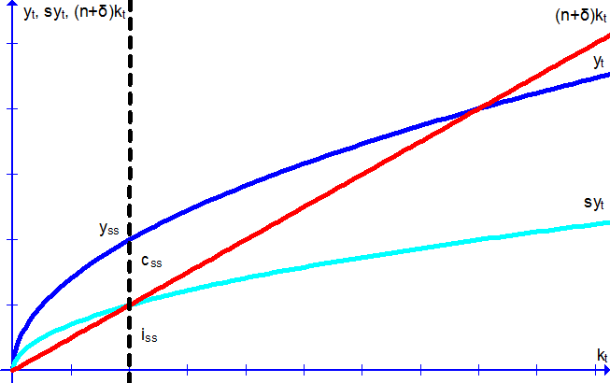
k_{ss}

D) (1.5 points) For this part onward, let Y . Labor-augmenting technological progress E grows at rate g such that E . Write the production function in effective units. For notation, you can use lower-case variables to stand for effective units now.
y

E) (1.5 points) Write the law of motion ( ∆k ) for k in effective units.
Δk

F) (3 points) Solve for the steady-state level of the capital stock in effective units, k .
0 ( sk
k

G) (3 points) Solve for the golden-rule level of the capital stock in effective units, k . c
αk
k

H) (2 points) Solve for the golden-rule savings rate s that maintains k as a steady-state.
Δk
s

I) (3 points) Graph y_{t}, s_{gr}f(k_{t}), and (n+g+δ)k_{t} versus k_{t}. All variables here are in effective units. Identify golden-rule levels k_{gr}, c_{gr}, and i_{gr} on your graph. Draw the tangent line of y_{t} at k_{gr} and make sure that its slope is approximately consistent with the geometric interpretation of the golden-rule level of the capital stock.
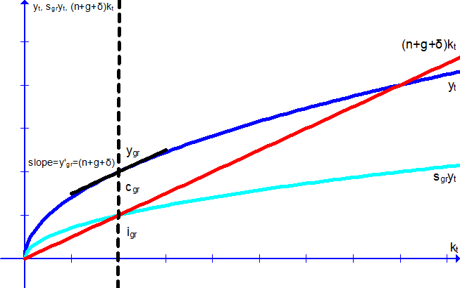
k_{gr}

2) (10 points) You are provided with the following information about the foreign exchange market for US Dollars ($US) where e denotes the nominal exchange rate (Japanese Yen per US Dollar, ). S_{$US} refers to the quantity supplied of US dollars while D_{$US} refers to the quantity demanded of US dollars.
S
D
A) (1 point) Solve for the equilibrium nominal exchange rate, e*.
S ; 5 + 2e* = 10 - e*; e* =

B) (1 point) Suppose that the price ratio . Solve for the equilibrium real exchange rate, ε*.
ε*=e*[] (

C) (3 points) Use the above information as well as the following information to answer this question. Assume the following model, treating the US as a small open economy:
Y ( C ( I ( G ( NX ( 300
C (
I ( 50 ( 200r
G ( 50
T ( 100
NX(ε*) = 75 - 40ε*
r
Solve for .
I ( 50 ( 200
NX ( 75 ( 40
Y ( T ( 300 ( 100 ( 200
C (
300 (

D) (1.5 points) Solve for S , S , and S ( S .
S
S
S ( S

E) (1.5 points) Solve for net capital outflows NCO using savings and investment. Compare this to your value for NX. Are they consistent?
NCO=S-I =95-30=65
NX=65
They are consistent; NCO ( S ( I ( is true by definition and should always hold as an identity.
F) (2 points) Graph ε versus NCO and NX; identify NX*, NCO*, and ε* on your graph.

