Economics 302 Name ________________________________________
Summer2007
Answers to Third Quiz* Student ID Number _____________________________

The following quiz is worth a total of 2.5 points. If your work is sloppy or illegible points will be subtracted.

- (.25 points) When spending is greater than production during the current time period in a small, open economy then
  - Exports for this country exceed imports for this country.
  - Exports for this country are less than imports for this country.

Answer: B.

- (.25 points) When exports are less than imports for a small open economy during a particular period of time then
  - This country is a net lender.
  - This country is a net borrower.

Answer: B.

- (.25 points) A country is running a trade deficit if
  - It is a net borrower in the world’s financial markets.
  - It is a net lender in the world’s financial markets.

Answer: A.

- (.25 points) Net Exports are equal to
  - Aggregate Output minus domestic spending.
  - Domestic spending minus aggregate output.

Answer: A.

- (.25 points) National saving is
I. Equal to the sum of private saving plus government saving.
II. Equal to the sum of investment spending and net exports.
III. Equal to aggregate disposable income minus consumption spending.

  - Statements I, II and III are true.
  - Statements I and II are true.
  - Statements I and III are true.
  - Statements II and III are true.
  - Statement I is true.

Answer: B.

- (.25 points) For a small, open economy if the world interest rate is lower than the prevailing interest rate in this economy we know that this economy is running a
  - Trade surplus.
  - Trade deficit.

Answer: B.

- (.25 points) For a small, open economy if the world interest rate is lower than the prevailing interest rate in this economy we know that this economy’s
  - National Savings is greater than its level of investment.
  - National Savings is less than its level of investment.

Answer: B.

Use the following graph of a small open economy with perfect capital mobility to answer the next three questions.

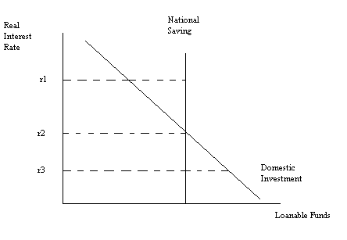
- (.25 points) If the world real interest rate is r1, then we know that this country
  - Is a net lender of funds.
  - Is a net borrower of funds.

Answer: A

- (.25 points) This small, open economy finds that it is running a trade surplus. Given the choices of world real interest rate in the above graph, the world real interest rate that most likely occurs when this country runs a trade surplus is
  - r1
  - r2
  - r3

Answer: A

- (.25 points) This small, open economy finds that it has a negative trade balance. Given the choices of world real interest rate in the above graph, the world real interest rate that most likely occurs when this country has a negative trade balance is
  - r1
  - r2
  - r3

Answer: C

