Economics 302 Name _________________________________
Summer 2007
Answers to Quiz #1 Student ID Number ______________________

- This question is designed to evaluate your recall of basic supply and demand principles. For each of the following sketch a diagram of supply and demand. Assume each market is initially in equilibrium before the stated event occurs. Draw this initial equilibrium and the subsequent equilibrium after the market adjusts. Label your graphs with the following notation where appropriate:

D₁ = the initial demand curve
D₂ = the new demand curve
S₁ = the initial supply curve
S₂ = the new supply curve
P₁ = the initial equilibrium price
P₂ = the new equilibrium price
Q₁ = the initial equilibrium quantity
Q₂ = the new equilibrium quantity

- (.25 points) Firms decide to hire more workers at every given wage (the price in the labor market).

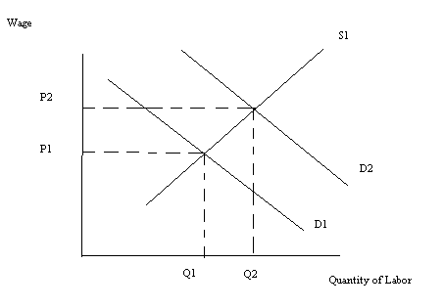

- (.25 points) Weather adversely affects firms’ ability to produce their product.

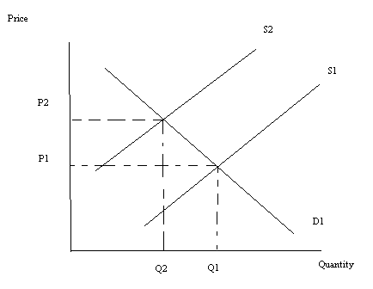

- (.25 points) The government subsidizes producers of the good with a fixed dollar subsidy per unit of the good supplied. On your graph label the price paid by consumers as P₂, and the price received by producers (this price includes the subsidy they receive from the government) as P₃.

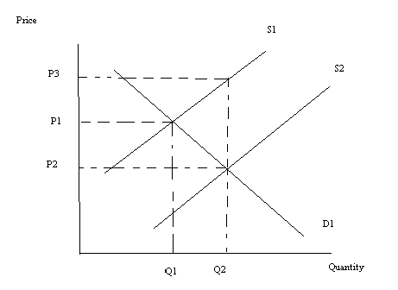

- This question is designed to evaluate your knowledge of the basic rules governing exponents. Simplify each of the following expressions.

  - (.25 points) X²Y⁵ = Y³/X
X³Y²

  - (.25 points) X^{.5}Y^{.5}Y^{1.5}X^{-1.5} = Y²/X

- This question is designed to provide a quick evaluation of your ability to move easily around a supply and demand diagram that involves a more complicated subject.

Suppose the domestic market for a good is described by the following demand and supply curves:
D _{domestic}: P = 500 – Q
S _{domestic}: P = Q

  - (.25 points) If the economy is closed to trade, what is the equilibrium price and quantity in this market?

Answer: 500 – Q = 500 = 2Q
250 = Q in equilibrium
P = 250 in equilibrium

  - (.25 points) Suppose the world price is $100 for this good. If this economy opens to trade, how many units of the good will it import or export?

It will import the good since the world price is less than the domestic price. At P = $100, the quantity demanded domestically equals 400 units while the quantity supplied domestically equals 100 units. The difference between the quantity demanded and the quantity supplied domestically, 300 units, will be imported.

  - (.25 poins) Suppose the government imposes a tariff of $50 per unit on this good but the economy remains open to trade. How many units of the good will be imported or exported by this economy given the imposition of this tariff?

The price with the tariff will now be $150 per unit. Domestic demand will equal 350 units while domestic supply will equal 150 units: the difference between domestic demand and supply, 200 units, will be imported.

- This is just a quick review of some terms I think you should be familiar with before we start the course. The diagram below illustrates an aggregate production function showing the relationship between the amount of labor utilized in a year by an economy and the level of real GDP this economy produces in a year from that labor. The aggregate production function that is represented is drawn holding the level of capital and technology constant.

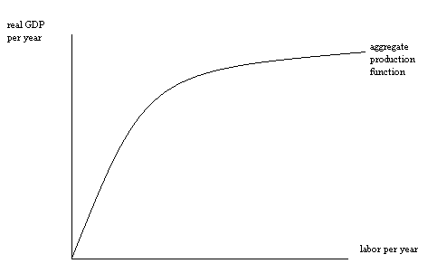
  - (.25 points) Using the graph as a reference, what is the marginal product of labor?

The marginal product of labor is the change in output divided by the change in labor; it is the slope of the aggregate production function; it is the first derivative of the aggregate production function with respect to labor.

  - (..25 points) Using the graph as a reference, what is labor productivity?

Labor productivity is output divided by labor; it is the amount of output produced per unit of labor; for a particular amount of labor, it is equal to the slope of the ray from the origin through that point on the aggregate production function that corresponds to that particular amount of labor.

