Economics 102
Spring 2008
Answers to Homework #5
Due in class on 5/5/08

On your homework please include at the top of the first page your name, TA name, and the section number for the discussion section you attend. All homeworks should be legible and neat: do a professional looking job!

(1) History tells us that the Spanish Conquistadors conquered the New World and its rich sources of precious metals. The conquistadors pillaged various natives and later operated local mines to extract silver and gold. From 1600 – 1650 there were about 268 tons of precious metals exported to Western Europe annually. After importing the metals, the metals were further exported to other countries. The following chart demonstrates a possible trade route of silver flows across the world for two different time periods.

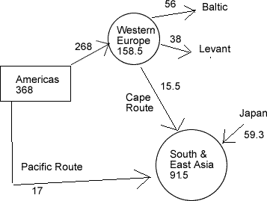  silver flows 1600 - 1650 | 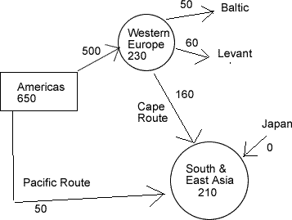  Silver flows 1725 - 1750

Source: Vries, J. de 2003. In: Global connections and monetary history 1497-1795

a) Assuming that the velocity of money was constant over the period and that output did not change, use the equation M V = P Y, or the (Quantity of Money * Money Velocity = Aggregate Price level * Output), to explain what was occurring in Europe’s economy during this time period.

Answer: the importation of massive quantities of silver and gold is an exogenous shock greatly affecting the price levels in Europe. The relative price of silver fell, thereby raising the general price level. Using the equation M V = P Y, we can see that if V and Y are constant while M (the money supply) increases, this will result in a proportionate increase in P, the aggregate price level. This same effect would continue throughout Europe as cross border trade in goods would transfer the precious metals throughout Western Europe.

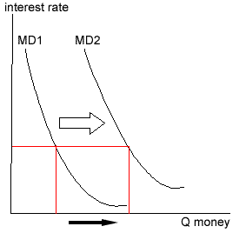 | Because prices are higher, it requires more cash-money to pay for goods. Thus the rise in the aggregate price level shifts the demand for money to the right.

b) During the 1725 – 1750 time period, assume there is a population boom in China, thereby greatly increasing output. Knowing that the Quantity of Money supplied = k * PY in equilibrium, what is one possible reason China was importing so much silver? In your answer, assume that k is constant.

Answer: Because of the population boom, the demand for money increases. But unlike in Europe, output in China is rising due to the increase in population. This rising output level requires an increasing stock of money in order for prices to stay stable. The quantity of money supplied = k PY in equilibrium, so as Y increases, more money is needed to monetize the economy. Thus, because output is rising the influx of silver into China results in little price change compared to the large price increases seen in Europe.

(2) Ernie the Economist runs the federal reserve. He believes that expansionary monetary policy is necessary to avoid recession.

- Ernie decides to have the Fed sell bonds they currently own in open economy . Draw a graph of the effect on the Fed’s decision on the interest and the quantity of money in this economy. In your graph label the y-axis “interest rate” and the x-axis “Quantity of Money. In your graph illustrate both the initial money supply and money demand curves and the changes in these curves after the Fed’s decision to sell bonds. Is Ernie’s plan to sell bonds successful in achieving his goal of using expansionary monetary policy to avoid recession?

By selling bonds, the Fed is gathering money from the economy. Thus selling bonds decreases the amount of money and the money supply contracts, it does not expands. The interest rate will go up.

Ernie’s plan is the exact opposite of what he wants to do.

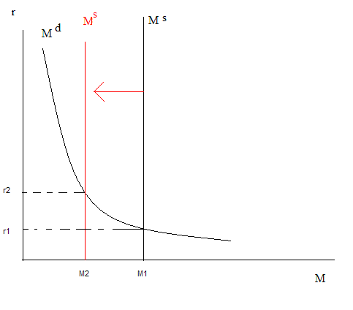

- When Ernie has the Fed sell bonds in the open market, what happens to Aggregate Demand?

Because the interest rate went up, the loanable funds market churns out less investment. This is because the higher interest rate causes borrowing to be more costly. Hence investment falls and aggregate demand shifts to the left.

- Ernie decides that he wants banks to do away with ATM fees. Assuming Ernie actually has the power to do this, what effect would this have on interest rates if the money supply remains constant?

Because of high fees to withdraw money, people often withdraw larger amounts of cash when they visit the bank. That way they don’t have to visit the bank as frequently and therefore they can avoid the fees levied on cash withdrawals. The larger the average bank withdrawal, the greater the money demand. Thus money demand will be greater when ATM fees are high. By removing ATM fees, the average withdrawal will fall and money demand falls. This lowers the interest rate.

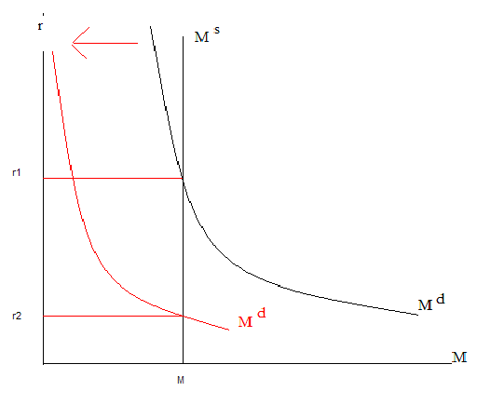

(3) You are given the following information about a closed economy.

Ms = 200
Md = 350 – 5000r
C = 150 + .5(Y-T)
I = 250 – 100 r where r, the real interest rate, is expressed as a decimal
G = 100, assume also that the government is running a balanced budget
TR = 0

(a) What is the equilibrium level of income in this economy?

Answer:

First, find the equilibrium interest rate
Set Ms = Md → 200 = 350 – 5000 r → 5000 r = 150 → r = 0.03 = 3%

Second, equilibrium condition: Y = AE where AE = C + I + G
Thus Y = C + I + G
–Now substitute for C, I, and G
C = 150 + .5(Y-T)
Y = 150 + .5(Y-T) + I + G
–Then in equilibrium: Y = [150 + .5(Y-T)] + 250 - 3 + 100
–But what is T?
•Recall the government is running a balanced budget. Hence T =100.
–Thus the equilibrium condition reduces to:
Y = [150 + .5(Y-100)]+ 247 + 100
= 150 –50 + 247 + 100 + .5Y
–Rearranging for Y we obtain 0.5Y = 447
–Hence in equilibrium Y = 894

(b) What is the equilibrium level of output if Government spending is increased by 500? Assume that taxes and the interest rate do not change from their initial levels.

The easiest way to solve for this is by using the expenditure multiplier.

Change in output = 1/(1-MPC) * change in autonomous spending

For example, the change in output = (1/(1- MPC))*(the change in government spending)

Change in output = 1/ (1- .5) * 500

Change in output = 1000

OR

We could also take the same method as before, but add in an additional 500 for G

Y = 150 + .5(Y-T) + I + G → Y = [150 + .5(Y-100)] + 250 - 3 + 600
Y = 150 + .5 Y – 50 + 247 + 600
.5Y = 947
Y = 1894 → Change in output = 1000

(c) Why did output increase by an amount different than the 500 increase in Government spending in question (b)?

This difference is due to the multiplier effect. The initial change in spending will set off a spending chain throughout the economy. Imagine that the Government’s spending into the economy becomes person A’s income. When person A spends their money, it becomes person B's income. Then person B will go spend their income which then becomes person C's money, etc. The cycle repeats, but because of the tendency to save which stays the same for every person percentage wise, the amount spent in each cycle is less and less.
Change in output = 1/(1-MPC) * change in autonomous spending

1000 = 1/ (1- .5) * 500

(4)

Let G = 100
I${}^{p}$= 200 where I${}^{p}$is planned investment spending
C = 150 + .5(Y-T)
T = 0

Assume that the current level of output is 1000 in this closed economy. What is the equilibrium level of output for this economy given the above information? Explain with numbers and a graph why the economy will adjust to that equilibrium level of output. Hint: try to do the calculations of this adjustment to equilibrium for each stage of the adjustment process as the economy moves towards the equilibrium level of output.

The equilibrium level of output is when Y = AE:
Y = C + I + G → C = Y – I – G→ 150 + .5(Y) = Y – 100 – 200→ .5 Y = 450 →Y* = 900

If Y = 1000, then AE = C + I + G = (150 + .5(Y-T)) + 200 + 100 = 650 + 240 + 100 = 950, Thus Y > AE as 1000 > 950 → more output is created then being consumed.
Therefore inventories build up and there was unplanned investment of 1000 – 950 = 50.

Thus next cycle output will fall by 50 and Y = 950.
Next cycle AE = 150 + .5(Y-T)) + 200 + 100 = 150 + 475 + 200 + 100 = 925
Thus Y > AE as 950 > 925 → more output is created then being consumed.
Therefore inventories build up and there was unplanned investment of 950 – 925 = 25.

Thus next cycle output will fall by 25 and Y = 925.
Next cycle AE = 150 + .5(Y-T)) + 200 + 100 = 150 + 462.5 + 200 + 100 = 912.5
Thus Y > AE as 925 > 912.5 → more output is created then being consumed.
Therefore inventories build up and there was unplanned investment of 925 – 912.5 = 12.5.

Thus next cycle output will fall by 12.5 and Y = 912.5. This cycle continues until the economy reaches equilibrium Y* = 900.

This can be seen on a graph of the Keynesian Cross.

