Economics 102
Spring 2008
Homework #5
Due in class on 5/5/08

On your homework please include at the top of the first page your name, TA name, and the section number for the discussion section you attend. All homeworks should be legible and neat: do a professional looking job!

(1) History tells us that the Spanish Conquistadors conquered the New World and its rich sources of precious metals. The conquistadors pillaged various natives and later operated local mines to extract silver and gold. From 1600 – 1650 there were about 268 tons of precious metals exported to Western Europe annually. After importing the metals, the metals were further exported to other countries. The following chart demonstrates a possible trade route of silver flows across the world for two different time periods.

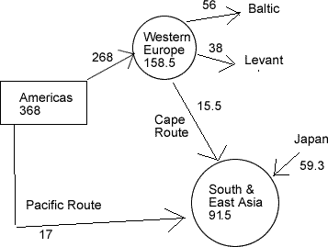  silver flows 1600 - 1650 | 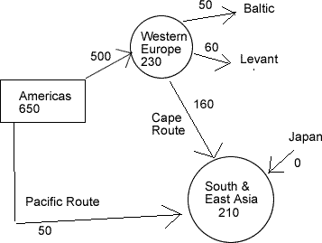  Silver flows 1725 - 1750

a) Assuming that the velocity of money was constant over the period and that output did not change, use the equation M V = P Y, or the (Quantity of Money * Money Velocity = Aggregate Price level * Output), to explain what was occurring in Europe’s economy during this time period.

b) During the 1725 – 1750 time period, assume there is a population boom in China, thereby greatly increasing output. Knowing that the Quantity of Money supplied = k * PY in equilibrium, what is one possible reason China was importing so much silver? In your answer, assume that k is constant.

(2) Ernie the Economist runs the federal reserve. He believes that expansionary monetary policy is necessary to avoid recession.

- Ernie decides to have the Fed sell bonds they currently own in the open economy. Draw a graph of the effect on the Fed’s decision on the interest and the quantity of money in this economy. In your graph label the y-axis “interest rate” and the x-axis “Quantity of Money. In your graph illustrate both the initial money supply and money demand curves and the changes in these curves after the Fed’s decision to sell bonds. Is Ernie’s plan to sell bonds successful in achieving his goal of using expansionary monetary policy to avoid recession?

- When Ernie has the Fed sell bonds in the open market, what happens to Aggregate Demand?

- Ernie decides that he wants banks to do away with ATM fees. Assuming Ernie actually has the power to do this, what effect would this have on interest rates if the money supply remains constant?

(3) You are given the following information about a closed economy.

Ms = 200
Md = 350 – 5000r
C = 150 + .5(Y-T)
I = 250 – 100 r where r, the real interest rate, is expressed as a decimal
G = 100, assume also that the government is running a balanced budget
TR = 0

- What is the equilibrium level of income in this economy?

- What is the equilibrium level of output if Government spending is increased by 500? Assume that taxes and the interest rate do not change from their initial levels.

- Why did output increase by an amount different than the 500 increase in Government spending in question (b)?

(4) Let G = 100
I${}^{p}$= 200 where I${}^{p}$is planned investment spending
C = 150 + .5(Y-T)
T = 0

Assume that the current level of output is 1000 in this closed economy. What is the equilibrium level of output for this economy given the above information? Explain with numbers and a graph why the economy will adjust to that equilibrium level of output. Hint: try to do the calculations of this adjustment to equilibrium for each stage of the adjustment process as the economy moves towards the equilibrium level of output.

