Economics 102
Spring 2009
Homework 2
Due 2/9/2009

Directions: The homework will be collected by your TA in a box before the lecture. Please make sure you know your TA name so that you can place your homework in the correct box. Please place your name, TA name and section number on top of the homework (legibly). Make sure you write your name as it appears on your ID so that you can receive the correct grade. Please remember the section number for the section you are registered, because you will need that number when you submit exams and homework. Late homework will not be accepted so make plans ahead of time. Good luck!

(1) Consider two firms, Hot Wheels and Biaggio, that produce bicycles and mopeds. You know that the plants of Hot Wheels produce 100 bicycles and 0 mopeds or 50 mopeds and 0 bicycles every month (or any combinations of these two goods that lie on the line between these two points) while the plants of Biaggio produce 150 bicycles and 0 mopeds or 150 mopeds and 0 bicycles every month (or any combinations of these two goods that lie on the line between these two points). For this problem assume that both firms have linear PPFs.

- What is the opportunity cost of producing one moped for the Hot Wheels firm? What is the opportunity cost of producing one moped for the Biaggio firm?

- Suppose that both Hot Wheels and Biaggio decide to specialize in the production of one of these goods, buying from the other company the good not produced. Do they gain from this agreement? Why?

- What would be the price range for a bicycle (in terms of mopeds) that the two firms would accept?

Suppose that the two firms decide to merge and their new CEO hires you to decide how the new company should allocate production.

- What would you suggest to the CEO? Draw a graph of the two firms’ PPFs to convince him (put mopeds on the x-axis).

- Assume nothing has changed HW’s PPF but Biaggio’s PPF is modified. What production plan would you suggest if Biaggio plants were able to produce either 200 bicycles and 0 mopeds or 150 mopeds and 0 bicycles per month (assume Biaggio maintains its linear PPF)? Would your answer change if Biaggio could produce 300 bicycles and 0 mopeds or 150 mopeds and 0 bicycles (assume a linear PPF connecting these two points)? Explain your answer?

(2) You and your friend Jack work at a restaurant. Your boss Paul Krugman has to decide who sets the tables and who has to wash dishes. Jack can wash 60 dishes in one hour or set 30 tables in one hour, you are new with this job and if you work hard you can wash 10 dishes in one hour or set 20 tables in one hour.

- What will Paul Krugman ask you to do? Use opportunity cost to explain your answer and illustrate your answer by drawing a graph to explain the choice Paul makes. In your graph measure washed dishes on the x-axis and tables set on the y-axis.

- Suppose that you prefer washing dishes. Assume your ability to set tables does not change. In order for Paul to assign you the task of dishwashing, must you be able to wash as many dishes per hour as Jack? In order for Paul to assign you this task, what is the minimum amount of dishes you must be able to wash per hour? Explain your answer.

(3) For the next question recall that shifts in the demand curve are caused by:
- Changes in the price of a related good
- Changes in income
- Changes in tastes
- Changes in expectations
Shift in the supply curve are caused by:
- Changes in input prices
- Changes in technology
- Changes in expectations

Consider the equilibrium price and equilibrium quantity of tickets for UW students to see the University of Wisconsin Basketball Team. For this question assume that student tickets to see the UW Basketball team play are a normal good. For each of the following events, explain:
- If it causes a supply curve and/or a demand curve shift;
- Why the supply/demand shifts; and
- If it leads to indeterminacy in equilibrium prices and/or in quantities.
Justify your answers.

- A rise in the price of tickets to see a football match

- An increase in university fees

- The beautiful UW campus starts to attract better basketball players from all over the country.

- An increase in the price of electricity

- The new coach is Michael Jordan and Warren Buffet donates a new bigger basketball stadium to the UW.

(4) The following figure shows the domestic market for ethanol in the Micronesia, a small closed economy.
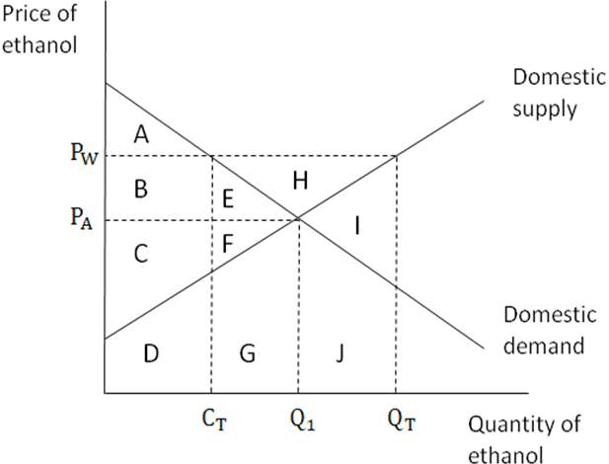
- When the Micronesia economy is closed to trade (referred to as “autarky”) the price of ethanol in Micronesia is. Assume that the world price for ethanol is . What area(s) on the above graph represent the value of consumer surplus in Micronesia if Micronesia is an autarky?
- What area(s) on the above graph represent the value of producer surplus in Micronesia if Micronesia is an autarky?
- If Micronesia opens to trade, then what area(s) would represent the value of consumer surplus and producer surplus in Micronesia once it was open to trade?
- What is the net gain to total surplus (measured by the area(s) in the above graph) if Micronesia opens its ethanol market to trade?

(5) For this problem assume that Madison is like a small, closed economy with regard to the market for calcium chloride. Suppose the domestic demand and supply curve for calcium chloride in Madison is:
Q_{d} = 10 – P_{d}
Q_{s} = P_{s} - 2
- Draw the domestic supply and the domestic demand curves and find the equilibrium price and quantity in the market for calcium chloride.
- Calculate the value of consumer surplus and producer surplus in the market for calcium chloride in Madison.
Suppose that this year heavy snowfalls are expected in Madison. The mayor of Madison decides to import calcium chloride to augment the quantity domestically supplied at every price. Suppose the world price of calcium chloride is $20 per unit.
c) Calculate the value of consumer and producer surplus once Madison opens its market for calcium chloride.
d) What are the net gains for the City of Madison once it opens its calcium chloride market to international trade?
Now, suppose that the government decides to levy a tariff of $10 on each unit of calcium chloride that is imported into Madison.
e) How many units of calcium chloride will be imported into Madison once this tariff is imposed?
f) Given this tariff, calculate the values of consumer surplus, producer surplus, government revenue, and the deadweight loss due to the tariff.

