Economics 102
Spring 2006
Homework #1

1. Find the following line. This line crosses the line y = ½ x -1 at x = 4. It crosses the line y = ½ x + 1 at x = 6. Write down the line in slope-intercept form.

2. State whether each statement is normative or positive.

a. Alan Greenspan’s work at the Fed has helped smooth the U.S. business cycle.

b. All professional economists do not know how to ride a bicycle.

c. All African countries should adopt free trade policies.

3. The countries of Glock and Crock produce guns and butter. The following graph is a graph of their production possibility frontiers.

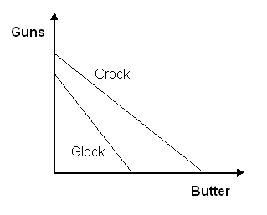
Should either country specialize in their production? If so, how and why? If not, how come?

4. The states of Michigan and Wisconsin are jointly holding an international fishing tournament in Lake Michigan. In preparation for the tournament Lake Michigan must be cleaned of pollution and zebra mussels. Both of these tasks are equally important. Michigan, the “Great Lakes State” is able to clean 2,000 pounds of pollution or exterminate 500 zebra mussels each day. Wisconsin, the “Dairy State” is only able to clean 1,000 pounds of pollution or exterminate 200 mussels each day.

a. What is Wisconsin’s opportunity cost of mussel removal? What is Wisconsin’s opportunity cost of cleaning pollution?
b. What is Michigan’s opportunity cost of mussel removal? What is Michigan’s opportunity cost of cleaning pollution?
c. Does either state have a comparative advantage in mussel removal? Does either state have a comparative advantage in cleaning pollution?
d. Does either state have an absolute advantage in mussel removal? Does either state have an absolute advantage in cleaning pollution?
e. How would you advise Jim Doyle and Jennifer Granholm (the governors of Wisconsin and Michigan, respectively) to divide the work so that the states can best prepare for the tournament?

5. Venezuela can produce coffee beans and oil. We will assume (unrealistically) that the opportunity cost of producing ten barrels of oil is a constant rate of 1 kilo of coffee beans. Currently Venezuela is producing about 3 million barrels of oil per day and 300,000 kilos of coffee per day.

- Graph the production possibilities frontier for Venezuela in terms of millions of barrels of oil and 100,000 kilos of coffee.
- Hugo Chavez claims that if he wanted to, his country could produce more oil per day than the US, which produces about 7.4 million barrels per day. According to our model, is he correct?
- Now Hugo is considering changing production to 3.5 million barrels of oil per day and 200,000 kilos of coffee. Is this production feasible? Is it efficient?
- Why is it unrealistic to assume that oil production has a constant opportunity cost in terms of coffee?

