Economics 102
Summer 2011
Answers to Handout #3

- Last year, the nation of Bruinville had $500 of private savings. Government spending was $400, and total tax revenue was $900. Households spent $2100 on consumption goods and businesses spent $1000 on investment. Transfer programs cost the government $200. Under the assumptions of the classical model, what was the value of capital inflows in Bruinville last year?

Answer:
Since leakages equal injections that tells us Sp + (T – TR) + M = G + I + X
Or, 500 + 700 + M – X = 400 + 1000
Or, M – X = 200 = KI
Note to answer this question you must calculate net taxes: T- TR = 900 – 200 = 700
Capital inflows are equal to 200

- If private savings equals investment in an open economy, then which of the following must also be true?
  - Capital inflows = G – (T – TR)
  - Imports = Exports

Answer: (a)
The loanable funds market is in equilibrium when Sp + Sg + KI = I
You know Sp = I so that implies Sg + KI = 0 are KI = -Sg
Sg = (T – TR) – G (the difference between net tax revenues and government spending is equal to government savings)
So, -Sg = G – (t – TR)

Use the information below to answer the following two questions:

When the government has a balanced budget and there are zero capital inflows, the market for loanable funds on Whaler Island is defined by
Supply: LF_{S} = S_{p} = 600 + 500i
Demand: LF_{D} = I = 4100 – 200i
where i is the interest rate expressed in percentages (i.e., i = 14 is a 14% interest rate), LF_{S} and LF_{D} are the quantity of loanable funds supplied and demanded in the economy, S_{P} is private savings, and I is investment.

- The Whaler Island government begins running a deficit and an equilibrium interest rate of 7% results in the loanable funds market. How large is the deficit?
  - $0
  - $200
  - $700
  - $1400

Answer: (d)
The loanable funds market is in equilibrium when Sp + Sg + KI = I. In this example there are zero capital inflows, so Sp + Sg = I or Sp = I – Sg. This last equation is the one I would choose to work with since the government is running a deficit: when the government runs a deficit this implies that Sg is a negative number. At an interest rate of 7%, I – SG = Sp. Using the Sp equation we can find Sp at 7%: Sp = 600 + 500i = 600 + 500(7) = 4100. Using the I equation we can find I at 7%: I = 4100 – 200i = 4100 – 200(7) = 2700. The difference between Sp and I is the government deficit: Sp – I = deficit or 4100 – 2700 = deficit. The deficit is therefore equal to $1400.
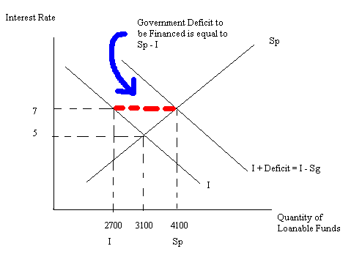

- How much private investment spending is crowded out by the government deficit?
  - $0
  - $200
  - $400
  - $1000

Answer: (c)
Before the deficit the equilibrium quantity investment in the loanable funds in the market was 3100. After the deficit the equilibrium quantity of investment in the loanable funds market was 2700. Investment decreases by 3100- 2700 = $400. $400 worth of investment is crowded out by the government deficit.
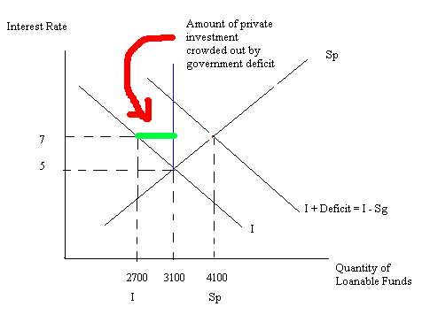
- In the classical model of a closed economy, if G increases by $1000 without any change in taxes or transfer programs, then which of the following best describes the response of other economic aggregate variables?
  - The equilibrium interest rate will fall, while consumption and investment fall by a combined amount of $1000
  - The equilibrium interest rate will rise, while consumption and investment fall by a combined amount of $1000
  - The equilibrium interest rate will rise, while investment will fall by $1000
  - The equilibrium interest rate will fall, while investment will fall by $1000

Answer: (b)
Start with a loanable funds market diagram. If G increases holding everything else constant this will cause the demand for loanable funds curve to shift to the right since the government will be running a deficit. For a given supply of loanable funds curve this will result in the interest rate increasing: as the interest rate increases this will cause investment to decrease, private savings to increase, consumption to decrease. See the diagram below:
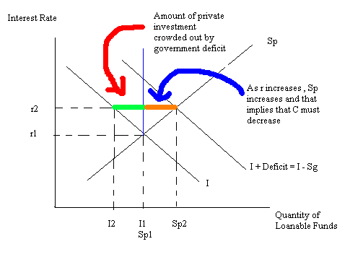

Use the information below to answer the following two questions using a classical model:

Cubland is a closed economy. The economy in Cubland has
T = taxes = 1000
TR = government transfer payments = 200
G = government spending = 600
I = investment spending = 5000 – 600i
S_{p} = private saving = 200i
Where i is the interest rate expressed in percentages (i.e., i = 14 is a 14% interest rate) and all numerical values are in dollars (e.g., government spending is equal to $600).

- What is the equilibrium interest rate?
  - 5%
  - 6%
  - 6.25%
  - 7%

Answer: (b)
T – TR = 100 – 200 = 800
(T – TR) – G = 800 – 600 = 200 = Sg
Sp + Sg = NS
Or, 200i + 200 = NS
In equilibrium in a closed economy NS = I. Thus,
200i + 200 = 5000 – 600i
800i = 4800
i = 6%

- What is the total quantity of leakages in Cubland?
  - $2000
  - $2050
  - $2200
  - $2250

Answer: (a)
Leakages = Sp + (T – TR) + M in general
Leakages = 200i + 800
Leakages = 200(6) + 800 = 2000

