Economics 101 and 102 Name _______________________________________
Summer 2010
Answers to Quiz #0
5/26/09 Discussion Section Day and Time ____________________

1. (Multiple Choice Question: circle the correct answer)

In 1993 Karen’s Pizza sold 125 million pizzas. In 1994 the company sold 100 million pizzas. In 1995 they sold 75 million pizzas. Using this information one can say that:

- There was a 25% decrease in sales from 1993 to 1994 and a 25% decrease in sales from 1994 to 1995.

- There was a 50% decrease in sales between 1993 and 1995.

- There was a 25% decrease in sales between 1993 and 1994 and a 20% decrease in sales between 1994 and 1995.

- There was a 20% decrease in sales between 1993 and 1994 and a 25% decrease in sales between 1994 and 1995.

2.

For each of the following equations find the requested information.

a. P = 10 – 100 W where W is the variable measured on the y-axis.

Slope = ______________ -1/100

Y- Intercept = _________1/10

b. Q = 20 + (1/2)R where Q is the variable measured on the y-axis.

Slope = ______________1/2

X- Intercept = __________20

c. M = 15 – (1/3)J where J is the variable measured on the y-axis.

Slope = _______________-3

Y – Intercept = _________45

Use the following information to answer the next three questions.

Suppose there are two straight lines: line A and line B. Line A's slope is equal to 2 and the point (X, Y) = (10, 20) sits on this line. Line B has a y-intercept of 10 and an x-intercept of 10.

3. What is the equation for line A? Show your work.

Y = 2X

4. What is the equation for line B? Show your work.

Y = 10 - X

5. Graph the two lines that you found for parts 3 and 4 on the same graph with X measured on the horizontal axis and Y measured on the vertical axis. Be careful to label the intercepts correctly.

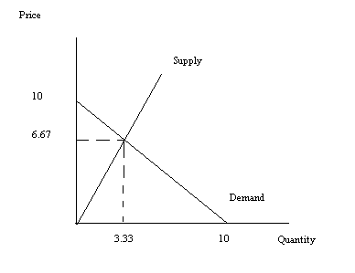

6. Fill in the blank for the following numerals. If the answer asks for a fraction provide its reduced form:

- 12/144 + 2/12 = __________________ 1/3
- 0.25 + ( 20% of 120 ) = ____________ 24.25
- 0.015*40 = ______________________ .6

- (0.5*2) + (25% of 4) = _____________ 2
- 9/2 + 1.5 = _______________________ 6

