Economics 102
Fall 1999
Midterm #1 Answers (Version #1)

Part I. Matching

- B
- G
- F
- E
- D
- A
- G
- E
- C
- B

Part II. Short Answer

Question 1:
- P = 14 – (.7)Q
- Q = 10
- Island A will pay $5 per lighthouse, Island B will pay $2 per lighthouse. $50(total), and $20, respectively, is also acceptable.

Question 2:
- P = 6, Q = 4
- Shift, movement, higher
- $4, $6
- $2, $8, the change in consumer surplus is -$6, and the deadweight loss is $3
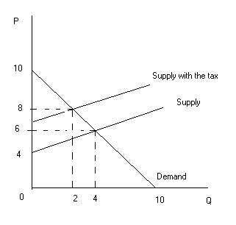
Question 3:
- No
- Albania
- I
- I
- Botswana, Albania

Part III: Multiple Choice
  - A
  - A
  - A
  - D
  - C
  - B
  - E
  - C
  - C
  - A
  - B
  - D

