Economics 102
Summer 2012
Answers to Homework #5
Due 7/18/12

Directions: The homework will be collected in a box before the lecture. Please place your name on top of the homework (legibly). Make sure you write your name as it appears on your ID so that you can receive the correct grade. Late homework will not be accepted so make plans ahead of time to insure your homework is turned in on time. Please show your work. Good luck!

1. Use the AD/AS model for this question. For each given scenario complete the following four steps:
Step 1: Draw the AD/AS model in long-run equilibrium. Label Yfe and the initial price level in this graph. Label all curves and both axes.
Step 2: In a second graph model the given event and identify clearly the new short-run equilibrium. This graph should include everything from the first graph as well as the short-run effect of the new event.
Step 3: Analyze verbally the short-run status of the economy: 1) is the economy in a boom or a recession?; 2) is unemployment relatively high or relatively low?; and 3) what is happening to the aggregate price level as this economy moves from the long-run position (step 1) to the short-run position (step 2)?
Step 4: Draw a third graph indicating how this economy will reach long-run equilibrium. Describe verbally this adjustment process.

a. Holding everything else constant, the real estate market collapses due to a housing bubble.

Answer:
Step 1:
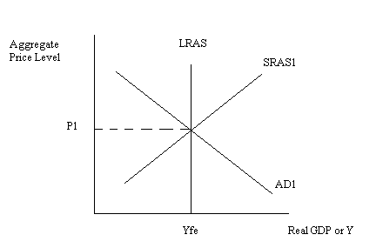

Step 2:

When the real estate market collapses, it makes people worse off since the value of their homes, an asset they own, fall. This causes households to reduce their spending levels at every aggregate price level. This will cause the AD to shift to the left.
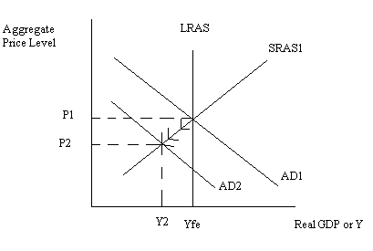
Step 3:
This economy is in a recession since Y2 is less than Yfe. Unemployment is relatively high due to the recession and the shift in AD to the left has resulted in a decrease in the aggregate price level.

Step 4:
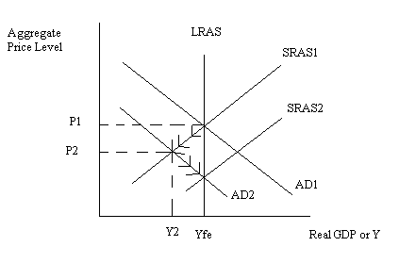
Over time wages and prices will fall since the economy is operating at a production level smaller than Yfe. As nominal wages decrease this will cause the SRAS to shift to the right from SRAS1 to SRAS2. Eventually the economy will return to Yfe but with a lower aggregate price level than the initial level. Unemployment will fall to the full employment or natural rate of unemployment.

b. Holding everything else constant, the stock market declines and this causes a reduction in people’s wealth.

Answer:
Step 1:

Step 2:

When the stock market declines this causes a reduction in people’s wealth and this reduction in wealth causes households to reduce their spending levels at every aggregate price level. This will cause the AD to shift to the left.
Step 3:
This economy is in a recession since Y2 is less than Yfe. Unemployment is relatively high due to the recession and the shift in AD to the left has resulted in a decrease in the aggregate price level.

Step 4:
Over time wages and prices will fall since the economy is operating at a production level smaller than Yfe. As nominal wages decrease this will cause the SRAS to shift to the right from SRAS1 to SRAS2. Eventually the economy will return to Yfe but with a lower aggregate price level than the initial level. Unemployment will fall to the full employment or natural rate of unemployment.

c. Holding everything else constant, uncertainty in European markets results in a loss of consumer confidence.

Answer:
Step 1:
Step 2:

When the uncertainty in European markets erodes consumer confidence this makes people less willing to spend at every aggregate price level. This will cause the AD to shift to the left.
Step 3:
This economy is in a recession since Y2 is less than Yfe. Unemployment is relatively high due to the recession and the shift in AD to the left has resulted in a decrease in the aggregate price level.

Step 4:
Over time wages and prices will fall since the economy is operating at a production level smaller than Yfe. As nominal wages decrease this will cause the SRAS to shift to the right from SRAS1 to SRAS2. Eventually the economy will return to Yfe but with a lower aggregate price level than the initial level. Unemployment will fall to the full employment or natural rate of unemployment.

d. Holding everything else constant, the government embarks on an austerity campaign and reduces government spending.

Answer:
Step 1:
Step 2:

When the government embarks on an austerity campaign this implies that there will be less government spending at every aggregate price level. This will cause the AD to shift to the left.
Step 3:
This economy is in a recession since Y2 is less than Yfe. Unemployment is relatively high due to the recession and the shift in AD to the left has resulted in a decrease in the aggregate price level.

Step 4:
Over time wages and prices will fall since the economy is operating at a production level smaller than Yfe. As nominal wages decrease this will cause the SRAS to shift to the right from SRAS1 to SRAS2. Eventually the economy will return to Yfe but with a lower aggregate price level than the initial level. Unemployment will fall to the full employment or natural rate of unemployment.

2. Suppose there is only one bank in Finlandia, the National Bank of Finlandia. Furthermore, suppose that in Finlandia there are no currency drains: that is, no one holds currency and all financial transactions are done via checks drawn on the National Bank of Finlandia. I n Finlandia the initial level of demand deposits in $1,000,000 and the initial level of reserves in the banking system is $100,000. Assume that the National Bank of Finlandia is not holding any excess reserves initially. You also know that in Finlandia the Central Bank of Finlandia has assets of $100,000 in Finlandia Treasury bills and reserve liabilities of $100,000. To simplify this problem, assume that the net worth of the National Bank of Finlandia is equal to zero.

a. Using the above information fill in the t-accounts for the Central Bank of Finlandia and the National Bank of Finlandia.

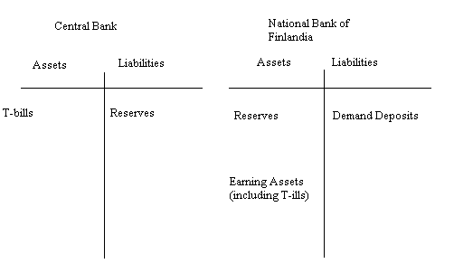
Answer:
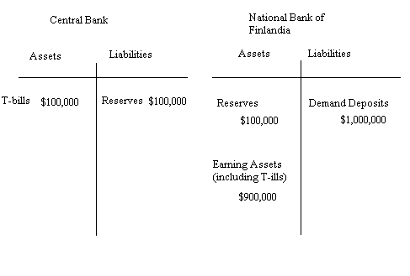

b. Given the above information, what is the required reserve ratio in Finlandia?

Answer:
Required reserve ratio = (required reserves)/(demand deposits) = $100,000/$1,000,000 = .1 or 10%

c. Given the above information, what is the value of the money multiplier in Finlandia?

Answer:
Money multiplier = (1/(required reserve ratio))
Money multiplier = 1/.1 = 10

d. Given the above information, what is the value of the money supply?

Answer:
Value of the money supply = demand deposits + cash in circulation
Cash in circulation = 0
So, value of the money supply = demand deposits = $1,000,000

e. Suppose the Central Bank sells $50,000 worth of T-bills. Provide a t-account that illustrates the immediate impact of this transaction on the Central Bank as well as on the National Bank of Finlandia. Assume that the Central Bank sells the T-bills to the National Bank of Finlandia.

Answer:
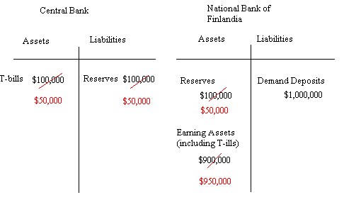
f. The t-account you drew in (e) should have assets equal to liabilities for the two institutions. If this is not true, you have an error and you need to go back and revise the t-account so that this is true. The t-account that you drew in (e) for National Bank of Finlandia no longer has the required amount of reserves. Describe the state of current reserves for the National Bank of Finlandia as represented in your answer to (e).

Answer:
The National Bank of Finlandia has $1,000,000 of demand deposits and since the required reserve ratio is 10% this implies that the National Bank of Finlandia does not meet the required reserve level since its reserves are only equal to $50,000 after purchasing the t-bills from the Central Bank. The National Bank of Finlandia can only support $500,000 in demand deposits given their level of reserves: they will need to call in some of their loans and reduce both their earning assets as well as their demand deposits in order to meet the required reserve level.

g. . Now, provide a t-account that illustrates the impact of this transaction on both institutions once full adjustment to this purchase has occurred. Explain verbally this adjustment process.

Answer:
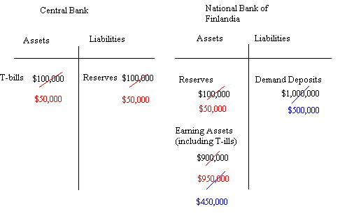

h. Given the transaction in (e), calculate the change in the money supply. Show any formulas you are using to find your answer.

Answer:
The change in the money supply = (money multiplier)(change in reserves)
The change in reserves = -$50,000 which is the amount of t-bills the Central Bank sold
The change in the money supply = 10(-$50,000) = -$500,000
That is, the money supply fell by $500,000 from $1,000,000 to $500,000

i. Instead of the scenario described in (e), suppose that the Central Bank purchases $80,000 worth of T-bills from the National Bank of Finlandia. Provide a t-account that illustrates the immediate impact of this transaction on the Central Bank as well as on the National Bank of Finlandia. Assume that the Central Bank sells the T-bills to the National Bank of Finlandia.

Answer:

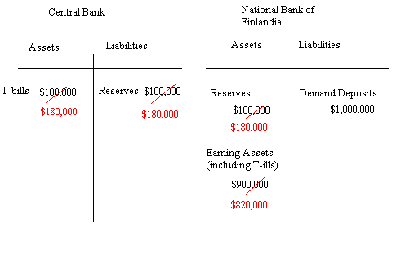

j. Now, provide a t-account that illustrates the impact of the transaction described in (h) on both institutions once full adjustment to this purchase has occurred. Explain verbally this adjustment process.

Answer:
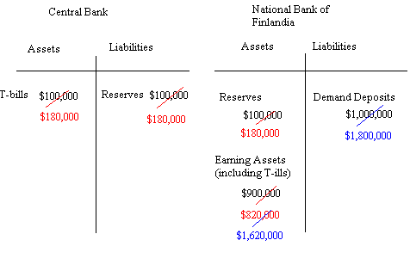

k. Given the transaction in (h), calculate the change in the money supply. Show any formulas you are using to find your answer.

Answer:
The change in the money supply = (money multiplier)(change in reserves)
The change in reserves = $80,000 which is the amount of t-bills the Central Bank purchased
The change in the money supply = 10($80,000) = $800,000
That is, the money supply increased by $800,000 from $1,000,000 to $1,800,000
3. You are given the following information about an economy.

Money supply = Ms = 1000
Money demand = Md = 2000 – 200r where r is the interest rate expressed as a percentage and not a decimal (hence, 2% would be 2 in the equation and not .2)
Required reserve ratio = rr = 10%
There are no currency drains in this economy.
There are no excess reserves in this economy.
Labor demand = Ld: W/P = 5 – (1/1000)Ld where W/P is the real wage and Ld is the quantity of labor demanded
Labor supply = Ls: W/P = (1/1000)Ls where W/P is the real wage and Ls is the quantity of labor supplied
P = aggregate price level = 1 initially
Y = AK^{α}L^{1-α} is the aggregate production function for the economy
A = 10
K = 400
Α = .5
C = 12,000 + .5(Y – T) – 10,000P
TR = 0
G = 100
T = 100
X = 500
M = 500
I = 15,000 – 1000r
SRAS: Ys = 17,050P
AD: Y = C + I + G + (X – M) where Y is aggregate demand

a. Start by finding the equilibrium in the money market. Use the above information to determine the equilibrium interest rate.

Answer:
Ms = Md
1000 = 2000 – 200r
200r = 1000
r = 5%

b. Now that you have the equilibrium interest rate calculate the level of investment in this economy when the money market is in equilibrium.

Answer:
I = 15,000 – 1000(5)
I = 10,000

c. What is the full employment level of labor? Find the real wage, W/P, and the nominal wage, W.

Answer:
Ld = Ls = Le
5 – (1/1000)Ld = (1/1000)Ls
5 = (2/1000)Le
2500 = Le
W/P = (1/1000)Ls
W/P = (1/1000)(2500) = $2.50
W = W/P since P is equal to 1 intitially. So, the nominal wage is $2.50 as is the real wage.

d. Find the full employment level of output for this economy.

Answer:
Yfe = AK^{α}L^{1-α}
Yfe = (10)(400)^{.5}(2500)^{.5}
Yfe = (10)(20)(50)
Yfe = 10,000

e. If this economy produces at its full employment level of output, what will labor productivity equal?

Answer:
Y/L = 10,000/2500
Y/L = 4 units of output per unit of labor

f. Given the above information, calculate the aggregate price level for this economy when it is in long run equilibrium.

Answer:
Yfe = SRAS = AD
SRAS = 17,050P
AD: Y = C + I + G + (X – M)
17050P = 12000 + .5(10,000 – 100) – 10,000P + 10,000 + 100 + 500 – 500
27,050P = 12000 + 5000 – 50 + 10,000 + 100
27,050P = 27,050
P = 1 when Yfe = 10,000

g. Suppose the Fed purchases $50 worth of T-bills in the open market. First, predict what will happen in the short run to the new interest rate (r’), the new short run level of Y (Y’), the new aggregate price level (P’), and the new real wage ((W/P)’) because of this monetary policy. Then, find the new short-run interest rate (r’), the new short run level of Y(Y’), the new aggregate price level (P”), and the new real wage ((W/P)’) because of this new monetary policy.

Answer:
Intuitively, the change in the money supply has expanded the money supply. This should result in lower interest rates, higher investment, greater aggregate demand (the AD curve is shifting to the right), a higher price level, and therefore a lower real wage for a given nominal wage.

This question has many steps in order to get the numeric values.
First step: calculate how the monetary policy affects the money supply.
Change in money supply = (money multiplier)(change in reserves)
Change in money supply = (1/.1)(50)
Change in money supply = 500
New money supply = 1500
Second step: find the new money market equilibrium since you need to know what the new equilibrium interest rate is.
In equilibrium Ms = Md
1500 = 2000 – 200r
200r = 500
r’ = 500/200 = 2.5%
Third step: calculate the new value of investment given the new interest rate you found in step 2.
I’ = 15,000 – 1000r
I’ = 15,000 – 1000(2.5)
I’ = 12,500
Fourth step: find the equation that now expresses aggregate demand. Graphically the monetary policy has shifted the AD curve to the right: at every aggregate price level you would see a higher level of aggregate demand.
Y = C = I + G + (X – M)
Y’ = 12,000 + .5(Y’ – T) – 10,000P’ + 12,500 + 100 + 500 – 500
Y’= 12,000 + .5Y’ – 50 – 10,000P’ + 12,500 + 100
.5Y’ = 24,550 - 10,000P’
Y’ = 49,100 – 20,000P’
Fifth step: Set SRAS equal to the new aggregate demand curve to find the new aggregate price level and the new short-run level of real GDP for this economy.
17,050P’ = 49,100 – 20,000P’
37,050P’ = 49,100
P’ = 1.33
Y’ = 49,100 – 20,000(1.33)
Y’ = 49,100 – 26,600 = 22,500
Sixth step: find the new nominal wage given the new aggregate price level you found in step 5.
(W/P)’ = 2.5/1.33 = $1.88

Conclusion: in the short run,
Interest rate decreased
Investment increased
Aggregate output increased
Aggregate price level increased
Nominal wage decreased

h. Discuss the long run adjustment process that will occur as this economy moves from the short-run equilibrium you found in (g) to the long run equilibrium.

Answer:
In the short run this economy is operating in a boom situation due to the rightward shift of the aggregate demand curve. The economy will adjust in the long run by having nominal wages bid up: this will shift the aggregate supply curve to the left restoring the economy to the full employment level of production but with a higher aggregate price level than the initial level.

