Economics 102
Spring 2011
Answers to Homework #5
Due 5/2/11 at the lecture

Directions: The homework will be collected in a box before the lecture. Please place your name, TA name and section number on top of the homework (legibly). Make sure you write your name as it appears on your ID so that you can receive the correct grade. Please remember the section number for the section you are registered, because you will need that number when you submit exams and homework. Late homework will not be accepted so make plans ahead of time. Please show your work. Good luck!
You may use a calculator to do all of the calculations. Round all decimals to the nearest hundredth if necessary.

1. Write down and interpret the following equations (without looking at your notes):
(a) GDP accounting equation (expenditure approach);
(b) National income accounting equation for Sprivate;
(c) National income accounting equation for Spublic;
(d) National income accounting equation for NS = Stotal = S;
(e) The most general equilibrium condition for the loanable funds market (you need to know this).

1. Write down and interpret the following equations:
(a) GDP accounting equation Y = C + I + G + NX;
(b) National income accounting equation for Sprivate = Y − T + TR − C;
(c) National income accounting equation for Spublic = T − TR − G;
(d) National income accounting equation for NS = Stotal = S = Sprivate + Spublic = Y − C − G;
(e) The most general equilibrium condition for the loanable funds market Sprivate + Spublic + KI = I.

2. Use the Classical Model and the following information to answer this problem.
Classical Model:
Y = C + S_{P} + T – TR
Y = C + I + G + (X – M)
KI = M – X
S_{G} = T – TR – G
NS = S_{P} + S_{G} = Y – C – G
I = Y – C – G + KI
Leakages = Injections in Equilibrium or S_{P} + T – TR + M = I + G + X

Note: in the table below i_{R} is the real interest rate and in the problem it is expressed as a decimal: e.g. if the real interest rate is 20%, then iR enters the mathematical expression as .2.

Country | GDP | C | G | T – TR | S_{P} | I
A | $5,000 | 3,500 | 700 | 300 | 1000+2000 i_{R} | 800-4000 i_{R}

a. Calculate the equilibrium real interest rate for country A.

a. To calculate the value of the equilibrium real interest rate you need to utilize the information you have and the model’s equations. Start by considering the equation Y = C + S_{P} + T – TR. For country A, you are given a value for Y, C, and (T – TR). That allows you to solve for private saving and get 1200. The table tells you that S_{P} = 1000 + 2000i_{R}: when private saving equals 1200, then the real interest rate must equal .1 or 10%.

b. Calculate the value of net exports for country A.

b. To calculate net exports again consult the model’s equations and the information you are given. Using the formula Y = C + I + G + (X – M) note that you know Y, C, and G but do not know I or (X – M). But, you do know the equilibrium real interest rate so, for example, in country A you can calculate I by noting that I = 800 – 4000i_{R} and plugging in a value of .1 into this equation. Thus, I for country A equals 400. Now, you can solve for the level of net exports for country A and you will get (X – M) = 400.

c. Calculate the supply of loanable funds and the demand for loanable funds in country A. Does the market for loanable funds clear in this country? That is, does the supply of loanable funds equal the demand for loanable funds?

c. If we define the supply of loanable funds as equaling private savings plus capital inflows (KI) then this means that the supply of loanable funds in country A equals 1200 + -400 for a total supply of loanable funds of 800. The demand for loanable funds in country A is comprised of the demand by businesses for funds (I) and the demand by government for funds (-S_{G}): thus, the demand for loanable funds in country A is 400 + 400 or 800. the demand for loanable funds equals the supply of loanable funds in country A.

d. Calculate NS + KI for each country and compare this sum with the value of investment. Use the classical model to prove the equality: NS + KI = I.

d. National saving: NS = S_{P} + S_{G} =1200-400=800
Capital inflows: KI = -NX = -400
Investment = 400.
So, NS + KI = I
Proof: NS = S_{P} + S_{G} = Y – C – G = I + NX = I - KI

3. Use the following information about an economy and the Keynesian Model to answer the following questions. Assume that government spending and planned investment are constant at 1,675 and the net export level is originally fixed and has a value of -500.

Real GDP | C |  | G | T - TR | NX | AE | Unplanned change in inventories
8,000 | 6,200 | 1,675 | 1,675 | 1,600 | -500 | 6200 + 1675 + 1675 - 500 = 9050 | 8000 - 9050 = -1050 decrease
9,000 | 6,800 | 1,675 | 1,675 | 1,800 | -500 | 6800 + 1675 + 1675 - 500 = 9650 | 9000 – 9650 = -650 decrease
10,000 | 7,400 | 1,675 | 1,675 | 2,000 | -500 | 7400 + 1675 + 1675 – 500 = 10250 | 10000 – 10250 = -250 decrease
11,000 | 8,000 | 1,675 | 1,675 | 2,200 | -500 | 8000 + 1675 + 1675 – 500 = 10850 | 11000 – 10850 = 150 increase
12,000 | 8,600 | 1,675 | 1,675 | 2,400 | -500 | 8600 + 1675 + 1675 – 500 = 11450 | 12000 – 11450 = 550 increase

a. Given the above information, what is the marginal propensity to consume?

We can see that Disposable Income (Real GDP – T + TR) is 0.8*Real GDP and consumption is increasing at a constant rate (600) for every 800 increase in Disposable Income. So MPC = 650/800 = .75.

b. Given the above information, what is the level of autonomous consumption?

Recall: C = autonomous + MPC * Y, so substituting => 6200 = auto + .75 * 6400
Autonomous Consumption = 1400

c. Given the above information, what is the macroeconomic equilibrium GDP?

Macroeconomic Equilibrium is defined by AE = Y
From AE = C + I + G + NX
= 1400 + 0.75*0.8Y + 1675 + 1675 – 500
So equilibrium GDP: Y = 10625

d. Suppose that planned investment spending is equal to 1,675 in this country and this level of planned investment spending does not change, no matter what the level of income is. If the current level of aggregate expenditure is equal to 13250, describe how this economy will respond to this level of aggregate expenditure given the model developed. In your answer comment on what is happening to unplanned investment spending, inventories, and the level of real GDP. Explain your answer fully.

AE= 1400 + 0.75*0.8Y + 1675 + 1675 – 500 = 13250
So the real GDP Y is equal to 15000 and this economy is mot in equilibrium since the level of planned aggregate expenditure is less than the level of real GDP. When spending is less than production, this causes a change in unplanned investment as inventories rise due to the fact that spending is less than production. Firms decrease their level of production in response to their rising inventories, moving the economy toward the income-expenditure equilibrium.

e. Given the above information, what is the multiplier in this problem?

Recall: multiplier = 1/(1 – MPC*0.8), thus substituting => 1/.4 = 2.5

f. In order to increase real GDP, the government can choose to increase the government spending or decrease the tax revenue. Which policy is more effective in increasing real GDP?

Since MPC < 1, |MG| > |MT |; Then given the same change in government spending and tax, the government spending will increase real GDP more. That is, the aggregate expenditure model predicts that an increase in government expenditure is more effective than a reduction in the level of taxes in terms of encouraging economic activity (increasing output).

4. This problem considers short-run and Long-run effects using the aggregate demand and aggregate supply model.
a. What factors shift the aggregate demand and aggregate supply curves?

Shifts of Aggregate Demand: the shifts of aggregate demand can be classified by three categories: changes in government policy, changes in expectations of households and firms and changes in foreign variables.
Increases in:
interest rates => Shift AD Left
government purchases => Shift AD Right
taxes => Shift AD Left
households expectation of future income => Shift AD Right
firm’s expectations of future profits from investment => Shift AD Right
growth of US GDP compared to foreign GDP => Shift AD Left
the exchange rate of US dollar relative to foreign currency => Shift AD Left

Shifts of Short-Run Aggregate Supply: there are five main factors that cause short-run aggregate supply to shift:
Increases in:
the labor force or capital stock => Shift SRAS right
productivity => Shift SRAS right
expected future prices => Shift SRAS left
workers & firms adjusting to higher prices than expected => Shift SRAS left
the expected price of an important national resource => Shift SRAS left

b. Consider the following events:
- Major fraud in the financial markets is uncovered by investigators and this leads to widespread concern about the integrity of all financial market transactions
- After a battle, many oil refineries were destroyed. This caused the price of oil to increase drastically.
- Recently, the department of mechanical engineering at the University of Wisconsin-Madison invents a high-tech product which greatly increases productivity. In your answer you will want to consider that if productivity increases and this increases the ability to produce output in the economy in the long run, then this increase in output will also affect aggregate demand. In your answer also remember that in the long run population increases.
For each of these events, determine:
- if the event causes a shift in the short run aggregate supply (SRAS) curve or the long run aggregate supply (LRAS) curve for the United States
- if the event is followed by an inflationary gap or a recessionary gap
- the long run adjustment process that occurs as a result of the event

- Short-Run Effect: This will cause a shift of the AD to the left due to increased uncertainty with regard to the financial markets: the level of aggregate demand is lower at every price level. This causes the economy to experience a recessionary gap. When aggregate demand shifts to the left this causes the economy in the short run to experience a reduction in the level of prices and a fall in output below the full employment level of output.
Long-Run Effect: Since output is lower than the full employment level of output that implies that unemployment is relatively high and that over time the unemployed will accept lower wages. In the long run we can expect the SRAS curve to shift to the right restoring the level of aggregate output to its full employment level while lowering the aggregate price level to a lower level than its initial level.

ii. SRAS1 shifts left to SRAS2 since the costs of production have increased.
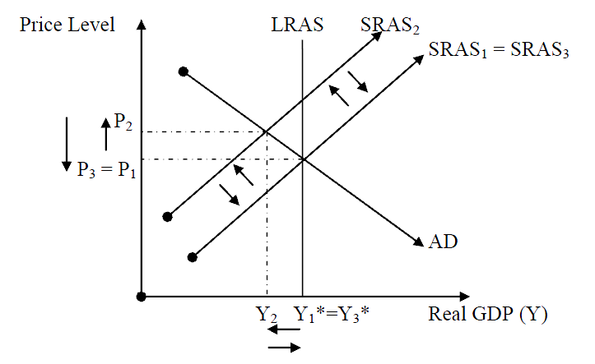
Short-Run Effect: The increase costs of production are passed onto consumers in the form of higher prices. We can see inflation as P1 has increased to P2. Output falls below potential and we enter a recession. This causes the economy to experience a recessionary gap and unemployment increases.
Long-Run Effect: The increase in unemployment makes workers eventually willing to accept lower wages in order to obtain scarce jobs. The firms hire workers at lower-wages and this increases SRAS2 to SRAS3. Output returns to potential, the price level returns to its original level and the recession ends. (Basically, over the long run the economy will self-adjust for the oil shock.)

iii.
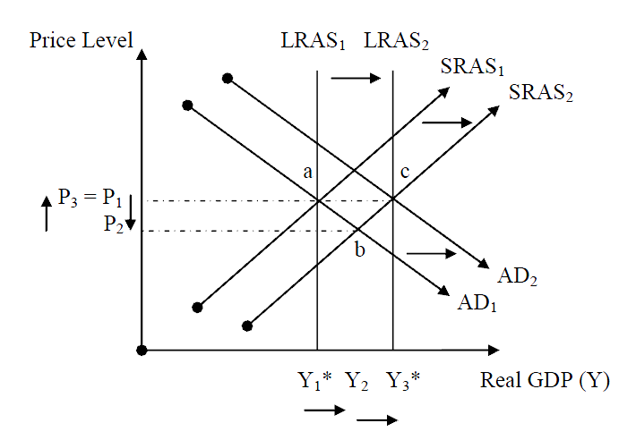
Short-Run Effect: LRAS increases due to the factors mentioned. This causes potential GDP to increase from Y1* to Y3*. Increases in productivity will cause the SRAS curve to shift to the right since the improvement in technology reduces the cost of producing any given level of output. In addition, as productivity increases and the level of potential GDP rises as the SRAS curve shifts to the right, this will cause the aggregate price level to fall and result in a movement along the AD curve. In the short run we can anticipate that the aggregate level of production will increase while the aggregate price level decreases. The short run equilibrium will occur at point b in the above graph.
Long-Run Effect: AD shifts right because incomes and population are increasing, which cause consumption to increase. This drives prices back to their original levels and allow us to reach the new long-run equilibrium c and obtain the new potential GDP Y3*.

5. Let:

C = consumption, I = investment spending, G = government spending, Tx = tax revenue, Y = national income, M_{S} = money supply, M_{D} = money demand (LP), i = interest rate.

Assume for a given closed economy:

- consumers spend $400 billion plus 90% of after-tax income, or
,

- investment demand varies inversely with the interest rate, such that
$I=\text{700}−\text{2000} i$,
(that is, if the interest rate is 10%, investors want to invest $700 billion minus 10% of $2,000 billion, or $500 billion in total),

- currently government spending and taxes are both equal to $200 billion, or
$G=\overline{G}=\text{200}$, $\text{Tx}=\overline{\text{Tx}}=\text{200}$,

- the total money demand or liquidity preference schedule for this economy is an inverse function of the rate of interest and is given by the equation
$M_{D}=\text{800}−\text{1000} i$,
(that is, if the interest rate is 10%, the demand for money will be $800 billion minus 10% of $1,000 billion, or $700 billion in total),

- the required reserve ratio for banks in this economy is 15%. No bank holds excess reserves, and everybody keeps their money in the bank. The total of reserves in the banks is $90 billion.

FOR EACH ANSWER TO THE FOLLOWING QUESTIONS, SHOW ALL YOUR WORK.

a. What is the total money supply? (HINT: begin with (v) above.)

MS = 90/.15 = 600

b. What is the equilibrium interest rate? (HINT: it is the result of supply of and demand for money.)

M_{S} = $M_{D}=\text{800}−\text{1000} i$
So, 600 = 800 – 1000i and therefore I = 20%

c. What is the equilibrium level of national income?

AE = C + I + G and in equilibrium Y = AE
So, Y = C + I + G
Y = 400 + 0.9*(Y- 200) + 700 – 2000(.20) + 200
Y = 400 + 0.9Y – 180 + 700 – 400 + 200
Y = 720 + 0.9Y
0.1Y = 720
Y = 7200

d. The economy is in a slump and the head of the central bank wants to increase the equilibrium level of national income to $10,000 billion using open market operations. Should she (the head of the central bank) buy or sell bonds to achieve this goal? How much in bonds (give a dollar figure) should she buy or sell? Assume that there are no other changes in the model except for this open market operation. Hint: you know how much aggregate output needs to be, but you will need to figure out what the interest rate must be in order for aggregate output to be at this level. Once you have the interest rate then you will need to calculate the implied money supply that results in this equilibrium interest rate.

In the equilibrium:
Y = AE = 400 + 0.9*(Y- 200) + 700 – 2000*i + 200
If Y = 10,000, then i = 6%
Need to buy $21 billion bonds.

So in order to maintain the national income at $10,000 billion, then the government needs to keep the interest rate at the level of 6% which is lower than the original interest rate of 20%. The head of the central bank will buy bonds in the bond market to push the price of bonds down and to increase the supply of money in the money market. This right shift in the supply of money will cause a movement along the money demand curve and a reduction in the interest rate. (The price of bonds and the interest rate are inversely related to one another: when the price of bonds increases this implies that the interest rate decreases.)

To calculate the change in the money supply we know that the interest rate must equal 6% in order for output to be at $10,000 billion. Using the money supply equals money demand equilibrium condition we can solve for the required money supply:

Money supply = money demand in equilibrium
Money supply = 800 – 1000i
Money supply = 800 - 1000(.06)
Money supply = 740

The money supply needs to increase from $600 billion to $740 billion. To calculate the amount of open market purchases the central bank must undertake recall that the change in the money supply is equal to the money multiplier times the change in reserves.

Thus,
Change in money supply = (1/rr)(change in reserves)
140 = (1/.15)(change in reserves)
21 = change in reserves

The central bank needs to make an open market purchase of bonds equal to $21 billion.

Let’s just verify our answer here:

If reserves in the banking system are equal to (90 + 21) = 111 then the amount of demand deposits in the banking system will equal 111/.15 or 740. When the money supply is equal to 740 this implies that the equilibrium interest rate in the money market will be 6%. To see this equate money supply to money demand: 740 = 800 – 1000i and then solve for i. 60 = 1000i or I = 6%. When i = 6%, then I = 700 – 2000i = 700 – 2000(0.06) = 580. Now, using the equilibrium condition Y = AE solve for the equilibrium Y. Thus,
Y = AE
Y = C + I + G
Y = 400 + 0.9(Y – Tx) + 580 + 200
0.1Y = 400 – 0.9(200) + 780
0.1Y = 1000
Y = 10,000

Our answer works!

