Economics 102
Summer 2012
Answers to Homework #4
Due 7/16/12

Directions: The homework will be collected in a box before the lecture. Please place your name, TA name and section number on top of the homework (legibly). Make sure you write your name as it appears on your ID so that you can receive the correct grade. Please remember the section number for the section you are registered, because you will need that number when you submit exams and homework. Late homework will not be accepted so make plans ahead of time. Please show your work. Good luck!

1. Use the loanable funds framework for this problem. Suppose that initially in an economy net taxes, T – TR, are equal to $400 while government expenditures are equal to $400. Furthermore, suppose you know that this economy is initially a closed economy. You are told that the demand for loanable funds by businesses is given by the equation
r = 10 – (1/100)LF_{D}
where r is the interest rate expressed as a percent rather than a decimal and LF_{D} is the quantity of loanable funds demanded. You also know that the supply of loanable funds curve (LF_{S}) curve is given by the equation
r = 2 + (1/300) LF_{S}
where LF_{S} is the quantity of loanable funds supplied.

a. Calculate the initial value of government savings, Sg.

Answer:
Sg = (T – TR) – G
Sg = 400 – 400
Sg = 0

b. Calculate the initial value of capital inflows for this economy.

Answer:
Since the economy is a closed economy there are no imports and no exports. Hence, X – M = 0 and that implies that capital inflows, KI, are also equal to zero. Recall that KI = M – X and since there are no imports and no exports that implies that KI = 0.

c. Calculate the equilibrium interest rate, the equilibrium level of investment spending, and the equilibrium level of private savings given the above information.

Answer:
In equilibrium LF_{D} = LF_{S} : since Sg = 0 this implies that LF_{D} = I where I is private investment spending; and since KI = 0 this implies that LF_{S} = Sp where Sp is private saving. Thus, in equilibrium I = Sp.
10 – (1/100)I = 2 + (1/300)Sp
3000 – (300/100)I = 600 + Sp
But, remember that I = Sp in equilibrium so
2400 = 4Sp
Sp = 600
I = 600
r = 10 – (1/100)(600) = 4%
or, r = 2 + (1/300)(600) = 4%

d. Suppose that government spending increases to $500 while net taxes remain at $400. Calculate government saving, Sg. Is the government running a budget deficit, a budget surplus, or a balanced budget?

Answer:
Sg = ((T – TR) – G
Sg = 400 – 500
Sg = -100
The government is running a budget deficit since net taxes are less than government spending.

e. Suppose we model the government’s deficit as additional demand for loanable funds at every interest rate. What would the new demand for loanable funds curve equation be given that government spending is now $500 and net taxes are $400. Assume nothing else changes except for the level of government spending.

Answer:
The new demand for loanable funds curve will shift to the right by $100 due to the government deficit described in (d). The slope of the new demand for loanable funds curve will be the same as the slope of the initial demand for loanable funds curve but the x-intercept will now be $1100 and the y-intercept must be determined. Use the point (0, 1100) that sits on the new loanable funds curve and the original slope to find this new y-intercept. Thus, r = b – (1/100)( LF_{D} ) and using the point we know that it is on the new demand for loanable funds curve we get
0 = b – (1/100)(1100) or b = 11. The new demand for loanable funds curve can therefore be written as r = 11 – (1/100) LF_{D} .

f. Given the new demand curve you found in (e) calculate the new equilibrium interest rate, the equilibrium level of investment spending, and the equilibrium level of private savings.

Answer:
To find the equilibrium use the new loanable funds demand curve, r = 11 – (1/100)(LFd), and the initial loanable funds supply curve, r = 2 + (1/300)(LFs). Thus,
11 – (1/100)(LFd) = 2 + (1/300)(LFs) and recall that in equilibrium LFd = LFs.
9 = (1/100)(LF) + (1/300)(LF)
$675 = LF
Plug 675 back into either the demand for or supply of loanable funds curve to find the equilibrium interest rate. Thus, r = 11 – (1/100)(675) = 4.25% is the equilibrium interest rate.
The equilibrium level of investment spending can be found by using the initial demand for loanable funds curve that does not include the government deficit and the new equilibrium interest rate. Thus, 4.25 = 10 – (1/100)(I) or I = $575.
The equilibrium level of private savings can be found by using the initial loanable funds supply curve and the new equilibrium interest rate or by recognizing that since KI = 0 then the supply of loanable funds at equilibrium is composed solely of private savings. The level of private savings in equilibrium is therefore $675.

2. Use the loanable funds framework for this problem. Suppose that initially in an economy net taxes, T – TR, are equal to $400 while government expenditures are equal to $200. Furthermore, suppose you know that this economy is initially a closed economy. You are told that the demand for loanable funds by businesses is given by the equation
r = 10 – (1/100)LF_{D}
where r is the interest rate expressed as a percent rather than a decimal and LF_{D} is the quantity of loanable funds demanded. You also know that the supply of private savings (Sp) curve is given by the equation
r = 2 + (1/300) Sp
where Sp is the quantity of private savings supplied at any given interest rate.

a. Calculate the initial value of government savings, Sg.

Answer:
Answer:
Sg = (T – TR) – G
Sg = 400 – 200
Sg = 200

b. Before calculating the equilibrium interest rate, the equilibrium level of investment spending, and the equilibrium level of private savings given the above information make a prediction of the direction of change for each of these variables given the values you found in problem 1c. Provide a verbal explanation justifying your prediction.

Answer:
When the government engages in savings this causes the supply of loanable funds curve to shift to the right by the amount of the government savings. For a given demand for loanable funds curve this should result in the interest rate decreasing, the level of investment spending increasing, and the level of private savings decreasing. When the interest rate decreases holding everything else constant businesses will increase their investment spending since the cost of borrowing has fallen and more of their potential projects will be worth doing if the interest rate is lower. When the interest rate decreases holding everything else constant households will choose to save less since the return on saving has fallen. The graph below illustrates these ideas.
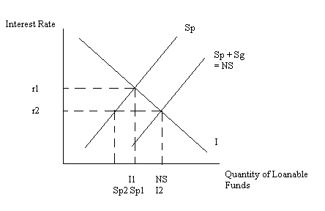
Alternatively you could model this government saving on the demand for loanable funds curve side of the market. You would have the same predictions, but your graph would look as follows:
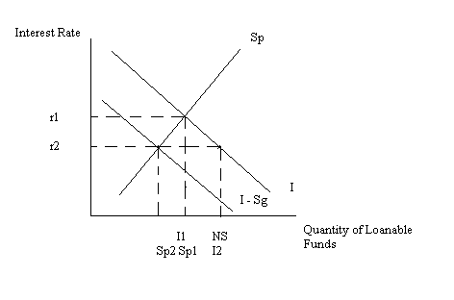

c. Calculate the equilibrium interest rate, the equilibrium level of investment spending, and the equilibrium level of private savings given the above information.

Answer:
In equilibrium LF_{D} = LF_{S} : since Sg = 200 we will need to take this government savings into account. We have a choice: we can model the government savings as part of the supply of loanable funds or we can model the government savings as part of the demand for loanable funds. Since Sg is a positive number I am going to model this on the supply side of the loanable funds market: when the government engages in positive savings this will shift the supply of loanable funds curve to the right. For any given interest rate there will be more savings. For any given demand for loanable funds curve this implies that the interest rate should decrease relative to its initial level. We know that LF_{D} = I where I is private investment spending; and since KI = 0 this implies that LF_{S} = Sp + Sg where Sp is private saving and Sg is government savings. Thus, in equilibrium I = Sp + Sg. Recall that Sp + Sg is equal to national savings, NS. To find the equilibrium in the loanable funds market we will first need to write our new supply of loanable funds curve. Our initial loanable funds supply curve is r = 2 + (1/300)(LF_{S}) and we know that our new supply of loanable funds curve will have the same slope (1/300) but be shifted to the right by 200 units. Here is one method for finding this new supply curve:
Start with the slope-intercept form: y = mx + b
Replace “y” with “r” and “x” with “NS”
So, r = mNS + b
Next recall that the slope of this new supply curve will be the same as the slope of the original supply of loanable funds curve.
Thus, r = (1/300)NS + b
To find “b” substitute in the coordinates of a point that you know sits on the new supply curve. For example, (200,2) or (800, 4) sit on this line.
Thus, 2 = (1/300)(200) + b
Or, b = 4/3
The new supply of loanable funds curve can be written as r = (4/3) + (1/300)NS.
Now, use the demand for loanable funds curve and the new supply of loanable funds curve to find the values you are looking for:
10 – (1/100)I = (4/3) + (1/300)NS
Recall that in equilibrium I = NS in this example so
3000 – 3I = 400 + I
2600 = 4I
I = 650
r = 10 – (1/100)I
r = 10 - (1/100)(650)
r = 3.5% (so as predicted our interest rate has fallen)
NS = 650 since NS = I
And, to find Sp, use the original supply of loanable funds curve and the new equilibrium interest rate or simply subtract 200 from NS to get Sp:
r = 2 +(1/300)(Sp)
3.5 = 2 + (1/300)Sp
1.5(300) = Sp
Sp = 450 which is 200 less than NS as predicted.

c. Suppose the government enacts a policy that results in higher savings by households at every interest rate. Suppose this policy results in savings increasing by $100 at every interest rate. Write a new equation for the supply of loanable funds curve given this information. In your equation for the supply of loanable funds include Sp as well as Sg: that is, write an equation for the supply of national savings, NS.

Answer:
The new policy will cause the supply of private savings curve to shift to the right by 100 units. The graph below illustrates this idea.
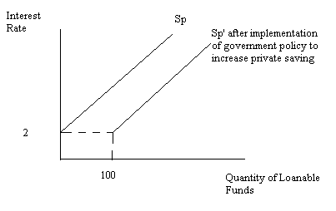
But, we also need to include government saving and we know that Sg = 200 in this problem. So, the figure below illustrates the new NS curve for this economy:
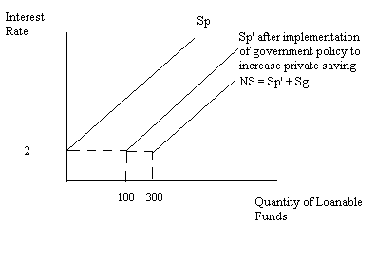
Now, all we need is an equation for this NS curve. We know that the NS curve has the same slope as the original Sp curve: slope = (1/300). So, y = mx + b where y = the interest rate, r, and x = NS. So, r = (1/300)NS + b. To find b substitute in a point that you know sits on the new supply of loanable funds curve: (300, 2) is one point you could use. Thus, 2 = (1/300)(300) + b or b = 1. So, the new supply of loanable funds curve is r = 1 + (1/300)LFs where LFs in this case is NS.

d. Given the change in (c), solve for the new equilibrium interest rate, the equilibrium level of investment spending, and the equilibrium level of private savings given the above information.

Answer:
To find the equilibrium use the demand for loanable funds curve and the new supply of loanable funds curve you found in (c). Thus, 1 + (1/300)NS = 10 – (1/100)I. Recall that in this example I = NS or I = Sp + Sg.
So, 1 + (1/300)I = 10 – (1/100)I
300 + I = 3000 – 3I
4I = 2700
I = 675
Sg = 200
Since I = NS or I = Sp + Sg then 675 = Sp + 200 or Sp = 475
r = 10 – (1/100)I = 10 – (1/100)(675) = 3.25%

3. Suppose the loanable funds market is initially in equilibrium in an open economy that is currently operating with a trade deficit and a balanced budget.

a. Draw a graph of the loanable funds market illustrating this initial equilibrium. In your graph be sure to identify Sp, Sg, KI, and I. Also, identify the initial equilibrium interest rate (r1) as well as the equilibrium levels of investment spending (I1) and private savings (Sp1). Label your graph carefully and completely.

Answer:
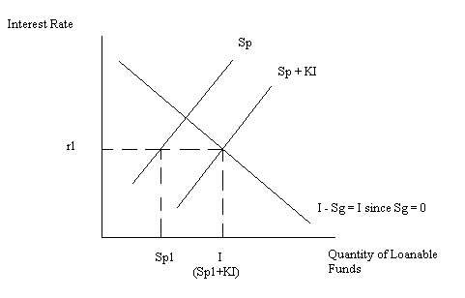

b. Now, suppose the government increases its level of government spending while maintaining the same net taxes. Redraw your graph from (a) illustrating this change. In your graph model this change in government spending on the demand side of the loanable funds market. Identify the new equilibrium interest rate (r2) as well as the new equilibrium level of investment spending (I2) and private savings (Sp2). On your graph indicate the amount of investment spending that is “crowded out” by this change in government policy. Provide a verbal explanation of the effect of this government spending change on the loanable funds market.

Answer:
When the government increases its spending with no change in net taxes this causes government saving to be negative (the government is running a budget deficit). If we model this negative government savings on the demand side of the loanable funds market we can show this change as an increase in the demand for loanable funds at every interest rate. That is, the demand for loanable funds curve will shift to the right. For a given supply of loanable funds curve we should expect the interest rate to increase since there is greater demand for funds at every interest rate, the level of private savings to increase in response to the higher interest rate, and the level of investment spending to fall in response to the higher interest rate. The amount of “crowding out” that occurs is equal to I1 – I2. The graph below illustrates these ideas.

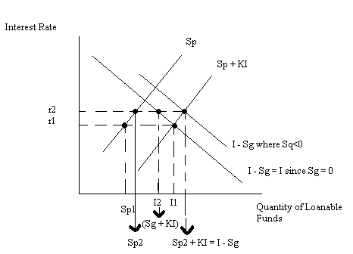

4. Use the simple Keynesian model to answer this set of questions. Assume that this is a closed economy. Assume TR equals zero and that the aggregate price level is constant. You are provided the following information.
Y | T | C | I | G | Unplanned Inventory Change | Direction of Change in Real GDP
100 | 40 |  | 10 | 20
200 | 40 |  | 10 | 20
300 | 40 | 308 | 10 | 20
400 | 40 | 388 | 10 | 20
500 | 40 |  | 10 | 20

a. What is the consumption function with respect to aggregate output, Y, for this economy?

Answer:
C = a + b(Y – (T - TR))
C = a + b(Y – 40)
b = MPC = (change in consumption)/(change in disposable income)
So,
Y | T – TR | Disposable Income | C
300 | 40 | 260 | 308
400 | 40 | 360 | 388
Thus, b = ΔC/Δ Disposable Income = 80/100 = 0.8
C = a + 0.8(Y – T)
But, we know T = 40 and (Y,C) = (300, 308) or (400, 388)
Thus, 308 = a + 0.8(300 – 40)
Or, a = 100
C = 100 + .8(Y – T)
C = 100 + .8(Y – 40)
C = 68 + .8Y

b. Fill in the missing values in the above table.

Answer:
Y | T | C | I | G | Unplanned Inventory Change | Direction of Change in Real GDP
100 | 40 | 148 | 10 | 20 | Decrease by 78 | Increase
200 | 40 | 228 | 10 | 20 | Decrease by 58 | Increase
300 | 40 | 308 | 10 | 20 | Decrease by 38 | Increase
400 | 40 | 388 | 10 | 20 | Decrease by 18 | Increase
500 | 40 | 468 | 10 | 20 | Increase by 2 | Decrease

c. From your work in part (b) give a range for the equilibrium value of real GDP for this economy.

Answer:
Range for equilibrium real GDP will be between 400 and 500 since when real GDP equals 400, inventories are falling and when real GDP equals 500, inventories are rising.

d. Find the equilibrium value for real GDP in this economy.

Answer:
Y = AE in equilibrium
Y = C + I + G + (X – M)
Y = C + I + G since (X – M) = 0
C = 68 + .8Y
Y = 68 + .8Y + 10 + 20
.2Y = 98
Y = 490

e. Suppose full employment real GDP equals 640. Calculate three possible options for reaching full employment real GDP:
- Option 1: reach full employment real GDP through a change in government spending.
- Option 2: reach full employment real GDP through a change in lump-sum taxes, T.
- Option 3: reach full employment real GDP through a policy where government spending and lump-sum taxes change by the same amount so that there is no change in the government deficit.
For each option identify what the change in G, the change in T, or the change in T and the change in G must be.

Answer:
Option 1:
Y = 490
Yfe = 640
ΔY = 150
ΔY = (1/(1-b)) ΔG
150 = (1/.2) ΔG
ΔG = 30, an increase in government spending of $30 will increase real GDP to its full employment level

Option2:
Y = 490
Yfe = 640
ΔY = 150
ΔY = (-b/(1-b)) ΔT
150 = (-.8/.2) ΔT
ΔT = -37.50, a decrease in lump-sum taxes of 37.50 will increase real GDP to its full employment level

Option 3:
Y = 490
Yfe = 640
ΔY = 150
ΔY = (1/(1-b)) ΔG + (-b/(1-b)) ΔT
ΔY = [(1 – b)/(1 – b)] ΔG since ΔG = ΔT
150 = ΔG = ΔT
An increase in government spending of $150 along with an increase of taxes of $150 will increase real GDP to its full employment level

f. Of the three options in part (e) which is the most economical option for reaching full employment real GDP?

Answer:
Option 1 is the most economical since with an increase of government spending of only $30 you get a change in real GDP of $150. Option 2 and Option 3 are more expensive than option 1.

5. Use the simple Keynesian model to answer this question. Assume that TR = 0 and that the price level is constant. You are given the following information. (S is private household saving.)

Y | T | C | I | G | X | M | S
20 | 20 | 18 | 2 | 6 | 3 | 4
30 | 20 |  | 2 | 6 | 3 | 4 | -16
40 | 20 |  | 2 | 6 | 3 | 4
50 | 20 |  | 2 | 6 | 3 | 4
60 | 20 |  | 2 | 6 | 3 | 4

a. Fill in the missing cells in the above table.

Answer:

To fill in the table you will need to recall that Y = C + S + T. That is, aggregate income in the economy when received by households is used to pay taxes (T), to set aside as savings (S), or to make consumer purchases (C). Use this equation to fill in the missing cells in the table on the first two rows.

Then you will need to use these two rows to figure out the consumption function. Recall that in general we can write the consumption function as C = a + b(Y – (T- TR)). In this example TR = o and T = 20. We can also calculate the value of b, the marginal propensity to consume, as the change in consumption divided by the change in disposable income. In this example, b = .8. Thus, the consumption function can be written as C = a + .8(Y – T). Using one of the income, consumption points we can solve for a’s value. Thus, when Y = 30, C = 26 tells us that 26 = a + .8(30 – 20) or a = 18. Therefore the consumption function is C = 18 + .8(Y – T) or C = 2 + .8Y. Use this consumption function to fill in the rest of the consumption column in the table.

Y | T | C | I | G | X | M | S
20 | 20 | 18 | 2 | 6 | 3 | 4 | -18
30 | 20 | 26 | 2 | 6 | 3 | 4 | -16
40 | 20 | 34 | 2 | 6 | 3 | 4 | -14
50 | 20 | 42 | 2 | 6 | 3 | 4 | -12
60 | 20 | 50 | 2 | 6 | 3 | 4 | -10

b. Using the information in the above table write an equation for consumption expressed as a function of disposable income, (Y – T). Then write a second equation for consumption as a function of aggregate income, Y.

Answer:
Once the cells are filled in for the first two rows we can calculate the MPC. Recall that the MPC = (change in consumption)/(change in disposable income). In this example, the MPC = 8/10 = .8. Then, use the general expression of the consumption function, C = a + b(Y – T), the value of the MPC, and one (Y, C) point to find the value of autonomous consumption, a. See the complete explanation under (a).

c. Using the information in the above table write an equation for private household savings expressed as a function of disposable income, (Y – T). Then write a second equation for private household savings as a function of aggregate income, Y.

Answer:
From parts (a) and (b) we know C = 18 + .8(Y – T). Recall that savings as a function of disposable income can be written as S = -a + (1 – b)(Y – T). Thus, savings as a function of disposable income is given by the equation S = -18 + .2(Y – T). Substituting T = 20 into this equation we get S = -22 + .2Y as the savings function with respect to aggregate income.

d. Given the above information, calculate the equilibrium level of real GDP, Y, for this economy.

Answer:
Y =AE in equilibrium
AE = C + I + G + (X – M)
C = 18 + .8(Y – T)
Thus, Y = 18 + .8(Y – T) + 2 + 6+ 3 - 4
.2Y = 18 + .8(-20) + 7
.2Y = 9
Y = 45

e. Given the above information, calculate capital inflows (KI), the trade balance, the budget balance, and government saving (Sg) for this economy.

Answer:
KI = M – X = 4 – 3 = 1
Trade Balance = X – M = -1. This economy is currently running a trade deficit.
Budget Balance = G – (T – TR) = 6 – 20 = -14. This economy is currently operating with a government surplus.
Sg = (T – TR) – G = 20 – 6 = 14. The government has positive savings.

f. Is the following true for this economy in equilibrium?

I = S + Sg + KI

Answer:
Yes.
I = 2 in equilibrium
S = -22 + .2Y and when Y = 45 then S = -13
Sg = 14
KI = 1
So, I = S + Sg + KI
Or, 2 = -13 + 14 + 1. Thus, the above statement is true when this economy is in equilibrium.

g. Suppose this economy is in equilibrium. Suppose full employment output is equal to 100. Draw a graph of the Keynesian cross to illustrate the current production level as well as the full employment production level. Describe current economic conditions in this economy paying particular attention to the unemployment level in the economy, inventory adjustment, and production levels.

Answer:

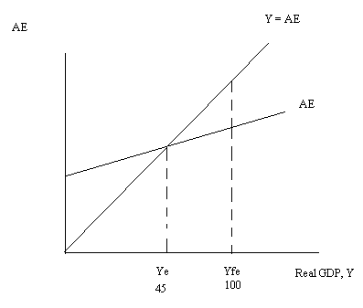
At Ye = 45 this economy is in a recession since its production level is below the full employment level of production. This implies that unemployment is higher than the natural rate of unemployment. At Ye = 45 there are no unplanned inventory changes since the economy is in equilibrium.

h. Use the information in part (g) for this question. Suppose government leaders tell producers to produce Yfe = 100 even though there have not been any other changes in this economy. What will happen in this economy if producers attempt to produce at Yfe = 100?

Answer:
Since AE does not cross the 45 degree reference line at Yfe = 100 we know Yfe = 100 cannot be an equilibrium for this economy given the information. At Yfe = 100, AE is less than production: that is, spending is less than production. If producers produce Yfe = 100 then unplanned inventories will increase and this will act as a signal to producers to reduce their production. The economy will return to its equilibrium level where Ye = 45.

i. Given the information in part (g), what must the change in government spending equal in order for this economy to return to the full employment level of output (Yfe = 100) through activist expansionary fiscal policy?

Answer:
Ye = 45 and Yfe = 100 so the desired change in Y is equal to 55. Recall that ΔY = (multiplier)( ΔG) holding everything else constant. Also, recall that the simple multiplier is equal to (1)/(1 – b). In this case, the multiplier is equal to (1/1 - .8) = 5. So, 55 = 5(ΔG), so ΔG = 11. If government increases its spending by 11 holding everything else constant this economy will produce at Yfe.

j. Verify that your answer in part (i) results in this economy producing at Yfe.

Answer:
C = 2 + .8Y
G’ = 17
T = 20
I = 2
X – M = -1
Y = AE in equilibrium
AE = C + I + G’ + (X – M)
So, Y = 2 + .8Y + 17 + 2 + (-1)
.2Y = 20
Y = 100 = Yfe

6. Use the simple Keynesian model to answer this question.
a. Draw a graph representing an economy that is in short-run equilibrium where the economy is in a recession. In your graph make sure you represent Ye and Yfe. Describe in words what would happen if this economy tried to produce at Yfe.

Answer:
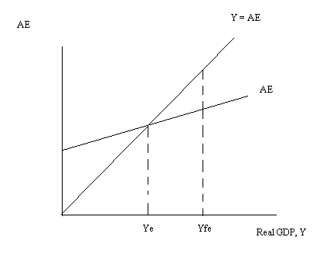
If this economy tries to produce at Yfe, aggregate expenditure will be less than aggregate production. This implies that unplanned inventories will increase and that producers will respond by decreasing their level of production. The economy will move back toward Ye.

b. Draw a graph representing an economy that is in short-run equilibrium where the economy is in a boom. In your graph make sure you represent Ye and Yfe. Describe in words what would happen if this economy tried to produce at Yfe.

Answer:

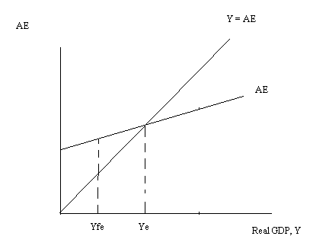
If this economy tries to produce at Yfe, aggregate expenditure will be greater than aggregate production. This implies that unplanned inventories will decrease and that producers will respond by increasing their level of production. The economy will move back toward Ye.

