Economics 102
Spring 2011
Answers to Homework #4
Due Wednesday 3/30/2011

Directions: The homework will be collected in a box before the lecture. Please place your name, TA name, and section number at the top of the homework (legibly). Make sure you write your name as it appears on your ID so that you can receive the correct grade. Please remember the section number for the section you are registered for, because you will need that number when you submit exams and homework. Late homework will not be accepted so make plans ahead of time. Please show your work. Good luck!

1. The economy of country A is described by the production function:
In this equation the symbol Y stands for real GDP, K for capital and L for the employed individuals in this economy. The labor force at the beginning of time, period 0, is 100 individuals. Capital in each period is constant and equal to 100 units. Assume this economy is under full employment. (Suggestion: Use Microsoft Excel or some other computer program to do the calculations and the graphs of the questions posed below rather than a regular calculator.)

a. Complete the following chart using the above information. Calculate real GDP with at least 3 decimal places. Hint: this will be far easier if you use Excel to do these calculations and you may present your own Excel Chart as the answer to this question.

Aggregate Variables | Capital(K) | Labor(L) | Change in L | Real GDP(Y) | change in Y | MPL
Period 0 | 100 | 100 | NA | 100 | NA | NA
Period 1 | 100 | 200 | 100 | 141.4213562 | 41.4213562 | 0.292893
Period 2 | 100 | 250 | 50 | 158.113883 | 16.6925268 | 0.105573
Period 3 | 100 | 370 | 120 | 192.3538406 | 34.2399576 | 0.178005
Period 4 | 100 | 480 | 110 | 219.089023 | 26.7351824 | 0.122029
Period 5 | 100 | 550 | 70 | 234.520788 | 15.431765 | 0.065801
Period 6 | 100 | 640 | 90 | 252.9822128 | 18.4614248 | 0.072975
Period 7 | 100 | 800 | 160 | 282.8427125 | 29.8604997 | 0.105573
Period 8 | 100 | 890 | 90 | 298.3286778 | 15.4859653 | 0.051909
Period 9 | 100 | 970 | 80 | 311.44823 | 13.1195522 | 0.042124
Period 10 | 100 | 1050 | 80 | 324.0370349 | 12.5888049 | 0.03885
Or see the excel file.

b. Graph Real GDP and the labor level for this economy. Please measure real GDP on the y-axis and labor on the x-axis, when the amount of capital is fixed at 100 units. For this question it is fine to present your answer as an Excel Graph (hint: this is much easier to do with a program like Excel).

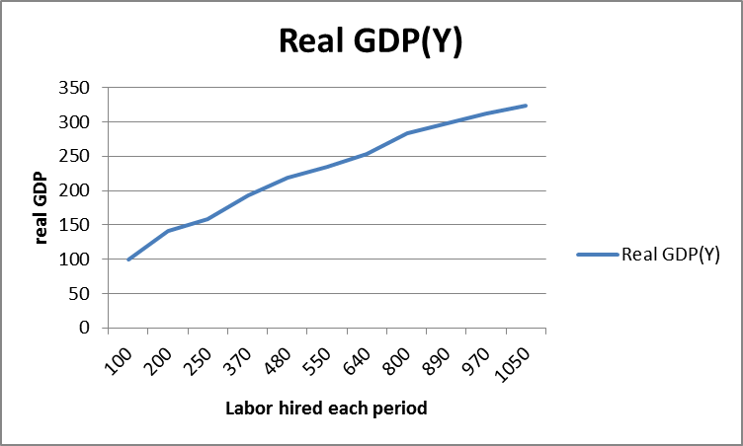
c. Graph the marginal product of labor each period for this economy. Measure the MPL on the y-axis and the amount of labor on the x axis. You will find this easiest to do using Excel and its graphing feature. Does the MPL you have calculated and graphed exhibit the property of diminishing return to labor? If not, why?

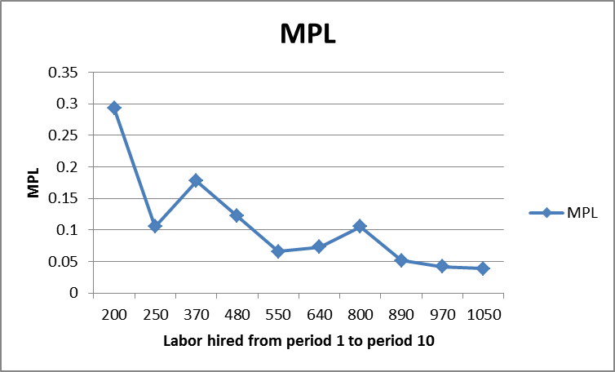
Answer:
First, notice that this production function is the same as in the exercise 3, handout 6. The output Y depends on two variables: L and K. To see the relation between output (Y) and labor (L), we can divide the function by K on both sides. So the function becomes. And if we measure Y/K on the y-axis and L/K on the x-axis, the function is , where y=Y/K, x=L/K. The graph of is:
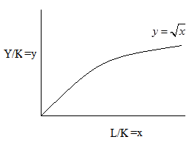
And this production function exhibits diminishing return to labor. Another judgment is that the marginal product per labor, MPL, should decreases with the amount of labor. The reason why that MPL is not a downward line here is that the change of labor each period is not the same. If the labor change in each period is the same, the MPL is a smooth downward line. To see this, let’s draw the graph using Excel for when the labor increases by 100 individuals each period.

Aggregate Variables | Capital(K) | Labor(L) | Change in L | Real GDP(Y) | change in Y | MPL
Period 0 | 100 | 100 | NA | 100 | NA | NA
Period 1 | 100 | 200 | 100 | 141.4213562 | 41.42135624 | 0.292893
Period 2 | 100 | 300 | 100 | 173.2050808 | 31.78372452 | 0.183503
Period 3 | 100 | 400 | 100 | 200 | 26.79491924 | 0.133975
Period 4 | 100 | 500 | 100 | 223.6067977 | 23.60679775 | 0.105573
Period 5 | 100 | 600 | 100 | 244.9489743 | 21.34217653 | 0.087129
Period 6 | 100 | 700 | 100 | 264.5751311 | 19.62615683 | 0.07418
Period 7 | 100 | 800 | 100 | 282.8427125 | 18.26758137 | 0.064586
Period 8 | 100 | 900 | 100 | 300 | 17.15728753 | 0.057191
Period 9 | 100 | 1000 | 100 | 316.227766 | 16.22776602 | 0.051317
Period 10 | 100 | 1100 | 100 | 331.662479 | 15.43471302 | 0.046537
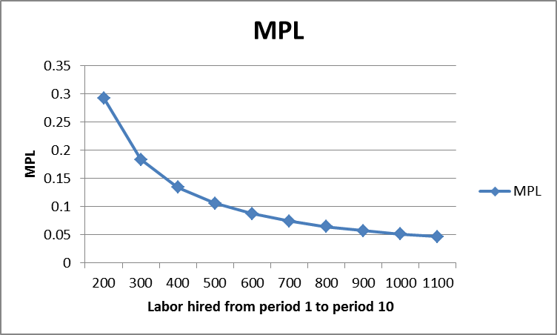
When the change in labor is constant in each period the MPL curve decreases smoothly as the level of hired labor increases.

When you want to analyze the MPL you should make sure that the change in labor is the same for each period.

d. Suppose now that the capital increases to a constant level of 200 units from period 0. Nothing else changes about this problem. Present real GDP under both situations in the same graph: situation one, where capital is equal to 100 units and situation two, where capital is equal to 200 units. On your graph measure real GDP on the y-axis and the time periods on the x-axis. Remember to note clearly the label of each curve.

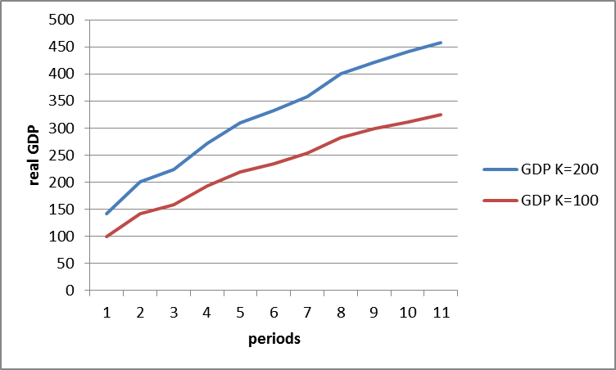

e. Suppose now that the technology changes, so that the productivity doubles. That is, the production function is now , and all other conditions remain the same. The amount of capital is fixed at 100 units. Present real GDP under both situations in the same graph: situation one, where ; and situation two, where .
Which production function has higher marginal return to labor? Why? (you can answer this question by analyzing the graph you have drawn)

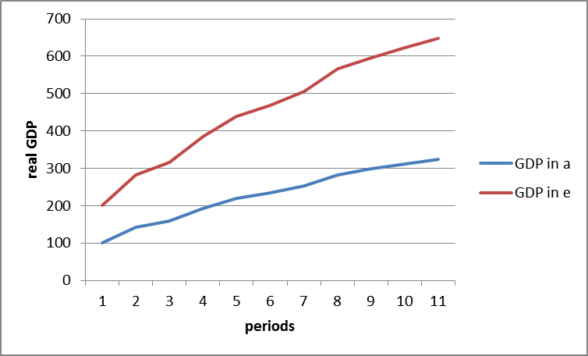

The new technology has higher marginal return to labor.
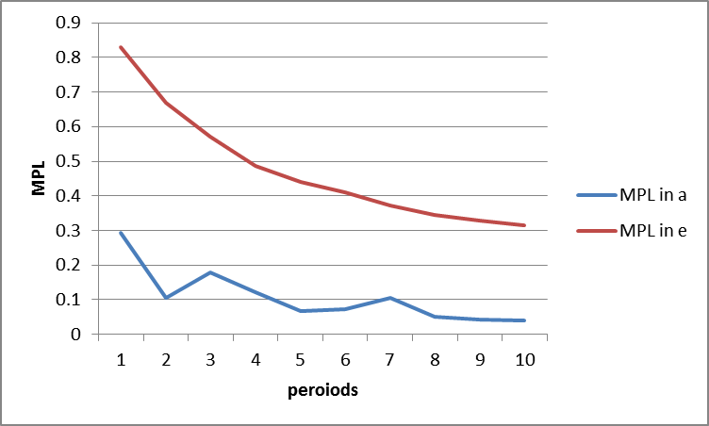

Question 2
Suppose that the demand for labor and supply of labor in Fantasyland are given by the following equations:
Demand for labor: w = 170 – L_{D}
Supply of labor: w = 8 + L_{S}
where w is the wage per week and L is the number of labor units hired per week. Assume that one labor unit is equal to one worker.
- Suppose we have full employment, what is the equilibrium level of employment per week and the equilibrium wage rate per week in Fantasyland?

Answer: 170-L=8+L => L=81, W=$89

- Suppose the aggregate production function in Fantasyland is given by the following equation:
where Y is real GDP in unit of dollars, K is capital and L is labor. Furthermore, suppose that Fantasyland has 100 units of capital. Given this information, what is the full employment output for this economy?

Answer: dollars.

- Suppose we define labor productivity for Fantasyland as output divided by the level of labor used in a week. What is the value of labor productivity for Fantasyland if it produces the full employment level of output?

Answer: 180/81=2.22 dollars per unit of labor.

Suppose now, that the government implements a minimum wage rate of $95 per week. Use this information to answer parts (d) through (f).
d. Holding everything else constant and given this new information, what is the number of unemployed people in this economy?

Answer: W = $95, L_{demand} = 170 – W = 75 workers; L_{S} = W – 8 = 87 workers.
We have excess labor supply: 87 – 75 = 12 workers.
The number of unemployed people = 12

e. Given this information, what is the new level of output for this economy and
the new level of labor productivity?

Answer dollars.
New labor productivity = Y/L_{em} = 173.2/75 = 2.31 dollars per unit of labor.

f. From your answers in parts (d) and (e), discuss whether or not the
government’s minimum wage policy makes workers better off or not.

Answer: The main facts to analyze here are: a minimum wage above the equilibrium level generates unemployment. For those who are employed after the policy of minimum wage, they become better off, since the wage increased. However, 12 people are unemployed due to this policy. And the firms are also worse off because labor cost increased. The firms could transfer this increased cost to consumers, but this will make the analysis more complicated and we would need additional information about output markets. Let’s focus on workers. If we measure welfare as income, for those who are still employed, the wage increased by 95 – 89 = $6/week. And there are 75 employed workers, so total income increased by 6*75 = $450/week. For those who are unemployed, each of them lost their job, which pays them $89/week. The total loss to the unemployed is 89*12 = $1068/week. This simple quantitative analysis shows that the society is worse off.

- Go back to the initial situation (no minimum wage imposed by the government).Suppose that the demand for labor shifts to the right and results in the equilibrium wage increasing to $108. What is the value of labor productivity when this increase in wages occurs?

Answer:
W=108, the labor demanded is L_{D}=170-W=62 workers
dollars,
labor productivity = Y/L_{em}=157.48/62 = 2.54 dollars per unit of labor.

3. Using a diagram of the labor market and a diagram of an aggregate production function, illustrate and verbally describe what happens for the following cases. Be sure to identify what happens to the level of employment, the wage rate, the level of production, and labor productivity.

- A baby boom 16 years ago drives the current labor force up.
The labor supply curve shifts right, leading to higher employment, a lower wage rate, greater output, and lower labor productivity.
- The average education level has been dramatically increased. Assume that this change does not alter the demand for or the supply of labor.
Better education increases the accumulation of human capital and causes the production function curve to shift upward. There is no change in employment and wage rate, and output and labor productivity increase.
- Plants switch their labor-intensive job positions overseas, but the aggregate production processes in the U.S. do not change.
The labor demand curve shifts left, resulting in lower employment, a lower wage, lower output, and an increase in labor productivity.
- Technological improvement rebuilds production function.
The production function curve shifts upward. There is no change in employment and the wage rate, and output and labor productivity increase.

4. Consider the market for loanable funds. Using the information below, graph the market for loanable funds. Measure the X-axis in millions of dollars of investment. Measure the interest rate (in percentage points) on the Y-axis. In the equations below r is the real interest rate, where the unit is percentage, and Q is the quantity of loanable funds, with the quantity measured in dollars. Assume the government initially has a balanced budget (that is, G = T – TR where G is government spending, T is taxes, and TR are transfers) and that this is a closed economy (that is, exports (x) are equal to zero and imports (IM) are equal to zero). The following two equations describe the supply of loanable funds from saving and the demand for loanable funds for investment:
Saving function:
Investment function:

- What is the equilibrium interest rate and quantity of investment in this market?

Answer: At equilibrium, S = I,

- Assume the government budget balance is zero (that is, G = T – TR). Suppose that at any given interest rate, consumers decide to decrease their saving by 2000 dollars. What is the new equilibrium interest rate and quantity of investment in the loanable funds market given this information?

Answer: Household savings shifts to the left by 2000. New saving S’=S-2000, where S is the original saving. Or S=S’+2000. The new saving function is
At equilibrium, S’=I,

- Assume the government budget balance is zero, and the saving function is the same as it is in (a). Suppose businesses become very pessimistic about future profitability due to the financial crisis. Business executives decide to cut their investment spending by 50% at any given interest rate. Given this information, what is the new equilibrium interest rate and quantity of investment in the loanable funds market?

Answer: new investment I’ is 50% of the original investment I, so I’=0.5I, or I=2I’
New investment function is
At equilibrium, S=I’,

Now suppose that the government decides to run a deficit equal to $15,000. That is G – (T – TR) = 15,000. For this question assume that the government will finance the deficit by borrowing funds in the loanable funds market.

- What is the new quantity of private investment and the new equilibrium interest rate in this market?

Answer: Total demand for loans becomes I + deficit = I + 15,000 = I’, where I’ is the new demand. So I = I’-15,000. Investing function:
At equilibrium, S=I’
I’=I+15000, so I=29,000.

- Draw a graph of the loanable funds market illustrating both the initial situation and the effect of the government deficit described in part (d) of this problem. Label your graph clearly and completely.
