Economics 102
Summer 2011
Answers to Homework #3
Due 6/30/11

Directions: The homework will be collected in a box before the lecture. Please place your name, TA name and section number on top of the homework (legibly). Make sure you write your name as it appears on your ID so that you can receive the correct grade. Please remember the section number for the section you are registered, because you will need that number when you submit exams and homework. Late homework will not be accepted so make plans ahead of time. Please show your work. Good luck!

1. Suppose there are 50,000 people 16 years old or older in Cedarburg. Of this 50,000 people:
- 4,000 are currently looking for work;
- 6,000 are currently employed part-time but wanting to work full-time;
- 10,000 are working full-time;
- 2,000 are discouraged workers; and
- 5,000 are either in school, the military, or institutionalized.
a. What is the current unemployment rate in Cedarburg?

The unemployment rate is equal to [(the number of unemployed)/(the number of unemployed + the number of employed)]*100= [4000/(4000 + 16,000)]*100 = 20%.

b. What is the unemployment rate if Cedarburg classifies discouraged workers as unemployed workers?

The number of unemployed workers changes to 6000. Thus, the unemployment rate is equal to [(6000)/(6000 + 16000)] * 100 = 27.3%.

c. What is the unemployment rate if Cedarburg classifies discouraged workers and part-time workers wanting to work full-time as unemployed workers?

The number of unemployed workers changes to 12000. Thus, the unemployment rate is equal to [(12000)/(12000 + 10000)] * 100 = 54.5%.

d. Does the way we defined who is unemployed matter? Explain your answer.

How we define unemployment matters when calculating the unemployment rate. As noted in parts (a), (b), and (c) you get quite different measures of the unemployment rate depending on how you classify a person who is either not working or not working as much as they would like. Our current definition of unemployment results in a lower measure of unemployment than would occur if we counted discouraged workers or part-time workers who would like to work full-time as unemployed workers.
2. Suppose that a community has 40,000 people in the civilian labor force. Of these 40,000 people 4,000 are currently structurally unemployed while 2,000 are currently frictionally unemployed. There are in addition 1,000 people who are cyclically unemployed.
a. What is the unemployment rate in this community given the above information?

The unemployment rate is equal to [7,000/40,000]* 100 = 17.5 %.

b. What is the cyclical unemployment rate in this community given the above information?

The cyclical unemployment rate is equal to [1000/40,000] * 100 = 2.5%.

c. What is the natural unemployment rate in this community given the above information?

The natural rate of unemployment rate is equal to [(the structurally unemployed + the frictionally unemployed)/(civilian labor force)] * 100 = [(4000 + 2000)/40,000] * 100 = 15%.

d. How do you know that this community is currently in a recession?

The economy is in a recession because there is a positive amount of cyclical unemployment. When there is positive cyclical unemployment it signifies that the labor market is not providing employment to some workers due to the economy not producing at its full potential.

3. The St. Louis Federal Reserve District Bank collects an abundance of information. Go to http://research.stlouisfed.org/fred2/categories/10 and “click on” Household Survey Data to find two different series on unemployment data. The first series is labeled “UNRATE” and is the Civilian Unemployment Rate. The second series of interest for this question is labeled “U6RATE” and is the Total Unemployed plus all marginally attached workers plus total employed part-time for economic reasons. Examine this data for the period 2007 to 2011 in order to answer this series of questions.

a. Prior to the recession of 2007 what was the unemployment rate reported in this data for the two different measures? Were the two values very different?

According to the general unemployment rate data, the unemployment rate before the beginning of the recession in 2007 was approximately 4.5%. The U6RATE indicated an unemployment rate of around 8%.

b. In this data set it is possible to have the data represented as the annual percentage change in unemployment. When you look at the two sets of unemployment data as annual percentage changes are the two sets of data growing at similar rates during the course of the recession? Explain your answer. If the rates are different how do you interpret this difference?

Over the course of the recession the UNRATE is growing from about ½% a year at the beginning of the recession to around 4% at the height of the recession. The U6RATE is growing at about 1% at the beginning of the recession to around 6.75% at the height of the recession. The two rates of unemployment are not growing at the same rate. This indicates that more and more workers are joining the marginally attached or discouraged worker pool.

4. Suppose that the market basket for purposes of computing the consumer price index in Winston contains 10 steaks, 20 potatoes, 5 cookies, and 2 bags of charcoal. You are given the following price data for the years 2005 through 2010 in Winston.

Item | Price in 2005 | Price in 2006 | Price in 2007 | Price in 2008 | Price in 2009 | Price in 2010
1 Steak | $4.00 | $5.00 | $4.00 | $6.00 | $5.00 | $7.00
1 Potato | $.50 | $.60 | $.60 | $.40 | $.50 | $.80
1 Cookie | $1.00 | $1.00 | $2.00 | $2.00 | $1.00 | $2.00
1 Bag of Charcoal | $5.00 | $5.00 | $5.00 | $6.00 | $7.00 | $5.00

a. Using the above data compute the cost of each market basket. Put your answers in the following table.
Cost of Market Basket in 2005
Cost of Market Basket in 2006
Cost of Market Basket in 2007
Cost of Market Basket in 2008
Coat of Market Basket in 2009
Cost of Market Basket in 2010

Answer:

Cost of Market Basket in 2005 | (10)(4) + (20)(.5) + (5)(1) + (2)(5) = $65
Cost of Market Basket in 2006 | (10)(5) + (20)(.6) + (5)(1) + (2)(5) = $77
Cost of Market Basket in 2007 | (10)(4) + (20)(.6) + (5)(2) + (2)(5) = $72
Cost of Market Basket in 2008 | (10)(6) + (20)(.4) + (5)(2) + (2)(6) = $90
Coat of Market Basket in 2009 | (10)(5) + (20)(.5) + (5)(1) + (2)(7) = $79
Cost of Market Basket in 2010 | (10)(7) + (20)(.8) + (5)(2) + (2)(5) = $106

b. Now, calculate the CPI for 2005 through 2010 using 2005 as the base year. Enter your results in the following table. Use a 100 point scale for the CPI. Carry your answer out to two places past the decimal.

Year | CPI
2005
2006
2007
2008
2009
2010

Answer:

Year | CPI
2005 | (65/65)*100 = 100
2006 | (77/65)*100 = 118.46
2007 | (72/65)*100 = 110.77
2008 | (90/65)*100 = 138.46
2009 | (79/65)*100 = 121.54
2010 | (106/65)*100 = 163.08

c. Now, using the answers you got in part (b) calculate the annual rate of inflation in this economy from 2006 through 2010. Enter your answers in the table provided. Carry your answer out to two places past the decimal.

Year | Rate of Inflation
2006
2007
2008
2009
2010

Answer:

Year | Rate of Inflation
2006 | [(118.46-100)/100]*100 = 18.46%
2007 | [(110.77 – 118.46)/118.46]*100 = -6.5%
2008 | [(138.46 – 110.77)/110.77]*100 = 25%
2009 | [(121.54 – 138.46)/138.46]*100 = -12.22%
2010 | [(163.08 – 121.54)/121.54]*100 = 34.18%

d. Now, redo the CPI you found in part (b) with 2010 as the base year. Enter your results in the following table. Use a 100 point scale for the CPI. Carry your answer out to two places past the decimal.

Year | CPI
2005
2006
2007
2008
2009
2010

Answer:

Year | CPI
2005 | (65/106)*100 = 61.32
2006 | (77/106)*100 = 72.64
2007 | (72/106)*100 = 67.92
2008 | (90/106)*100 = 84.91
2009 | (79/106)*100 = 74.53
2010 | (106/106)*100 = 100

e. Now, using the answers you got in part (d) calculate the annual rate of inflation in this economy from 2006 through 2010. Enter your answers in the table provided. Carry your answer out to two places past the decimal.

Year | Rate of Inflation
2006
2007
2008
2009
2010

Answer:

Year | Rate of Inflation
2006 | [(72.64 – 61.32)/61.32]*100 =18.46 %
2007 | [(67.92 – 72.64)/72.64]*100 = -6.5%
2008 | [(84.91 – 67.92)/67.92]*100 = 25.01%
2009 | [(74.53 – 84.91)/84.91 ]*100 = -12.22%
2010 | [(100 – 74.53)/74.53]*100 = 34.17%

5. Suppose an economy’s aggregate production function can be expressed as
Y = AK^{α}L^{1-α}
where Y is real GDP, A is a measure of the available technology, K is the number of units of capital available, L is the number of units of labor available, and α is a constant between zero and one that measures capital’s share of total product or total income (recall from the circular flow diagram that total production equals total income in the aggregate economy).

Suppose that A = 20, K = 100, and L varies. In addition, you know that α is equal to .5. Use this information to answer the following questions. You might find it helpful to use excel to answer this question since a spreadsheet program will simplify the calculations and, in addition, the program can graph the data you submit.

a. Given the above information fill in the following table. In the real GDP and marginal product of labor columns carry your answer out to two places past the decimal.

Units of Labor | Units of Capital | Real GDP | Marginal Product of Labor
0 |  |  | -----
1
2
…..
All the way to 36

Answer:

Labor | Capital | Real GDP | Marginal Product of Labor
0 | 100 | 0.00 | 200.00
1 | 100 | 200.00 | 82.84
2 | 100 | 282.84 | 63.57
3 | 100 | 346.41 | 53.59
4 | 100 | 400.00 | 47.21
5 | 100 | 447.21 | 42.68
6 | 100 | 489.90 | 39.25
7 | 100 | 529.15 | 36.54
8 | 100 | 565.69 | 34.31
9 | 100 | 600.00 | 32.46
10 | 100 | 632.46 | 30.87
11 | 100 | 663.32 | 29.50
12 | 100 | 692.82 | 28.29
13 | 100 | 721.11 | 27.22
14 | 100 | 748.33 | 26.27
15 | 100 | 774.60 | 25.40
16 | 100 | 800.00 | 24.62
17 | 100 | 824.62 | 23.91
18 | 100 | 848.53 | 23.25
19 | 100 | 871.78 | 22.65
20 | 100 | 894.43 | 22.09
21 | 100 | 916.52 | 21.57
22 | 100 | 938.08 | 21.08
23 | 100 | 959.17 | 20.63
24 | 100 | 979.80 | 20.20
25 | 100 | 1000.00 | 19.80
26 | 100 | 1019.80 | 19.43
27 | 100 | 1039.23 | 19.07
28 | 100 | 1058.30 | 18.73
29 | 100 | 1077.03 | 18.41
30 | 100 | 1095.45 | 18.11
31 | 100 | 1113.55 | 17.82
32 | 100 | 1131.37 | 17.54
33 | 100 | 1148.91 | 17.28
34 | 100 | 1166.19 | 17.03
35 | 100 | 1183.22 | 16.78
36 | 100 | 1200.00

b. Given your results in(a), describe what is happening to the marginal product of labor as the number of units of capital is increasing?

Answer:
The marginal product of labor decreases as the amount of labor used increases. Labor becomes less productive since each additional unit of labor has less capital to work with.

c. Draw a graph of your aggregate production function with real GDP on the vertical axis and labor on the horizontal axis.

Answer:

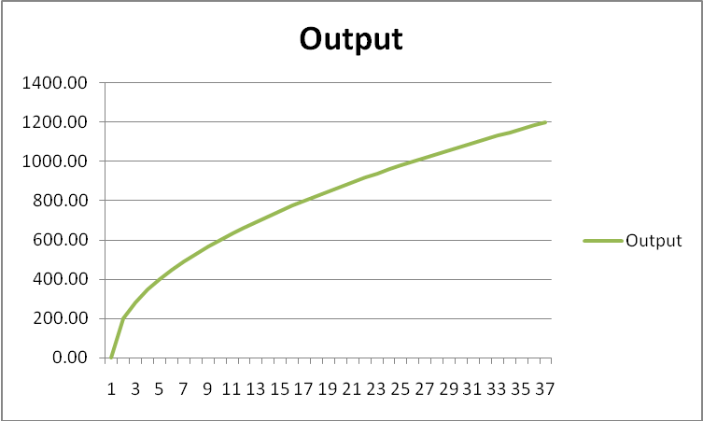

d. Now, suppose that the level of technology changes in this economy so that the value of A is now equal to 30. Redraw the graph of this economy’s new aggregate production function on a new graph. On this new graph represent the economy’s original aggregate production function as well as the economy’s new aggregate production function. What happens to the aggregate production function when the level of technology increases?

Answer:

When the level of technology increases the aggregate production function shifts up: at every level of labor (except zero units) the economy can now produce a larger amount of output. This is due to each unit of labor now having access to improved technology.

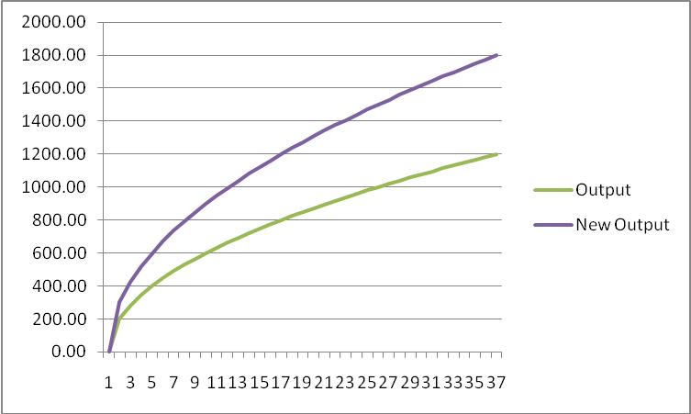

e. Given your work in part (d), what happens to labor productivity when the level of technology increases holding everything else constant?

Answer:

Holding everything else constant, an increase in technology will make labor more productive. Labor productivity is equal to output/unit of labor and can be measured as the slope of the ray drawn from the original to the point on the aggregate production function corresponding to the given level of labor. As the aggregate production function shifts up the slope of this ray gets steeper for any given level of labor usage: hence, labor productivity increases with technological improvement.

6. Suppose that the supply and demand curves for labor for an economy are given by the following equations:
Demand for Labor: w = 20 – (1/500)L
Supply of Labor: w = 5 + (2/500)L
where w is the wage rate per unit of labor and L is the quantity of labor. Furthermore, you now that aggregate production, Y, in this economy is determined by the following aggregate production function:
Y = f(K, L) = AK^{α}L^{1-α}
where A is a measure of the available technology, K is capital, and L is labor. Suppose the value of A is 100, K is 144, and α is .5.
a. Given the above information, what is the equilibrium quantity of labor and the equilibrium wage rate?

Answer:
20 – (1/500)L = 5 + (2/500)L
15 = (3/500)L
L = 2500
w = 20 – (1/500)(2500) = 15 0r w = 5 + (2/500)(2500) = 15

b. What is labor’s total income in this economy?

Answer:
(2500)(15)= $37,500

c. Assume the labor market is in equilibrium. What is the value of full employment for this economy?

Answer:
Y = 100 (12)(50)
Y = 60,000

d. Suppose there is no change in this economy’s labor market but that new technology becomes available so that the value of A is now 120. Describe what happens to the full employment level of output for this economy.

Answer:
Y’ = 120(12)(50) = 72,000
Y increases to 72,000 from its original value of 60,000.

