Economics 102
Summer 2010
Answers to Homework #3
Due June 24, 2010

This homework is due at the beginning of the class lecture. Make sure that your homework includes your name, section number, and is stapled. There will be no stapler at the class lecture. Submitted homework should be legible, neat, and of professional quality. Please show all necessary work and please be sure that your answer is easy to identify and find.
**Where appropriate calculate your answer to the nearest hundredth.**
Rule of 70
- Suppose you receive $100 from your grandfather when you are born and you invest this $100 in an account that pays you 5% interest a year. Each year you reinvest the initial amount plus any interest you have earned. Assume the interest rate is paid at the end of each year.
  - What is the value of your account at the end of the first year?

Answer:
Value of the account at end of first year = 100(1 + r) = 100( 1 + .05) = $105

  - What is the value of your account at the end of the fifth year?

Answer:
Value of the account at end of fifth year = 100(1 + r)⁵ = 100(1.05)⁵ = $127.63

  - What is the value of your account at the end of the tenth year?

Answer:
Value of the account at end of tenth year = 100(1 + r)¹⁰ = $162.89

  - According to the rule of 70, how many years will it take to approximately double the initial value of $100?

Answer:
# of years for variable to double ≈ 70/(growth rate) = 70/5 = 14 years
To verify this, calculate the value of the account at the end of fourteen years = 100(1 + r)¹⁴ = $197.99
Now, suppose you instead invest this amount in an account that pays you 10% interest a year.
  - What is the value of your account at the end of the first year?

Answer:
Value of the account at end of first year = 100(1.1) = $110
  - What is the value of your account at the end of the fifth year?

Answer:
Value of the account at the end of the fifth year = 100(1.1)⁵ = $161.05
  - What is the value of your account at the end of the tenth year?

Answer:
Value of the account at the end of the tenth year = 100(1.1)¹⁰ = $259.37

  - According to the rule of 70, how many years will it take to double the initial value?

Answer:
# of years for variable to double ≈ 70/(growth rate) = 70/10 = 7 years
To verify this, calculate the value of the account at the end of seven years = 100(1 + r)⁷ = $194.87

Economic Growth
- You are given the following information about India and the United States (information taken from the CIA Factbook).
Variable | United States | India
GDP (2008 estimated) | $14.44 trillion | $3.304 trillion
GDP growth rate | 2.1% (2007) | 7.4% (2008 )
Population (2009 estimated) | 307,212,123 | 1,166,079,217
Population growth rate (2009 estimated) | .975% | 1.548%
  - Provide an estimate of GDP per capita for 2008 (just use the numbers given) for these two countries.

Answer:
GDP per capita in India = S3.304 trillion/1,166,079,217 people = $3304 per person (this is what the figures compute to, but the CIA Factbook actually gives GDP per capita in India estimated for 2008 as $2900)
GDP per capita in United States = $14.44 trillion/307,212,123 people = $47,003 per person (this is what the figures compute to, but the CIA Factbook actually gives GDP per capita in the United States estimated for 2008 as $47,500)

  - Calculate GDP per capita in the United States for 2018 (ten years time) assuming that GDP and population grow at the rates given in the above table. Then, calculate the rate of growth of GDP per person over this ten year period of time.

Answer:
To do this calculation, first calculate the value of GDP in ten years time:

Value of GDP in ten years = current GDP (1 + growth rate of GDP)¹⁰ = ($14.44 trillion)(1.021)¹⁰ = ($14.44 trillion)(1.23) = $17.78 trillion

Then, calculate the size of the population in ten years time:

Size of population in ten years = (current population)(1 + growth rate of population) = (307,212,123)(1.00975)¹⁰ = 337,933,335 people

Estimated GDP per capita in ten years = ($17.78 trillion)/(337,933,335 people) = $52,614 per person

Rate of growth of GDP per person in ten year period = [($52,614 - $47,003)/($47,003)] *100 = 11.94%
  - Calculate GDP per capita in India for 2018 (ten years time) assuming that GDP and population grow at the rates given in the above table.

Answer:
To do this calculation, first calculate the value of GDP in ten years time:

Value of GDP in ten years = current GDP (1 + growth rate of GDP)¹⁰ = ($3.304 trillion)(1.074)¹⁰ = ($3.304 trillion)(2.042) = $6.747 trillion

Then, calculate the size of the population in ten years time:

Size of population in ten years = (current population)(1 + growth rate of population) = (1,166,079,217)(1.01548)¹⁰ = 1,359,695,933 people

Estimated GDP per capita in ten years = ($6.747 trillion)/(1,359,695,933 people) = $4962 per person

  - Given your calculations in parts (b) and (c), what is happening to India’s GDP per capita relative to the United States’ GDP per capita over this ten year period of time?

  - If these growth rates persist, what will happen in the very long run to United States’ GDP per capita and India’s GDP per capita?

- Suppose you are told that an economy’s aggregate production function is
Y = 20K^{1/2}L^{1/2}
where Y is real GDP, K is units of capital and L is units of labor. Suppose that initially this
economy’s stock of capital is fixed at 100 units.
a. Using Excel, fill in the following table. For your homework you can submit a truncated table
giving the values in the table for L = 1 to 10 and L = 90 to 100. [Hint: the “Hide” function in Excel will make this easy.]
Y | L | K
 | 1
 | 2
 | 3
 | …
 | 100

Answer:
Y | L | K
0.00 | 0 | 100
200.00 | 1 | 100
282.84 | 2 | 100
346.41 | 3 | 100
400.00 | 4 | 100
447.21 | 5 | 100
489.90 | 6 | 100
529.15 | 7 | 100
565.69 | 8 | 100
600.00 | 9 | 100
632.46 | 10 | 100
1897.37 | 90 | 100
1907.88 | 91 | 100
1918.33 | 92 | 100
1928.73 | 93 | 100
1939.07 | 94 | 100
1949.36 | 95 | 100
1959.59 | 96 | 100
1969.77 | 97 | 100
1979.90 | 98 | 100
1989.97 | 99 | 100
2000.00 | 100 | 100

b. Plot the data you found in part (a) in a graph where Y, real GDP, is measured on the vertical axis and L, labor, is measured on the horizontal axis. [Hint: Excel’s graphing tools will make this a relatively simple matter.]
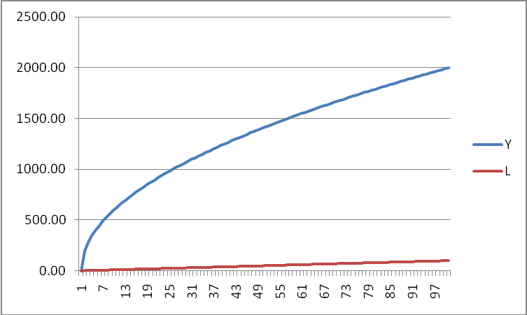
c. Suppose L equals 25. What is the value of labor productivity?

Answer:
To find labor productivity, Y/L, we need to know both L and Y. When L is equal to 25, Y is equal to 1000. So, labor productivity is equal to 1000/25 = 40 units of output per worker.

d. Suppose L increases to 49. What is the value of labor productivity now? Explain what is happening to labor productivity as L increases from 25 to 49.

Answer:
When L increases to 49, Y also increases to 1400. Labor productivity is now equal to 1400/49 = 28.57 units of output per worker. As labor increases, holding capital and technology constant, labor productivity declines since each unit of labor now has less capital to work with and this results in diminishing marginal productivity for labor.

- Suppose you are told that an economy’s aggregate production function is
Y = 20K^{1/2}L^{1/2}
where Y is real GDP, K is units of capital and L is units of labor. Suppose that initially this
economy’s stock of capital is fixed at 25 units.
  - Fill in the following table.
Y | L | K
 | 0
 | 1
 | 4
 | 9
 | 16
 | 25

Answer:
Y | L | K
0 | 0 | 25
100 | 1 | 25
200 | 4 | 25
300 | 9 | 25
400 | 16 | 25
500 | 25 | 25

  - Sketch a graph of this economy’s aggregate production function measuring real GDP on the vertical axis and units of labor on the horizontal axis. Label the line on your graph carefully as “aggregate production function 1”.

Answer:

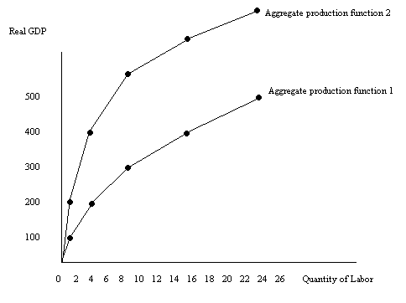
  - Now, suppose technology improves in this economy and the aggregate production function is now given by the equation
Y = 40K^{1/2}L^{1/2}
Fill in the following table. Assume there is no change in capital.
Y’ | L | K
 | 0
 | 1
 | 4
 | 9
 | 16
 | 25

Answer:

Y’ | L | K
0 | 0 | 25
200 | 1 | 25
400 | 4 | 25
600 | 9 | 25
800 | 16 | 25
1000 | 25 | 25

  - Now draw “aggregate production function 2” on your graph in part (b). Label this new line clearly. Describe in words the effect of a change in technology on the aggregate production function.

Answer:
The increase in technology, holding everything else constant, shifts the aggregate production function up. At every level of labor usage the economy can now produce a greater level of output. This implies that labor is more productive.

  - Suppose L is equal to 25 units. What happens to labor productivity in this economy as technology improves? Explain your answer.

Answer:
When L equals 25 units, the economy can initially produce 500 units of output: thus, labor productivity is 500/25 = 20 units of output per unit of labor. When the technological improvement occurs, the economy can now produce 1000 units of output when employing 25 units of labor. The economy’s labor productivity is now 1000/25 = 40 units of output per unit of labor. Labor productivity increases when the level of technology increases.

- Suppose you are told that an economy’s demand for labor and supply of labor are given by the following equations where L is units of labor and W is the real wage rate.
Demand for Labor: W = 200 – 4L
Supply of Labor: W = 4L
Furthermore, you know that this economy’s aggregate production function is
Y = 2K^{1/2}L^{1/2}
where Y is real GDP and K is units of capital. In this economy capital is fixed and equal to 9 units.
  - Given the above information, what is the equilibrium real wage and equilibrium level of labor in this economy?

Answer:
To find the equilibrium real wage and level of labor use the labor demand and labor supply equations. Thus, 200 – 4L = 4L or L = 25. To find W, substitute L = 25 into either the labor demand or labor supply equation: thus, W = 4(25) = 100.

  - When the labor market is in equilibrium, what is the level of aggregate production in this economy?

Answer:
When L = 25, then Y = (2)(3)(5) = 30.

  - Given your answers in parts (a) and (b), calculate the value of labor productivity for this economy.

Answer:
Labor productivity is found by dividing the level of output, Y, by the level of labor usage, L. In this example Y/L = 30/25 = 1.2 units of output per unit of labor.

Now, suppose at every real wage employers now wish to hire 22 additional units of labor.

  - What is the equation for the new labor demand curve?

Answer:
The new labor demand curve shifts to the right of the original labor demand curve. This is a parallel shift so both curves have the same slope equal to -4. To write the new equation we need at least one point that we know lies on the new labor demand curve and the slope value. When W = 100 the original quantity of labor demanded was 25 units. Now, at W = 100 we know that employees wish to hire 22 more units of labor. Thus, the point (W,L) = (100, 47) lies on the new labor demand curve. The new labor demand curve can be found using this information and the slope intercept form:
y = mx + b
And, y = W and x = L
Thus, W = mL + b
m = slope = -4
So, W = b – 4L
Using the point (W, L) = (100, 47) we can find the value for b, the y-intercept: 100 = b – 4(47) or b = 288. Thus, the new labor demand equation is W = 288 – 4L.

  - Given this new information, calculate the new equilibrium real wage, W’, and the new equilibrium level of labor, L’, in this economy.

Answer:
W = 288 – 4L is the new labor demand curve and W = 4L is the labor supply curve. So, using these two equations we find L’ = 36 and W’ = 144.

  - Given your answer in (e), what is the new level of aggregate production, Y’, for this economy?

Answer:
Using the aggregate production function and our new value for L’, we find Y’ = 36.

  - Given your answers in (e) and (f), calculate the value of labor productivity for this economy.

Answer:
Y’/L’ = 36/36 = 1 unit of output per unit of labor

  - Compare and contrast your answers in parts (c) and (g). Provide a verbal explanation for what is happening to labor productivity and why this is happening.

Answer: Labor productivity falls from 1.2 units of output per unit of labor to 1 unit of output per unit of labor as this economy hires more labor (36 units of labor instead of 25 units of labor) while capital and technology are held constant. Labor productivity fall since each unit of labor is now working with less capital per worker.

- Suppose you know a country’s aggregate production function and you also know that this aggregate production function exhibits diminishing marginal returns (i.e., as the level of factor usage increases holding all other factors constant, output increases but it increases at a diminishing rate).
  - Suppose the level of labor used in the economy increases. What happens to capital productivity and to the level of real GDP in this economy? Provide a verbal explanation as well as a sketch or sketches to illustrate your answer.

Answer:
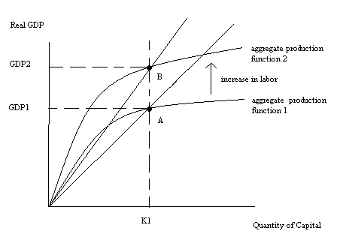
Capital productivity increases since each unit of capital is now working with more labor. Real GDP increases.

  - Suppose the level of labor used in the economy increases. What happens to labor productivity and to the level of real GDP in this economy? Provide a verbal explanation as well as a sketch or sketches to illustrate your answer.

Answer:
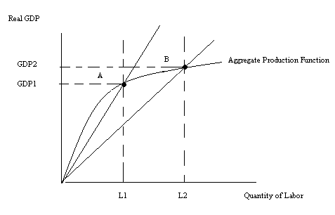
Labor productivity decreases while real GDP increases.

  - Suppose the level of capital used in this economy increases at the same time that there is a technological advance in the economy. What happens to capital productivity and to the level of real GDP in this economy? Provide a verbal explanation as well as a sketch or sketches to illustrate your answer.

Answer:

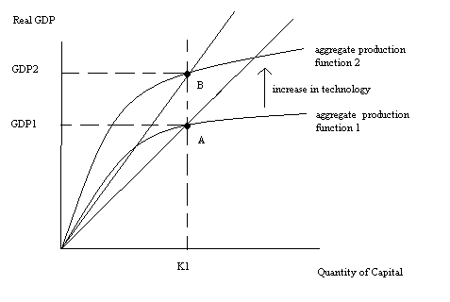
Holding capital constant, an increase in technology increases productivity while also increasing real GDP.
But, if capital is increasing simultaneously it is impossible to know whether capital productivity increases, decreases or remains the same. Thus,
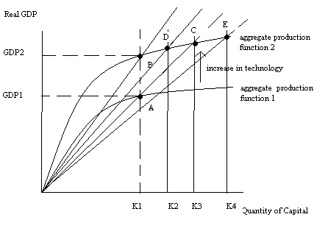
Capital increases from K1 to K3, and production goes from point A to point C: capital productivity remains constant.

Capital increases from K1 to K2, and production goes from point A to point D: capital productivity increases.

Capital increases from K1 to K4, and production goes from point A to point E: capital productivity decreases.

