Economics 102
Summer 2012
Answers to Homework #2
Due 7/2/12

Directions: The homework will be collected in a box before the lecture. Please place your name, TA name and section number on top of the homework (legibly). Make sure you write your name as it appears on your ID so that you can receive the correct grade. Please remember the section number for the section you are registered, because you will need that number when you submit exams and homework. Late homework will not be accepted so make plans ahead of time. Please show your work. Good luck!

- Econoland and Free Enterprise are two economies each producing two goods: airplanes (A) and grains (G). Currently the two economies do not trade with one another. The table below provides information about the amount of labor needed to produce one airplane or one ton of grains for each economy. Assume that labor is the only input needed to produce either airplanes or grains.

 | Quantity of Labor Needed to Produce One Airplane | Quantity of Labor Needed to Produce One Ton of Grains
Econoland | 100 hours of labor | 50 hours of labor
Free Enterprise | 150 hours of labor | 100 hours of labor

For this question assume that both economies have linear production possibility frontiers (PPF). Furthermore, assume that both countries have 3000 hours of labor available for the production of airplanes and grains.

- In two separate graphs draw the PPFs for these two economies. In each graph measure airplanes on the horizontal axis and grains on the vertical axis. Make sure you label each graph clearly as to whose PPF is represented in the graph. Also label the numerical values of the x and y intercepts in each graph.

Answer:
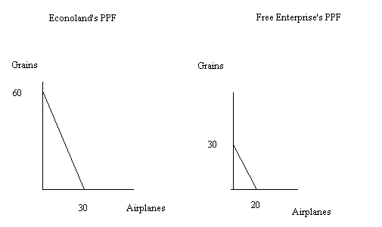
- Write an equation in slope intercept form for Econoland’s PPF and an equation in slope intercept form for Free Enterprise’s PPF.

Answer:
Econoland: G = 60 – 2A
Free Enterprise: G = 30 – (3/2)A

- What is Econoland’s opportunity cost of producing one additional airplane?

Answer: 2 tons of grain

- What is Free Enterprise’s opportunity cost of producing one additional ton of grain?

Answer: 2/3 of an airplane

- What is Econoland’s opportunity cost of producing ten additional tons of grain?

Answer: 5 airplanes. To see this use the equation in (b). If Econoland is initially producing 0 tons of grain that means they can produce 30 airplanes. If Econoland then produces 10 tons of grain then it can only produce 25 airplanes. The opportunity cost of producing the 10 tons of grain is equal to the five airplanes that they must give up in order to produce the additional 10 tons of grain.

- What is Free Enterprise’s opportunity cost of producing four additional airplanes?

Answer: 6 tons of grain. To see this use the equation in (b). If Free Enterprise is initially producing 0 airplanes that means they can produce 30 tons of grain. If Free Enterprise then produces 4 airplanes then it can only produce 24 tons of grain. The opportunity cost of producing the 4 airplanes is equal to the 6 tons of grain that they must give up in order to produce the additional 4 airplanes.
Suppose these countries decide to specialize and trade with one another.

- What good should Econoland produce? Explain your answer.

Answer:
Econoland should specialize in producing grains since it can produce grains at a lower opportunity cost than can Free Enterprise. For Econoland the opportunity cost of producing one ton of grains is ½ airplane while for Free Enterprise the opportunity cost of producing one ton of grains is 2/3 airplane.

- What good should Free Enterprise produce if the two economies specialize? Explain your answer.

Answer:
Free Enterprise should specialize in producing airplanes since it can produce airplanes at a lower opportunity cost than can Econoland. For Free Enterprise the opportunity cost of producing one airplane is 3/2 tons of grains while for Econoland the opportunity cost of producing one airplane is 2 tons of grain.

- Provide a range of trading prices in terms of tons of grain acceptable to both countries if 10 airplanes are traded.

Answer: If is helpful to think about this as a number line visually. Free Enterprise is willing to produce one airplane provided it receives at least 3/2 tons of grain. Econoland is willing to pay 2 tons of grain or less for one airplane. Examine the provided visual below.
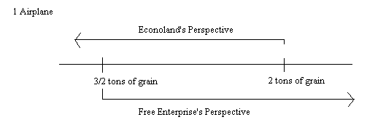
But, the question asks for the range of trading prices for 10 airplanes. So,
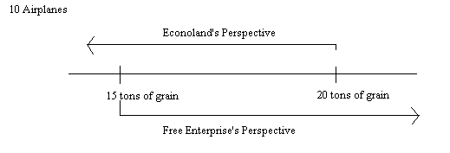
The acceptable range of trading prices for 10 airplanes will be between 15 and 20 tons of grain.

- Provide a range of trading prices in terms of airplanes acceptable to both countries if 25 tons of grain are traded. (Note: these numbers will be messy.)

Answer:
Use the same reasoning as in part (i). The acceptable range of trading prices for 25 tons of grain will be between 12.5 and 50/3 airplanes.

- Draw a graph of the joint PPF of these two economies. Measure airplanes on the horizontal axis and grains on the vertical axis. Provide numerical values for any intercepts as well as any “kinks” in your PPF.

Answer:
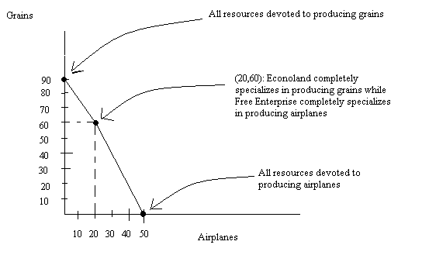
Although this graph looks almost like it’s a linear PPF if you will on close examination that it is not! See the answers to the next part of this question.

- Write the equations for each segment of the PPF you drew in (k). Make sure you identify the relevant range for each equation you write.

Answer:
For airplanes less than or equal to 20, the PPF can be written as G = 90 – (3/2)A. for airplanes greater than or equal to 20, the PPF can be written as G = 100- 2A. The two segments do not have the same slope and are therefore not the same line.

- Econoland and Free Enterprise, the two economies from the first problem are still our focus. Nothing has changed with these two economies except that Econoland has trained their labor force and now finds that it takes only 50 hours of labor to produce one airplane. Given this information you are asked to answer this next set of questions.

- Who has the comparative advantage in producing airplanes now?

Answer:
Econoland has the comparative advantage in producing airplanes now since Econoland’s opportunity cost of producing one airplane is 1 ton of grain while Free Enterprise’s opportunity cost of producing one airplane is 3/2 tons of grain.

- Who has the comparative advantage in producing tons of grain now?

Answer:
Free Enterprise has the comparative advantage in producing tons of grain now since Free Enterprise’s opportunity cost of producing one ton of grain is 2/3 airplane while Econoland’s opportunity cost of producing one ton of grain is 1 airplane.

- Provide a range of trading prices in terms of tons of grain acceptable to both countries if 10 airplanes are traded.

Answer:
An acceptable range of trading prices for 10 airplanes is between 10 and 15 tons of grain.

- Provide a range of trading prices in terms of airplanes acceptable to both countries if 25 tons of grain are traded.

Answer:
An acceptable range of trading prices for 25 tons of grain is between 50/3 airplanes and 25 airplanes.

- Draw the new joint PPF of these two economies. Measure airplanes on the horizontal axis and grains on the vertical axis. Provide numerical values for any intercepts as well as any “kinks” in your PPF.

Answer:

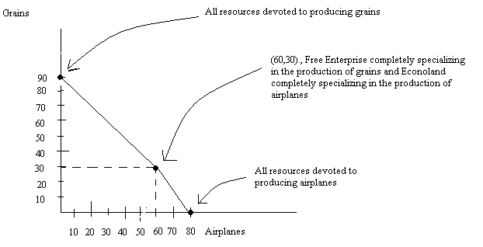

- Write the equations for each segment of the PPF you drew in (k). Make sure you identify the relevant range for each equation you write.

Answer:
For airplane production less than or equal to 60 airplanes, the PPF can be written as G = 90 – A. For airplane production greater than or equal to 60 airplanes, the PPF can be written as G = 120 – (3/2)A.

- Draw a diagram for each of the following scenarios and then make a verbal statement about the effect of the described changes on the market. In your description make sure you discuss shifts and the direction of these shifts, movements, changes in the equilibrium price, and changes in the equilibrium quantity.

  - The market for bicycles is initially in equilibrium. Suppose that the Madison Transit Authority imposes a mandatory usage fee to all bicyclists in Madison.

Answer:
The usage fee is effectively a complementary good to bicycles. When the usage fee increases this causes the quantity demanded of the complementary good to decrease at every price: the demand curve for bicycles shifts to the left. This results in a movement along the supply curve and the equilibrium price and quantity of bicycles decreasing from their initial levels.
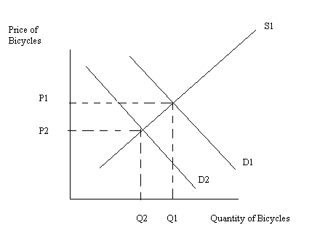

  - Consider the market for petroleum which is initially in equilibrium. Civil unrest erupts in the Middle East, a major production region for petroleum.

Answer:
Civil unrest in the Middle East causes the supply curve for petroleum to shift to the left due to the disruption in production. The impact of the pollution tax is to raise the cost of producing petroleum products for producers of these products: the supply curve will also shift to the left due to this change. The shift in supply causes a movement along the demand curve: the equilibrium price for petroleum will increase and the equilibrium quantity of petroleum will decrease relative to their initial levels.
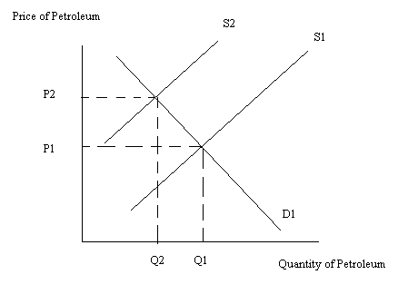
  - Consider the level of aggregate production in an economy. The economy is initially in equilibrium and then, due to a financial bubble, the demand for goods and services in this economy decreases at every price level. At the same time government reacts to consumer pressure to reduce government spending on goods and services.

Answer:
Due to the financial bubble there is a decrease in the demand for goods and services at every price level: this implies that the demand for all goods and services as measured in the aggregate is going to decrease or, in other words, that the demand for aggregate production in this economy will shift to the left. At the same time if the government also reduces its demand for goods and services this will cause an even greater shift to the left of the demand for aggregate production curve in this economy. These shifts will cause a movement along the aggregate supply curve. Relative to the initial level we can expect both the aggregate production level in the economy as well as the aggregate price level in the economy to fall.
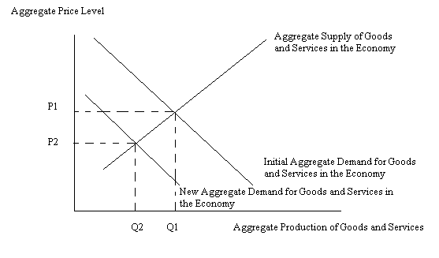
  - Consider the market for brownies which is initially in equilibrium. Suppose that the price of chocolate, a major ingredient in brownies, increases while simultaneously the price of milk, a complementary good to brownies, decreases.

Answer:
The supply curve for brownies will shift to the left due to the increase in the price of chocolate since chocolate is an input in the production of brownies. The demand for brownies will shift to the right due to the decrease in the price of the complementary good, milk. The result of these two shifts is that the equilibrium price of brownies will increase relative to its initial level while the equilibrium quantity is indeterminate. That is, the equilibrium quantity may increase, decrease, or remain the same as the initial equilibrium quantity.
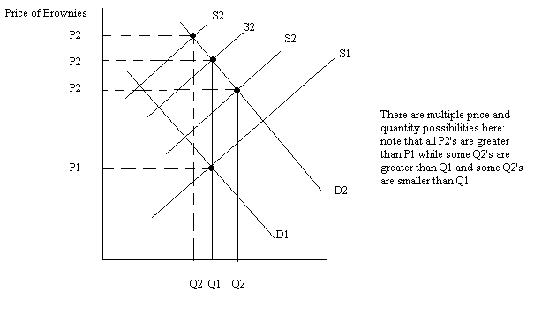

- Consider the small closed economy of Smithville. Smithville produces birdhouses and the domestic demand and domestic supply curves for birdhouses in Smithville are given below.
Domestic Demand for birdhouses: Q = 10 – P
Domestic Supply for birdhouses: Q = P – 2
The world price of birdhouses is $4.

  - Calculate the value of consumer surplus (CS), producer surplus (PS), and total surplus (TS) in the market for birdhouses if Smithville is a closed economy.

Answer:
CS = (1/2)($10 per birdhouse - $6 per birdhouse)(4 birdhouses) = $8
PS = (1/2)($6 per birdhouse - $2 per birdhouse)(4 birdhouses) = $8
TS = CS + PS = $16

  - Calculate the value of consumer surplus (CSopen), producer surplus (PSopen), and total surplus (TSopen) in the market for birdhouses if Smithville is an open economy.

Answer:
CSopen = (1/2)($10 per birdhouse - $4 per birdhouse)(6 birdhouses) = $18
PSopen = (1/2)($4 per birdhouse - $2 per birdhouse)(6 birdhouses) = $2
TSopen = CSopen + PSopen = $20

  - If Smithville is an open economy how many birdhouses will Smithville export or import?

Answer:
At a world price of $4, the quantity of birdhouses domestically demanded in Smithville is equal to 6 birdhouses. At a world price of $4, the quantity of birdhouses domestically supplied in Smithville is equal to 2 birdhouses. The number of birdhouses imported is equal to the quantity demanded domestically minus the quantity supplied domestically, or 4 birdhouses will be imported.

  - Suppose Smithville opens its economy to trade but imposes a tariff of $1 per birdhouse. How many birdhouses will Smithville import or export given this scenario?

Answer:
A tariff of $1 per birdhouse will increase the price of birdhouses from $4 per birdhouse to $5 per birdhouse. At a price of $5, the quantity of birdhouses demanded domestically will equal 5 while the quantity of birdhouses supplied domestically will equal 3. The number of birdhouses imported when there is a $1 tariff per birdhouse is equal to 2 birdhouses.

  - Calculate the value of consumer surplus with the tariff (CStariff), producer surplus with the tariff (PStariff), tariff revenue for the government, and deadweight loss due to the tariff (DWLtariff).

Answer:
CStariff = (1/2)($10 per birdhouse - $5 per birdhouse)(5 birdhouses) = $12.50
PStariff = (1/2)($5 per birdhouse - $2 per birdhouse)(3 birdhouses) = $4.50
Tariff Revenue for the government = ($1 per birdhouse)(2 birdhouses) = $2
DWLtariff = (1/2)($5 per birdhouse - $4 per birdhouse)(3 birdhouses – 2 birdhouses) + (1/2)($5 per birdhouse - $4 per birdhouse)(6 birdhouses – 5 birdhouses) = $1
Note that the sum of CStariff + PStariff + Tariff Revenue + DWLtariff is equal to the sum of TSopen you found in (b).

  - Relative to open trade, will this tariff be politically supported by consumers in Smithville? Explain your answer.

Answer:
No, consumers will not support this tariff since they are better off when there is no tariff but an open economy. Notice that with an open economy they get the good for a lower price, they get more of the good, and their CS is equal to $18. With the tariff they pay a higher price, get less of the good, and their CS is smaller since it is equal to $12.50 with the tariff.

  - Is opening the market for birdhouses to trade in Smithville a good policy move? Discuss your answer.

Answer:
Yes, having an open economy here increases total surplus from $16 to $20.However, opening this market to trade does have distributional consequences: domestic consumers benefit from the market opening to trade while domestic producers are hurt when the market is open to trade.

- Consider the small closed economy of Smithville. Smithville produces birdhouses and the domestic demand and domestic supply curves for birdhouses in Smithville are given below.
Domestic Demand for birdhouses: Q = 10 – P
Domestic Supply for birdhouses: Q = P – 2
The world price of birdhouses is $4. Officials in Smithville have decided to open the birdhouse market to trade while imposing an import quota of 3 units. (Here a unit of birdhouses might be a box of hundreds of birdhouses…don’t worry if you get a fraction of a unit as your answer!)

  - What will be the price of birdhouses in Smithville with this import quota?

Answer:
With the quota we know that the quantity supplied domestically plus the quota must equal the quantity demanded domestically. We can write this as
Qs + quota = Qd
But, we know that Qs = P – 2 and Qd = 10 – P. Furthermore we know that the quota is 3 units. So,
P – 2 + 3 = 10 – P
2P = 9
Pquota = $4.50

  - What will be the total quantity of birdhouses demanded in Smithville with this import quota?

Answer:
Use the demand equation to find out how many birdhouses will be demanded if the price is $4.50. We have Qd = 10 – 4.5 = 5.5 birdhouses.

  - How many birdhouses will domestic producers in Smithville provide to this market?

Answer:
Use the supply equation to find out how many birdhouses will be supplied by domestic producers if the price is $4.50. We have Qs = 4.5 – 2 = 2.5. Note that if you add the 3 birdhouses that are the import quota to Qs you get Qd.

  - What is the deadweight loss due to this import quota?

Answer:
DWLimportquota= (1/2)(4.5 – 4)(2.5 – 2) + (1/2)(4.5 – 4)(6 – 5.5)
DWLimportquota = $.25

  - If the government officials in Smithville wanted to implement a quota that had the same impact on consumer and producer surplus as a tariff of $1, how big would the import quota need to be? (Hint: if you think about this logically you will not need to do any math-provided you answered question #4 in its entirety!)

Answer:
From problem 4 we saw that when the government implements a tariff of $1 per birdhouse this resulted in imports of 3 birdhouses. So, an import quota of 3 birdhouses would have the same impact on CS and PS as a tariff of $1 per birdhouse.

- Suppose that the market for widgets is described by the following demand and supply curves:
Demand: P = 20 – 2Qd
Supply: P = 2Qs

- What is the equilibrium price and quantity given this information?

Answer:
Use the two equations that are given to find the equilibrium.
20 – 2Qe = 2Qe
4Qe = 20
Qe = 5
Pe = 10

Suppose the government decides to limit the production of widgets in this economy by imposing a quantity control of 2 units.

- How much will it cost producers to purchase a permit allowing them to produce the good?

Answer:
Suppliers are willing to supply 2 units when the price is equal to $4 (use the supply curve to get this price suppliers must get to be willing to supply 2 units). Demanders must pay $16 per unit in order to limit their demand to 2 units. This suggests that there is a wedge of $12 between the price consumers must pay and the price that suppliers must receive in order for 2 units to be provided in this market. The permit will cost $12 per widget.

- Given the quantity control, what will the value of consumer surplus be?

Answer:
Consumer surplus will equal (1/2)($20 per widget - $16 per widget)(2widgets) = $4

- Given the quantity control, what will the value of producer surplus be?

Answer:
Producer surplus will equal (1/2)($4 per widget - $0 per widget)(2 widgets) = $4

- Given the quantity control, what will be the government revenue from issuing and selling permits to produce widgets?

Answer:
Government revenue from the quantity control = ($12 per widget)(2 widgets) = $24

- Given the quantity control, what will the deadweight loss from this program be?

Answer:
DWL from the quantity control = (1/2)($16 per widget - $4 per widget)(5 widgets – 2 widgets) = $18

- Does the sum of government revenue from the quantity control + producer surplus from the quantity control + consumer surplus from the quantity control + deadweight loss from the quantity control equal total surplus prior to the imposition of this program by the government?

Answer:
Yes, in both cases these two sums equal $50.

