Economics 102
Spring 2009
Homework 2
Due 2/9/2009

Directions: The homework will be collected by your TA in a box before the lecture. Please make sure you know your TA name so that you can place your homework in the correct box. Please place your name, TA name and section number on top of the homework (legibly). Make sure you write your name as it appears on your ID so that you can receive the correct grade. Please remember the section number for the section you are registered, because you will need that number when you submit exams and homework. Late homework will not be accepted so make plans ahead of time. Good luck!

(1) Consider two firms, Hot Wheels and Biaggio, that produce bicycles and mopeds. You know that the plants of Hot Wheels produce 100 bicycles and 0 mopeds or 50 mopeds and 0 bicycles every month (or any combinations of these two goods that lie on the line between these two points) while the plants of Biaggio produce 150 bicycles and 0 mopeds or 150 mopeds and 0 bicycles every month (or any combinations of these two goods that lie on the line between these two points). For this problem assume that both firms have linear PPFs.

- What is the opportunity cost of producing one moped for the Hot Wheels firm? What is the opportunity cost of producing one moped for the Biaggio firm?
A: the opportunity cost of producing one moped is 2 bicycles for HW; the opportunity cost of producing one moped is 1 bicycle for Biaggio.

- Suppose that both Hot Wheels and Biaggio decide to specialize in the production of one of these goods, buying from the other company the good not produced. Do they gain from this agreement? Why?
A: Yes, specialization according to comparative advantage and then trade based on this will enable these two firms to jointly produce more mopeds and bicycles than in “autarky” (i.e., a situation in which there is no trade) as the theory of comparative advantage tells us.

- What would be the price range for a bicycle (in terms of mopeds) that the two firms would accept?
A: The opportunity cost of one bicycle is 1/2 moped for HW, while for Biaggio the opportunity cost of one bicycle is 1 moped. The trading range for one bicycle will fall between ½ moped and 1 moped.

Suppose that the two firms decide to merge and their new CEO hires you to decide how the new company should allocate production.

- What would you suggest to the CEO? Draw a graph of the two firms’ PPFs to convince him (put mopeds on the x-axis).
A: the graph:
50
150
100
150
Biaggio
HW
bicycles
mopeds
The CEO should allocate all the production of mopeds at Biaggio and all the production of bicycles to the plants of HW.

- Assume nothing has changed HW’s PPF. What production plan would you suggest if Biaggio plants were able to produce either 200 bicycles and 0 mopeds or 150 mopeds and 0 bicycles per month (assume Biaggio maintains its linear PPF)? Would your answer change if Biaggio could produce 300 bicycles and 0 mopeds or 150 mopeds and 0 bicycles (assume a linear PPF connecting these two points)? Explain your answer?
A: If Biaggio plants can produce either 200 bicycles and 0 mopeds or 150 mopeds and 0 bicycles the answer does not change: Biaggio should use all of its resources to produce mopeds while HW uses its resources to produce bicycles. If Biaggio can produce either 300 bicycles or 0 mopeds or 150 mopeds and 0 bicycles then its opportunity cost of production for each good will be the same as HW’s opportunity cost of production for each of the goods. There are no gains to be had through specialization and trade since both firms have the same opportunity cost for producing mopeds and bicycles.

(2) You and your friend Jack work at a restaurant. Your boss Paul Krugman has to decide who sets the tables and who has to wash dishes. Jack can wash 60 dishes in one hour or set 30 tables, you are new with this job and if you work hard you can wash 10 dishes or set 20 tables.

- What will Paul Krugman ask you to do? Use opportunity cost to explain your answer and illustrate your answer by drawing a graph to explain the choice Paul makes. In your graph measure washed dishes on the x-axis and tables set on the y-axis.
A: the graph:
10
60
20
30
Jack
Me
tables
dishes
The opportunity cost of 1 washed dish is 1/2 table set for Jack while the opportunity cost of 1 washed dish is 2 tables set for me: Jack has the lower opportunity cost for washing dishes and he will therefore wash dishes while I set tables.

- Suppose that you prefer washing dishes. Assume your ability to set tables does not change. In order for Paul to assign you the task of dishwashing, must you be able to wash as many dishes per hour as Jack? In order for Paul to assign you this task, what is the minimum amount of dishes you must be able to wash per hour? Explain your answer.

A: I do not need to be able to wash as many dishes as Jack because what matters is the opportunity cost. If I wash 40 dishes, my opportunity cost of 1 washed dish is ½ a table, the same as Jack. Therefore as long as I can wash more than 40 dishes per hour Paul Krugman will ask me to wash dishes.

(3) For the next question recall that shifts in the demand curve are caused by:
- Changes in the price of a related good
- Changes in income
- Changes in tastes
- Changes in expectations
Shift in the supply curve are caused by:
- Changes in input prices
- Changes in technology
- Changes in expectations

Consider the equilibrium price and equilibrium quantity of tickets for UW students to see the University of Wisconsin Basketball Team. For this question assume that student tickets to see the UW Basketball team play are a normal good. For each of the following events, explain:
- If it causes a supply curve and/or a demand curve shift;
- Why the supply/demand shifts; and
- If it leads to indeterminacy in equilibrium prices and/or in quantities.
Justify your answers.

- A rise in the price of tickets to see a football match
A: It’s a change in the price of a related good, and it increases the demand for basketball tickets. Equilibrium quantity and equilibrium price increase.

- An increase in university fees
A: This reduces the level of discretionary income available to students and assuming UW basketball tickets are a normal good this will cause the demand curve for basketball tickets to shift to the left: equilibrium price and equilibrium quantity decrease.

- The beautiful UWM campus starts to attract better basketball players from all over the country.

A: The increase in the quality of players leads to an expectation that the team will be better due to the effect of these better players. Thus, the demand curve shifts to the right: the equilibrium price and quantity will increase.

- An increase in the price of electricity
A: An increase in the price of electricity is an increase in input prices and this will cause the supply curve to shift to the left: the equilibrium price will increase while the equilibrium quantity will decrease.

- The new coach is Michael Jordan and Warren Buffet donates to the UWM a new bigger basketball stadium.
A: The hiring of Michael Jordan raises expectations on the demand side and will cause the demand curve for basketball tickets to shift to the right. The building of a new stadium (at no cost for UW) will allow UW to sell more seats to the games: this will cause the supply curve to shift to the right. Therefore the equilibrium quantity will be higher wile the effect on equilibrium price is indeterminate.

(4) The following figure shows the domestic market for ethanol in the Micronesia, a small closed economy.
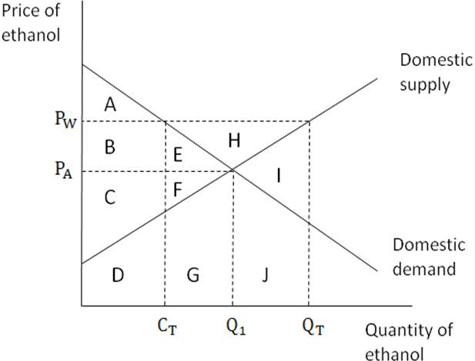
- When the Micronesia economy is closed to trade (referred to as “autarky”) the price of ethanol in Micronesia is. Assume that the world price for ethanol is . What area(s) on the above graph represent the value of consumer surplus in Micronesia if Micronesia is an autarky?
- What area(s) on the above graph represent the value of producer surplus in Micronesia if Micronesia is an autarky?
- If Micronesia opens to trade, then what area(s) would represent the value of consumer surplus and producer surplus in Micronesia once it was open to trade?
- What is the net gain to total surplus (measured by the area(s) in the above graph) if Micronesia opens its ethanol market to trade?

(5) For this problem assume that Madison is like a small, closed economy with regard to the market for calcium chloride. Suppose the domestic demand and supply curve for calcium chloride in Madison is:
Q_{d} = 10 – P_{d}
Q_{s} = P_{s} - 2
- Draw the domestic supply and the domestic demand curves and find the equilibrium price and quantity in the market for calcium chloride.
- Calculate the value of consumer surplus and producer surplus in the market for calcium chloride in Madison.
Suppose that this year heavy snowfalls are expected in Madison. The mayor of Madison decides to import calcium chloride to augment the domestic supply of the good. Suppose the world price of calcium chloride is $20 per unit.
c) Calculate the value of consumer and producer surplus once Madison opens its market for calcium chloride.
d) What is the net gain to total surplus when the City of Madison opens its market to trade in calcium choride?
Now, suppose that the government decides to levy a tariff of $10 on each unit of calcium chloride that is imported into Madison.
e) How many units of calcium chloride will be imported into Madison once this tariff is imposed?
f) Given this tariff, calculate the values of consumer surplus, producer surplus, government revenue, and the deadweight loss due to the tariff.
Answers
4.
(a) When the Micronesia economy is in an autarky, the price of ethanol in Micronesia is , and would be exchanged. Thus, consumer surplus would be A+B+E.
(b) Since the equilibrium price and quantity are and , the corresponding producer surplus would be C+F.
(c) If the market is opend to trade and the world price of ethanol is , the price in the domestic market will rise to . Domestic producers will sell units of ethanol, domestic consumers will purchase, and the difference between and will be the volume of exported ethanol. At, consumers will only have a surplus of A; producer surplus will increase to B+C+E+F+H.
(d) Without trade, the sum of consumer and producer surplus is A+B+C+E+F. With trade, the sum of consumer and producer surplus becomes A+B+C+E+F+H. Thus, the net gain to total surplus would be H.
5.
(a)
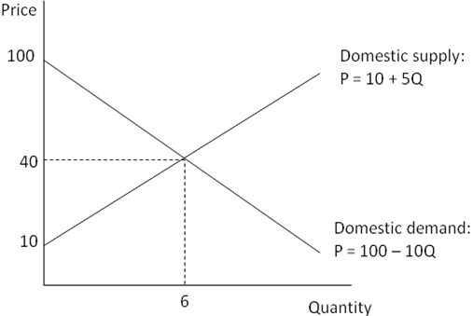
The equilibrium price and quantity are P=40, Q=6, respectively.
(b) Consumer surplus and producer surplus can be calculated as follows:
CS = the area of triangle {(6,40), (0,40), (0,100)} =
PS = the area of triangle {(6,40), (0,10), (0,40)} =
(c)
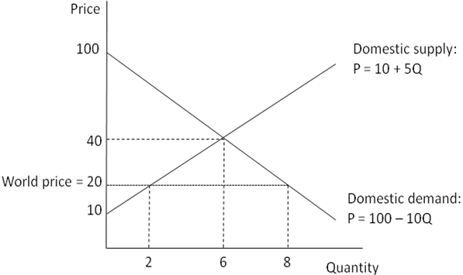
If the market is opened to trade and the world price of calcium chloride is $20 per unit, the price in the domestic market will fall to $20 per unit. Domestic producers will sell 2 units of calcium chloride, domestic consumers will purchase 8 units, and the difference between the two, 6, represents the volume of imported calcium chloride. Consumer surplus and producer surplus can be calculated as follows:
CS with trade = the area of triangle {(8,20), (0,20), (0,100)} =
PS with trade = the area of triangle {(2,20), (0,10), (0,20)} =
(d) Net gain in total surplus due to trade = (320 + 10) – (180 – 90) = $60
(e)
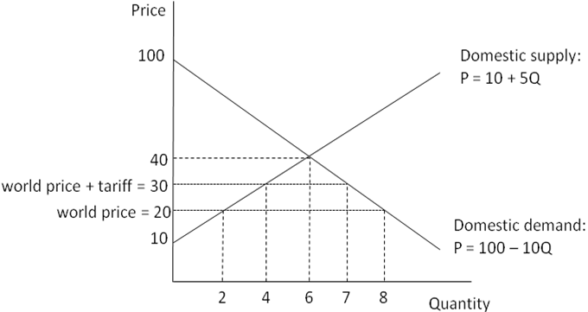
A tariff will increase the price of the good received by the producers and paid by the consumers while decreasing imports. When the govenment levies the tariff, the price of calcium chloride rises to $30 per unit from $20; before the tariff, imports equaed 8 – 2 = 6, and imports fell to 7 – 4 = 3 after the imposition of the tariff.
(f) Consumers are worse off because of the tariff; CS w/ tariff =. Producers are better off; PS w/ tariff =. The government raises 3 in revenue from the tariff. Deadweight loss due to the tariff equals to $15.

