Economics 102
Spring 2006
Answers to Homework #1

1. Substitute x = 4 into y = ½ x-1. This shows y=1 so the desired line passes through (4,1). Similarly, using the second equation, the line passes through (6,4). So the slope of our line is

∆y/∆x = 3/2

The y-intercept, b, can be found by entering a point into the equation y = 3/2 x +b

1 = (3/2)*4 + b
b = -5

So the solution is y = 3/2 x – 5

2. a. positive b. positive c. normative

3. Glock should specialize in guns because their opportunity cost of producing guns is less than the Crock’s opportunity cost of producing guns. Glock has a comparative advantage in producing guns. Similarly, the country of Crock should specialize in butter since they have a comparative advantage in producing butter.

4. a. 5, 1/5 b. 4, ¼
c. Wisconsin has a comparative advantage in reducing pollution. Michigan has a comparative advantage in eliminating mussels.
d. Michigan has an absolute advantage in both eliminating mussels and reducing pollution.
e. Wisconsin should specialize in reducing pollution and Michigan should specialize in eliminating mussels.

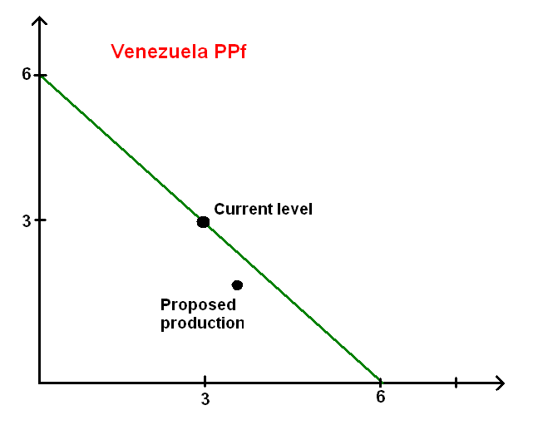
US level of oil production
Oil
(Millions of Barrels)
Coffee
(100,000
pounds)

5. a. See above graph
b. No, according to the model, Venezuela can only produce 6 million barrels.
c. The propose level is feasible, yet inefficient since it is a point interior to the production possibility frontier.
d. The two products do not use the same equipment and skills. The opportunity cost of producing oil would go up as more oil is produced.

