Economics 101 Name __________________
Summer 2008
Answers to Quiz #1
5/28/08 Discussion Section Day and Time _____________

1. For each of the following equations find the requested information.

a. (.2 points) P = 10 – 100 W where W is the variable measured on the y-axis.

Slope = ______(-1/100) or (-.01)________

Y- Intercept = ___(1/10 or (.1)______

b. (.2 points) Q = 20 + (1/2)R where Q is the variable measured on the y-axis.

Slope = ______(1/2) or (.5)________

X- Intercept = ____(-40) ______

c. (.2 points) M = 15 – (1/3) J where J is the variable measured on the y-axis.

Slope = _______(-3)________

Y – Intercept = _____(45)____

2. The production possibility frontier (PPF) for Vidalia is drawn in the graph below. Vidalia produces only two types of goods: bicycles and onions. This PPF is drawn holding resources, technology and time constant. Vidalia’s PPF is linear between each point labeled on the graph.
Onions 1000
950

800

500
50 100 150 200 Bicycles
BA
CB
D
E
A
a. (.2 point) The opportunity cost of producing 50 bicycles when Vidalia is currently producing 1000 onions equals _______________50 onions__________________ (provide a unit of measurement as well as a number).
b. (.2 point) The opportunity cost of producing one additional bicycle when Vidalia is currently producing 950 onions equals __________________3 onions_______________ (provide a unit of measurement as well as a number).
c. (.2 point) The opportunity cost of producing one additional onion when Vidalia is currently producing 150 bicycles equals _______________(1/6) bicycle______________ (provide a unit of measurement as well as a number).
d. (.2 point) The Law of Increasing Opportunity Cost means that the opportunity cost of producing one more bicycle increases as you move down the PPF. (Circle your answer.)
i. True
ii. False
e. (.2 point) The Law of Increasing Opportunity Cost means that the opportunity cost of producing one more onion decreases as you move up the PPF. (Circle your answer.)
i. True
ii. False

3. Suppose Tom and Mary are the only two individuals living in Bananaville. Tom and Mary both produce bananas and fish and currently they do not trade with one another. Tom and Mary use only labor to produce bananas and fish and they have equivalent amounts of labor available to use in the production of these two goods. Tom and Mary’s current production is given in the table below. Assume Tom and Mary’s production possibility frontiers are both linear.
CURRENT PRODUCTION | Bananas | Fish
Tom | 10 | 20
Mary | 20 | 25
Total Production | 30 | 45
In addition you are given the following information about the number of hours of labor Tom and Mary use to produce one banana or one fish.
 | Hours of Labor Used to Produce One Banana | Hours of Labor Used to Produce One Fish
Tom | 10 | 5
Mary | 5 | 4

a. (.1 point) Given the above information, who has the absolute advantage in producing bananas? ____________Mary________________
b. (.1 point) Given the above information, who has the absolute advantage in producing fish? ______________Mary______________
c. ( .1 points) What is the total amount of labor available to Tom? ______200 hours_____ (provide a unit of measurement with your numeric answer)
d. (.4 points) In the space below draw two graphs. In the first graph draw Tom’s PPF and in the second graph draw Mary’s PPF. Label each graph: “Tom’s PPF” and “Mary’s PPF”, respectively. In your graph label the vertical axis “Bananas” and the horizontal axis “Fish”. Indicate on your graphs the numeric values for the y-intercepts and the x-intercepts.
Answer: Split points between the two graphs and look for labeling and accurate location of the PPF.
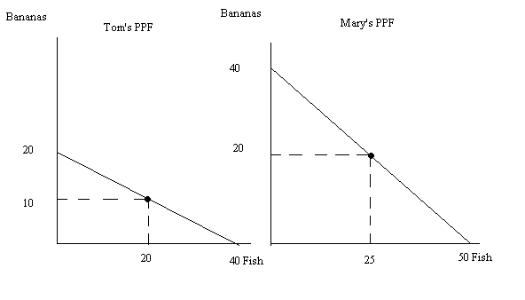

e. (.2 points) Who has the comparative advantage in the production of bananas? _______Mary________

