Practice Questions 3 - Answers
Fall 2003
Econ 101

1. In a market economy, who determines the price and quantity demanded of goods and services that are sold?
a. Consumers
b. The Government
c. Producers
d. Both consumers and producers
e. None of the above
Answer: d. In a market economy producers and consumers interact to determine what the equilibrium price and quantity will be.

2. If a good is “inferior” then a decrease in income will result in:
a. an increase in the demand for the good
b. a decrease in the demand for the good
c. a higher market price
d. a lower market price
e. a lower demand for complementary goods
Answer: a. If a good is inferior then it is negatively related to income, so if income decreases demand will increase.

3. Suppose a decrease in the price of good X leads to more of good Y being sold. Then X and Y are:
a. Substitutes
b. Complements
c. Normal Goods
d. Inferior Goods
e. Unrelated Goods
Answer: b. A decrease in the price of a complementary good will result in more of the complement being demanded and also increase the demand for the good itself.

4. The law of demand tells us that:
a. when price falls, quantity demanded rises
b. when price falls, quantity demanded falls
c. when price rises, quantity demanded rises
d. when price rises, quantity demanded falls
e. both a and d satisfy the law of demand
Answer: e. According to the law of demand, an increase (decrease) in the price of the good will reduce (increase the quantity demanded.

5. Which of these would not cause a shift in the demand curve for a good or service?
a. A change in the price of a substitute good
b. A change in tastes towards the good
c. An increase in population
d. A decrease in the price of the good
e. A change in expectations regarding prices
Answer: d. A change in the price of the good will cause a movement along the demand curve, whereas all the other factors will result in shifts in the demand curve.

6. Consider the following table of demands for Potatoes by Paddy, Sean and Seamus.

Price, $ | Paddy | Sean | Seamus | Market
0 | 12 | 7 | 2 | 21
1 | 10 | 6 | 2 | 18
2 | 8 | 5 | 2 | 15
3 | 6 | 4 | 2 | 12
4 | 4 | 3 | 2 | 9
5 | 2 | 2 | 2 | 6
6 | 0 | 1 | 2 | 3
- Use the data above to plot the demand curve for each person individually. Is there something unusual about the shape of Seamus’ demand curve?
- Find the market demand curve (horizontally sum the individual demand curves).
- Find the expressions for all the individual and market demand equations over a price range from 0 to 6.
Answer: a. The individual demand curves are given below. Seamus’ demand is “perfectly inelastic”. This means he demands the same amount no matter what the price is. 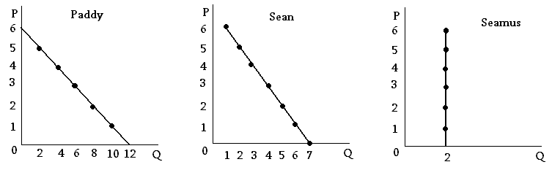
b. The market demand is given in the table above. Horizontally summing the individual demand curves gives the linear relationship shown below.
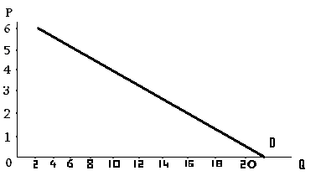
c. As in Problem Set 1, use any two price/quantity combinations to calculate the slope, and then use one of those points to get the equation of the demand curve over the range P=[0,6]. For Paddy:
Let (x₁,y₁) =(Q₁,P₁) = (12,0) and (x₂,y₂) = =(Q₂,P₂) = (0,6)
m = (y₂ – y₁)/(x₂-x₁) = (6-0)/(0-12) = -1/2
Then use the formula y= mx + b with (x,y)= (Q,P) = (0,6).
So,P=-1/2Q+b and b = 6
Then our demand equation is P = -1/2 Q_{d} + 6 so solving fordemand we get Q_{d} = 12 – 2P
Similar calculations yield: Sean: Q_{d} = 7 –P
Seamus: Q_{d} = 2
Market: Q_{d} = 21 – 3P
7. Consider the following data regarding the market for pizzas.
Price $ | Qty Dem | Qty Sup
0 | 20 | 5
1 | 18 | 8
2 | 16 | 11
3 | 14 | 14
4 | 12 | 17
5 | 10 | 20
6 | 8 | 23
- Given the information above, find the equation for the demand and supply curves.
- Plot the Demand and Supply curves and find the point of intersection graphically.
- Suppose the price is currently $4. Explain in words what you expect to happen to price.
- Suppose the price is currently $2. Explain in words what you expect to happen to price.
- Suppose that the demand and supply equations change to :
Q_{d} = 20 – 4P Q_{s} = 5 + P
What is the new equilibrium?

Answer: a. First consider demand. We can use any two price/quantity observations to calculate the slope Let (x₁,y₁) =(Q₁,P₁) = (20,0) and (x₂,y₂) = =(Q₂,P₂) = (8,6)
m = (y₂ – y₁)/(x₂-x₁) = (6-0)/(8-20) = -1/2
Then use the formula y= mx + b with (x,y)= (Q,P) = (20,0).
So,P=-1/2Q+b and b = 10.
Then our demand equation is P = -1/2 Q_{d} + 10 so solving for demand we get Q_{d} = 20 – 2P

Similarly for the supply curve, Let (x₁,y₁) =(Q₁,P₁) = (5,0) and (x₂,y₂) = =(Q₂,P₂) = (23,6)
m = (y₂ – y₁)/(x₂-x₁) = (6-0)/(23-5) =6/18 =1/3
Then use the formula y= mx + b with (x,y)= (Q,P) = (5,0).
So,P=1/3Q+b and b = -5/3
Then our supply equation is P = 1/3 Q_{s} – 5/3 so solving for supply we get Q_{s} = 3P + 5
b. From the graph, the equilibrium is at P=3, Q_{d} = Q_{s} =14
To find this algebraically, we set Q_{d} = Q_{s} to get 20-2P = 3P+5 so that 5P=15 and P=3. Then Q_{d} = Q_{s} =14.
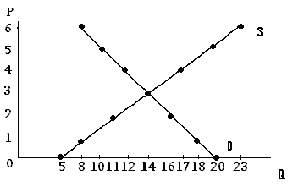
c. If P=4 then we have excess supply, which will put downward pressure on prices.
d. If P=2 then we have excess demand, which will put upward pressure on prices.
e. Our new equations are: Q_{d} = 20 – 4P
Q_{s} = 5 + P
To find the equilibrium, we set Q_{d} = Q_{s} to get P=3 once again, but now Q_{d} = Q_{s} =8.

8. Consider the supply of Pizza. Which of the following will cause a movement along the supply curve?
a. An increase in the price of cheese
b. A decrease in the price of cheese
c. An increase in the price of pizza
d. An increase in the number of pizza sellers
e. An improvement in pizza making technology

Answer: c. All of the others will cause a shift in the supply curve

9. Use a diagram to illustrate the difference between the concepts of a change in supply and a change in quantity supplied. Explain whether each of the following will change supply or quantity supplied.
a. An increase in the number of sellers
b. A decrease in the price of inputs
c. An improvement in technology
d. A change in the price of the good
e. A change in producer expectations
Answer: Only d will result in a change in quantity supplied (a movement along the supply curve), all the other factors lead to a change in supply (a shift in the supply curve).

10. What would happen to the equilibrium price and quantity of bread if the price of wheat goes up, fewer firms decide to produce wheat, it is proven that eating bread makes you live longer and also the price of butter (a complementary good) decreases?
a. Price will increase and the effect on Quantity is ambiguous
b. Price will fall and the effect on Quantity is ambiguous
c. Quantity will increase and the effect on Price is ambiguous
d. Quantity will fall and the effect on Price is ambiguous
e. The overall effect on both Price and Quantity is ambiguous
Answer: a. All of these factors will put upward pressure on prices. However, the effect on total quantity in the market is ambiguous since some factors will increase quantity while others will decrease it.

11.Everybody loves Potato Chips. Illustrate the effects of each of the following changes using a separate qualitative graph for each.
- The income of everybody in the economy increases (assume potato chips are a normal good)
- The price of dip increases
- A potato famine destroys the crop
- The government announces that potato chips cure cancer
- A new fertilizer increases the potato crop and the population of the economy increases
- There is a potato famine and the government announces that potato chips cure cancer
