Practice Questions 7
Fall 2003
Econ 101
1. Match the following:
a. Excludable and rival. 1. Common resources.
b. Excludable but not rival. 2. Public goods.
c. Rival but not excludable. 3. Natural monopolies.
d. Neither excludable nor rival. 4. Private goods.
ANSWER: a-4, b-3, c-1, d-2.
2. Too few resources are devoted to the creation of knowledge because profit-seeking firms
1. undervalue knowledge in their pursuit of revenues.
2. abuse their patents.
3. tend to free-ride on the knowledge that others have developed.
4. tend to rely on existing employee knowledge.
5. tend to ignore possible positive externalities due to their research.
Which of the above statements are correct? Statement(s)
a. 1 and 3.
b. 2, 3 and 5.
c. 3 and 5.
d. 3, 4 and 5.
e. All of the above.
ANSWER: c.
3. In determining an optimal pricing scheme for a public good we need to have individuals reveal their preferences. In addition, we would need to know the
a. number of beneficiaries.
b. value of external benefits which accrue to resource owners.
c. whether the good is excludable or not.
d. All of the above are correct.
e. Both a and c are correct.
ANSWER: e. Both a and c are correct.
4. Suppose that Martin owns a lighthouse and Lewis owns a nearby port. Martin’s lighthouse benefits only those ships that enter Lewis’s port. Which of the following statements is FALSE?
a. Martin’s lighthouse may be considered a private good.
b. Martin can combat the free-rider problem by charging Lewis a usage fee.
c. Martin can exclude Lewis’s port from benefiting from the lighthouse by simply turning the power off.
d. Martin’s lighthouse would be considered a common resource.
Now, suppose that nobody owns the port. Analyze each of the above statements in light of this change.
ANSWER: d. Martin’s lighthouse would be considered a common resource is a false statement.
5. Suppose that you want to put on a fireworks display in your hometown of 1,000 people this July. The cost of the display is $6,000 and each person values the display at $5. After a month, you have only sold 50 tickets at $5 each. The result is
a. the local government will put on the display but you will not.
b. you will still put on the display but the local government would not.
c. neither you nor the local government would put on the display.
d. either you or the local government can put on the display.
e. This question cannot be answered without knowing the amount of tax the local government would charge for the display.
ANSWER: c. neither you nor the local government would put on the display because people value the display at $5,000 while the cost is $6,000. Since the cost exceeds the benefit neither you nor the local government will sponsor the fireworks.
6. The following are data on Ted's, Kate's and Ben's quantity demanded from a pure public good.
Price | Quantity Demanded by
Price | Ted | Kate | Ben
3 | 0 | 0 | 0
2 | 2 | 0 | 0
1 | 4 | 3 | 0
0 | 6 | 6 | 6
The supply curve for the public good is given by the following equation:
P = 0.5Qs + 3.
a. Plot each of these demand curves and use this information to plot the public’s total willingness to pay for this public good.
b. Given the public’s willingness to pay, what is the efficient level of production for the public good?
c. What price will Ted, Kate and Ben each pay for the public good?
ANSWER:
a. The public’s total willingness to pay for this public good is $4 (See diagram)
b. The efficient level of production is equal to 2.
c. The following are the equations for quantity demanded by:
Ted: P_{t} = -(1/2)Q + 3
Kate: P_{k} = -(1/3)Q + 2
Ben: P_{b} = -(1/6)Q + 1
So, the public’s total willingness to pay for the public good is:
P_{m} = P_{t} + P_{k} + P_{b} = -(1/2)Q + 3 - (1/3)Q + 2 -(1/6)Q + 1 = -Q + 6.
Equating the public’s total willingness to pay to the market supply we get the efficient outcome equals to 2 units. Government can generate $4x2 = $8 required to buy 2 units of the public good by taxing in the following manner:
Tax collected from Ted = Willingness to pay 2 units*2=$2*2=$4
Tax collected from Kate = Willingness to pay 2 units*2=$1.333*2 = $2.67
Tax collected from Ben = Willingness to pay 2 units*2=$0.666*2 = $1.33
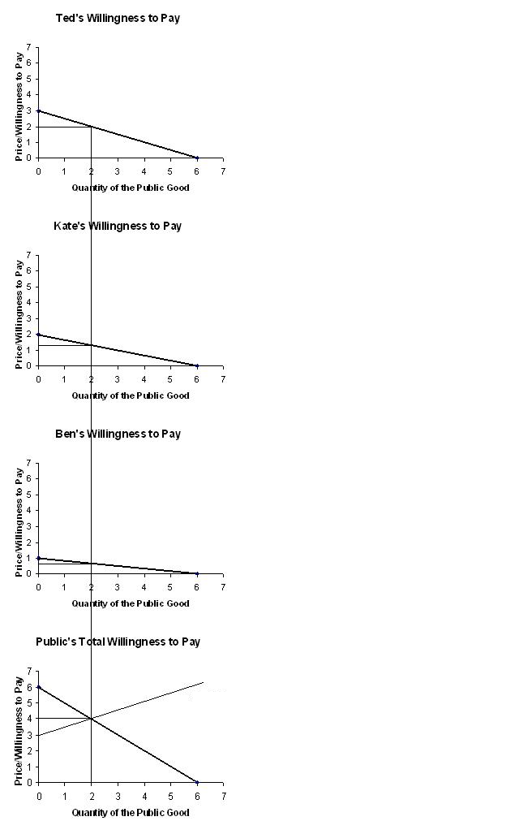
7. Deadweight losses occur in markets in which
a. firms decide to downsize.
b. the government imposes a tax.
c. profits fall because of low consumer demand.
d. equilibrium price rises, causing a loss in consumer surplus.
e. supply curve shifts leftward due to increase in the cost of inputs.
ANSWER: b. the government imposes a tax.

8. A typical person in the U.S. pays 4% of income in a state income tax and 15.3% of income in federal payroll taxes. Federal income taxes are paid as in the following table:
Income | Tax Rate
Up to $27,050 | 15.0%
From $27,050 to $65,550 | 27.5%
a. How much of each type do you pay if you earn $20,000 a year?
b. Taking all taxes into account, what are your average and marginal tax rates?
c. What happens to your tax bill and to your average and marginal tax rates if your income rises to $40,000?
ANSWER:
a. If you earn $20,000 a year, then you pay $20,000 x 0.15 = $3,000 in federal income taxes, $20,000 x 0.153 = $3,060 in federal payroll taxes, and $20,000 x 0.04 = $800 in state income taxes, for a total tax bill of $6,860.
b. Your average tax rate is $6,860/$20,000 = 0.343 = 34.3 percent. Your marginal tax rate is 0.15 + 0.153 + 0.04 = 0.343 = 34.3 percent.
c. If you earn $40,000 a year, then you pay federal income taxes in two parts: 15 percent on the first $27,050 of income and 27.5 percent on the amount above $27,050, so your federal income taxes are $27,050 x 0.15 = $4,057.50 plus $12,950 x 0.275= $3,561.25, for a total of $7,618.75 in federal income taxes. You also pay $40,000 x 0.153 = $6,120 in federal payroll taxes, and $40,000 x 0.04 = $1,600 in state income taxes. Your total tax bill is $15,338.75. Your average tax rate is $15,338.75/$40,000 = 0.383 = 38.3 percent. Your marginal tax rate is 0.275 + 0.153 + 0.04 = 0.468 = 46.8 percent.

9. Economists normally assume that the goal of a firm is to
(i) sell as much of their product as possible.
(ii) set the price of their product as high as possible.
(iii) maximize profit.
(iv) maximize total revenue.
a. (i) and (ii)
b. (ii) and (iii)
c. (iii) only
d. (iv) only
e. All of the above are correct.
ANSWER: c. (iii) only.
10. Which of the following is an implicit cost?
(i) the owner of a firm forgoing an opportunity to earn a large salary working for a Wall Street brokerage firm
(ii) interest paid on the firm’s debt
(iii) rent paid by the firm to lease office space
(iv) the opportunity cost of investment
a. (ii) and (iii)
b. (i) and (iii)
c. (i) only
d. (i) and (iv)
e. All of the above are correct.
ANSWER: d. (i) and (iv).

