Economics 101 Name _____________________________
Spring 2011 TA Name _________________________
3/3/11 Discussion Section #_________________
Second Midterm Student ID # _______________________

Version 1

DO NOT BEGIN WORKING UNTIL THE INSTRUCTOR TELLS YOU TO DO SO
READ THESE INSTRUCTIONS FIRST.

You have 75 minutes to complete the exam. The exam consists of 30 multiple choice questions. Each question is worth 10/3 points for a total of 100 points.
- We reserve the right to deduct four points for failing to fill out the scantron completely and accurately and the exam booklet completely and accurately!
- Answer all questions on the scantron sheet with a #2 pencil

NO CELL PHONES, CALCULATORS, OR FORMULA SHEETS ARE ALLOWED.
PICK THE BEST ANSWER FOR EACH QUESTION.

How to fill in the scantron sheet:
- Print your last name, first name, and middle initial in the spaces marked "Last Name," "First Name," and "MI." Fill in the corresponding bubbles below.
- Print your student ID number in the space marked "Identification Number." Fill in the bubbles.
- Write the number of the discussion section you’ve been attending under "Special Codes" spaces ABC, and fill in the bubbles. You can find the discussion numbers below on this page.
- Write the version number of your exam booklet under "Special Codes" space D, and fill in the bubble. The version number is on the top of this page.

If there is an error on the exam or you do not understand something, make a note on your exam booklet and the issue will be addressed AFTER the examination is complete. No questions regarding the exam can be addressed while the exam is being administered.

When you are finished, please get up quietly and bring your scantron sheet and this exam booklet to the place indicated by the instructors.

Discussion sections are as follows:

Irina Merkuryeva | Patricia Abbott | Ryan Veiga | Yi Li
Dis 386 Th 16:35 | Dis 382 Fr 07:45 | Dis 384 Th 16:35 | Dis 385 Fr 07:45
Dis 388 Fr 11:00 | Dis 383 Fr 09:55 | Dis 389 Fr 11:00 | Dis 387 Fr 08:50
Dis 390 Fr 08:50 | Dis 393 Fr 12:05 | Dis 391 Fr 09:55
Dis 392 Fr 12:05 |  | Dis 394 Fr 13:20

Work Sheet

I, __________________________________, agree to neither give nor receive any help on this exam from other students. Furthermore, I understand that use of a calculator is an academic misconduct violation on this exam.
Signed ____________________________________

- In which of the following scenarios will it be impossible to say how the quantity traded will change?
  - The quantity demanded increases a little at every price, but at every price the quantity supplied decreases by a lot.
  - The quantity demanded decreases at every price while the quantity supplied increases at every price, but no one knows how much either curve changes.
  - The quantity demanded and the quantity supplied both increase at every price by a lot.
  - The quantity demanded and the quantity supplied decreases at every price but the decrease for both curves is of an unknown amount.
  - The quantity demanded decreases by a little at every price while the quantity supplied increases by a lot at every price.

- Consider the market for Tuna fish. Which of the following scenarios will likely result in a decrease in the quantity traded, but an indeterminate change in price?
  - A well-published study makes the general public concerned about the environmental impact of over-fishing, and the government starts restricting the number of fishing vessels.
  - Salmon becomes relatively more expensive, and many Tuna fishermen decide to fish for salmon instead.
  - Sushi (a Japanese raw fish delicacy) starts to lose popularity, to the great misfortune of several companies that are currently opening up a large number of new Tuna farms.
  - Answers (a) and (c) are both correct.
  - Answers (a), (b) and (c) are all correct.

- In a particular market, price increases while at the same time the quantity of the good traded decreases. Assuming the market is in equilibrium then this change in the equilibrium price and quantity is most likely due to
  - A shift in the supply curve.
  - A movement along the supply curve.
  - A shift in the demand curve.
  - A shift in both the demand and supply curves to the right.

- A firm’s supply curve is given by P = (1/2)Q + 5. Assume a new technology allows them to double their output at any given price. What will be their new supply curve?
  - Q = 4P - 20
  - Q = 4P – 10
  - Q= (1/4)P – 2.5
  - Q = (1/4)P + 20
  - Q = (1/4) P – 10

- Suppose the supply curve for a firm is given by P = (1/2) Q + 5. A corrupt government official decides to require an unnecessary “quality inspection” surcharge of $5 on every unit sold. The new supply curve will be:
  - P = (1/10) Q + 5
  - P = (5/2) Q + 5
  - P = 2.5 Q + 10
  - P = (1/2) Q
  - P= (1/2) Q +10

Use the following information to answer the next three (3) questions.

Assume the market for corn has the following demand and supply curves:
Demand: P = 20-2Q
Supply: P = 3Q

- Assume the government wants to maintain a price of $18 per unit of corn. Suppose the government decides to do this by buying corn. How many units of corn will the government have to buy?
  - 3 units of corn
  - 5 units of corn
  - 6 units of corn
  - 1 units of corn
  - 4 units of corn

- Suppose the government decides instead to lower the price of corn by means of a subsidy for corn producers. If it gives businesses $5 per unit of corn they produce, how much corn will be traded in this market?
  - 3 units of corn
  - 4 units of corn
  - 5 units of corn
  - 6 units of corn
  - 7 units of corn

- As a third possible policy, the government commits to buying 2.5 units of corn regardless of the price, how much money will this policy cost the government? Assume that there are no storage costs to the government.
  - $22.50
  - $11.25
  - $42.50
  - $37.50
  - $8.75

- Suppose the demand for donuts is linear. When donuts cost $2 each, 20 are purchased and the elasticity of demand is 1. Given this information, the slope of this demand curve is:
  - 1/10
  - -20
  - -10
  - -1/10

Refer to the following graph to answer the next two (2) questions:

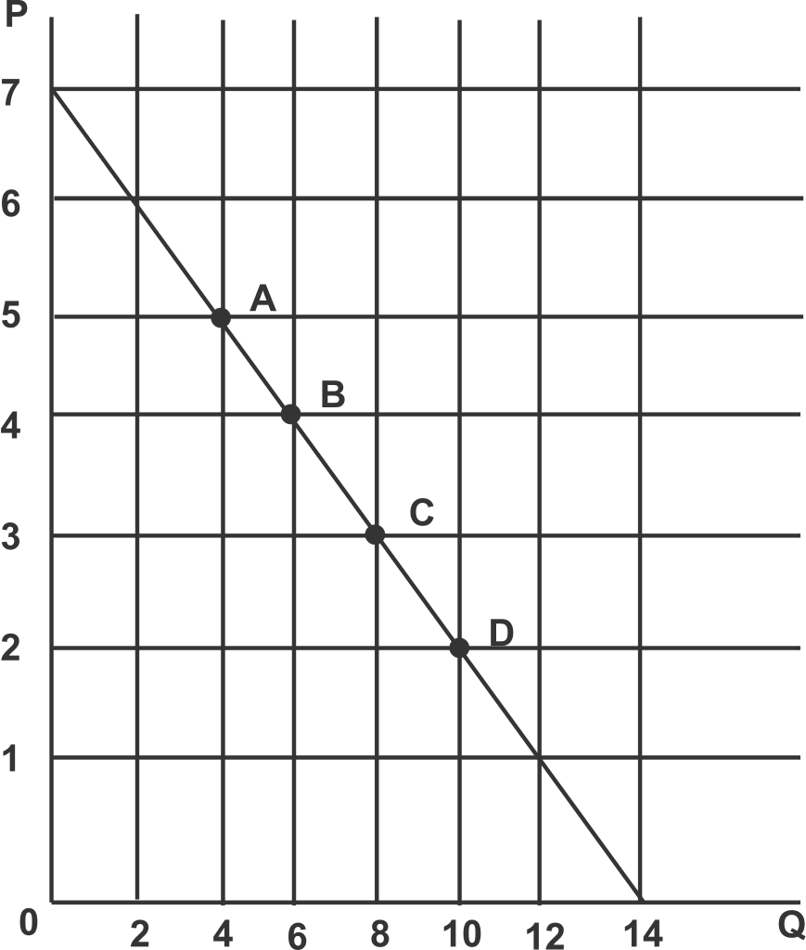

- The price elasticity of demand when moving from point A to point B is
  - 1/45
  - 45
  - 9/5
  - 5/9

- Holding everything else constant, suppose producers reduce price from $3 to $2. Which of the following statements is true?
  - Total revenue will increase since demand is price elastic at point C.
  - Total revenue will decrease since demand is price inelastic at point C.
  - Total revenue will increase since demand is price inelastic at point C.
  - Total revenue will decrease since demand is price elastic at point C.

- Suppose there is a small open economy where in a particular market the world price of the good is less than the price that would prevail in this small economy if the market were closed to trade. Suppose the government of this small economy imposes a tariff on this market. Assume the price with the tariff is still less than the domestic price if the market is closed to trade. Holding everything else constant, if the domestic supply decreases at every price, then government tariff revenue will
  - Increase.
  - Decrease.
  - Not Change.
  - Be impossible to determine since it depends on the prices in the market.
  - Be impossible to determine since it depends on the quantity of the good traded.

- Consider a market for organic grapes. The following equations describe the demand and supply curves for organic grapes:
Demand: P = 15 – 5Q
Supply: P = 3 + Q
Suppose the government decides to make organic fruit more affordable by imposing a price ceiling of $4 per unit of organic grapes on this market. What is the deadweight loss associated with the imposition of this price ceiling?
  - $9
  - $3
  - $8.5
  - $0.5

- The implementation of an effective price ceiling results in
  - excess supply and a decrease in producer surplus relative to the initial equilibrium situation.
  - excess demand and a decrease in producer surplus relative to the initial equilibrium situation.
  - a decrease in both consumer and producer surplus relative to the initial equilibrium situation.
  - excess supply and an increase in consumer surplus relative to the initial equilibrium situation.

Use the following information to answer the next three (3) questions.

In a small country’s market for sugar, the DOMESTIC demand curve and DOMESTIC supply curve are given by the following equations:
Domestic Demand: P = 28 - Q
Domestic Supply: P = 2 + Q

- How much will the country import if the world price is $8 per unit, but the Government imposes a $2 tariff on each unit sold?
  - 18 units of the good will be imported
  - 10 units of the good will be imported
  - 14 units of the good will be imported
  - 15 units of the good will be imported
  - 20 units of the good will be imported

- Continue to assume that the world price is $8. Suppose the government decides not to use a tariff, and instead imposes an import quota of 10 units. What is the new market supply curve ABOVE the world price?
  - Q=P+8
  - Q=P-2
  - Q=10P+20
  - Q=(P+2)/10
  - None of the above are correct answers.

- Given the information in the previous question, what is the market supply curve BELOW the world price?
  - Q=P+8
  - Q=P-2
  - Q=10P+20
  - Q=(P+2)/10
  - None of the above are correct answers.

Use the following information to answer the next three (3) questions.

The demand and supply curves for gasoline are given by the following equations:
Demand: Q^{D} = 25 − (1/10) P
Supply: Q^{S} = (1/10) P−5
Assume that price, P, is measured in cents and quantity, Q, is measured in gallons of gasoline.

- Suppose that the government implements on gas station operators an excise tax of 60 cents per gallon of gasoline. The after-tax price (including the tax per gallon) in the market will be
  - $1.50 per gallon of gasoline
  - $2.10 per gallon of gasoline
  - $1.20 per gallon of gasoline
  - $1.80 per gallon of gasoline

- What is the change in consumer and producer surplus associated with this tax? In your answer compare the consumer and producer surplus before the tax with the consumer and producer surplus after the tax: calculate the change in consumer surplus after the imposition of the tax and the change in producer surplus after the imposition of the tax.
  - ΔCS = −$205, ΔPS = −$205
  - ΔCS = −$250, ΔPS = −$250
  - ΔCS = −$255, ΔPS = −$255
  - ΔCS = −$340, ΔPS = −$340

- What is the deadweight loss and the government revenue associated with this tax?
  - DWL = $90, Tax Revenue = $350
  - DWL = $450, Tax Revenue = $50
  - DWL = $720, Tax Revenue = $50
  - DWL = $90, Tax Revenue = $420

Use the following information to answer the next three (3) questions.

In equilibrium the wage rate of baristas is $10 per hour, and the amount of labor supplied in equilibrium is 40 hours per week. In addition you know that at a wage of $5 per hour, 60 hours of labor are demanded and 20 hours of labor are supplied per week. Assume both the labor supply and the labor demand curves are linear.

- Given the above information which of the following represent the demand and supply equations for baristas?
  - P = 20 – (1/4)Q^{S}; P = (1/4)Q^{D}
  - P = 20 – (1/4)Q^{D}; P= (1/4)Q^{S}
  - P =20 – 4Q^{S} ; P = 4Q^{D}
  - P =20 – 4Q^{D} ; P = 4Q^{S}

- Suppose the government decides to impose a price floor in the market for baristas that results in 48 hours of labor being supplied and 32 hours of labor being demanded. What wage rate did the government set as a price floor?
  - $15 per hour
  - $12 per hour
  - $5 per hour
  - $11 per hour

- Given the above information and the minimum wage described in the last question, we know that the minimum wage resulted in
  - a shortage of 32 labor hours.
  - a shortage of 16 labor hours.
  - a surplus of 48 labor hours.
  - a surplus of 16 labor hours.

- The cross price elasticity of demand for dried cherries and apricots is 0.21. Therefore dried cherries and apricots are _____ goods.
  - substitute
  - inferior
  - normal
  - complementary

- A 10 percent increase in the price of coffee decreases the demand for sugar by 12 percent. Therefore the cross-price elasticity of demand between coffee and sugar is
  - 1.2
  - -1.2
  - 12
  - -12

- Lucia’s income elasticity of demand for pasta is 0.4. Pasta is therefore a(n) _____ good for Lucia.
  - substitute
  - inferior
  - complementary
  - normal

- If a consumer buys 60% more postcards when her income rises by 30%, then her income elasticity for postcards is
  - 2
  - -2
  - 0.5
  - -0.5

- Suppose you are a producer facing market demand curve P = 100 - 2Q. If you were to maximize your total revenue the price of your product would need to be _____ and your total revenue would equal _____.
  - $50; $1,250
  - $100; $5,000
  - $60; $1,800
  - $40; $1,800

- An increase in the price of good A leads to rightward shift in the demand curve for good B. Relative to B, this means that A is:
  - An Inferior Good
  - A Supplementary Good
  - A Complementary Good
  - A Substitute Good
  - A Normal Good

- Suppose a government is deciding between a tariff and a quota. Which of the following is true?
  - If the quantity imported under each policy is the same, then the price in the domestic market will also be the same.
  - If the domestic price is the same under each policy, then the quantity imported is also the same.
  - If both policies lead to the same quantities of imports, then they both necessarily entail the same deadweight loss.
  - Answers (a) and (b) are both true.
  - Answers (a), (b) and (c) are all true.

Key
- b
- a
- a
- a
- e
- b
- c
- d
- d
- c
- b
- a
- b
- b
- b
- a
- b
- d
- c
- d
- b
- b
- d
- a
- b
- d
- a
- a
- d
- e

