You have 75 minutes to complete this exam. There are 39 multiple choice questions. Each question is worth 2.5 points for a total of 97.5 points. The remaining 2.5 points will be added to your score for filling out your scantron EXACTLY as instructed. Your NAME and STUDENT ID (NOT social security number) go in the appropriate areas of the scantron. Your DISCUSSION SECTION YOU ATTEND must go in the special codes section as described below. Discussion numbers are on the back of this exam.

How to fill in the special codes section of the scantron:
- Write the number of the section YOU ATTEND in the special codes spaces ABC and fill in the bubbles. The discussion sections are listed on the back of the exam.
- Write the VERSION NUMBER of the exam under special codes space D and fill in the bubble. The version number is at the top of every page of the exam including this one.

The proctors cannot answer any questions about the content of the exam. Raise your hand if you have a question regarding a procedural issue (i.e. if you do not understand the above instructions regarding filling in the special codes section of the scantron)

If there is an error on the exam or if you do not understand something, make a note on your exam booklet and the issue will be addressed AFTER the examination is complete. No questions regarding the exam can be addressed while the exam is being administered.

GOOD LUCK!!!

- Bob consumes two goods, x and y. With which of the following can we infer that good x is inferior?
  - Bob’s demand for good x rises as the price of good y falls
  - Bob’s demand for good y falls as his income rises
  - Bob’s demand for both goods rises as his income rises
  - Bob’s demand for good x falls as his income falls
  - Bob’s demand for good x falls as his income rises
- A government-imposed maximum price at which a good can be sold is called a price ______
  - floor.
  - ceiling.
  - support.
  - maximum.
  - minimum.

- Which of the following is a positive statement?
  - Elasticity is a measure of the responsiveness of quantity demanded to one of its determinants.
  - Government is not good for the economy.
  - People must think at the margin.
  - Society prefers inflation to unemployment.
  - People should try to avoid trade offs.

- If you are studying Microeconomics, then you are interested in:
  - The growth in GDP from 2002 to 2003.
  - How firms price goods in particular markets.
  - The study of economy-wide phenomena, including inflation and unemployment.
  - How exchange rates affect trade.
  - How saving affects growth.

- All of the following explain how macroeconomics differs from microeconomics except:
  - Macro is concerned more with aggregate figures.
  - Macro provides a broader view of economic activity.
  - Micro is more concerned with optimal decisions by consumers.
  - Micro studies firms, markets, and pricing decisions.
  - Micro provides figures for the CPI and GDP.

- The demand for a good increases when the price of a substitute ____ and also increases when the price of a complement ____.
  - rises; rises
  - rises; falls
  - falls; rises
  - falls; falls
  - all of above are possible

Here are two points on the P.P.F. of Dane County. (Assume Dane County produces only books and brats.)

 | Books | Brats
Pair 1 | 1,500 | 0
Pair 2 | 0 | 3,000
- Assume that the P.P.F. is straight line. What is the opportunity cost of brats in terms of books?
  - 1,500
  - 3,000
  - 1/3,000
  - 1/2
  - 2

- Which of the following would usually be consistent with the Law of Supply if everything else were held constant?
  - An increase in the price of a good increases the quantity demanded.
  - An increase in the price of a good decreases the quantity demanded.
  - A decrease in the price of a good increases the quantity supplied.
  - An increase in the price of a good decreases the quantity supplied.
  - An increase in the price of a good increases the quantity supplied.

- Consider a market for widgets. The equilibrium quantity of widgets is 150 and equilibrium price is $5. The government imposes a tax of $2 on widgets and raises $200 as revenue. The equilibrium number of widgets has fallen by
  - 30 per month
  - 25 per month
  - 35 per month
  - 20 per month
  - 50 per month

- If demand shifts rightward and supply shifts leftward, then equilibrium
  - Quantity demanded goes up and so does price.
  - Quantity demanded goes down and price goes up.
  - Quantity demanded changes in an indeterminate way and price goes down.
  - Quantity demanded changes in an indeterminate way and price goes up.
  - Quantity demanded goes up and price changes in an unknown way.

- Consider the following PPF for a beverage factory. Which of the points of production is efficient?

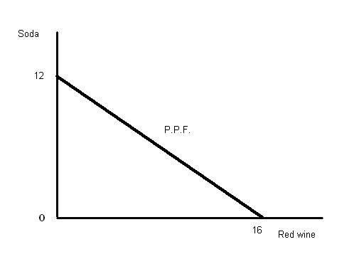

  - 16 red wine, 5 soda
  - 2 red wine, 12 soda
  - 8 red wine, 5 soda
  - 12 red wine, 3 soda
  - 12 red wine, 4 soda

Please use the following figures to answer the next two questions.

Each graph shows the demand of diet vanilla Coke by Cory, Sack and Molly.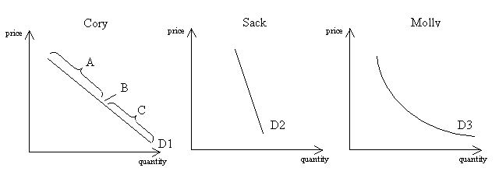
- According to the figures, we can say that:
  - Sack’s demand is more elastic than Cory and Molly’s demand.
  - Sack’s demand is more inelastic than Cory’s demand.
  - Molly’s demand is more inelastic than Cory’s demand.
  - Sack has a perfectly inelastic demand.
  - Molly’s demand is perfectly inelastic.

- Regarding Cory’s demand, if market price falls while it is in the range A of the demand curve we can expect total revenue to___________, while if the market price falls from point B on the demand curve we can expect total revenue to__________.
  - Increase; stay the same.
  - Decrease; increase.
  - Stay the same; increase.
  - Decrease; stay the same.
  - Increase; decrease

Consider the following table for the following three problems. Assume the PPF’s for Ben and Sol are linear.

 | Time to produce 1 dozen
 | Apple pies | Cream puffs
Ben | 4 hrs | 2 hrs
Sol | 2 hrs | 5 hrs
- How many apple pies or cream puffs can be produced in 20 hours by Ben?
  - 80 dozen apple pies or 40 dozen cream puffs.
  - 40 dozen apple pies or 80 dozen cream puffs.
  - 5 dozen apple pies or 10 dozen cream puffs.
  - 10 dozen apple pies or 5 dozen cream puffs.
  - 10 dozen apple pies or 4 dozen cream puffs.

- What is the opportunity cost of producing 1 dozen cream puffs for Sol?
  - 2/5 dozen apple pies.
  - 5/2 dozen apple pies.
  - 2 dozen apple pies.
  - 1/2 dozen apple pies.
  - 4/10 dozen apple pies.

- Which of the following is true?
  - Ben has the comparative advantage in the production of apple pies and absolute advantage in the production of cream puffs.
  - Sol has the comparative advantage in the production of apple pies and absolute advantage in the production of cream puffs.
  - Sol has the absolute and the comparative advantage in the production of apple pies.
  - Ben has the comparative advantage in the production of apple pies.
  - Ben has the absolute and the comparative advantage in the production of apple pies.

For the next question consider the following table.

Price $ | Demand | Supply
10 | 20 | 5
20 | 10 | 10
- Using the information in the table above, what is the equation of the supply curve (assume it is linear)?
  - Q^{s} = 7.5 + 0.5P
  - Q^{s} = 0.5P
  - Q^{s} = 2P
  - Q^{s} = 10 + 2P
  - Q^{s} = 10 + 0.5P

- Suppose the demand curve of a good is horizontal (perfectly elastic) and the supply curve is upward sloping. If a tax is imposed on the suppliers of the good, the economic burden of the tax will fall
  - completely on the seller
  - half on the buyer and half on the seller
  - 1/3 on the buyer and 1/3 on the seller
  - completely on the buyer
  - 1/3 on the seller and 1/3 on the buyer

- Consider a market for widgets. The equilibrium quantity of widgets is 100 .The government imposes a tax which raises the price paid by buyers by $2 and reduces the price received by sellers by $1. The government raises $180 as revenue from the tax. What is the deadweight loss?
  - $60
  - $80
  - $70
  - $50
  - $120

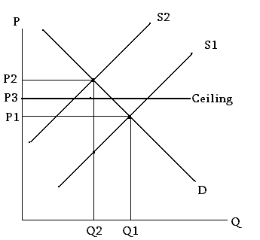
- According to the graph above, with a price ceiling present in this market, when the supply curve for gasoline shifts from S1 to S2
  - the price will increase to P2.
  - a surplus will occur at the new market price of P2.
  - the market price will stay at P1 due to the pricing ceiling.
  - a shortage will occur at the price ceiling of P3.
  - nothing happens to the equilibrium.

- Consider the equation y=x+b/m. What is the slope of this line?
  - m
  - b
  - 1
  - b/m
  - 1/m

- In a given market we know that the slope of the demand curve is –2 and that when the quantity demanded is zero, the price is 16. If this is the case, then the demand equation should be:
  - Q = -2 + 16P
  - Q = 16 - 2P
  - Q = 8 – (1/2)P
  - Q = (1/2) + 8P
  - Q = 1-(1/8)P

- If the price elasticity of cigarettes is 0.5, then a 20 percent increase in price would result in a
  - 10 percent decrease in the quantity demanded.
  - 20 percent decrease in the quantity demanded.
  - 50 percent decrease in the quantity demanded.
  - 100 percent decrease in the quantity demanded.
  - No change because we know that the demand of cigarettes is inelastic.

The next three questions are based on the following information.

Let the market demand curve of wheat be p=7-q.
Let the market supply curve of wheat be p=1+2q

- What is the market equilibrium?
  - Price=$3, quantity=4
  - Price=$5, quantity=2
  - Price=$2, quantity=5
  - Price=$4, quantity=3
  - None of the above

- Now suppose the government sets a floor on the price of wheat; i.e it declares that the price of wheat cannot be lower than $6. Find the quantities demanded and supplied at the new price of $6
  - demand=2, supply=4
  - demand=1.5, supply=3
  - demand=1, supply=3
  - demand=2, supply=2.5
  - demand=1, supply=2.5

- As a result of the imposition of the price floor, the government has to bear a cost (assume it buys the surplus). Calculate this cost to the government.
  - $6
  - $8
  - $9
  - $10
  - $12

- Suppose supply increases and demand decreases. Then equilibrium price will _____ and equilibrium quantity will ______.
  - rise; fall
  - rise; rise
  - fall; rise
  - not be determined; rise
  - fall; not be determined

- If a drought wipes out the majority of the cotton crop this year, the _______ of cotton will likely be ________.
  - Supply; higher;
  - Demand; lower;
  - Quantity demanded; higher;
  - Quantity demanded; lower;
  - Demand; higher;

- Peter has the option to work at a library or at a restaurant. He cannot work at both places at the same time. The hourly wage at library is $10, while it is $15 at the restaurant. For Peter, what's the opportunity cost of having a 2-hour-party with his friends?
  - $10
  - $15
  - $20
  - $25
  - $30

- Suppose demand is Qd=12-2P and supply is Qs=P. Producer surplus in equilibrium is
  - 4
  - 8
  - 12
  - 16
  - 18

- Domestic supply is Qs=15+3P and domestic demand is Qd=25-2P. If world price is $1/unit, then how much is supplied by domestic suppliers?
  - 21
  - 20
  - 19
  - 18
  - 15

For the next three questions consider the following market supply and demand equations:

Market supply is: Qs= 5P – 10
Market demand is: Qd= 8 - P
- Equilibrium quantity demanded is:
  - 2
  - 3
  - 4
  - 5
  - 6

- Suppose the government imposes a tax of $2/unit on the sellers. The new supply curve is:
  - Qs = 5P – 8
  - Qs = 5P – 12
  - Qs = 10P – 8
  - Qs = 5P – 20
  - Qs = 10P – 20

- If Pt and Qt are the prices and quantities that arise after the tax, consumer surplus after the tax would be calculated as
  - [ (8-Pt) x 5 ] / 2
  - [ (8-Pt) x (Qt) ] / 2
  - [ (10-Pt) x (Qt-5) ] / 5
  - [ (10-Pt) x (5-Qt)] /2
  - It doesn’t exist in this example

- Suppose demand is Qd=5-2P. At what price will the point elasticity be 1?
  - $0.50
  - $0.75
  - $1.00
  - $1.25
  - $1.50

- Suppose supply is Qs=2+2P and demand is Qd=3-2P. What is the point elasticity of demand in equilibrium?
  - 1/5
  - 1/10
  - 1/15
  - 1/20
  - 1/25

Consider the following graph for the next two questions.
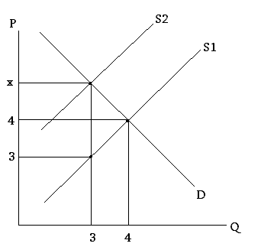

- Supply is originally at S1. If the graph represents a tax on suppliers, and the amount of the tax is $2/unit, then the demand curve is:
  - Qd=7-2P
  - Qd=8-P
  - Qd=12-2P
  - Qd=10-2P
  - Qd=5-P

- Supply is originally at S1. With demand as in the above question, what would the deadweight loss be from a tax on suppliers of $1/unit?
  - 20 cents
  - 25 cents
  - 33 cents
  - 50 cents
  - $1.00

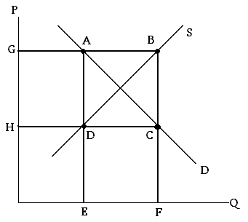

- In the market above the government is implementing an agricultural farm subsidy program. In this program the government guarantees a price of at least G (on the vertical axis the point G is the price which the government guarantees to suppliers), but instructs the sellers to sell all of their output at the market price (the price buyers are willing to pay for that amount of output). The government will then subsidize farmers so that they receive the target price. The amount paid by the government for this program can be represented by the area:
  - ABCD
  - DCEF
  - ABFE
  - GBCH
  - GADH

