You have 75 minutes to complete this exam. There are 39 multiple choice questions. Each question is worth 2.5 points for a total of 97.5 points. The remaining 2.5 points will be added to your score for filling out your scantron EXACTLY as instructed. Your NAME and STUDENT ID (NOT social security number) go in the appropriate areas of the scantron. Your DISCUSSION SECTION YOU ATTEND must go in the special codes section as described below. Discussion numbers are on the back of this exam.

How to fill in the special codes section of the scantron:
- Write the number of the section YOU ATTEND in the special codes spaces ABC and fill in the bubbles. The discussion sections are listed on the back of the exam.
- Write the VERSION NUMBER of the exam under special codes space D and fill in the bubble. The version number is at the top of every page of the exam including this one.

The proctors cannot answer any questions about the content of the exam. Raise your hand if you have a question regarding a procedural issue (i.e. if you do not understand the above instructions regarding filling in the special codes section of the scantron)

If there is an error on the exam or if you do not understand something, make a note on your exam booklet and the issue will be addressed AFTER the examination is complete. No questions regarding the exam can be addressed while the exam is being administered.

GOOD LUCK!!!

- Holding everything else constant, the change in price that results from a leftward shift of the supply curve will be greater if:
  - the demand curve is relatively steeper than if the demand curve is relatively flat.
  - the demand curve is relatively flat than if the demand curve is relatively steep.
  - the demand curve is horizontal than if the demand curve is vertical.
  - the demand curve is horizontal than if the demand curve is downward sloping.
  - the demand curve is relatively elastic.
- The demand for a good decreases when the price of a substitute ____ and also decreases when the price of a complement ____.
  - rises; rises
  - rises; falls
  - falls; rises
  - falls; falls
  - the all of above are possible

- A central focus of microeconomics is:
  - aggregation
  - scarcity
  - GDP
  - economic growth
  - the rate of inflation

- Which of the following is a normative statement?
  - There are about 365 days in a year.
  - Microeconomics is the study of consumer choice, firms, and markets.
  - Macroeconomics is less helpful to consumers than microeconomics.
  - September was very hot this year compared to last year.
  - There are 725 students in lectures one and two of economics 101 during the fall semester of 2003.

- Holding everything else constant, if an increase in the price of one good leads to an increase in the quantity demanded of another good that is sold, then the two goods are:
  - Substitutes
  - Complements
  - Normal Goods
  - Inferior Goods
  - Unrelated Goods

For the next two questions consider the following domestic demand and supply curves:

Market demand is Qd=20-4P
Market supply is Qs=5+P
- Consumer surplus in equilibrium is:
  - $8
  - $15
  - $16
  - $18
  - $24

- If the world price is $2 and trade is allowed, how much is supplied by domestic suppliers?
  - 4
  - 5
  - 6
  - 7
  - 8

For this question and others like it, be sure to read all the answer choices.
- If a good is inferior, then:
  - An increase in income will decrease quantity demanded
  - An increase in income will increase quantity demanded
  - A decrease in the price of a related good in consumption will increase quantity demanded
  - Both a and c hold
  - Both b and c hold

- Which of the following would cause a movement along the supply curve for a good?
  - An increase in the price of an input
  - A decrease in the price of an input
  - An increase in the price of a related output in consumption
  - A reduction in the number of sellers of the good
  - An increase in the level of technology.

- What effect would very bad weather destroying much of the wheat crop have on the market for wheat?
  - A movement along the supply curve to a higher price
  - A movement along the supply curve to a lower price
  - An outward (rightward) shift in the supply curve
  - An inward (leftward) shift in the supply curve
  - The effect on the market is indeterminate

For the next three questions, consider the following diagram illustrating the demand and supply curves for a good.
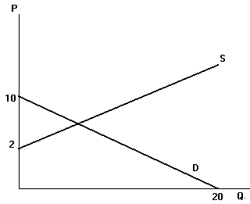
- What can we say about the demand curve, D, in the graph?
  - It is perfectly inelastic
  - It is perfectly elastic
  - It satisfies the Law of Demand
  - It violates the Law of Demand
  - It is unit elastic

- The equation of the demand curve is:
  - Q^{d} = 10 – 2P
  - Q^{d} = 20 + 2P
  - Q^{d} = 20 – 2P
  - Q^{d} =10 – 1/2P
  - Q^{d} = 20 + 1/2P
- What would the slope of the supply curve have to be for the market equilibrium to be at P = 5, Q = 10?
  - 8/5
  - 5/8
  - 3/10
  - 3/8
  - 3/5

Price, $ | Demand | Supply
10 | 20 | 5
20 | 10 | 10
- Using the information above, what is the equation of the demand curve?
  - Q^{d} = 10 – P
  - Q^{d} = 10 – 2P
  - Q^{d} = 10 – 3P
  - Q^{d} = 20 – P
  - Q^{d} = 30 – P

For the next two questions, consider the following demand schedule for a good. Assume the market consists of persons 1, 2, 3, and 4.

Price, $ | Person 1 | Person 2 | Person 3 | Person 4
0 | 12 | 7 | 3 | 20
1 | 10 | 6 | 3 | 17
2 | 8 | 5 | 3 | 14
3 | 6 | 4 | 3 | 11
4 | 4 | 3 | 3 | 8
5 | 2 | 2 | 3 | 5
6 | 0 | 1 | 3 | 2
- What is the equation for the market demand curve?
  - Q^{d} = 7 – 1/6P
  - Q^{d} = 7 – 6P
  - Q^{d} = 42 – 6P
  - Q^{d} = 42 – 1/6P
  - Q^{d} = 6 – 6P

- If the market supply curve is Q^{s} = 22 + 4P, what is the equilibrium?
  - P = 3, Q = 20
  - P = 3, Q = 30
  - P = 2, Q = 20
  - P = 2, Q = 30
  - P = 2, Q = 40

- The concept of comparative advantage is the comparison among producers of a good according to
  - their productivity.
  - their relative opportunity cost.
  - their efficiency.
  - the terms of trade advantage.
  - the demand they are facing.
- If Paul is more productive than David in all areas of production, then
  - neither Paul nor David can benefit from trade.
  - Paul can benefit from trade but David cannot.
  - David can benefit from trade but Paul cannot.
  - David will not have comparative advantage in any of the goods.
  - both Paul and David can benefit from trade.

- Consider the following PPF and answer which of the following combinations of good X and good Y is attainable and efficient.
  - (4,9)
  - (9,9)
  - (12,2)
  - (10,6)
  - (16,6)

- If Harry can produce 8 glasses (G) and 0 plates (P) or 3 glasses (G) and 4 plates (P), which of the following could be the equation for the linear PPF for Harry?
  - 4G + 5P = 32.
  - 5G + 4P = 8.
  - 4G + 5P = 8.
  - 5G + 5P = 32.
  - G + 5P = 8.

- Roger can make 15 pancakes in 30 minutes or 10 sandwiches in 10 minutes. The opportunity cost of 1 pancake to Roger is
  - 2/3 of a sandwich.
  - 2 sandwiches.
  - 3/2 sandwich.
  - 1/2 of a sandwich.
  - 1/2 of a pancake.

- Demand is Qd=3-2P. What is the point elasticity of demand at P=1, Q=1?
  - 1/2
  - 1/4
  - 2
  - 4
  - 1

Consider the following figures for the next two problems. The production possibility frontier for country A and country B can be represented by the following graphs:
- The opportunity cost of rice in terms of wheat in country A and the opportunity cost of rice in terms of wheat in country B are
  - 1/2 and 3/2 respectively.
  - 3/2 and 1/2 respectively.
  - 2/3 and 1/2 respectively.
  - 2/3 and 2 respectively.
  - 2 and 2/3 respectively.

- Which of the following is true?
  - Country A has absolute and comparative advantage in the production of rice.
  - Country B has absolute and comparative advantage in the production of rice.
  - Country A has absolute advantage in the production of rice and comparative advantage in the production of wheat.
  - Country B has absolute advantage in the production of rice and comparative advantage in the production of wheat.
  - Country B has absolute and comparative advantage in the production of wheat.

- Deadweight loss is the
  - Increase in government revenue when taxes are increased
  - Change in total consumer surplus when a tax is imposed
  - Change in total producer surplus when a tax is imposed
  - Reduction in total surplus that results from a tax
  - Change in total quantity of the good consumed

- Consider good A and good B. The demand elasticity of both goods is equal. Supply elasticity of A is greater than the supply elasticity of B. If the same percentage excise tax were imposed on both goods, the tax on which good would create a larger deadweight loss?
  - Tax on good A
  - Tax on good B
  - Deadweight loss will be same
  - The question is impossible to answer without knowing the prices of the two goods.
  - Deadweight loss will depend upon the prices of complementary goods of the two goods.

- A $4 tax on the suppliers of DVDs will shift the supply curve:
  - right (downward) by exactly $4.
  - right (downward) by slightly more than $4.
  - left (upward) by slightly less than $4
  - left (upward) by exactly $4
  - the tax has no affect on the supply curve.

- Consider the equation of a line 6x+11y=13. The slope and y-intercept of the line are:
  - slope=13/11, intercept=6/11
  - slope= -11/6, intercept=13/11
  - slope=6/11, intercept=13/11
  - slope= -6/11, intercept= -13/11
  - slope= -6/11, intercept= 13/11

- Consider a market for widgets. The equilibrium quantity of widgets is 150 and equilibrium price is $5. The government imposes a tax of $2/unit on widgets and raises $250 as revenue. The equilibrium number of widgets has fallen by:
  - 30 per month
  - 25 per month
  - 35 per month
  - 20 per month
  - 40 per month

- Suppose the supply curve of a good is upward sloping and the demand curve is vertical (perfectly inelastic). If a tax is imposed on the seller of the good the economic burden of the tax will fall
  - completely on the seller.
  - half on the buyer and half on the seller.
  - 1/3 rd on the buyer and 1/3 rd on the seller.
  - completely on the buyer.
  - 1/3 rd on the seller and 1/3 rd on the buyer.

The next two questions are based on the information given below.

Market demand: P=9-Qd
Market supply: P=1+3Qs

- The market equilibrium is
  - Q=1, P=3
  - Q=2, P=4
  - Q=2, P=7
  - Q=4, P=5
  - Q=4, P=6

- Assume now that the government sets a price ceiling of $5, i.e. the market price cannot be more than $5. Calculate the amount demanded by consumers at $5. Also calculate the price that producers will require in order to supply the amount that is demanded by consumers at $5.
  - quantity demanded=4, price required=10
  - quantity demanded=4, price required=13
  - quantity demanded=4, price required=19
  - quantity demanded=5, price required=16
  - quantity demanded=7, price required=22

The next two questions are based on the information given below.
Consider a market.

Market demand is P=20-5Qd.
Market supply is P=4+3Qs.
Market equilibrium is therefore (quantity=2, price=10).
Note that you do not have to calculate market equilibrium.

- Find consumer surplus (CS) and producer surplus (PS).
  - CS=8, PS=4.
  - CS=12, PS=6.
  - CS=10, PS=6.
  - CS=10, PS=12.
  - CS=6, PS=10.

- Now suppose the government imposes a tax that reduces the equilibrium quantity sold (and consumed) in the market to 1. Find the deadweight loss.
  - $3
  - $4
  - $2
  - $5
  - $1

- If the price elasticity of demand for cigarettes is 0.75, then a 20 percent increase in price would result in a
  - 10 percent decrease in the quantity demanded.
  - 15 percent decrease in the quantity demanded.
  - 20 percent decrease in the quantity demanded.
  - 100 percent decrease in the quantity demanded.
  - No change because we know that the demand of cigarettes is inelastic.

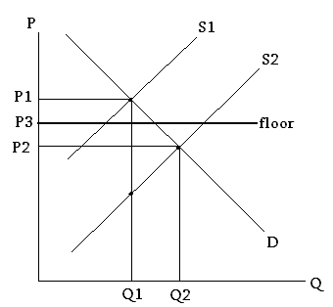
- According to the graph above, with a price floor present in this market, when the supply curve for gasoline shifts from S1 to S2
  - the market price will fall to P2.
  - a surplus will occur at the price floor of P3.
  - a surplus will occur at the new market price of P2.
  - the market price will stay at P1 due to the pricing floor.
  - This market is unaffected by the price floor.

- Suppose demand is Qd=8-2P. At what price will the point elasticity be 1?
  - $1.00
  - $1.25
  - $1.50
  - $1.75
  - $2.00

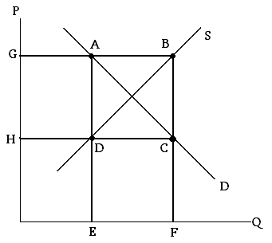

- In the market above the government is implementing an agricultural price support program. In this program the government sets a price floor at price G. The amount paid by the government in this program can be represented by the area:
  - ABCD
  - DCEF
  - ABFE
  - GBCH
  - GADH

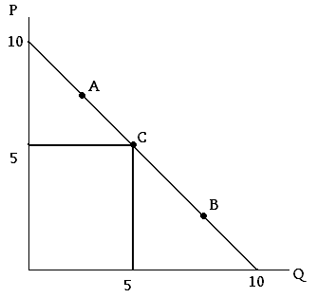
- With demand as is shown in the graph above, at point “A” revenue would _____ if price rose. At point “B” revenue would _____ if price rose. At point “C” revenue would ______ if price rose.
  - increase, increase, increase
  - increase, decrease, increase
  - decrease, increase, decrease
  - decrease, decrease, decrease
  - increase, increase, decrease

