Economics 101
Summer 2014
Homework #4
Due Thursday, June 12, 2014

Directions: The homework will be collected in a box before the lecture. Please place your name, TA name and section number on top of the homework (legibly). Make sure you write your name as it appears on your ID so that you can receive the correct grade. Late homework will not be accepted so make plans ahead of time. Please show your work. Good luck!
Please realize that you are essentially creating “your brand” when you submit this homework. Do you want your homework to convey that you are competent, careful, professional? Or, do you want to convey the image that you are careless, sloppy, and less than professional. For the rest of your life you will be creating your brand: please think about what you are saying about yourself when you do any work for someone else!

1. Suppose you are told that the production function for widgets is given by the following equation where Q is the quantity of widgets, K is the number of units of capital used in producing widgets, and L is the number of units of labor used in producing widgets:
Q = 4K^{1/2}L^{1/2}
You are also told that total cost for this firm can be found by using the following equation where TC is total cost, P_{k} is the price per unit of capital, and P_{l} is the price per unit of labor:
TC = P_{k} K + P_{l} L

a. Using this information, fill out the following table depicting the production function and the cost functions for this firm. Make sure you provide the units of measurement in your answers. If necessary, round your answers to the nearest hundredth.

L | K | Q | VC | FC | TC | AVC | AFC | ATC | MC
0 | 25 |  |  |  |  | --- | --- | --- | ---
1 | 25
4 | 25 |  |  |  |  |  | $1.25 per unit of output
9 | 25
16 | 25 |  |  |  |  | $2.00 per unit of output
25 | 25

b. Given the above information, which input is the variable input? Explain why this is your answer.

c. Given the above information, what is the price per unit of capital and what is the price per unit of labor?
d. Does this firm experience diminishing returns to labor? To answer this question you will find it helpful to calculate the values for the marginal product of labor, MP_{l}. Here’s a table to use in calculating these values. Make sure you provide the units of measurement in your answers. If necessary, round your answers to the nearest hundredth.
L | K | Q | MP_{l}
0 | 25 |  | ---
1 | 25
4 | 25
9 | 25
16 | 25
25 | 25

2. Consider the perfectly competitive industry for gadgets where there are initially 10 identical firms producing. Each firm has the same MC and TC curves and these curves are given by the following equations where TC is total cost, q is the amount of gadgets produced by a firm, and MC is the marginal cost:
TC for each firm: TC = 4 + 5q + q²
MC for each firm: MC = 5 + 2q
You also know that the market demand curve is given by the following equation where P is the price per gadget and Q is the total amount of gadgets demanded in the market:
Market Demand for Gadgets: Q = 17 – P

a. Given this information, the first thing you need to do is to determine the short-run equilibrium. But, you cannot do this until you find the market supply curve. This will take some work: you will need to have some conceptual knowledge (the market supply curve is the horizontal summation of the firms’ MC curves) and some creativity (you will need to figure out how to get a second point that lies on the individual firm’s MC curve and then extrapolate from this point to the market supply curve). Find the market supply curve and show the work you did to find this curve.

b. Given the information and the market supply curve you found in (a), compute the short-run equilibrium market quantity (Q), the short-run equilibrium price (P), and the short-run level of production for a representative firm (q). Show your work.

c. Given your work in (b), determine the level of short-run profits for a representative firm in this industry? Given your calculation will the representative firm produce in the short-run? Explain your answer. Given your calculation what do you predict will happen in this industry in the long-run? Explain your answer.

d. Calculate the long-run equilibrium price (P’), long-run equilibrium market quantity (Q’), the long-run equilibrium firm quantity (q’), and the level of profits in the long-run for a representative firm. Show your work. In the long-run how many firms will be in this industry?

3. Suppose that there is a monopoly that is described by the following information:
Demand curve for product: P = 11- (1/1000)Q
MC of production for firm: MC = 2 + (1/1000)Q
Total Cost of production for firm: TC = 2Q + (1/2000)Q² + 1000

a. Determine the profit maximizing quantity and price if this firm acts as a single price monopolist. Show your work.

b. Determine the firm’s total revenue (TR), total cost (TC) and profit if it acts as a single price monopolist. Show your work.

c. Determine the value of consumer surplus (CS), producer surplus (PS), and total surplus (TS) if this firm acts as a single price monopolist. Show your work.

d. Determine the value of deadweight loss if this firm acts as a single price monopolist. Show your work.

Suppose that instead of acting as a single price monopolist, this firm acted as if it was operating in a perfectly competitive industry. Assume the following:
Market demand curve for product: P = 11- (1/1000)Q
Market supply curve for product: P = 2 + (1/000)Q
Total cost of production of good: TC = 2Q + (1/2000)Q² + 1000

e. If this firm operated as if it was a perfectly competitive market, what would be the market equilibrium price and market equilibrium quantity? Show your work.

f. If this firm operated as if it was a perfectly competitive market, what would be the firm’s total revenue (TR’), total cost (TC’), and profit under these assumptions? Show your work.

g. If this firm operated as if it was a perfectly competitive market, what would be the value of consumer surplus (CS’), producer surplus (PS’), and total surplus (TS’) under these assumptions? Show your work.

h. If this firm operated as if it was a perfectly competitive market, what would be the value of deadweight loss under these assumptions? Explain your answer.

4. Suppose you are given the following graph of a monopoly.
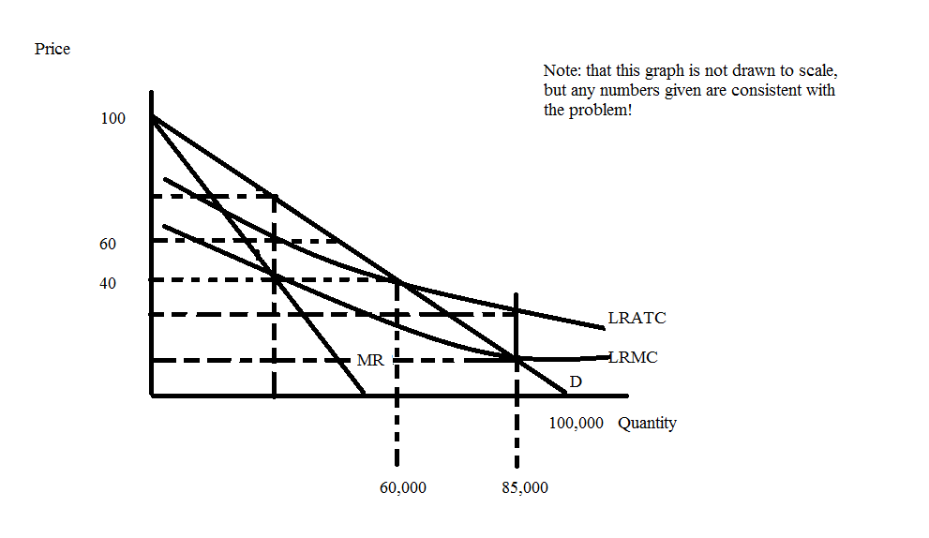

a. Given this graph, write an equation for this monopolist’s marginal revenue curve (MR).

b. If this monopolist is a single price monopolist, what price and output will this monopolist produce? What will be the monopolist’s profits at this price and output combination? Show how you found your answers.

c. If this monopolist is instead regulated to produce the socially optimal amount of the good, what price and output will the monopolist produce? What will the regulatory authority need to do in order to get the monopolist to produce at this price and output level? Explain your answer fully.

d. If this monopolist is instead regulated to produce at an output level where the firm breaks even, what price and output will the monopolist produce? Is there a deadweight loss associated with this level of production? Explain your answer verbally and then provide a mathematical calculation of this area of deadweight loss.

5. Suppose a monopolist can be described by the following equations:
Monopolist’s demand curve: P = 250 – 5Q
MC for the monopolist: MC = 30
Assume that the monopolist has no fixed costs
a. Determine the profit maximizing level of output for this monopolist if it charges a single price. Determine the profit maximizing quantity and the level of the monopolist’s profit. Show your work. Also, enter your answers in the table below (you will be adding to this table throughout your work on this problem).

Pricing Scheme | Price Charged | Quantity Produced | Profit
a) Single Price Monopolist
b) Monopolist charges two prices
c) Monopolist practices perfect price discrimination

b. Suppose this monopolist decides that it will charge 2 prices: $140 for the first 22 units and $100 for the next 8 units. Determine the profit the monopolist will earn when it charges two prices and then enter your answers into the above table. Show how you found your answers.

c. Suppose this monopolist decides to be a perfect price discriminator. What quantity of the good will the monopolist choose to produce? Explain your answer. Then, calculate the value of the monopolist’s profit if the monopolist is a perfect price discriminator. Show your work and then enter your answers in the above table.

d. From your analysis in (a) through (c), what conclusion do you draw about price discrimination? Explain your answer fully.

6. Consider a monopolist who sells her product to two different classes of customers. Suppose this monopolist knows the following information:
Demand for product from class one: P = 10 – Q
Demand for product from class two: P = 5 – (1/2)Q
MC = $2 per unit; and assume there are no fixed costs for this monopolist

a. Find the market demand curve for the monopolist’s product if there are only these two classes of buyers. Make sure you identify any ranges (or domains) where appropriate.

b. If the monopolist charges a single price to all the buyers of its product, what price will she charge and how many units will the monopolist produce? Show how you found this price and quantity. Then, calculate the amount of profits the monopolist will earn with this combination of price and quantity.

c. Suppose this monopolist decides to engage in third degree price discrimination. What price and quantity will she provide to class one buyers? What price and quantity will she provide to class two buyers? What will profits from class one be for this price discriminating monopolist? What will profits from class two be for this price discriminating monopolist? What will total profits be for this price discriminating monopolist? Is it profitable to engage in third degree price discrimination? Explain your answers fully.

