Economics 101
Fall 2007
Answers to Homework # 3:

1.
- If this economy is closed to world trade, the equilibrium quantity is 20 and the price is $60. The consumer surplus is (1/2)*20*(100-60)= $400. The producer surplus is (1/2)*20*60= $600.
- The world price is lower than the equilibrium price, so we know that this country will import printers. At a price of $30, consumers want to buy 35 units and domestic suppliers want to sell 10 units. Thus, the country will import 25 units. Consumer surplus equals (1/2)*35*(100-30)= $1225. Producer surplus equals (1/2)*10*30= $150. Deadweight loss is $0.
- This tariff raises the effective world price to $42. At this price, consumers demand 29 printers, and domestic suppliers are willing to sell 14 printers. Thus, 15 printers are imported. Consumer surplus equals (1/2)*29*(100-42)= $841, and producer surplus equals (1/2)*14*42= $294. Government revenue is $12 per import, so it equals $180. Thus, total welfare, which is consumer surplus plus producer surplus plus government revenue, equals $1,315. In part (b), total welfare equaled consumer surplus plus producer surplus, which equals $1375. Thus the deadweight loss, which is the lost welfare, equals 1375-1315= $60.
- A quota means that they can only import 15 units. We need to solve for a price where the difference between the quantity demanded and the quantity supplied is 15. Thus, (100-p)/2-p/3=15. Solving for p, we find that p= $42. At this price, quantity demanded is 29, and quantity supplied is 14, meaning that 15 printers (the amount of the quota) are imported. These numbers are the same as in part (c). Thus we know that consumer and producer surplus are the same as before (CS= $841, PS= $294). There is no government revenue in this case, because there is no tax. However, in part (b), foreign producers earned $30 for each import. Now, they are earning $42 per import. We call the increase in earnings to these foreign producers quota rent. In this case, quota rent equals 12*15= $180 (the same as the government revenue in part (c)). Thus deadweight loss is the same as before ( $60).
- Parts (c) and (d) indicated that we could get the same outcome if we use a quota or a tariff. The only difference is that, with a tariff, the government gets tax revenue, while with a quota, foreign producers get extra profits.

- Jerry is at a picnic. The following table gives the total utility that Jerry gets from eating free cheese at the picnic.

  - What is his marginal utility after eating each piece?

Chunks of Cheese | Total Utility | Marginal Utility
0 | 0 | 0
1 | 5 | 5
2 | 11 | 6
3 | 17 | 6
4 | 20 | 3
5 | 22 | 2
6 | 21 | -1

  - How many chunks of cheese would Jerry choose to eat?

Jerry will continue to eat as long as his marginal utility is positive. If we assume he can only eat cheese in chunks, he will eat 5 chunks of cheese.

Suppose there is also free ice cream at the picnic. The following table gives the marginal utility of eating ice cream. Calculate the total utility of eating each unit of ice cream.

Ice Cream | Total Utility | Marginal Utility
0 | 0 | 0
1 | 5 | 5
2 | 9 | 4
3 | 12 | 3
4 | 14 | 2
5 | 15 | 1
6 | 13 | -2

  - Suppose now that Jerry had to pay for the cheese and ice cream. Each chunk of cheese costs $3 and each ice cream costs $4. How many chunks of cheese and ice cream would Jerry consume?

Jerry will eat cheese and ice cream until the marginal utility per dollar from the consumption of each good is the same. Hence he will eat 2 ice creams and 4 chunks of cheese.

- Tom likes to play squash and tennis. He enjoys a game of squash twice as much as a game of tennis.

  - Draw a few indifference curves for Tom with tennis games on the y-axis and squash games on the x-axis. (Consider 1 game of squash to be perfect substitutes to 2 games of tennis.)

The indifference curves would be straight lines with a slope of 2 if you have number of tennis games on the y-axis.

  - Suppose that Tom has $12 per week to spend on playing squash or tennis. It costs $4 to play a game of squash and $3 to play a game of tennis at the local gym.

- Draw Tom’s budget line and find the equation of the line.
The budget line will be a straight line that intercepts the axis with tennis games at 4 and the axis with squash games at 3. The intercepts indicate that with $12 Tom can afford 4 tennis games when he does not buy any squash games, and he can afford 3 squash games if he does not buy any tennis games.
The equation of the line is T = -4/3S + 4, where T is the number of tennis games and S is the number of squash games.

- How many games of squash and tennis will Tom play in a week?
Tom will play 3 squash games and zero tennis games. This maximizes his utility.

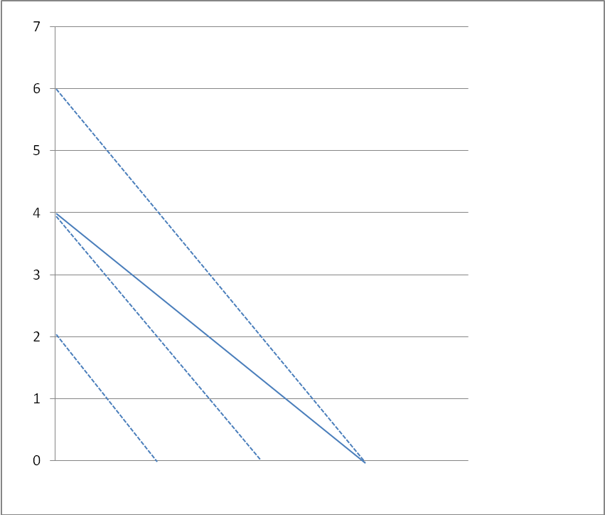
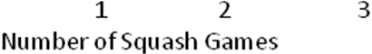

The dotted lines are indifference curves. The solid line is the budget constraint.

- The left shoe is a perfect complement to the right shoe. Suppose you could buy left and right shoes separately. Draw a few indifference curves for left and right shoes with left shoes on the y-axis and right shoes on the x-axis.

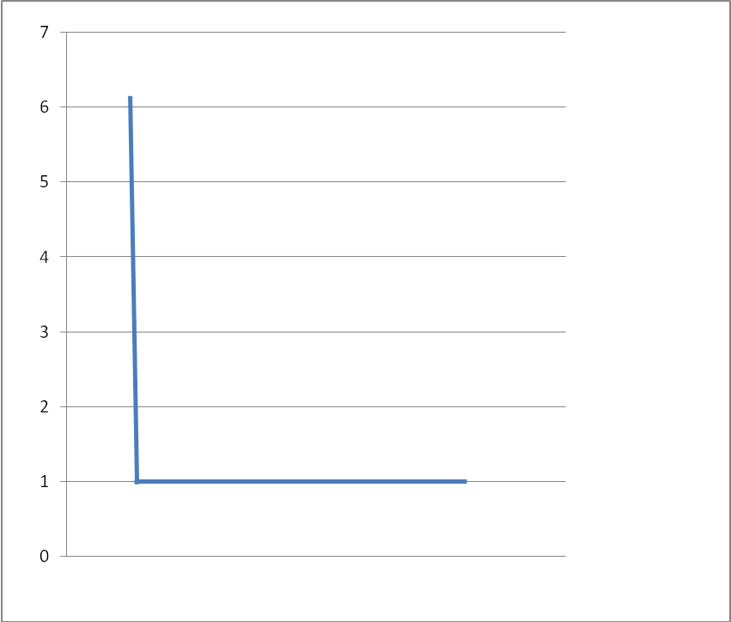
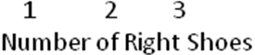

- Given below are some of Elmer’s indifference curves. Suppose Elmer has $40 to spend on baseball games and movies. Suppose a baseball game costs 8$ while a movie ticket costs $4.

Draw Elmer’s budget line. How many movies and baseball games does Elmer go to watch? Look at the diagram below: Elmer will choose 2 baseball games and 6 movies.

Suppose the price of a baseball game goes down to $5. Draw the new budget line. How many baseball games and movie does Elmer watch now? Look at the diagram below: Elmer will choose 4 baseball games and 5 movies.

