Economics 101
Summer 2008
Answers to Homework #2
Due 6/3/08

Please make sure your homework includes your name and the time and day of your discussion section. In addition, please write legibly and neatly and make sure your answer is clearly marked (you might place a box around your answer). Homework should be stapled (there is no stapler at the lecture), and it should be neat. All homework must be turned in on the date it is due in the large lecture and it must be turned in at the beginning of the lecture. No late homework assignments will be accepted.

Note: Homework #2 includes a review of production possibility frontiers and comparative and absolute advantage; the homework also includes questions on supply and demand.

1.
a.
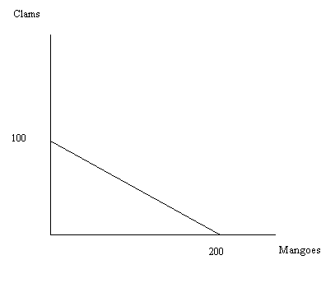
b.
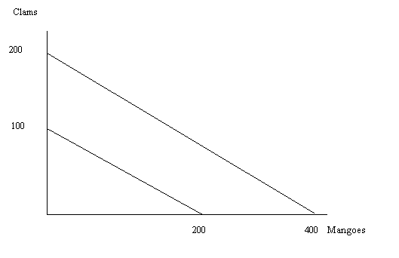
c.
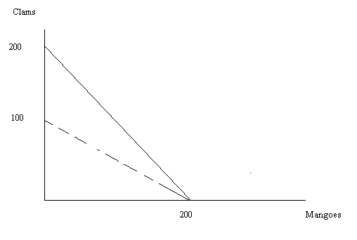
The clamrake causes the production possibility frontier to shift out along the vertical axis while maintaining the same x-axis intercept. With the new technology represented by the clamrake it is possible to produce more clams than was previously possible.
d.
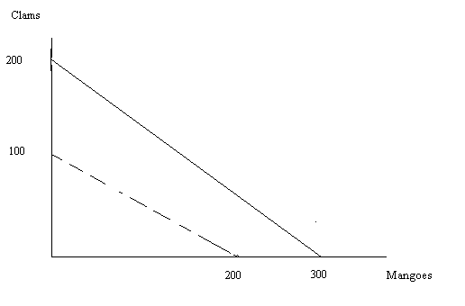
Now, with the improvement in technology (the clamrake and your knowledge of mangoes) the production of both goods has increased relative to their initial levels.
e. The opportunity cost of producing a mango was originally ½ clam and with the changes in technology the opportunity cost of producing a mango is now 2/3 clam.
f. Clams have gotten relatively cheaper since originally it cost 2 mangoes to get a clam and now it only costs 1.5 mango to get a clam.

2.
a.
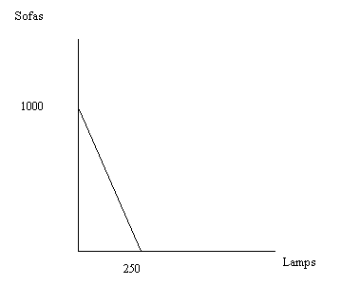

b.
Combination | Number of Lamps Possible | Number of Sofas Possible
A | 0 | 1000
B | 50 | 800
C | 125 | 500
D | 200 | 200
E | 225 | 100
F | 250 | 0

- -4
- The opportunity cost of producing one additional sofa is ¼ lamp.
- The opportunity cost of producing one additional lamp is 4 sofas.
- The value of the y-intercept is 1000 sofas.
- S = 1000 – 4L

3.
a. The production possibility frontier drawn below is based upon 60 hours of labor.
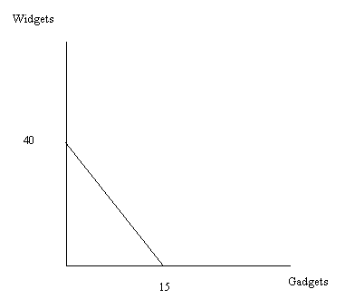
b. The slope of the production possibility frontier is -4.
c. The opportunity cost of producing an additional widget is ¼ gadget.
d. The opportunity cost of producing an additional gadget is 4 widgets.

4.
a. The supply of bread curve will shift to the right causing a movement along the demand curve for bread. The equilibrium price will fall and the equilibrium quantity will increase.
b. The supply of automobiles will shift to the right causing a movement along the demand curve for automobiles. The equilibrium price will fall and the equilibrium quantity will increase.
c. The demand for sweatshirts will shift to the right causing a movement along the supply curve. The equilibrium price and the equilibrium quantity will increase.
d. The demand curve for cars will shift to the left while the supply curve for cars will shift to the right. The equilibrium price will definitely decrease but the equilibrium quantity is indeterminate. The equilibrium quantity may increase, decrease, or remain the same relative to its initial level.
e. The change in tastes and preferences will cause the demand for pasta dinners to shift to the left, but the change in income will cause the demand for pasta dinners to shift to the right since pasta dinners are an inferior good. Without more information it is impossible to say what has happened to the equilibrium price and quantity in this market.

5.
a. The equilibrium price is $8 and the equilibrium quantity is 6 units of chocolate.
b. The equation for the new supply curve for chocolate is P = Q + 4. The new equilibrium price is $8.50 and the new equilibrium quantity is 4.5 units of chocolate. The price increased by $.50 per unit of chocolate.
c. The demand for oil is inelastic relative to the demand for chocolate. That is, a change in the price of oil causes a relatively small change in the quantity demanded of oil while a change in the price of chocolate causes a relatively large change in the quantity demanded of chocolate.
d. The equilibrium price in the oil market is $8 per unit of oil and the equilibrium quantity is 6 units of oil.
e. The new supply curve equation is the same one that we found in the chocolate market since the shift in the supply curve is equivalent. Thus, the new supply equation is P = Q + 4 where Q is the quantity of oil and P is the price of oil. But, even though the supply curve equations are the same in the two markets, the change in the equilibrium price is much greater in the market for oil than for the market for chocolate since demand is much more inelastic in the market for oil. The equilibrium price increases to $(68/7) or approximately $9.71. The equilibrium quantity is now equal to 40/7 units of oil or approximately 5.71 units of oil. The change in the price of oil is approximately equal to $1.71 per unit of oil.
f. The change in the price of oil is larger than the change in the price of chocolate because the demand for oil is relatively more inelastic than the demand for chocolate at the initial equilibrium point.

6.
a. The equilibrium price of wheat is $800 per unit of wheat and the equilibrium quantity of wheat is 200 units.
b. The value of consumer surplus is $20,000.
c. The value of producer surplus is $80,000.
d. The value of total surplus is equal to the sum of producer and consumer surplus or $100,000.
e.
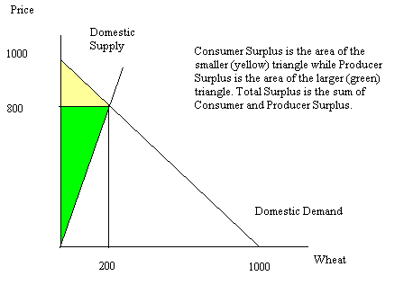

7.
a. When the world price is $500 and Fantasia opens its wheat market to trade, Fantasia will import wheat since the world price is lower than the domestic price. At a world price of $500 Fantasia will import 375 units of wheat.
b.
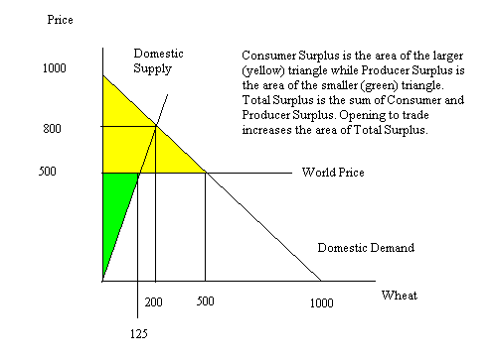
c. Consumer Surplus is originally equal to $20,000 and when Fantasia opens its wheat market to trade Consumer Surplus increases to $125,000 or a change of $105,000.
d. Producer Surplus is originally equal to $80,000 and when Fantasia opens its wheat market to trade Producer Surplus decreases to $31,250 or a decrease of $48,750.
e. Domestic consumers favor opening the market to trade since their consumer surplus is enhanced, but domestic producers are against opening this market to trade since their producer surplus is decreased when the market opens to trade.
f. Yes, trade benefits Fantasia overall since total surplus increases from $100,000 to $156,250.

8.
a. Fantasia will import 100 units of wheat when this legislation is passed.
b. The value of consumer surplus is $39,200 with this quota.
c. The value of producer surplus is $64,800 with this quota.
d. The value of the license holder revenue is $22,000 with this quota.
e. The value of deadweight loss is $30,250 with this quota.
f. Relative to completely open trade, domestic producers benefit from this legislation while domestic consumers are harmed. Domestic producers benefit from this legislation since it increases producer surplus from $31,250 to $64,800 while domestic consumers are harmed by this legislation since it decreases consumer surplus from $125,000 to $39,200.

9.
a. The equilibrium number of gallons of gas in Smalltown is 800 gallons.
b. The tax per gallon of gasoline is $2.50. To see this first substitute 400 gallons of gasoline into the demand curve to see what price corresponds to the price that demanders are willing to pay for 400 gallons of gasoline. This price is $3. Then, substitute 400 gallons of gasoline into the supply curve to see what price corresponds to the price that suppliers are willing to see 400 gallons of gasoline. This price is $.50. Thus, in order for 400 gallons of gasoline to be demanded and supplied, the supply price of $.50 must be increased by $2.50. Thus, the net price of gasoline ($.50) plus the excise tax of $2.50 equals the total price of gasoline.
c. Consumer surplus is initially equal to $1600 and with the imposition of the excise tax decreases to $400. Thus, the change in consumer surplus is equal to $1200.
d. Producer surplus is initially equal to $400 and with the imposition of the excise tax decreases to $100. Thus, the change in producer surplus is equal to $300.
e. The tax revenue from this tax is equal to the tax per unit times the number of units sold. Or, the tax revenue is equal to ($2.50)(400 gallons of gasoline) is equal to $1000.
f. The deadweight loss associated with this excise tax is equal to (1/2)($2.50)(400 units) or $500.

