Economics 101 Student Name :
10/07/2009 Section # :
First Midterm TA Name :

Version X
DO NOT BEGIN WORKING UNTIL THE INSTRUCTOR TELLS YOU TO DO SO. READ THESE INSTRUCTIONS FIRST.
You have 75 minutes to complete the exam. The exam consists of 13 binary choice questions and 24 multiple choice questions. Each binary choice question is worth 2 points, and each multiple choice question is worth 3 points. You will get 2 point for filling in your name, student ID number, number of the discussion section that you are enrolled in, and version number correctly. Please answer all questions on the scantron sheet with a #2 pencil.
No cell phones, calculators, or formula sheets are allowed.
PICK THE BEST ANSWER FOR EACH QUESTION.

How to fill in the scantron sheet:
- Print your last name, first name, and middle initial in the spaces marked "Last Name," "First Name," -, and "MI." Fill in the corresponding bubbles below.
- Print your student ID number in the space marked "Identification Number." Fill in the bubbles.
- Write the number of the discussion section you are enrolled in under "Special Codes" spaces ABC, and fill in the bubbles. You can find the discussion numbers below on this page.
- Write the version number of your exam booklet under "Special Codes" space D, and fill in the bubble. The version number is on the top of this page.

Other Instructions:
- If there is an error on the exam or you do not understand something, make a note on your exam booklet and the issue will be addressed AFTER the examination is complete. No questions regarding the exam can be addressed while the exam is being administered.
- When you are finished, please get up quietly and bring your scantron sheet and this exam booklet to the place indicated by the instructors.
Discussion sections are as follows:

Atsuko Tanaka  363 2:25 F 53 BASCOM  370 3:30 F 6310 SOC SCI | Jiabin Wu  360 8:50 F 52 BASCOM  357 11:00 F 286 VAN HISE  358 12:05 F 52 BASCOM  364 13:20 F 222 INGRAHAM | Heewoo (Hugh) Kang  366 8:50 F 214 INGRAHAM  373 9:55 F B337 VAN VLECK  361 13:20 F 116 INGRAHAM  362 14:25 F 123 INGRAHAM
Drew Anderson  371 9:55 F 475 VAN HISE  356 11:00 F 290 VAN HISE  359 12:05 F 115 INGRAHAM  372 15:30 F 6224 SOC SCI | Young Wook Lee  367 8:50 F 122 INGRAHAM  374 12:05 F 123 INGRAHAM  365 13:20 F 120 INGRAHAM

Work sheet:

I. Binary Choice Questions: (Worth 2 points each)

- Consider the statement “The macroeconomy is in a recession”.
  - This statement is a positive statement.
  - This statement is a normative statement.

Use the following information to answer the next two (2) questions.

Analyze the market for Cinnamon Toast Crunch Cereal. Assume in the market for Cinnamon Toast Crunch Cereal that the demand curve is downward sloping the supply curve is upward sloping.

- Frosted Flakes is a substitute for Cinnamon Toast Crunch Cereal. The demand curve for Frosted Flakes is downward sloping. If the price of milled corn, the number one ingredient in Frosted Flakes (but not an ingredient used for Cinnamon Toast Crunch Cereal) decreases, then the equilibrium price of Cinnamon Toast Crunch Cereal
  - increases.
  - decreases.

- Cows throughout the United States contract a rare disease carried by mosquitoes, making all domestic milk unsafe to drink. Milk is considered a complement to Cinnamon Toast Crunch Cereal. At the same time, the price of cardboard boxes, which are used in packaging Cinnamon Toast Crunch Cereal, increases. The effect of these two events on the equilibrium _______ of Cinnamon Toast Crunch Cereal is ambiguous.
  - price
  - quantity

- Suppose the initial demand curve for good Z is given by
Q _{D} = 15 − P.
Income for the individuals in this market increases, and the demand curve is now given by
3Q _{D} =10 − 3P.

We know that good Z is
- a normal good.
- an inferior good.

- The table below shows the demand & supply schedules for Kawasaki Eliminator 250V motorcycles, a popular model in Madison. In order to reduce noise pollution from the motorcycles, the city of Madison imposes a price floor of $5000 per motorcycle. According to the demand & supply schedule below, the price floor is ______.
- effective
- not effective

- The price of computer memory in 2005 was $20/GB. It has since decreased by 25%. The government is proposing a tax that would increase the cost of all consumer goods by 25%. The cost of 1 GB of memory will be
- $20/GB
- $18.75/GB

- The law of demand states that the quantity demanded of a certain good is a direct function of its price, holding all else equal. This statement is
  - true
  - false

- The government increases the gas tax on gas producers by $2 per gallon. Holding everything else constant, the equilibrium quantity of gas decreases. The change in the quantity demanded is due to _______.
  - a movement along the demand curve.
  - a shift in the demand curve.

- Beth has eaten pineapple upside-down cake five times at school this month. She also noticed that pineapple prices in grocery stores have risen compared to last month. Such a situation occurs if the government is implementing an agricultural farm _______ program.
  - subsidy
  - support

- Total consumer surplus is defined as the sum of
- net gains to individual buyers from the purchase of a good.
- all the buyers' willingness to pay for a good plus the price of that good.

- Legislation of an effective minimum wage results in a of labor in the low skilled labor market.
- surplus
- shortage

Use the following information to answer the next three (3) questions. (Two (2) binary choice question & one (1) multiple choice question)

The linear production possibility curves for 2 countries are shown in the following figure. Assume that both countries only produce coconuts and fish. Use the figure to answer the following three questions.
1500
fish
500
Country A
Country B
coconuts
coconuts
fish
2500
500
- Which country has the comparative advantage in producing coconuts?
  - Country A
  - Country B

- Which graph shows the combined PPF of these two countries?
(Note: graphs are NOT drawn to scale)
  - Graph 1
  - Graph 2
fish
1000
4000
coconuts
1000
4000
coconuts
fish
(1500, 500)
(2500, 500)
GRAPH 1
GRAPH 2

II Multiple Choice Questions (Worth 3 points each):

- If Country A and Country B engaged in specialization and trade, _____ will specialize in producing coconuts. A price (in terms of number of fish) acceptable to both countries for a coconut is ______ .
  - country A; 3.5 fish
  - country A; 0.3 fish
  - country B; 4 fish
  - country B; 0.2 fish

- According to Gregory Mankiw, one of the key principles of economics is that
- trade is too costly to be practical.
- markets rarely work.
- prices fall when the government prints too much money.
- people respond to incentives.

- Suppose the market for soft drinks is competitive. Which of the following will cause the equilibrium quantity of soft drinks sold to decrease?
- The price of fruit juices increases due to poor weather for fruit growing
- The price of aluminum, used in making cans for soft drinks decreases
- The sales tax levied on all consumer goods decreases
- Legislation banning the sale of soft drinks in elementary schools is implemented

- Which of the following is considered both an opportunity cost and an accounting cost of attending college?
  - Food Expenses
  - Housing Expenses
  - Text books
  - Foregone salaries

The graph below shows the demand and supply curves in the market for good X.

S
D

- Use the above graph to answer this question. The government wants to promote the use of good X and decides to pay producers a subsidy of $25 for each unit of good X that they produce. How much money will the government pay to producers under this policy? Calculate the approximate amount of the government expenditure from the above graph. Government expenditure is
  - about $750
  - about $1000
  - about $1250
  - about $1500

- Suppose the following two events happen simultaneously:
EVENT 1: Consumers think that the price of toilet paper will increase significantly in the near future.
EVENT 2: Hurricane Atsuko destroys half of the nation’s oil and toilet paper production facilities.
What happens to the equilibrium price and quantity of toilet paper?
- The price of toilet paper rises, and the quantity of toilet paper falls.
- The price and quantity of toilet paper both increase.
- The quantity of toilet paper rises, but the price of toilet paper could rise or fall.
- The price of toilet paper rises, but the quantity of toilet paper could rise or fall.

- The equation Ax + By = C expresses a linear relationship between variables x and y. A, B, and C are constants. (Assume that B ≠ 0.) On a graph with x on the horizontal axis and y on the vertical axis, what is the slope of this line?
- A / B
- (BC) / A
- − A / B
- ( − A + C) / B

- The UW Lacrosse Club plays a game of lacrosse every Thursday night. The fee a player must pay in order to participate in each game is $10. Troy is thinking about playing this Thursday. Troy is also considering other alternative uses of his time including the following two possibilities:
I) tutoring in the college Library and earning $21.
II) selling pizza and earning $18.

What is the opportunity cost of playing Lacrosse this Thursday night?
- $21
- $31
- $39
- $49

Use the graph below to answer the following 2 questions.

The production possibility frontier for Wonderland is shown in the following figure. Assume that Wonderland only produces bicycles and computers. Use the figure to answer the following two questions. Assume the PPF is linear between any two adjacent points (e.g. the PPF is linear between points A and B, or between points B and C).

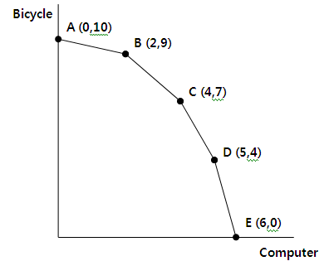

- What is happening to the opportunity cost of producing more bicycles as we move from point D to point B?
- The opportunity cost of a bicycle increases.
- The opportunity cost of a bicycle decreases.
- The opportunity cost of a bicycle stays the same all along the PPF.
- The opportunity cost of a bicycle cannot be calculated from the given information.

- Currently, Wonderland is producing at point D. The opportunity cost of producing one more computer is ; the opportunity cost of producing one more bicycle is _______.
- 1/4 bicycle; 1 computer
- 4 bicycles; 1/4 computer
- 1/4 bicycle; 3 computers
- 4 bicycles; 1/3 computer

- The news last night reported a huge earthquake in the North Sea, near England. Several important offshore oilfields are located nearby, but details about the damages have not been confirmed. As a Futures Broker on Wall Street, what would you expect this morning?
- the demand curve for shares of oil stock is unchanged, but the quantity of oil stock shares demanded increased.
- the demand for shares of oil stock shifted right in anticipation of future price increases.
- the demand for shares of oil stock shifted left in anticipation of future price increases.
- there would be no change in either the demand curve for shares of oil stock or the quantity demanded of oil stock shares, because not enough time has passed for the earthquake's effects on the world economy to be known.

Use the following information to answer the next three (3) questions.

The demand for text books is given by Q D = 750 − 30P and the supply is given by Q S = 30P − 450.

- An excise tax imposed in this competitive market for textbooks will
  - increase the equilibrium quantity as well as the equilibrium price.
  - not affect the equilibrium quantity but will increase the equilibrium price.
  - decrease the equilibrium quantity while the equilibrium price increases.
  - decrease the equilibrium quantity as well as the equilibrium price.

- An excise tax of $2.00 per book is levied on book producers. What is the equilibrium price after the tax is imposed? What is the net price received by producers?
  - The equilibrium price after the tax is $19, the net price received by producers is $17.
  - The equilibrium price after the tax is $21, the net price received by producers is $19.
  - The equilibrium price after the tax is $20, the net price received by producers is $18.
  - The equilibrium price after the tax is $18, the net price received by producers is $20.

- Given the excise tax of $2.00 per book, what is the value of consumer surplus after the imposition of the tax?
  - $375
  - $240
  - $480
  - $360
Use the following information to answer the next two (2) questions.

Consider a market for good X that has only two consumers, June and Langdon. June’s demand for the good is given by the equation P = 12 − 3 Q D , while Langdon’s demand for the good is given by the equation P = 5 − 0.5 Q D.

- Which graph shows the aggregate demand function in this market?
- Graph 1
- Graph 2
- Graph 3
- Graph 4

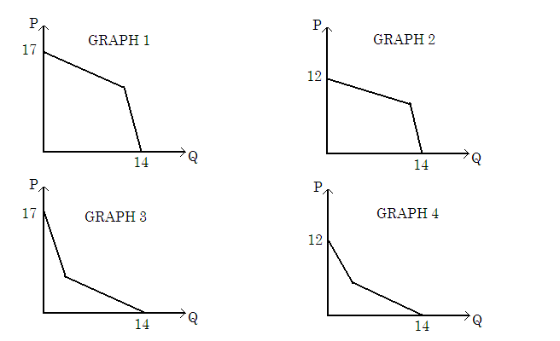

- The market supply is P = 4 + Q S. What are the equilibrium price and quantity in this market?
- Price = 7 , Quantity = 3
- Price = 5 , Quantity = 1
- Price = 4.8 , Quantity = 0.8
- Price = 6 , Quantity = 2

Use the following information to answer the next two (2) questions.

In Wisconsin, the demand for red t-shirts is given by the equation P = 12 – Q_{d} and the supply of red t-shirts is given by the equation P = Q_{s} + 2.

- What is the equilibrium price of red t-shirts in Wisconsin assuming that the market for red t-shirts in Wisconsin is a closed market (i.e., there is no trade with other states or other countries in this market)?
- P = $7
- P = $10
- P = $8
- P = $11

31. Suppose that the price of red t-shirts in Minnesota is P = $5. If the State of Wisconsin starts to trade with Minnesota, then how many red t-shirts would Wisconsin import?
- 3 red t-shirts
- 4 red t-shirts
- 5 red t-shirts
- 6 red t-shirts

Use the following information to answer the next three (3) questions.

Suppose the market for eggs is competitive. In this market, egg farmers are producers and grocery shoppers are consumers. The demand and supply curves in the market for eggs can be expressed as follows:

P = 20 − (2/5)Q_{D}
P = (3/5)Q_{S}

Where quantity is measured in millions of gross of eggs per year and price is measured in US dollars per gross (144 eggs). Given the above information, please answer the following three questions:

32. The equilibrium price for a gross of eggs is
- $10
- $12
- $20
- $50

33. The total consumer surplus in this market is
- greater than the total producer surplus.
- equal to the total producer surplus.
- less than the total producer surplus.
- not enough information to say.

34. Suppose that the government intervenes in the market and buys 25 million gross of eggs. What is the price floor for eggs?
- $6
- $12
- $18
- $20

Use the following information to answer the next three (3) questions.

Suppose that the worldwide demand for oil is given by P = − 4Q_{d} + 20, and the worldwide supply for oil is given by P = Q_{s}/2 + 2. Also, suppose that only countries that are members of the Organization of Petroleum Exporting Countries (OPEC) can supply oil internationally.

35. Suppose supply decreases by 2 units at each price level, what is the new supply function?
- P = Q_{s}/2 or Q_{s} = 2P
- P = Q_{s}/2 + 4 or Q_{s} = 2P − 8
- P = Q_{s}/2 + 3 or Q_{s} = 2P − 6
- P = Q_{s}/2 + 1 or Q_{s} = 2P − 2

36. Answer this question starting with the initial demand and supply equations. Suppose people are buying twice as much at each price level than they did initially. Which graph below shows this change in demand?
  - Graph 1
  - Graph 2
  - Graph 3
  - Graph 4
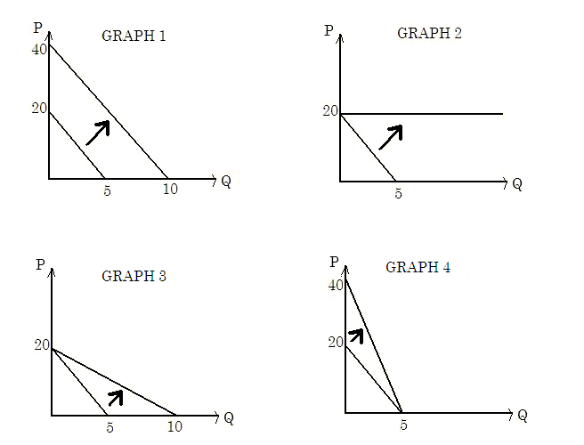

37. (Warning: this is a challenging question.) One day, OPEC decides to impose a quota of 3 in order to reduce CO2 emissions. That is, they only supply 3 units of oil at most, no matter how high the demand is. How much is the deadweight loss associated with this quota?
- $9/2
- $3
- $9/4
- $9/5

Answer
- a
- b
- a
- b
- b
- b
- b
- a
- b
- a
- a
- a
- b
- a
- d
- d
- c
- a
- d
- c
- b (dropped)
- a
- d
- b
- c
- b
- b
- d
- d
- a
- b
- b
- c
- c
- c
- c
- c

