Economics 101 Name ____________________
Summer 2010
Quiz #4
6/30/10 Discussion Section Day and Time ____________________

Question 1: CPI/Inflation (1 Point)

You have the following information about the economy for Little Italy

Year | Price of Spaghetti | Price of Meatball | Price of Cannoli
2005 | $4 | $1 | $2
2006 | $6 | $1 | $2
2007 | $6 | $2 | $2

The market basket of goods in Little Italy is one Italian dinner. The Italian dinner is comprised of:
1 order of Spaghetti, 2 Meatballs and 1 Cannoli (This is the market basket)

Using any base year you would like, calculate the inflation rate between 2006 and 2007. (Hint: the inflation rate is the same no matter what base year you use.)

It is easiest to pick the base year to be 2006, so that the CPI for 2006 will be 100. This makes calculating inflation between 2006 and 2007 much easier to calculate.
CPI (2006) | 100
CPI (2007) | Unknown

The inflation rate is just:
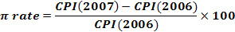

To find the CPI for 2007, we calculate it by:
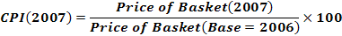

Substituting this in to the CPI(2007) formula gives us:
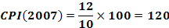
Now we can substitute this information into our inflation rate formula:
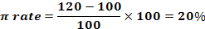
Question 2: Elasticity (1 point)

You have the following information about Steak and Lobster.

Quantity of Steak | Quantity of Lobster | Price of Lobster
100 | 100 | $20
75 | 80 | $25

- Find the cross price elasticity of demand for steak, using the arc-elasticity formula.

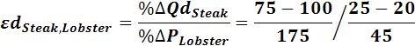

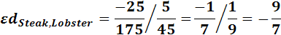

- Are steak and lobster substitutes, complements or neither? (Circle your answer)

- Substitutes
- Complements
- Neither
- Not enough information

Question 3: Utility and Preferences (.5 points)

You know the following information about an individual and their preferences between X and Y, and information about the market for goods X and Y.

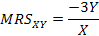

- Write down the equation for the individual’s budget constraint. Be specific.

A budget constraint follows the equation I = PxX + PyY, so substituting in the values we end up with: 240 = 6X + Y

- Determine the optimal combination of good X and Y that the individual buys.

Set:

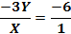

Cross multiplying you get your optimality condition (the ratio of Y to X at optimal combo):

Plug in the optimality condition into the budget constraint you found in part a:
Then, Y*=60, and X*=30

