Economics 101 Name _____________________________________
Summer 2009
Answers to Quiz #4
June 16, 2009 Day and Time of Discussion Section _____________

1. Consider a particular market. If this market supplier is a monopolist then
a. The market quantity will be lower than if the market was characterized as a perfectly competitive market.
b. The market price will be higher than if the market was characterized as a perfectly competitive market.
c. The value to the consumer of the last unit produced by the monopolist will be greater than the cost of producing the last unit.
d. All of the above statements are true.
e. Answers (a) and (b) are true statements.
f. Answers (b) and (c) are true statements.
g. Answers (a) and (c) are true statements.

2. A monopolist who charges two different prices for their product
a. Cannot be profit maximizing since there is only one profit maximizing price where MR = MC.
b. Will decrease the area of deadweight loss associated with the provision of this product.
c. Can capture more of the area of consumer surplus than if the monopolist charges a single price.
d. All of the above statements are true.
e. Answers (a) and (b) are true statements.
f. Answers (b) and (c) are true statements.
g. Answers (a) and (c) are true statements.

3. Suppose a natural monopoly is regulated to produce the socially optimal amount of output. This will
a. Require a tax on the monopolist in order for the government to capture the positive economic profits the firm will earn.
b. Require a subsidy for the monopolist in order for the monopolist to be willing to produce the socially optimal amount of the output.
c. Result in the monopolist earning zero economic profit in the long run.
d. Result in the monopolist producing in its decreasing returns to scale portion of its average total cost curve.

Answer the next question on the basis of the following information. You are told the market demand curve for a product produced in a perfectly competitive industry. You are also given an equation for the firm’s total cost curve and an equation for the firm’s marginal cost curve.

4. From this information which of the following statements is true?
I. It is possible to determine the long run equilibrium price by setting TC equal to MC and solving first for the equilibrium quantity and then using this quantity to find the equilibrium price.
II. In the long run the perfectly competitive firm will produce that level of output where the firm breaks even.
III. Once the long-run equilibrium price is determined in this market, it is then possible to determine the market quantity and the representative firm’s level of production. You can then calculate the number of firms in the industry in the long-run.
a. Statement I is correct.
b. Statement II is correct.
c. Statement III is correct.
d. Statements I and II are correct.
e. Statements II and III are correct.
f. Statements I and III are correct.
g. Statements I, II and III are correct.

Use the following information to answer this last set of questions.

The market demand curve for gadgets is given by the equation P = 1000 – 4Q. The MC of gadget production is given by MC = 200. Assume the fixed cost of producing gadgets is equal to $300.

5. If the market for gadgets is supplied by a monopolist, what is the equilibrium output and price for gadgets assuming that the monopolist charges a single price for gadgets? Show your work.

To find the equilibrium price you first need the firm’s MR curve: MR = 1000 – 8Q. Setting MR = MC you get 1000 – 8Q = 200 or Q = 100. To find the equilibrium price you need to plug this quantity into the market demand curve: P = 1000 – 4(100) = 600.

6. If the market for gadgets is supplied by a monopolist, what is the value of consumer surplus (CS)? Show your work.

CS = (1/2) ($1000/unit - $600/unit)(100 units)
CS = $20,000
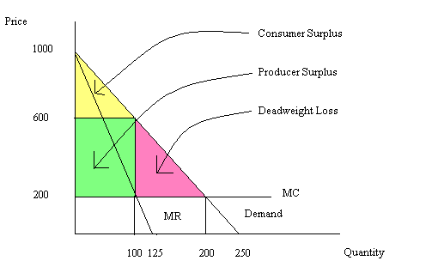
7. If the market for gadgets is supplied by a monopolist, what is the value of producer surplus (PS)? Show your work.

PS = ($600/unit - $200/unit)(100 units)
PS = $40,000

8. If the market for gadgets is supplied by a monopolist, what is the value of the deadweight loss?

DWL = (1/2)($600/unit - $200/unit)(200 units – 100 units)
DWL = ($200/unit)(100 units)
DWL = 20,000

9. Suppose this monopolist is able to practice perfect price discrimination (first degree price discrimination). How many units of output will the monopolist produce? Explain why this is the socially optimal amount of output.

The perfect price discriminating monopolist views the market demand curve as its marginal revenue curve since it charges a different price for each unit of output it produces. The monopolist charges that the highest price the consumer is willing to pay for each unit of output. The monopolist then selects its profit-maximizing level of output by equating its MR curve to its MC curve. Thus, 1000 – 4Q =200 and Q = 200 units.

10. Suppose this monopolist is able to practice perfect price discrimination (first degree price discrimination). What is the area of producer surplus equal to in this case? Show your work.

PS with perfect price discrimination is equal to (1/2)($1000/unit - $200/unit)(200 units) = ($400/unit)(200 units) = $80,000.

