Economics 101 Name ________________________________________
Summer 2012
Answers to Quiz #3
6/13/12

- Libby’s income is $100 and she uses all of her income to purchase balloons and sodas. Use this information and the graph below to answer this set of questions.
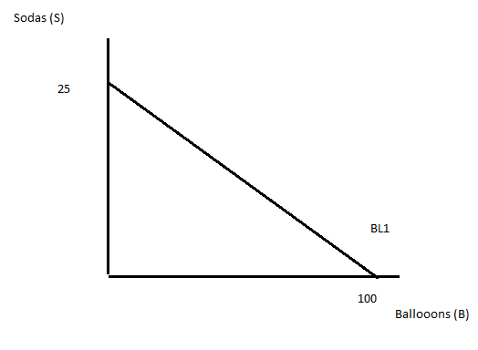
- (1 point) Given the above information and the figure, what is the price of a balloon?

Answer:
The price of a balloon is $1 since Libby can afford to buy 100 balloons when she uses all of her income to buy balloons. Or, Income = (Price of balloons)(Quantity of balloons) and substituting in what we know, we have 100 = (price of balloons)(100 balloons) or the price of balloons is $1 per balloon.

- (1 point) Given the above information and the figure, what is the price of a soda?

Answer:
The price of a soda is $4 since Libby can afford to buy 25 sodas when she uses all of her income to buy sodas. Or, Income = (Price of soda)(Quantity of sodas) and substituting in what we know, we have 100 = (Price of soda)(25 sodas) or the price of soda is $4 per soda.

- (1 point) Write an equation in slope-intercept form for Libby’s budget line.

Answer:
S = 25 – (1/4)B

- Suppose that Libby maximizes her utility given budget line 1 when she selects a bundle that includes 20 sodas.

- (1 point) How many balloons are in this optimal consumption bundle?
- (1 point) On the graph indicate this optimal consumption bundle and label it bundle A. Identify numerically on the graph the quantity of balloons and the quantity of sodas associated with bundle A.
- ( 1 point) Draw an indifference curve (IC1) on the graph such that bundle A represents the utility maximizing bundle for Libby.

Answers:
- When Libby buys 20 sodas this purchase costs her $80 since the price of a soda is $4 and she buys 20 sodas. That leaves her $20 to spend on balloons and since each balloon costs $1 she can buy 20 balloons.
- See graph below.
- See graph below.
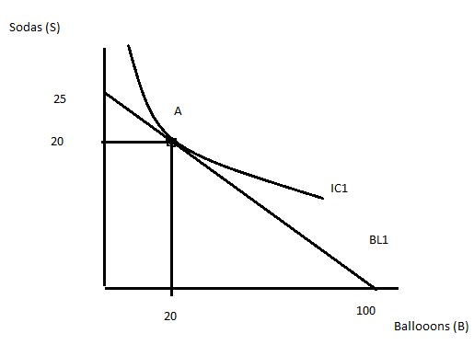

- (2 points) Suppose the price of balloons doubles. On the graph draw BL2 given this new information.

Answer:

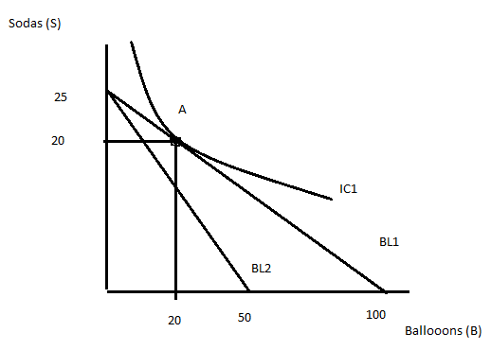
- (2 points) Given BL2, can Libby still consume bundle A? Explain your answer.

Answer:
No Libby cannot afford bundle A once the price of balloons increases while her income stays constant. We can see that since her new budget line, BL2, sits beneath BL1.

- (1 point) On BL2 identify a bundle of sodas and balloons that could represent the new utility maximizing choice for Libby and label this bundle B. Identify the quantity of sodas (S2) and the quantity of balloons (B2) Libby will choose to consume given this consumption bundle B.

Answer:
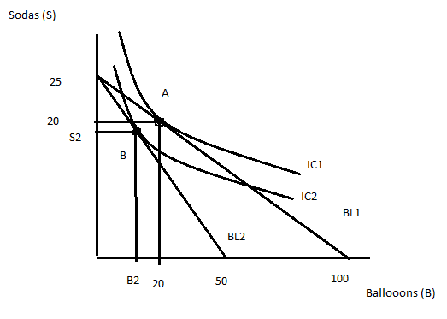

- (1 point) Draw in BL3, the imaginary budget line that adjusts the income of Libby so that she is now paying the new prices for the two goods, while she is still getting the level of utility she had initially. Label this budget line and identify bundle C, the bundle of sodas and balloons she would choose to consume on BL3 given her tastes and preferences.

Answer:
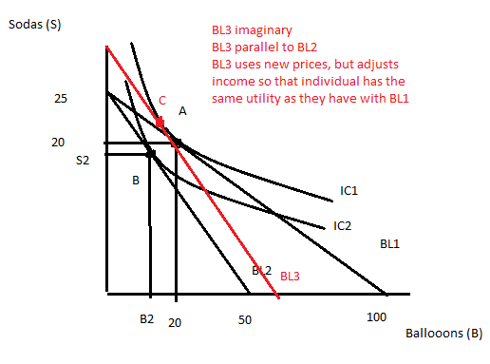

- (3 points) On the graph identify the substitution effect and the income effect. Describe in words what these two effects are in the space below.

Answer:
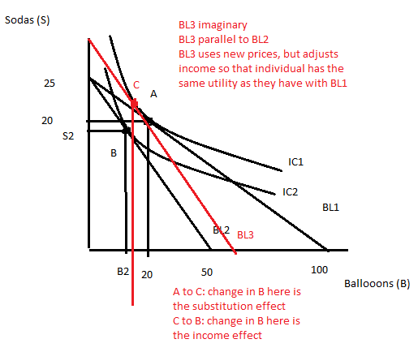
Substitution effect: is the change in consumption of the good due to the change in the relative price of the good having adjusted income for any change in purchasing power due to the change in the price of the good. On the above graph the substitution effect for balloons would be the change in the number of balloons going from point A to point C. Notice that with the substitution effect we are comparing points that lie on the same indifference curve while using the old prices for one budget line and the new prices for the other budget line.

Income effect: the change in consumption of the good due to the change in purchasing power that occurs when the price of the good changes. On the above graph the income effect for balloons would be the change in the number of balloons going from point C to point B. Notice that with the income effect we are comparing points that lie on parallel budget lines.

