Economics 101 Name ____________________
Summer 2010
Answers to Quiz #2
6/9/10 Discussion Section Day and Time ____________________

Each question is worth 1/4th of a point, except where noted.

Assume that all demand and supply curves are linear.

Use the following information for the next SIX questions.

Suppose you have the following information about a demand curve.

Price | Quantity
10 | 2
9 | 4

- What is the equation for the demand curve? _______________________

Answer: Given these two points, one can determine the slope of the demand curve, which is – .5. So we know that
P = B – .5Q
and we just need to find the y-intercept. To determine B we can use a combination of P and Q that we know lie on the demand curve (either of the points in the table). Doing this we can find that:
10 = B – .5(2)
10 = B – 1
11 = B
So the equation for the demand curve is just: P = 11 - .5Q

Suppose that you also know that the supply curve is P = 4 + .2Q

- What is the equilibrium price and quantity? _______________________

Answer: Using our equation for demand and equating the prices gives us
11 - .5Q = 4 + .2Q
7 = .7Q
10 = Q
and we can then solve for P by substituting our value for Q into either the supply or demand equation. Using supply:
P = 4 + .2(10)
P = 4 + 2
P = 6
So, equilibrium price = 6 and equilibrium quantity = 10.

- Determine consumer surplus for this market. _______________________

- Determine producer surplus for this market. _______________________

Both of these are easiest to figure out if you draw a graph for the market.
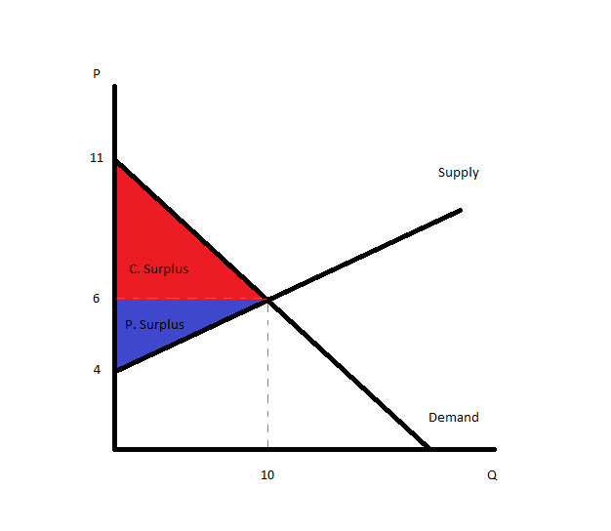

The area of the triangle for consumer surplus is: (.5)*(5)*(10) = $25
The area of the triangle for producer surplus is: (.5)*(2)*(10) = $10

- Suppose that the government introduced a price floor in this market, and set it at $5.00. Determine the impact of this price floor on this market: be specific about whether the price floor creates a shortage or a surplus and provide a numeric measure with your answer.
_______________________

A price floor of $5.00 does not affect this market. A price floor makes it so that firms cannot set prices below a certain amount. In this case, the equilibrium price is $6.00, which would not be prevented by a $5.00 price floor. So there is no excess supply or demand.

- Suppose that the government introduced a price ceiling in this market, and set it at $5.00. Determine the impact of this price ceiling on this market: be specific about whether the price ceiling creates a shortage or a surplus and provide a numeric measure with your answer. ______________________

A price ceiling of $5.00 would have an effect on this market. The situation is graphed below.

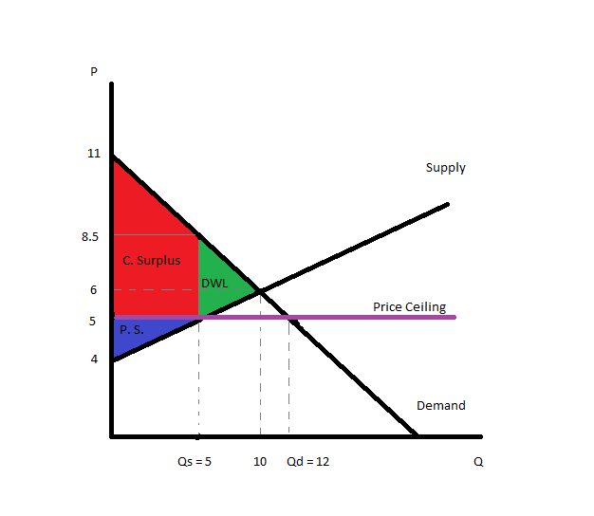
There is excess demand (a shortage) of 7 units.

Reminder: the rest of the questions on this quiz are separate from the first six questions on the quiz.

7. The iPhone and the Blackberry are substitute goods in the smart phone market. What happens to the demand for iPhones when the price of the Blackberry decreases? Draw a graph of this scenario. Clearly label your axes, and indicate which curves are shifting (if any). Label the new equilibrium point. Also be sure to describe any indeterminacy which may occur and would not be apparent on your graph.

The graph is included below.

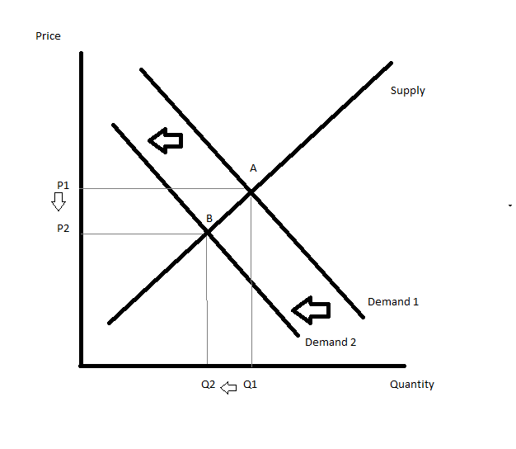
A decrease in the price of the Blackberry causes demand for iPhones to shift from Demand 1 to Demand 2. Individuals flock towards the now relatively cheaper Blackberry as a substitute option. As a result of the shift, the equilibrium quantity falls from Q1 to Q2, and the equilibrium price falls from P1 to P2. We move from equilibrium A to equilibrium B. There is no indeterminacy here since there is only one shift.

8. (This question is worth 1/2 of a point) Chocolate syrup and ice cream are complementary goods. Consider the effect of both of the following on the ice cream market. First, the price of chocolate syrup increases. Additionally, the food and drug administration endorses a new hormone which allows cows to produce more milk than before. What happens in the ice cream market? Draw a graph of this scenario. Clearly label your axes, and indicate which curves are shifting (if any). Label the new equilibrium point. Also be sure to describe any indeterminacy which may occur and would not be apparent on your graph.

The graph is included below.

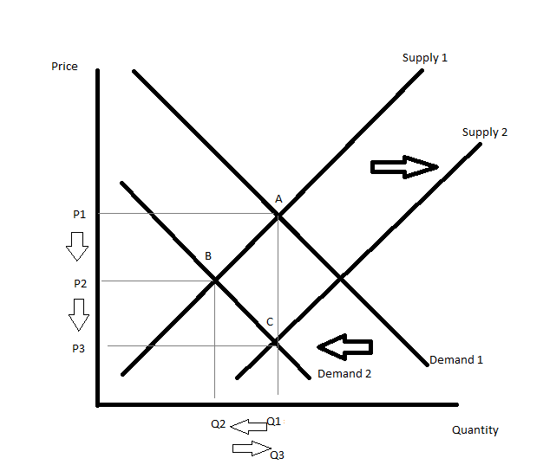
An increase in the price of syrup will reduce demand for ice cream, causing demand to shift from Demand 1 to Demand 2. We move from equilibrium A to equilibrium B, prices fall from P1 to P2, and quantity falls from Q1 to Q2.

The new hormone is an example of a technological improvement that allows cows to make more milk, which makes more ice cream. This shifts the supply curve from Supply 1 to Supply 2. We move from equilibrium B to equilibrium C, prices fall from P2 to P3, and quantity increases from Q2 to Q3.
It is clear that prices decrease (both shifts cause prices to fall in equilibrium). However, quantity is indeterminate because the demand shift reduces quantity while the supply shift increases quantity.

Getting the shifts right was worth 1/4th of a point, and talking about the indeterminacy was worth another 1/4th of a point.

9. Consider the shrimp market. A friend of yours suggests that because of the recent oil spill, the supply of shrimp will decrease and the price of shrimp will increase. However, when you draw a supply curve for shrimp, you notice that higher quantities supplied are associated with higher prices, and that lower quantities supplied are associated with lower prices. Is your friend right? What is going on here? A brief answer is all that is required.

This is the difference between a movement along a curve and a shift of a curve. As you move up the supply curve, the supplier will increase quantity supplied as prices increase. This describes the association of higher prices to higher quantities supplied.
However, the oil spill is going to shift the supply curve of shrimp to the left (as an example of a natural disaster or weather) so we do not want to think about this as a movement along the curve. As the supply curve shifts to the left, in equilibrium we will observe higher prices and less quantity.

