Economics 101 Name ____________________
Summer 2012
Answers to Quiz #1
6/ Discussion Section Day and Time ____________________

Please answer all questions neatly and legibly. Your TA will not want to spend their time hunting for your answers or trying to decipher difficult handwriting.

- Use the figure below to answer this question. In the figure the location of line 2 is meant to be ambiguous-you must actually figure out its location from the given information! Show your work in order to get full credit.

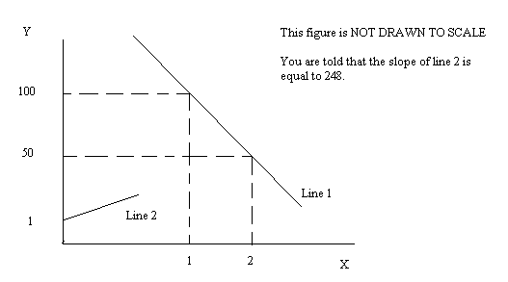
- (One point) Write an equation in slope intercept form for Line 1.

Answer: y = mx + b
m = -50/1
y = -50x + b
100 = (-50)(1) + b
b = 150
Y = 150 – 50X

- (One point) Write an equation in slope intercept form for Line 2.

Answer: y = mx + b
Y = 248X + 1

- (One point) Give the coordinates (X, Y) for the point where Line 1 intersects Line 2.

Answer: 150 – 50X = 248X + 1
149 = 298X
X = .5
Y = 150 – (50)(.5)
Y = 150 – 25
Y = 125
(X, Y) = (.5, 125)

- Joe and Marge each produce basketballs and doughnuts. The table below expresses how many hours it takes for each of them to produce 1 basketball or 1 dozen doughnuts. For this problem assume they each have forty hours each week to devote to the production of basketballs and/or doughnuts. Assume that both of their production possibility frontiers are linear.

 | Hours of Labor to Produce One Basketball | Hours of Labor to Produce One Dozen Doughnuts
Joe | 4 hours | 1 hour
Marge | 2.5 hours | 2 hours

- (2 points) In the space below draw two separate graphs. In the first graph (label this Joe’s PPF) draw Joe’s PPF measuring basketballs on the horizontal axis and dozens of doughnuts on the vertical axis. Label the x-axis intercept as well as the y-axis intercept. Repeat this for the second graph for Marge’s PPF. Label these graphs clearly and completely to get full credit.

Answer:
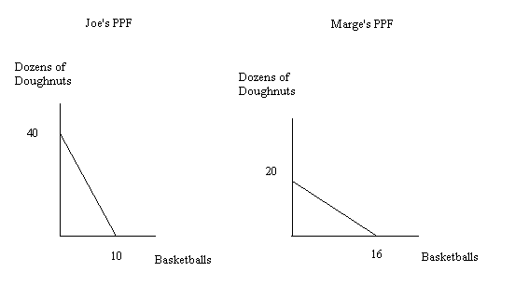
- (One point) Compare the opportunity cost of producing one dozen doughnuts for these two individuals. Who has the lower opportunity cost for producing one dozen doughnuts? (Provide numerical measures with appropriate units of measurement in your answer.)

Answer:
Joe’s opportunity cost of producing one dozen doughnuts is ¼ basketball. Marge’s opportunity cost of producing one dozen doughnuts is 4/5 basketball. Joe has the lower opportunity cost of producing doughnuts than does Marge: Joe should specialize and produce doughnuts while Marge should specialize and produce basketballs.

- (One point) Provide the range of trading prices in terms of dozens of doughnuts that 20 basketballs will trade for given the above information.

Answer:
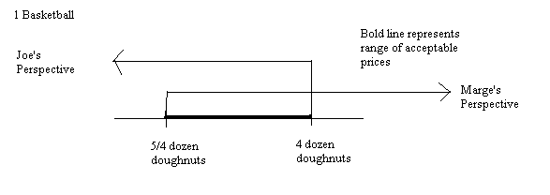
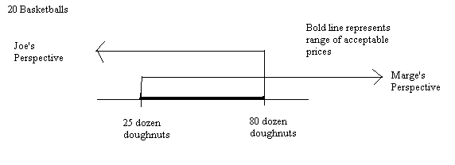
The range of trading prices for 20 basketballs will be between 25 dozen doughnuts and 80 dozen doughnuts.

- For each of the following scenarios draw a graph to illustrate the initial situation and the situation after the scenario. Then provide a verbal explanation of what will happen to price and quantity given the scenario. Mark the initial curves and points as D1, S1, P1, and Q1. Mark the final curves and points as D2, S2, P2, and Q2.
  - (One point) The market for gasoline-powered cars is initially in equilibrium. The price of gasoline rises due to political upheavals in the oil producing regions of the world. Holding everything else constant, depict the effect of this scenario on the market for gasoline-powered cars and provide a verbal explanation of these effects as well.
Answer:
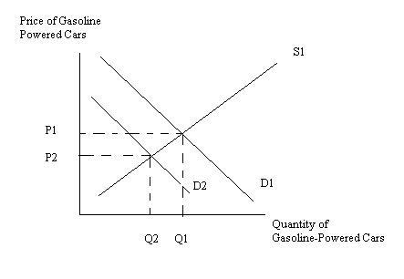
The demand curve for gasoline-powered cars will shift to the left when the price of gasoline, a complementary good to these cars, increases. The equilibrium price and quantity will both decrease.

  - (One point) The cookie market is initially in equilibrium. Suppose the price of sugar, an ingredient in cookies, increases while at the same time people’s incomes increase. Holding everything else constant, depict the effect of these changes on the market for cookies and provide a verbal explanation of these effects as well.

Answer:
The increase in the price of sugar causes the supply curve of cookies to shift to the left. The increase in income will cause the demand curve of cookies to shift to the right if cookies are a normal good and to shift to the left if cookies are an inferior good. So, you need to either make an explicit assumption here that is stated: e.g., “Cookies are a normal good.” or else you need to draw two graphs depicting the two possibilities.

The first graph is the one if cookies are a normal good: the result after these two changes in this example is that the equilibrium price will increase relative to P1 while the equilibrium quantity is indeterminate relative to Q1: the quantity may increase, decrease or remain the same.
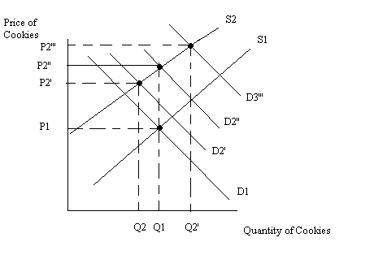

The second graph is the one if cookies are an inferior good: the result after these two changes in this example is that the equilibrium quantity will decrease relative to Q1while the equilibrium price is indeterminate relative to P1: the price may increase, decrease or remain the same.

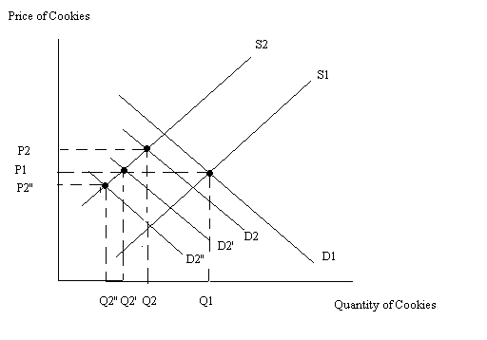

- (One point) Suppose a market is composed of two consumers, George and Martha. George’s demand for the product is given by the equation P = 100 – Q while Martha’s demand for the product is given by the equation P = 50 – 4Q. Find the market demand curve. If the demand curve has more than one segment, write the equations as well as the relevant ranges for all the segments of the demand curve.

Answer:
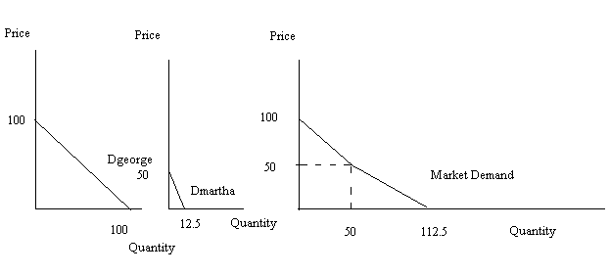
P = 100 – Q for 0 ≤ Q ≤ 50 or for 100 ≥ P ≥ 50
P = 90 - .8Q for Q≥50 or for P ≤ 50

