Economics 101
Answers to Homework #5
Spring 2009
Due 04/28/2009 in lecture

Directions: The homework will be collected in a box before the lecture. Please place your name, TA name and section number on top of the homework (legibly). Make sure you write your name as it appears on your ID so that you can receive the correct grade. Please remember the section number for the section you are registered, because you will need that number when you submit exams and homework. Late homework will not be accepted so make plans ahead of time. Please show your work. Good luck!

Problem One
Suppose the total cost of production for a firm is given by the equation:
This firm’s marginal cost equation is:
Market demand is given by:

a) Give the formulas for: fixed cost: FC = 400
This is the component of total cost that doesn’t vary with quantity.

variable cost:
This is the component of TC that depends on quantity.

average total cost:

average variable cost:

Now suppose this firm is operating in a perfectly competitive market (in which all firms have access to the same technology and hence face the same costs).

b) What is the long run equilibrium price in this market?

First we’ll find the equilibrium quantity supplied by a representative firm in the market.
Since firms make zero profit in the long run, the price in the long run moves to
the minimum point of ATC.

MC = ATC at the minimum point on ATC.
Set MC = ATC: and solve for

Now we can find the long run equilibrium price by plugging q = 20 into either the MC or the ATC equation.

Using MC:

c) Calculate the economic profit earned by a perfectly competitive firm in the long run.

We actually don’t need to calculate anything.
It is a fact that in the long run a perfectly competitive firm makes economic profit = 0.
You can verify this is you want by calculating total revenue and total cost.
You will find TR = TC which implies that economic profit = 0.

Now suppose the cost equations given (and derived) above belong to a monopolist.

d) What quantity will the monopolist produce?

We know the monopolist chooses the quantity where MR = MC.
To find this quantity we first need to derive MR from the market demand equation.
Recall that the MR curve has the same vertical intercept as demand but slope that is
twice as steep.

Since demand can be expressed: marginal revenue is:
Set MR = MC:

e) What price will the monopolist charge?

The monopolist will charge the max. price consumers would pay for 23 units.
This is given by the demand curve.
Plug q = 23 into the demand curve to find:

f) What is the monopolist’s economic profit?

The monopolist’s economic profit is TR – TC.
Economic Profit is therefore:

g) What is the monopolist’s producer surplus?

Producer surplus is the area above the MC curve and below the market price.

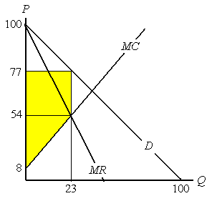

Here we can see this can be broken down into two parts.
Area of top part:
Area of bottom part:
So producer surplus is: 529 + 529 = 1058.

Now consider a monopolist in a different market with costs:
Suppose market demand is given by:

h) Give the formulas for:
fixed cost: FC = 0, (All of TC depends on the quantity of output.)

variable cost: (All of TC is variable cost.)

average total cost:

average variable cost:

i) What quantity will this firm produce?

The firm will choose the quantity such that MR = MC.
Using the market demand equation we can derive:
Set MR = MC:

j) What price will consumers face in this market?

The firm chooses the highest possible price (given by the demand equation).

k) Calculate the monopolist’s economic profit.

First find:
So profit is:

l) Calculate the monopolist’s producer surplus.

Producer surplus is the area above the MC curve and below the market price.

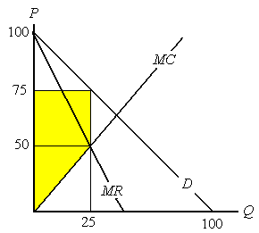

Here we can see this can be broken down into two parts.
Area of top part:
Area of bottom part:
So producer surplus is: 625 + 625 = 1250.

m) Looking back over this problem, under what conditions is a firm’s economic profit = producer surplus?

In the special case that a firm has no fixed costs, economic profit = producer surplus.

Problem Two
A representative firm has an average total cost curve that is described by the equation:
The firm’s marginal costs equation is:
Market demand is given by:

a) Sketch ATC, MC, MR (you need to derive this), and the market demand curve. Hint: to draw ATC you may want to plot points then connect the dots. Assume that the firm perceives that the market demand curve is the demand curve for the product they are producing.

First derive MR using the fact that demand can be written: so

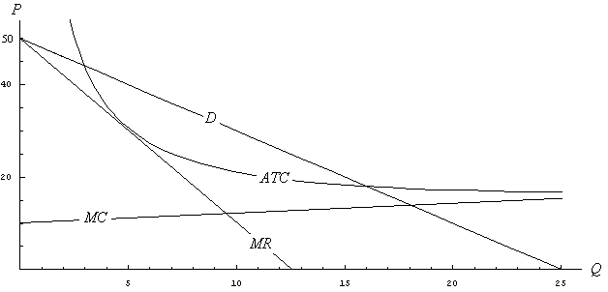

b) Suppose the representative firm is an unregulated monopolist. What quantity will they produce and what price will they charge?

A monopolist chooses the quantity that equates MR and MC.
To find this quantity set and solve for

To find the price, plug into the demand equation:

c) Is the monopolist’s chosen level of output allocatively efficient? Explain your answer.

No. The marginal cost of the last unit is:
This is less than the price. So, for the last unit produced, price > marginal cost.
If more of the good were produced / consumed, surplus would increase (deadweight loss
would decrease).

d) Is there any way to regulate the firm to achieve allocative efficiency in the long run without government intervention beyond price regulation? Why or why not?

No. Recall the concept of marginal cost pricing: the firm is allowed to charge a price up to the marginal cost of the last unit produced. This pricing scheme can lead to an allocatively efficient outcome. Looking at the graph we see that MC < ATC for all levels of output consumers would ever possibly demand (q = 0 to q = 25). If the price cannot be greater than MC then price < ATC and the firm is losing money. Therefore, if the firm cannot charge a price greater than MC it will exit the industry in the long run. There is no way to have price = marginal cost in the long run.

Now suppose the government decides that 18 units of the good should be produced.

e) Suppose two firms meet this level of output by each producing 9 units. What is the total cost of production?

Each firm produces 9 units.
When q = 9,
Recall that total cost is equal to (quantity) x (ATC), so each firm’s total cost is:
22.11 x 9 = 199.

The total cost of production is thus:

f) What would be the optimal number of firms if we wanted to produce 18 units at minimum cost per unit? Hint: look carefully at the shape of the ATC function.

First note, ATC is falling over the range of possible quantities demanded, this is a natural
monopoly. In this situation, to minimize per-unit production costs it is best for a single firm to supply the market.

Suppose one firm supplies all 18 units.
ATC at q = 18 is:
Total cost of production is thus:

g) How would we describe this market?

For the reasons described in part f), this is a natural monopoly.

Problem Three
A monopolist has costs given by:

A monopolist faces demand from two groups of consumers.

Demand from class 1 is given by:
Demand from class 2 is given by:

a) Which group of customers has the more elastic demand curve?

Start by solving the demand equations for P. Class 1 demand:
Class 2 demand:

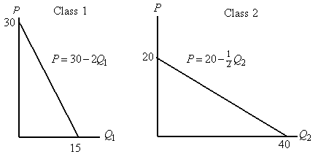

We can see that the demand from class 2 is more sensitive to changes in price.

b) Which group do you expect will pay a higher price under 3rd degree price discrimination?

Demand from class 1 is relatively inelastic compared to class 2.
We would thus expect class 1 to pay a higher price.

c) A market research firm offers to provide the monopolist with information which would allow it to identify which class any given consumer belongs to. What is the maximum amount the monopolist would be willing to pay to hire the company? Hint: to solve this problem find the monopolist’s profit if it cannot price discriminate and compare to the monopolist’s profit if it can price discriminate. Please show all the steps you take to find the monopolist’s profit.

Step one: find the monopolist’s profit if it doesn’t hire the firm (i.e. it cannot price
discriminate).

We need to find the market demand and from that find the marginal revenue.

Find market demand by horizontal summation.

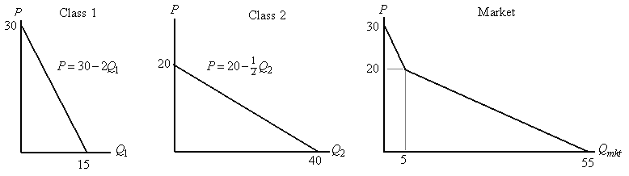

The equation for market demand is:
Or, expressed in slope / intercept form, market demand is:

MR has the same vertical intercept but is twice as steep as market demand.

Marginal revenue is thus:

The monopolist will choose the quantity where MC = MR.

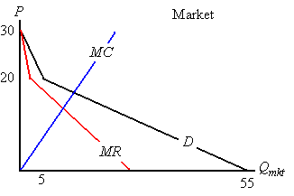

Graphing carefully we see that the intersection is in the lower portion of MR.

Set MC = MR, using the equation for the lower part of the MR curve:

The monopolist will choose the price given by the market demand curve at

Plug into the market demand equation (for Q > 5).

We find:

Now we can calculate the monopolist’s profit:

Step two: find the monopolist’s profit if it does hire the market research firm.

Start by finding the marginal revenue equations for each class of consumers.

For class 1, demand is given by:
So,

For class 2, demand is given by:
So,

The next step is to find the quantity supplied to each different group,

These quantities will satisfy:

We already found the optimal total quantity is

Now find by setting:

Find by setting:

Now that we have the optimal quantities for each class, find the optimal price to
charge each group.

We found
The monopolist charges the highest possible price Class 1 consumers
will pay for 3.57 units. This is given by the Class 1 demand:

We found
The monopolist charges the highest possible price Class 2 consumers
will pay for 4.28 units. This is given by the Class 2 demand:

Finally we can calculate the monopolist’s profit given that they can practice 3rd
degree price discrimination.

Profit π = TR – TC
TR = P₁ × Q₁ + P₂ × Q₂ = (22.86 × 3.57) + (17.86 × 4.28)
= 81.61 + 76.44 = 158.05.
TC = Q² = 7.86² = 61.78.
So the profit is: 158.05 – 61.78 = $96.27.

So, found that the monopolist’s profit is:
if they can’t price discriminate,
if they can price discriminate.

The difference is: 96.27 – 86.46 = 9.81.
This is the max. amount the monopolist would be willing to pay the market research firm.

Problem Four
You and your little sister can each choose between two strategies. Each of you will make your choice of strategy at the same time (i.e. neither of you can wait for the other to move first).

Each of the following matrices shows the strategies available and the payoff from each strategy choice. The payoff is shown with payoff to you first, then your little sister. Assume a larger number payoff is superior to a smaller number payoff.

a. Find the dominant strategy for player (if one exists).

You | Your Little Sister
You |  | Cry | Throw things
You | Threaten | 4,4 | 16,24
You | Bribe | 48,8 | 0,32

You have no dominant strategy.
Your little sister’s dominant strategy is to throw things.

b. Find the dominant strategy for each player (if one exists).

You | Your Little Sister
You |  | Lie | Truth
You | Tell Mom | 10,2 | 8,12
You | Tell Dad | 1,6 | 6,3

Your dominant strategy is to tell mom.
Your little sister doesn’t have a dominant strategy.

c. Find the dominant strategy for each player. Who ends up with the highest payoff?

You | Your Little Sister
You |  | Look cute | Freak out in public
You | Ignore | 20,20 | 8,12
You | Placate | 16,24 | 0,16

Your dominant strategy is to ignore.
Your little sister’s dominant strategy is to look cute.
Each player ends up with the same payoff: 20.

