Economics 101
Answers to Homework 5
Spring 2006

1.
a. The aggregate demand function is:

For P>16 , P = 20 – 2Q and
For P<= 16 , P = 84/5 – (2/5)Q

Assuming price to be <= 16, we work with P = 84/5 – (2/5)Q
MC = 2Q
Hence Q = 6 and P = $14.4
Profit = $50.4

b. MC = MR1 = MR2 where MR1 is the marginal revenue for class 1 and MR2 for class 2. Thus, if the total quantity produced is 6 units, the MC of producing this level of output is $12.

For the first market class, setting MC calculated as $12 equal to the MR1 curve yields the following equation:

12 = 20 – 4Q1

For the second market class, setting MC calculated as $12 equal to the MR2 curve yields the following equation:

12= 16 – Q2

Solving these we get Q1 = 2 and Q2 = 4 and hence P1 = $16 and P2 = $14

c. Total profit = (16 – 6)*2 + (14 – 6)*4 = 20 + 32 = 52 which is higher than the profit without price discrimination.

d. |Price elasticity of demand for class 1|; e1 = (1/slope) *P1/Q1 = 4

|Price elasticity of demand for class 2|; e2 = (1/slope) *P2/Q2 = 7

The firm charges a higher price for the market class with lower price elasticity of demand and a lower price for the market class with higher price elasticity of demand.

e. Now the equations are

20 – 4Q1 = 4 and 16 – Q2 = 4
So Q1 = 4, P1 = 12 and Q2 = 12, P2 = 10

Net profit = (12 – 4)*4 + (10 – 4)*12 = 32 + 72 = 104 > profit generated in part b.

f. e1 = (1/2)*(12/4) = 1.5 and e2 = 2*(10/12) = 5/3

e1 < e2 and P1 > P2 So, the relationship observed in part d still holds true.

- a.

 |  | Ben
 |  | Soup | Shrimp
Al | Chicken | (2,-2) | (1,-1)
 | Ham | (0,0) | (-2,2)

The first entries in the parentheses indicate Al’s utility and the second entry Ben’s utility.

b. Al’s dominant strategy is to choose Chicken
Ben’s dominant strategy is to choose Shrimp

c. Chicken and shrimp is the only possible pair.

d. No other pair makes them both better off simultaneously

e. There is no dominant strategy for Al, but Ben’s dominant strategy is still the same; he should choose Shrimp.

- Assumption (c) is altered to having possible product differentiations.

- Setting MR = MC we get 100 – 4Q = 12 ➔ Q = 22, P = 56
Profit = 22*56 – 20 – 12*22 = 44*22 – 20 = 948

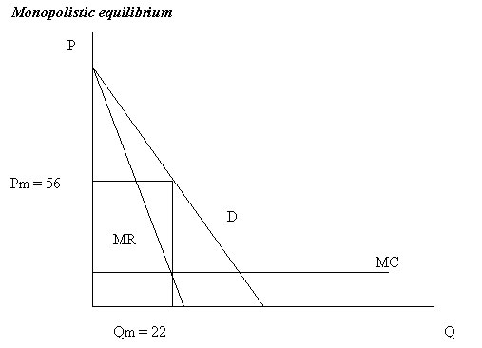

Since there are positive economic profits in the short run, firms will enter the market and due to the substitution effect (differentiated products), the demand curve for each firm will shift toward the origin. This will continue until in the long run the demand curve is tangent to the ATC curve at which point profits are zero. (Note that the long run price might still be higher than the MC and hence the allocation might not be efficient.)
The ATC curve is a decreasing curve, that’s arbitrarily large for Q = 0 and decreases with an increase in Q and becomes asymptotic to the MC curve which is a horizontal line.

