Economics 101
Answers to Homework #5
Fall 2009

Due 12/9/2009 before lecture

- Monopoly
Suppose Harley-Davidson is a Monopolist of motorcycle manufacturing in Wisconsin. The market demand curve faced by Harley Davidson is, and the cost of producing motorcycles is comprised of fixed costs of $100,000 plus an additional $60 for each motorcycle produced.

- What is the equation for Marginal Revenue?

First rewrite Demand Curve as,
Since the slope of Marginal Revenue curve is twice as large as the slope of Demand Curve, and they have the same Y-intercept, we can see the Marginal Revenue curve is

- What is the equation for Marginal Cost?

We know that, and since marginal cost is the slope of total cost, the equation for Marginal Cost is

- Draw the Demand curve, Marginal Revenue curve, and Marginal Cost curve for this monopolist in a graph.
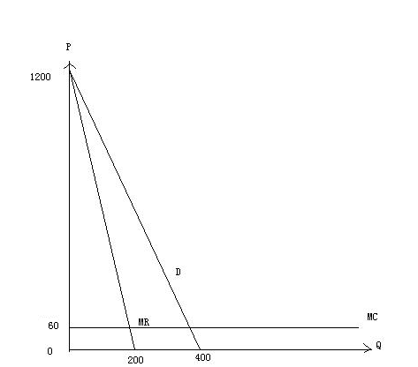

- What is the monopolist’s profit-maximizing production quantity Q_{M}?

Use MR=MC, we have , and we can get

- What price will the monopolist charge P_{M}?

Since, and, we have

- Suppose this market was a perfectly competitive market (i.e., the monopolist’s demand curve is still the market demand curve, but now there are many producers providing motorcycles for the market). Given the market is perfectly competitive, what would be the equilibrium price (P_{C} ) in this competitive market?
The competitive market equilibrium price should satisfy, so

- What is the equilibrium quantity (Q_{C}) demanded in this market if the market is a perfectly competitive market?
Since, we have, and thus.
Now, let us compare the monopoly and perfect competition outcomes.
- What is the difference between the consumer surplus in the monopoly case and the consumer surplus in the perfect competition case?

The Consumer Surplus in perfect competition case is
The Consumer Surplus in monopoly case is
So the difference is

- What is the difference between the producer surplus in the monopoly case and the producer surplus in the perfect competition case?

The Producer Surplus in perfect competition case is
The Producer Surplus in Monopoly case is
So the difference is .

- What is the monopolist’s profit?

Profit=Producer Surplus-Fixed cost, from the equation for Total Cost, we can see Fixed cost=100000 so the Profit=108300-100000=8300.

- What is the dead weight loss caused by the monopolist?

- Natural Monopoly
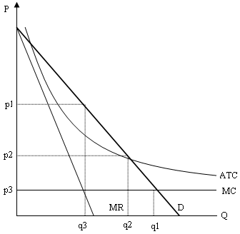

Use the above graph to answer this next set of questions.
- What is the natural monopolist’s profit maximizing quantity and price?
We still have MR=MC, so the corresponding quantity and price are P1 and q3.
- Explain why a natural monopoly that acts as a single price monopolist is inefficient in at least two ways.

The natural monopoly is inefficient if operated as a monopolist because it restricts output to a level less than the allocatively efficient level of output where P = MC for the last unit produced and because it charges too high a price for the product. Consumers face a restricted output and a higher price than would occur if the firm were producing at the allocatively efficient level of output.

- What will happen to the monopolist in the long run if the government chooses to regulate its production to the point where price equals marginal cost? Explain your answer.
Since P=MC<ATC, the Firm will quit the market in the long run.

- What is the break even quantity and price for this monopolist? Should the government regulate the monopolist to produce at this breakeven point in the long run? Give a brief argument supporting or refuting this type of regulation.
We know that P=ATC at the breakeven point, so q2 and P2 are the desired quantity and price.
Although (q3, P1) is socially efficient since P=MC at this point, the monopolist will be driven out of the market in the long run since P<ATC, so in a view of long run social welfare, regulating the monopolist at P=ATC is more reasonable.
- Reservation Price and Price discrimination
- Nathan is the only barber on State Street, and he has customers with the following reservation prices for a haircut:
Customer | Reservation Price
A | $ 18
B | $ 20
C | $ 11
D | $ 16
E | $ 13

Suppose it costs Nathan $8 per haircut, and assume everyone just needs
one haircut.
- What is the socially efficient number of haircuts? Explain your answer.
Since all five customers have reservation prices higher than $8, the socially efficient number of haircuts is 5.
- What is the profit maximizing number of haircuts for Nathan if Nathan can charge only one price for his hair cuts? Show a step by step procedure for determining the profit maximizing number of haircuts.
If P=$20, Profit=20-8=$16
If P=$18, Profit= (18-8)*2=$20
If P=$16, Profit= (16-8)*3=$24
If P=$13, Profit= (13-8)*4=$20
If P=$11, Profit= (11-8)*5=$15
Thus the profit maximizing number of haircuts is 3 for Nathan.
- Suppose University Book Store is the only place that sells UW T-shirts in Madison. The following table gives the reservation price of the customers interested in buying a UW T-shirt.

Customer | Reservation  Price
A | $100
B | $90
C | $75
D | $60
E | $50
F | $40
G | $30
H | $25
I | $10

The University Book Store does know its customers’ reservation prices, and it knows that customers with reservation prices above $45 never go to the Book Store’s T-shirt sale, while the other customers will go to the T-shirt sale whenever it is available. The University Book Store can only set two prices for UW T-shirts, one is the list price, and the other is its on-sale price. In order to maximize profits, what is the list price and on sale price the University Book Store should charge for its UW T-shirts? Show the procedure you used to find your answer. Assume that the marginal cost of producing a T-shirt is $0.

Since the University Book Store knows that customers with reservation prices above $45 never go to its T-shirt sales, it will set the list price larger than $45. It is easy to verify that a list price = $50 will give the highest profit to the University Book Store.
Also, the on-sale Price must be less than $45, and again, it is easy to verify that an on-sale price = $25 will give the highest profit to the University Book Store.
- First Degree Price discrimination vs. Entry Fee
Kollege Club is holding a party on Saturday night. An individual’s demand for drinks is given by the equation P=15-Q. Suppose Kollege Club is a monopolist offering only one kind of drink with a constant marginal cost of $5 and there is no fixed cost.
- If Kollege Club were able to perfectly price discriminate, how many drinks would it sell? What range of prices would it charge? Is there Consumer Surplus and deadweight loss if Kollege Club perfectly price discriminates? Explain your answer.

Since Kollege Club can perfectly price discriminate, it will sell until P = MC, so we have. Kollege Club would sell Q = 10 drinks,
The range of prices would be from the highest possible price which is the Y-intercept of the demand curve: P = 15 to the lowest possible price which is the price at which P = MC: P = 5, so the range is (5, 15).
Again, since Kollege Club can perfectly price discriminate, it can extract all the Consumer Surplus, thus the Consumer Surplus is 0, and there is no dead weight loss when Kollege Club perfectly price discriminates.
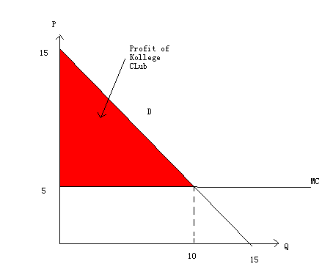

- Suppose in order to get in the party, people need to pay an entry fee and then, once they are admitted to the Kollege Club all drinks sell for a single price. How much will Kollege Club charge for a drink and how much is the entry fee so that Kollege Club maximizes its profit? Is there a Consumer Surplus and deadweight loss when Kollege Club implements this plan? Explain your answer.

We know that the maximum profit Kollege Club can get is the Consumer Surplus in the perfectly competitive case, as indicated by the red Triangle in the above graph. If Kollege Club charges any price that is higher than 5, and then sets the entry fee equal to the corresponding consumer surplus, there will always exist a dead weight loss, which means Kollege Club hasn’t extracted all the possible profit. Thus Kollege Club will set the drink price at P = 5 and the entry fee to $50 which is the value of the corresponding amount of consumer surplus (The Area of the red Triangle) = (15-5)*10*1/2 = 50.

- Game Theory
Please look at the following table:

Player 2
L R
L  Player1  R | 15,12 | 16,11
L  Player1  R | 10,7 | 2, 7

- What is player 1’s strictly dominant strategy? Explain your answer.
When Player 2 chooses L, Player 1 strictly prefers L to R, when Player 2 chooses R, Player 1 still strictly prefers L to R, thus L is Player 1’s strictly dominant strategy.
- Is there any strictly dominant strategy for player 2? Explain your answer.
When Player 1 chooses L, Player 2 strictly prefers L to R, when Player 1 chooses R, Player 2 is indifferent between L and R, thus there is no strictly dominant strategy for Player 2.

- What is the equilibrium you can predict from this game?
Player 2 knows that Player 1 will always choose L, so he/she will choose L, thus (L,L) is the equilibrium for this game.

