Economics 101
Fall 2006
Answers to Homework #5

1. First and Second Price Discrimination
- The equilibrium is decided by the intersection between MC curve and Demand Curve, so Q=9 and P= $12. The producer surplus is (12-3)*9*1/2= $40.50.
- MR=-8Q+48. When MR=MC, Q=5. When Q=5, P= $28. The producer surplus is (28-8)*5+(8-3)*5*1/2=100+25/2=225/2= $112.5. Please be careful that the MC curve has a positive slope, and the producer surplus is the area between the price and MC.
- Under 1st Degree Price Discrimination, the consumer surplus that occurred in the competitive market becomes the producer surplus. The consumer surplus under the competitive market is (48-13)*9*1/2=315/2= $157.5. Thus, under 1st Degree Price Discrimination, the producer surplus is 157.5+45= $202.5.
- The price is decided by the demand curve. Thus, X= $32, Y= $16 and Z= $0.
- The producer surplus equals (1/2)(4)(4) + (25)(4) + ½(4)(4) + 5(4) = $136.

2. Third Price Discrimination
- Group A: Q=3/2, P= $7
Group B: Q=3/2, P= $11/2 = $5.50
Note that the sum of the quantity produced for the market A plus the quantity produced for market B equals 3 units.
- Group A: Profit= $9/2 =$4.50
Group B: Profit= $9/4 = $2.25
Total: $27/4 = $6.75
We just need to derive the monopolistic price, quantity and profits for each sub-market.
- Group B: The reason is that Group B has a demand curve that is more sensitive to price changes than group A.
- Inelastic. This result holds in not only this problem but also in all cases.
- If a group has a more inelastic demand curve, it means that they do not alter the quantity the demand very much when price changes. On the other hand, ff a group has a more elastic demand curve, they change the quantity demanded with only a small change in price. Therefore, the monopolist can charge a higher price for the inelastic group, but cannot set a higher price for the elastic group.

3. Monopolistic Competition
(a)
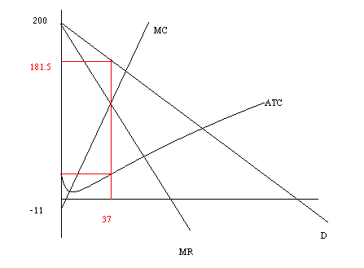
164.83
70.33
(b) MR=200-Q
(c) Let MR=MC => 200-Q=-11+2Q => Q=70.33, plug Q into demand
P=200-0.5*(211/3)=164.83
Profit=P*Q-TC=70.33*164.83- (20 –11*70.33+70.33^2)
=11592.49-4192.68=7399.81

(d) Demand shift to the left. Firm’s profit=0 ;P=ATC

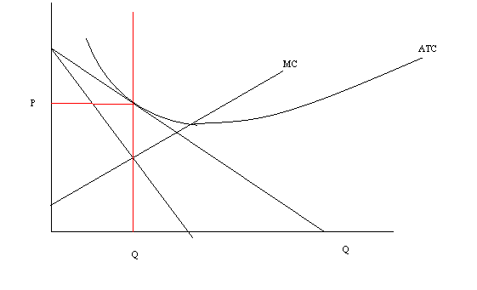
4. Game Theory
(a) Mr. Crane’s dominate strategy is D. IRS’s dominate strategy is RD.
(b) The equilibrium outcome is (D, RD)
(c) Mr. Crane doesn’t have any dominate strategy. The IRS’s dominate strategy is RD. The equilibrium outcome is (D, RD)
(d) The IRS will need to set X at a value that is greater than 18.

5. Oligopoly
- Q=4 and P=6, so total profit is (6-2)*4= $16. Thus, each company’s profit is 16/2= $8.
- Bigsoft’s profit is zero since no one buys its more expensive software. Smallsoft’s price is 4, so Q=6 from demand function. Thus, Smallsoft’s profit is (4-2)*6= $12.
- 12/2= $6.

Smallsoft | Bigsoft
Smallsoft |  | Monopoly | P= $4
Smallsoft | Monopoly | $8, $8 | $0,$12
Smallsoft | P= $4 | $12,$0 | $6,$6
The dominant strategy for each firm is “P= $4.” The outcome for the game is (P= $4, P= $4).
- If the firm sets the monopolistic price, the profit becomes zero since the other firm will set P= $4. When the other firm sets P= $4, the profit-maximizing price for the firm is P= $4. Thus, neither firm has an incentive to set the monopolistic price.

