Economics 101
Summer 2012
Answers to Homework #4
Due 6/14/12

Directions: The homework will be collected in a box before the lecture. Please place your name, TA name and section number on top of the homework (legibly). Make sure you write your name as it appears on your ID so that you can receive the correct grade. Late homework will not be accepted so make plans ahead of time. Please show your work. Good luck!
Please realize that you are essentially creating “your brand” when you submit this homework. Do you want your homework to convey that you are competent, careful, professional? Or, do you want to convey the image that you are careless, sloppy, and less than professional. For the rest of your life you will be creating your brand: please think about what you are saying about yourself when you do any work for someone else!

1. George has $100 in income to be spent on hamburgers (H) and milk (M). The price of milk is $1 per unit and George is currently consuming at a point on his budget line that consists of 10 hamburgers and 10 units of milk.

a. Draw George’s budget line in a graph with milk measured on the horizontal axis and hamburgers on the vertical axis. Label this graph clearly and completely.

Answer:
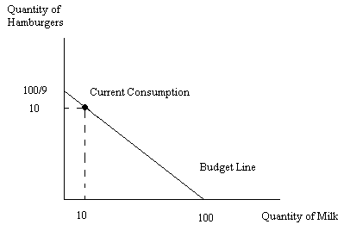

b. Given the above information, what is the price of a hamburger?

Answer:
The price of a hamburger is $9. To see this recall that income = (price of hamburgers)(quantity of hamburgers) + (price of milk)(quantity of milk). Or, 100= (price of hamburgers)(10 hamburgers) + ($1 per unit of milk)(10 units of milk). Solving this equation we get $9 as the price of a hamburger.

c. Write an equation for George’s budget line? (Keep your equation with improper fractions rather than converting the equation to decimals.)

Answer:
H = (100/9) – (1/9)M
Recall that the y-intercept of the budget line is equal to Income/(price of the good measured on the y-axis) or in this case (100/9). The slope of the budget line is equal to (-Pmilk/Phamburgers) = (-1/9).

d. Given the above information and your calculations identify whether the combinations of milk and hamburgers below are on George’s budget line, are inside his budget line, or are beyond his budget line.

Combination | Hamburgers | Milk | Location
A | 8 | 30
B | 6 | 46
C | 2 | 80
D | 10 | 9
E | 11 | 2

Answer:
Combination | Hamburgers | Milk | Location
A | 8 | 30 | Beyond the PPF
B | 6 | 46 | On the PPF
C | 2 | 80 | Inside the PPF
D | 10 | 9 | Inside the PPF
E | 11 | 2 | Beyond the PPF

2. The price of a movie ticket is $8 and the price of a box of popcorn is $5. Sue always consumes a box of popcorn when she goes to the movies. She never consumes less than one box or more than one box however.

a. Draw an image of Sue’s indifference curve map that includes at least three indifference curves. In your graph, measure movies along the horizontal axis and popcorn along the vertical axis.

b. Suppose Sue has $130 a year that she can spend on movies and popcorn. On your indifference curve map depict Sue’s budget line and her optimal consumption bundle given this information.

Answer:
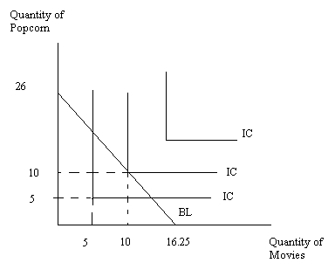
3. Joey has $200 to spend on cereal and steak. For this problem assume that Joey always spends all of his available income and he always selects that consumption bundle that maximizes his satisfaction. Suppose when the price of steak is $10 he purchases 4 steaks and 40 boxes of cereal. However, Joey finds that if the price of steak increases to $20 he purchases only 2.8 steaks. Assume that only the price of steak changes in this problem.

a. Given the above information, what is the price of cereal?

Answer:
We know Income = (Price of steaks)(Quantity of Steaks) + (Price of cereal)(Quantity of Cereal) or I = PsQs + PcQc. Using the numbers we are given we have 200 = 10(4) + Pc(40) or Pc = $4 per box of cereal.

b. How many boxes of cereal does Joey purchase when the price of steaks increases to $20?

Answer:
I = PsS + Pc C
200 = (20)(2.8) + 4C
200 = 56 + 4C
4C = 144
C = 36 boxes of cereal

c. From the above information write Joey’s demand curve for steak. Assume that this demand curve is linear. Hint: After deriving your demand curve verify that both (Q, P) points you used are actually on this demand curve.

Answer:
We know (Q, P) = (4, $10) and (2.8, $20) are points on the demand curve. Calculate the slope of the demand curve: m = (10 – 20)/(4 – 2.8) = -10/1.2. Then, use the standard slope intercept form to derive the demand equation.
Y = mX + b
P = (-10/1.2)Q + b
10 = (-10/1.2)(4) + b
b = 43.33
P = 43.33 – (10/1.2)Q

4. Jung’s income is $100 and he spends all of this income on good X and good Y. Good X costs $10 per unit while good Y costs $10 per unit. Jung maximizes his utility given this information when he selects point A which corresponds to Jung consuming 5 units of good X and 5 units of good Y.

a. In a graph with good X on the horizontal axis and good Y on the vertical axis draw Jung’s budget line, BL1, given the above information. Mark point A on your graph and indicate the quantity of good X and good Y associated with point A.

Suppose that the price of good X decreases to $5 per unit while nothing else changes. When the price of good X decreases Jung maximizes his utility when he selects point B. Point B corresponds to Jung consuming 8 units of good X and 6 units of good Y.

b. On the same graph draw Jung’s new budget line, BL2, based on the above information. Mark point B which corresponds to Jung consuming 8 units of good X and 6 units of good Y.

c. In this part of the question we want to find the income and substitution effects with respect to good X for Jung when the price of good X decreases. Suppose you are told that if Jung had to pay the new prices for the two goods but was constrained to have the initial level of utility, he would choose to consume at point C which corresponds to Jung consuming 6 units of good X and 5 units of good Y.
i. Given this information what level of income would Jung need to have in order to be at point C? (Hint: the decrease in the price of good X effectively makes Jung’s $100 have greater purchasing power. If Jung is going to be constrained to be back on indifference curve 1 that implies that his income would need to be decreased from its $100 level.)
ii. In your graph draw this new budget line, BL3, and label both the x and y intercepts for this budget line. In your graph also mark point C.
iii. With respect to good X, what is the value of the substitution effect for Jung?
iv. With respect to good X, what is the value of the income effect for Jung?
v. According to your work, is good X a normal or inferior good? Explain your answer.
vi. According to your work, is good Y a normal or inferior good? Explain your answer.

Answer:
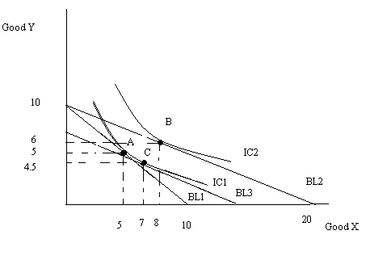
a., b., and c.: see the above graph
c.
i. We know that I’ = PyY + PxX and we know that Px = $5 and Py = $10. We also know that (X, Y) = (7, 4.5). So using this information we get I’ = (10)(4.5) + (5)(7) or I’ = $80.
ii. Y-intercept for BL3 is 8 and X-intercept for BL3 is 16.
iii. The substitution effect with respect to good X is 2 units: this is measured as the change in the consumption of good X from point A to point C in the above graph.
iv. The income effect with respect to good X is 1 unit: this is measured as the change in the consumption of good X from point C to point B in the above graph.
v. Good X is a normal good. As income increases (BL3 to BL2) the consumption of good X increases from 7 units to 8 units.
vi. Good Y is a normal good. As income increases (BL3 to BL2) the consumption of good Y increases from 4.5 units to 6 units.

5. You are given the following table and asked to complete the table. You are also told that the price of labor (L) is $2 per unit of labor and the price of capital (K) is $5 per unit of capital. After completing the table there are a number of fill in the blank questions for you to do.

Labor (L) | Capital (K) | Output (Q) | Marginal Product of Labor (MPl) | Variable Cost (VC) | Fixed Cost (FC) | Total Cost (TC) | Average Variable Cost (AVC) | Average Fixed Cost (AFC) | Average Total Cost (ATC) | Marginal Cost (MC)
0 | 10 | 0 | --------- |  |  |  | -------- | -------- | ---------- | ----------
1 | 10 | 50
2 | 10 | 70
3 | 10 | 80
4 | 10 | 88
5 | 10 | 90

a. ATC =

b. ATC = _______ + _________

c. MC = ________________________________/___________________________

d. VC = ___________________*_____________________

e. VC/(price of labor) = _______________________________

f. TC = ___________________*___________________________

g. AFC = ____________________ - ___________________________

h. MPl = ______________________________/_____________________________

Answer:
Labor (L) | Capital (K) | Output (Q) | Marginal Product of Labor (MPl) | Variable Cost (VC) | Fixed Cost (FC) | Total Cost (TC) | Average Variable Cost (AVC) | Average Fixed Cost (AFC) | Average Total Cost (ATC) | Marginal Cost (MC)
0 | 10 | 0 | --------- | $0 | $50 | $50 | -------- | -------- | ---------- | ----------
1 | 10 | 50 | 50 | 2 | 50 | 52 | $.04/unit | $1/unit | $1.04/unit | $.04/unit
2 | 10 | 70 | 20 | 4 | 50 | 54 | .06 | .71 | .77 | .1
3 | 10 | 80 | 10 | 6 | 50 | 56 | .08 | .63 | .70 | .2
4 | 10 | 88 | 8 | 8 | 50 | 58 | .09 | .57 | .66 | .25
5 | 10 | 90 | 2 | 10 | 50 | 60 | .11 | .56 | .67 | 1

a. ATC = TC*Q

b. ATC = AFC + AVC

c. MC = change in TC/change in Q

d. VC = AVC*Q

e. VC/(price of labor) = units of labor

f. TC = ATC*Q

g. AFC = ATC - AVC

h. MPl = change in output/change in labor

6. Use the graphs below of a perfectly competitive industry to answer this question. The graph on the left represents a typical firm in this industry while the graph on the right represents the entire industry. For this question assume all firms are identical.

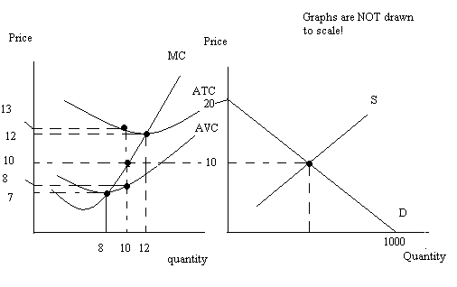
a. Given the above graphs, is this a short-run or long-run equilibrium? Explain your answer.

Answer:
This is a short-run situation. From the graphs we can see that AVC is different from ATC: this implies that there are variable costs as well as fixed costs. Fixed costs are a short-run phenomena. We can also see that P is not equal to the minimum point on the ATC curve: in the long-run we know firms in the perfectly competitive industry break-even.

b. Given the above graphs, what is fixed cost equal to for a representative firm?

Answer:
At quantity q = 10, the ATC is $13 per unit while the AVC is $8 per unit. Thus, the AFC when q = 10 is $5 per unit. To find fixed cost remember that FC = AFC*q. So, in this case FC = ($5 per unit)(10 units) = $50. Since FC is constant for the firm no matter the level of output, we can conclude that fixed cost for this firm is $50.

c. In the short-run how many units of the good does a representative firm produce?
Answer:
The firm will produce where MR = MC. Recall that for a perfectly competitive firm price = MR. The market equilibrium price is given as P = $10. So equating P = MR = MC we find that the firm will produce 10 units of output.

d. Given the above graphs, in the short-run what is the equilibrium market quantity?

Answer:
To find the equilibrium market quantity we need either the market supply curve or the market demand curve. Once we have an equation for one of these curves we can plug in the market price of $10 to determine the equilibrium quantity. From the graph we can see that there are two points on the demand curve that are given to us: (Q, P) = (0, 20) and (1000, 0). Using these two points we can calculate the slope of the market demand curve and then write the equation for the market demand curve. Thus, P = 20 – (1/50)Q. Then, if P = 10 that implies that Q is equal to 500 units.

e. Given the above graphs, how many firms are currently in the market?

Answer:
We know that each representative firm is producing 10 units of output and that total market output is 500 units. Thus, 500 units/(10 units per firm) gives us 50 firms in the market.

f. Given the above graphs, what do you predict will happen in this industry in the long run?

Answer:
Since representative firms are currently earning negative economic profit in the short run this implies that there will be exiting of firms in the long run. This exiting of firms will shift the supply curve to the left and increase the equilibrium price and decrease the equilibrium quantity.

g. Holding everything else constant, how many firms will be in the industry in the long run? (Hint: partial firms are okay for your answer here.)

Answer:
From the graph we know that the long-run equilibrium price is $12 per unit since this is the price associated with the minimum point on the ATC curve. Using the market demand curve and a price of $12 we can solve for the long-run market equilibrium quantity. Thus, 12 = 20 – (1/50)Q or Q = 400 units. From the graph on the left we see that MC = min ATC at a price of $12 and a quantity of 12 units. So if total production is 400 units and each representative firm produces 12 units, it will take a total of 33.3 firms to produce this level of output.

