Economics 101
Summer 2010
Answers to Homework #4
Due Thursday, July 1, 2010

This homework is due at the beginning of the class lecture. Make sure that your homework includes your name, section number, and is stapled. There will be no stapler at the class lecture. Submitted homework should be legible, neat, and of professional quality. Please show all necessary work and please be sure that your answer is easy to identify and find.

Production and Cost

- You are given the following table where Q is the quantity of output, L is the number of labor units, K is the number of units of capital, MPL is the marginal product of labor (the change in output divided by the change in labor), VC is variable cost, FC is fixed cost, TC is total cost, AVC is average variable cost (variable cost divided by output), AFC is average fixed cost (fixed cost divided by output), ATC is average total cost (total cost divided by output or AVC + AFC), and MC is marginal cost (the change in total cost divided by the change in output). For the problem assume that capital is fixed and does not change as the level of output changes. Furthermore, assume that labor and capital are the only inputs used to produce the output.

Q | L | K | MPL | VC | FC | TC | AVC | AFC | ATC | MC
0 | 0 | 4 | ----- | $0 | $36 |  | ----- | ----- | ----- | -----
1 | .4
2 | 1.2
3 |  |  | .83
4 | 4 |  | .625 | $20
5 | 6 |  | .5
6 | 8.4
7 | 11.2
8 |  |  |  | $72
9 |  |  |  | $90
10 |  |  |  | $110

Q | L | K | MPL | VC | FC | TC | AVC | AFC | ATC | MC
0 | 0 | 4 | ------ | $0 | $36 | $36 | ----- | ----- | ----- | -----
1 | .4 | 4 | 2.5 | $2 | $36 | $38 | $2 | $36 | $38 | $2
2 | 1.2 | 4 | 1.25 | $6 | $36 | $42 | $3 | $18 | $21 | $4
3 | 2.4 | 4 | .83 | $12 | $36 | $48 | $4 | $12 | $16 | $6
4 | 4 | 4 | .625 | $20 | $36 | $56 | $5 | $9 | $14 | $8
5 | 6 | 4 | .5 | $30 | $36 | $66 | $6 | $7.2 | $13.2 | $10
6 | 8.4 | 4 | .42 | $42 | $36 | $78 | $7 | $6 | $13 | $12
7 | 11.2 | 4 | .36 | $56 | $36 | $92 | $8 | $5.14 | $13.14 | $14
8 | 14.4 | 4 | .31 | $72 | $36 | $108 | $9 | $4.5 | $13.5 | $16
9 | 18 | 4 | .28 | $90 | $36 | $126 | $10 | $4 | $14 | $18
10 | 22 | 4 | .25 | $110 | $36 | $146 | $11 | $3.6 | $14.6 | $20

  - Fill out the above table. In filling out this table you may find it helpful to remember the following:

TC = (price of labor)(number of units of labor) + (price of capital)(number of units of capital)
VC = (price of labor)(number of units of labor)
FC = (price of capital)(number of units of capital)
In addition, assume that from the production function and the input costs we can also write variable costs as VC = Q² + Q and total cost as TC = FC + Q² + Q

  - What is the price of a unit of capital?

The price of capital is $9 per unit of capital.

  - What is the price of a unit of labor?

The price of labor is $5 per unit of labor.

  - Write two equations for TC given the above information and the work you have done in filling out the table.

TC = 36 + Q² + Q
TC = ($5 per unit of labor)(# of units of labor) + $9 per unit of capital)(4 units of capital) = ($5 per unit of labor)(# of units of labor) + 36

  - Suppose for the firm depicted in the above table that we can write its MC as MC = 2Q + 1. What is the optimal output level for this firm given the information you have about its cost function and this marginal cost equation?

Optimal output occurs where MC = ATC. So,

2Q + 1 = (36 + Q² + Q)/Q
Or,
2 Q² + Q = 36 + Q² + Q
Q² = 36
Q = 6

  - Suppose this firm is currently breaking even, that is, its economic profit is equal to $0. What must the market price be given this information?

When a firm breaks even this implies that its total revenue is equal to total cost. Or, TR = TC. We know that the firm is producing 6 units of output and that the cost of producing this level of output is $78. Recall that total revenue is equal to price times quantity and in this case we have price times 6 units. Thus, TR = P(6 units). But, we also know that TR = $78. So, 78 = 6*P or P = $13. This, price must also equal ATC in order for the firm to break even and therefore earn 0 economic profit. From the table you can see that ATC at 6 units of output is indeed equal to $13 per unit.

- Suppose you are told that a firm’s production function for producing bicycles is given by the equation Y = 10L^{.5}K^{.5} (hint: remember that L^{.5} is the same as the square root of L) where Y is the number of bicycles produced, L is the amount of labor used, and K is the amount of capital used. Furthermore, suppose that capital is constant and equal to 100 units.

  - Fill in the following table. (Hint: you may find it saves you time to use Excel to do your calculations here.)
Labor (L) | Capital (K) | Bicycles (Y) | Marginal Product of Labor
0 |  |  | ---
1
4
9
16
25
36
49
64

Answer:

Labor (L) | Capital (K) | Bicycles (Y) | Marginal Product of Labor
0 | 100 | 0 | ---
1 | 100 | 100 | 100/1= 100
4 | 100 | 200 | 100/3 = 33.3
9 | 100 | 300 | 100/5 = 20
16 | 100 | 400 | 100/7 = 14.3
25 | 100 | 500 | 100/9 = 11.1
36 | 100 | 600 | 100/11 = 9.1
49 | 100 | 700 | 100/13 = 7.7
64 | 100 | 800 | 100/15 = 6.7

  - Now, suppose that you know that the price of each unit of capital is $1 and the price of a unit of labor is $500. Complete the following table given this information and the work you did in part (a).
L | K | Y | Variable Cost (VC) | Fixed Cost (FC) | Total Cost (TC) | Average Variable Cost (AVC) | Average Fixed Cost (AFC) | Average Total Cost (ATC) | Marginal Cost (MC)
0 |  |  |  |  |  | --- | --- | --- | ---
1
4
9
16
25
36
49
64

Answer:
L | K | Y | Variable Cost (VC) | Fixed Cost (FC) | Total Cost (TC) | Average Variable Cost (AVC) | Average Fixed Cost (AFC) | Average Total Cost (ATC) | Marginal Cost (MC)
0 | 100 | 0 | $0 | $100 | $100
1 | 100 | 100 | $500 | $100 | $600 | $5.00 | 1.00 | 6.00 | 5
4 | 100 | 200 | $2,000 | $100 | $2,100 | $10.00 | 0.50 | 10.50 | 15
9 | 100 | 300 | $4,500 | $100 | $4,600 | $15.00 | 0.33 | 15.33 | 25
16 | 100 | 400 | $8,000 | $100 | $8,100 | $20.00 | 0.25 | 20.25 | 35
25 | 100 | 500 | $12,500 | $100 | $12,600 | $25.00 | 0.20 | 25.20 | 45
36 | 100 | 600 | $18,000 | $100 | $18,100 | $30.00 | 0.17 | 30.17 | 55
49 | 100 | 700 | $24,500 | $100 | $24,600 | $35.00 | 0.14 | 35.14 | 65
64 | 100 | 800 | $32,000 | $100 | $32,100 | $40.00 | 0.13 | 40.13 | 75

  - Does this production function for bicycles exhibit diminishing marginal returns to labor? Explain your answer.

Answer:

Yes, diminishing marginal returns to labor refers to the change in output divided by the change in labor, holding all other factors of production constant. In this case, we would be holding capital constant and then computing what happens to the marginal product of labor as our level of labor usage increases. From the answer in part (a) you can see that the MPL decreases as the level of labor increases. Once you have diminishing marginal returns to labor this tells us that each successive unit of labor is less productive in the preceding unit of labor: intuitively, this should make sense to you since as you increase the level of labor used for a fixed amount of capital eventually each unit of labor will be less productive since they have less capital per unit of labor to work with in producing their output.

  - Suppose that the price of a bicycle is $55. Given this price and the number of bicycles the firm produces you can calculate the firm’s total revenue (price times quantity equals total revenue). Use this information and your previous work to complete the following table. Although we may not have talked about profit, I think you can figure out that profit will equal the difference between total revenue and total cost. If this firm wishes to profit maximize, how many bicycles should they produce? (Hint: in your table you are going to find two quantities that result in the highest level of profits, but you might want to think about what is the quantity that leads to the maximum profit. This is definitely a challenge question for you!)

Y | Total Cost of Production | Total Revenue | Profit
0
100
200
300
400
500
600
700
800

Answer:

Y | Total Cost of Production | Total Revenue | Profit
0 | $100 | 0 | ($100)
100 | $600 | 5500 | $4,900
200 | $2,100 | 11000 | $8,900
300 | $4,600 | 16500 | $11,900
400 | $8,100 | 22000 | $13,900
500 | $12,600 | 27500 | $14,900
600 | $18,100 | 33000 | $14,900
700 | $24,600 | 38500 | $13,900
800 | $32,100 | 44000 | $11,900

From the table we can see that profit is maximized at $14,900 at an output level of either 500 or 600 bicycles. That suggests that the profit maximizing level of output is somewhere between 500 and 600 bicycles. Suppose we think about an output of 550 bicycles and see what happens to profit at that level of production. First, we would need to find the level of labor used to produce this level of output. This will require returning to the production function and plugging in Y = 550 into that equation: thus Y = 100L ^{.5} or 550 = 100 L ^{.5} . This can be solved to give L = 30.25. The variable cost of 30.25 units of labor is equal to $500(30.25) = $15,125, while the fixed cost is equal to $100. Thus, the total cost of producing 550 bicycles is equal to $15,225. The total revenue of producing 550 bicycles is equal to (550 bicycles)($55 per bicycle) = $30,250. Thus, the profit from producing 550 bicycles is equal to $15,025. This profit is greater than the profit produced when 500 or 600 bicycles are produced. If you want to really challenge yourself (and you have taken calculus) see if you can derive an expression for MC and an expression for MR. Then, using these two expressions figure out the quantity of bicycles for which MC = MR. You will find that MC = MR at a quantity of 550 bicycles!

Perfect Competition

- Suppose that you are told that the market demand curve for a perfectly competitive industry is given by the equation P = 100 – Q while the market supply curve is given by the equation P = (1/9)Q. Furthermore, you are told that all firms in this industry are identical and that the MC curve for one of these firms is given by the equation MC = (1/2)q where q is the quantity produced by a representative firm.
  - What are the market equilibrium price and quantity in this market?

To find the market equilibrium price and quantity set the market demand curve equal to the market supply curve. Thus,
100 – Q = (1/9)Q
100 = (10/9)Q
Q = 90
Then, plugging Q = 90 into the market demand or market supply curves:
P = 100 – 90 = 10 or P = (1/9)(90) = 10

  - At the equilibrium found in part (a), what quantity does a representative firm produce?

To find the quantity produced by a representative firm you need to first remember that the market price is equal to the firm’s MR and that the firm profit maximizes by producing that quantity where MR = MC. Thus,
MR = 10
And MR = MC gives us
10 = (1/2)q
Or q = 20

  - Suppose you are told that there is an increase in input prices so that at every price the market supply changes by 90 units. What is the new market supply curve given this information? What is the new equilibrium price and quantity in this market? What quantity will a representative firm produce given this change in input prices?

To find the new market supply curve you need to realize that the new curve will shift to the left (increase in input prices) and be parallel to the initial supply curve: hence, the new supply curve has the same slope as the original supply curve. Secondly, on the old supply curve you know that point (90,10) lies on that supply curve. Now, if supply decreases by 90 units at every price, you now know that (10,0) must lie on the new supply curve. Thus, P = (1/9)Q + b is the base formula that you can then plug this point into in order to find the new supply curve. The new supply curve is thus, P = (1/9)Q + 10.

To find the new equilibrium price and quantity you will use this new supply curve and the original demand curve. Thus, P = 100 – Q’ and P = (1/9)Q’ + 10 are the equations we will use and thus,
100 – Q’ = (1/9)Q’ + 10
90 = (10/9)Q’
Q’ = 81
And, P’ = 100 – Q’ = 19 or P’ = (1/9)Q’ + 10 = 19

To find the new quantity produced by the representative firm use the market price of 19 and the firm’s MC equation. Remember that the firm profit maximizes when it produces that quantity where MR = MC. Thus, 19 = (1/2)q or q = 38.

Utility, Optimality and Income/Substitution Effects
4. Consider a consumer with the following information.
- Utility = Y³X
- MRS of good X for good Y = Y/(3X)
- P_{X} = 1
- P_{Y} = 3
- Income (I) = 16

- Find the optimal consumption bundle with these prices. (Hint: set MRS = price ratio from the budget line).
MRS = (P_{X}/P_{Y})
Y/3X = (1/3) simplifies to Y = X

Budget Line:
I = P_{X}X + P_{Y}Y
16 = X + 3Y

Substituting Y = X
16 = Y + 3Y
16 = 4Y
Y = 4, X = 4 (since Y = X) is the optimal consumption bundle

- What is the consumer’s utility with the consumption bundle you found in part a)?
Utility = Y³X
Utility = 4³4
Utility = 256

- Now, let P_{X} = 4. What is the new optimal consumption bundle?
MRS = (P_{X}/P_{Y})
Y/3X = (4/3) simplifies to Y = 4X

Budget Line (Remember, prices changed so this is a different line):
I = P_{X}X + P_{Y}Y
16 = 4X + 3Y

Substituting Y = 4X
16 = Y + 3Y
16 = 4Y
Y = 4, X = 1 (since Y = 4X) is the optimal consumption bundle

- Look at the new consumption bundle you found in part c) and compare it to the one you found in part a). Are goods X and Y substitutes, complements or neither? Why? (Hint: look at how consumption of good Y responds to the price change in good X.)

Neither. As the price of X increases, the consumption of good Y does not change. There are 4 units of good Y bought under either set of prices. The goods are neither substitutes nor complements.

- What is the new utility with the consumption bundle you found in part c)?

Utility = Y³X
Utility = 4³1
Utility = 64

Now, let’s examine substitution and income effects on good X. Notice that the consumption of good X decreases after the price increase. This is based on both the income effect (purchasing power has fallen) and the substitution effect (good X has become relatively more expensive). We can determine how much of this decrease is due to the income and substitution effects numerically.

- Find a hypothetical combination of X and Y that can give you the level of utility you found in part b), but with the new prices from part c). (Substantial hint: Set the MRS equal to the new price ratio. Use the utility function, but set U = the original level of utility. Find the hypothetical combination of goods X and Y that satisfy this level of utility.) What is the consumption of good X in this hypothetical combination?

MRS = (P_{X}/P_{Y})
Y/3X = (4/3) simplifies to Y = 4X

Utility = Y³X
Original Utility was 256, so set:
256 = Y³X

To find out how much good X is consumed, plug in Y = 4X into this utility equation as follows:

256 = (4X)³X
256 = 64X⁴
4 = X⁴
X = square root of 2 or 1.41

- Determine the substitution effect by taking the quantity of X that you found in part a) and subtracting the hypothetical quantity of good X you found in part f). Since these two combinations are both on the same indifference curve (they yield the same level of utility) they show how the consumer would substitute away from the more expensive good under the new prices.

Original consumption of X: 4
Consumption of X after price increase: 1
Hypothetical Consumption of X: 1.41

4 – 1.41 = 2.59

- Determine the income effect by taking the hypothetical quantity of X that you found in part f) and subtracting the quantity of X that you found in part c). Both of these quantities take the new prices as given, so the difference in the consumption of X is purely based on the consumer having a lower income (less purchasing power) when the price of X increases.
1.41 – 1 = 0.41

Perfect Complements

5. Johanna enjoys skiing and purchases skis and bindings. Since each ski needs a binding (and bindings are useless without skis) skis and bindings are perfect, one-for-one complements. Johanna spends her entire equipment budget of $1200 on these two goods. The price of skis is $200 each and the price of bindings is also $200 each.

- Draw an indifference curve for Skis and Bindings with Skis on the vertical axis and Bindings on the horizontal axis. Also draw the budget set and label the optimal consumption point (since the two are perfect complements, this should require very little math).
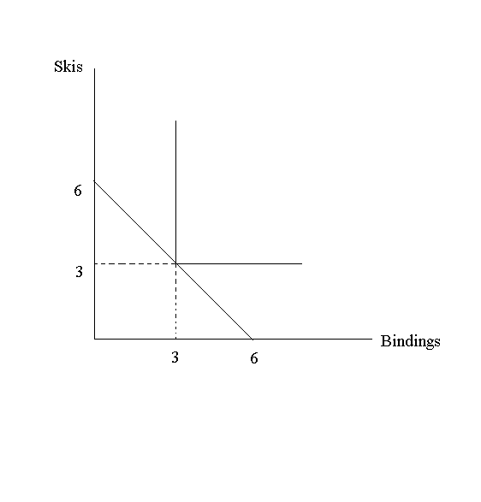
- Now suppose that the price of bindings goes up to $400 each. What are the income and substitution effects of this price increase? Explain your answer in detail and show your work graphically.

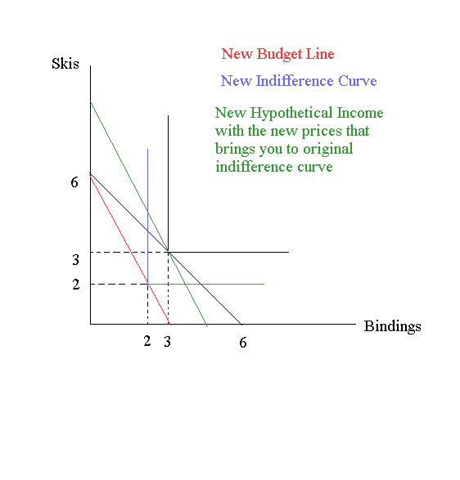
From the above picture we can see that there is only an income effect because the goods are perfect substitutes. Notice that you consume the same bundle (3 of each) with the new hypothetical income that uses the new prices. This suggests that with a higher income and a different price ratio, the same choice of units is optimal and the consumer does not substitute away from the more expensive good (bindings) to the cheaper good (skis). This is intuitive since the consumer only wants to buy the two together.

- Why does the substitution effect you found in part b) make sense? What is it about this particular question that leads to the results you find?

There is no substitution effect in part b) since the goods are perfect complements. The individual doesn’t substitute consumption between the two goods as prices change since the goods are purchased together.

Perfect Substitutes

6. A consumer’s utility function depends form the quantity of two goods X and Y and it is equal to U=18X+3Y. The prices of two goods are P_{X} = 50 and P_{Y} = 20 and his income I= 500.

- Draw the budget line for this consumer. Put good X on the X axis and good Y on the Y axis.
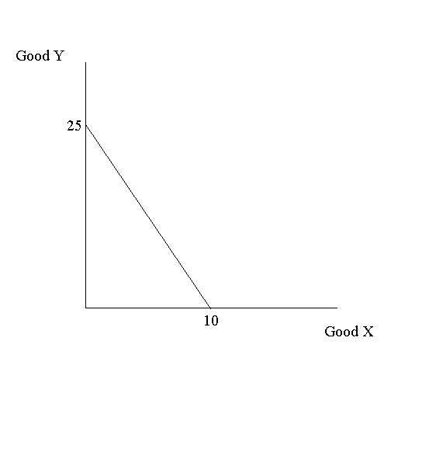
- Draw an indifference curve for this consumer. (Hint, pick some level of utility and graph combinations of X and Y that achieve that level of utility. Choosing the level of utility “wisely” will help you get whole numbers for X and Y).

Suppose that Utility is 180. Then an indifference curve can look like:
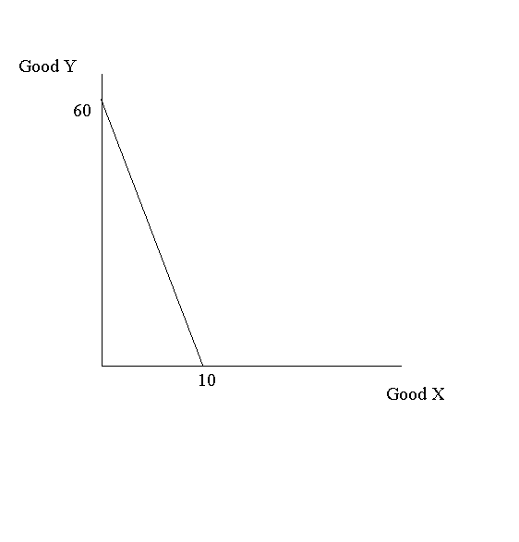
- Given the indifference curve you drew in part b), are goods X and Y perfect complements, perfect substitutes or neither?

Since the indifference curve is linear, the goods are perfect substitutes.

- What is the optimal consumption bundle of good X and Y? (Hint, parts a-c should help you a lot here).

The optimal consumption is 10 units of good X (spending all of the income on good X). This is because good X provides more utility per dollar to this individual and the goods are perfect substitutes. The individual will choose to spend all of their income on X. The indifference curve will only touch the budget line at one point like the following graph shows:
