Economics 101
Summer 2014
Answers to Homework #3
Due Tuesday, June 10, 2014

Directions: The homework will be collected in a box before the lecture. Please place your name, TA name and section number on top of the homework (legibly). Make sure you write your name as it appears on your ID so that you can receive the correct grade. Late homework will not be accepted so make plans ahead of time. Please show your work. Good luck!
Please realize that you are essentially creating “your brand” when you submit this homework. Do you want your homework to convey that you are competent, careful, professional? Or, do you want to convey the image that you are careless, sloppy, and less than professional. For the rest of your life you will be creating your brand: please think about what you are saying about yourself when you do any work for someone else!

1. In Surburbia the demand and supply curves for gasoline are given by the following equations where P is the price per gallon and Q is the quantity of gasoline in gallons:
Market Demand: Q = 10,000 – 1000P
Market Supply: Q = 2000P + 4000
a. What is the slope of the demand curve? What is the slope of the supply curve?
b. What is the equilibrium price and equilibrium quantity of gasoline in Surburbia? Show your work in finding these answers.
c. What is the value of consumer surplus (CS) in this market? What is the value of producer surplus (PS) in this market? Show your work in finding these answers. In your answer be sure to include the units of measurement throughout your work.
d. Suppose that the government of Surburbia decides that less gasoline should be consumed in Surburbia due to concerns about climate change. The government decides to enact an excise tax so that the total consumption of gasoline falls by 3000 gallons from its equilibrium quantity. The government has asked you to advise them as to the size of the excise tax that will be necessary in order to achieve this goal. Assume that the only thing that changes in this market is the excise tax and also assume that this excise tax is levied on producers of gasoline.
e. Given the excise tax you calculated in (d): [Hint: you may find it helpful to do step (vii) before you tackle the rest of the steps!]
i. What is the total tax revenue that will be collected from this excise tax?
ii. What is the consumer tax incidence (CTI) equal to given this excise tax?
iii. What is the producer tax incidence (PTI) equal to given this excise tax?
iv. What is the deadweight loss (DWL) from this excise tax?
v. What is the change in consumer surplus due to this excise tax?
vi. What is the change in producer surplus due to this excise tax?
vii. Draw a diagram of the market for gasoline illustrating this excise tax. Make sure your graph is completely and carefully labelled!
f. Instead of the excise tax described in (d), suppose the government of Surburbia decides to approach the problem of too much gasoline being produced and consumed in Surburbia by targeting a particular price for gasoline. Suppose the government mandates that the price per gallon of gasoline must be $8 per gallon. How big must the excise tax be in order for the government of Surburbia to achieve their goal of the price of gasoline being $8 per gallon?
g. Given the excise tax you calculated in (f): [Hint: you may find it helpful to do step (vii) before you tackle the rest of the steps!]
i. What is the total tax revenue that will be collected from this excise tax?
ii. What is the consumer tax incidence (CTI) equal to given this excise tax?
iii. What is the producer tax incidence (PTI) equal to given this excise tax?
iv. What is the deadweight loss (DWL) from this excise tax?
v. What is the new consumer surplus given this excise tax?
vi. What is the new producer surplus given this excise tax?
vii. Draw a diagram of the market for gasoline illustrating this excise tax. Make sure your graph is completely and carefully labelled!

Answer:
a. Be careful on this question: this is not a hard question, but it does require that you recognize that both the demand and the supply equations are written in x-intercept form and not y-intercept form. That means that the coefficient for P represents the reciprocal of the slope, or 1/m. So, for the demand equation we see that the coefficient for P is -1000 and we plug this value into the equation: 1/m = -1000. Solving for m, the slope of the line, we get m = -1/1000 for the slope of the demand curve. We will follow a similar procedure for the slope of the supply curve: 1/m = 2000 or m = 1/2000: the slope of the supply curve is 1/2000.
b. To find the equilibrium we need to set the demand equation equal to the supply equation: 10,000 – 1000P = 2000P + 4000 or 3000P = 6,000 or P = 2. That is, the equilibrium price of gasoline is $2 per gallon. To find the equilibrium quantity you can substitute P = 2 into either the demand or the supply equation: Q = 10,000 – 1000(2) – 8,000 gallons of gasoline is demanded when the price of gasoline is $2 per gallon; or, Q = 2000(2) + 4000 = 8,000 gallons of gasoline is supplied when the price of gasoline is $2 per gallon.
c. CS = (1/2)($10 per gallon - $2 per gallon)(8,000 gallons) = $32,000
PS = the sum of the area of a triangle and the area of a rectangle = (1/2)($2 per gallon - $0 per gallon)(8000 gallons – 4000 gallons) + ($2 per gallon - $0 per gallon)(4000 gallons) = $12,000
The diagram below illustrates these areas:
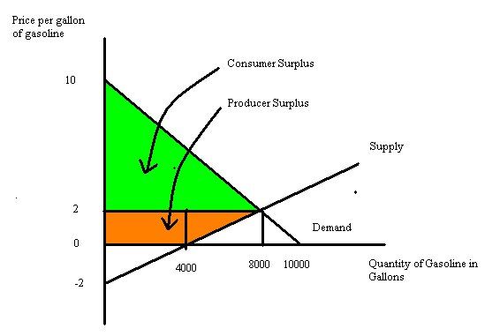
Note: that producer surplus is only the area above the supply curve and beneath the equilibrium price that is also in the first quadrant: the triangle that “sits” below the horizontal axis is not included in this calculation since it does not represent anything meaningful from an economic point of view.
d. The government wants to implement an excise tax that will result in total gasoline consumption falling by 3000 gallons. That means that the government wants Surburbia to end up consuming 5,000 gallons of gasoline instead of their current consumption level of 8,000 gallons of gasoline. If we set Q = 5000, then we find that demanders will demand this level of gasoline if the price per gallon is $5. (Q = 10,000 – 1000P and 5000 = 10,000 – 1000P and therefore P = $5 per gallon of gasoline.) If we set Q = 5000, then we find that suppliers will supply this level of gasoline if the price per gallon is $0.50 per gallon. (Q = 2000P + 4000 and 5000 = 2000P + 4000 and therefore P = $0.50 per gallon of gasoline.) The difference between the price consumers must pay to limit their consumption of gasoline to 5000 gallons and the price suppliers must receive in order to limit their production of gasoline to 5000 gallons is the amount of the excise tax: thus, $5 - $0.50 = $4.50 per gallon of gasoline is the level the excise tax should be set at. That is, the government of Surburbia should implements an excise tax of $4.50 in this market if it wishes to reduce gasoline consumption to 5000 gallons of gasoline.
e.
i. Total tax revenue = (Excise Tax per Unit)(# of Units Sold with the Excise Tax)
Total tax revenue = ($4.50 per gallon of gasoline)(5000 gallons of gasoline)
Total tax revenue = $22,500
ii. Consumer Tax Incidence = (Price consumer pays with the tax – Price consumer paid without the tax)(# of Units sold with the excise tax)
CTI = ($5 per gallon of gasoline - $2 per gallon of gasoline)(5000 gallons of gasoline) = $15,000
iii. Producer tax incidence needs to be equal to the total tax revenue minus the CTI or $7,500. So, let’s check to see if that is true: PTI = (Price suppliers received before the tax – Price suppliers now get to keep once the tax is implemented)(# of units sold with the excise tax) = ($2 per gallon of gasoline - $0.50 per gallon of gasoline)(5000 gallons of gasoline) = $7500. Make sure you understand that CTI + PTI = Total Tax Revenue.
iv. DWL = (1/2)($5 per gallon of gasoline - $0.50 per gallon of gasoline)(8000 gallons of gasoline – 5000 gallons of gasoline) = $6750
v. Change in CS = CS after the implementation of the tax – CS before the implementation of the tax. CS before the implementation of the tax = $32000. CS after the implementation of the tax = (1/2)($10 per gallon of gasoline - $5 per gallon of gasoline)(5000 gallons of gasoline) = $12,500. The change in CS = $12,500 - $32,000 = a decrease of $19,500.
vi. Change in PS = PS after the implementation of the tax - PS before the implementation of the tax . PS before the implementation of the tax = $12,000. PS after the implementation of the tax = (1/2)($0.50 per gallon of gasoline - $0.00 per gallon of gasoline)(5000 gallons of gasoline - 4000 gallons of gasoline) + ($0.50 per gallon of gasoline)(4000 gallons of gasoline) = $2250. The change in PS = $2,250 - $12,000 = a decrease of $9750.
vii.
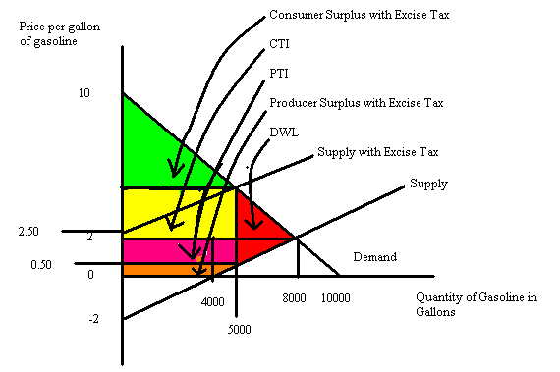

f. To answer this question, one method is to start by thinking about how many gallons of gasoline will be demanded if the price per gallon is $8. To find this quantity we use the demand curve and substitute P = 8: Q = 10,000 – 1000P or Q = 10,000 – 1000(8) = 2000 gallons of gasoline. Then, we can recognize that the excise tax is going to shift the supply curve to the left but parallel to the initial supply curve. That implies that the new supply curve with the excise tax could be written as P = b + (1/2000)Q where b is the new y-intercept of this supply curve that includes the tax. Recall that we can measure the vertical distance from the new y-intercept to the initial y-intercept in order to calculate the amount of the excise tax per unit. With this new supply curve that includes the excise tax we know the P = $8 (that’s the price that the government has decided is the “right” price for gasoline. We also know that Q = 2000 because if this market is going to be in equilibrium with this new excise tax it must be the case that at the new price the quantity demanded equals the quantity supplied. Thus, 8 = b = (1/2000)(2000) or b = 7. Recall the initial supply curve was given as Q = 2000P + 4000 and if we solve this equation for the slope-intercept form we have P = (1/2000)Q – 2. So, the initial y-intercept is -2 and the new y-intercept is 7. The difference, $9 per gallon of gasoline, is the amount of the excise tax per unit.
g.
i. Total tax revenue = ($8 per gallon of gasoline)(2000 gallons of gasoline) = $16,000. Note that although the tax is $9 per gallon of gasoline, that producers will not be netting -$1 per gallon of gasoline in this example. The lowest price producers can receive after they pay the tax to the government is $0 per gallon of gasoline they sell.
ii. CTI = (the new price consumers pay with the excise tax – the initial price consumers pay with there is no excise tax)(# of units of gasoline sold when there is an excise tax) = ($8 per gallon of gasoline - $2 per gallon of gasoline)(2000 gallons of gasoline) = $12,000.
iii. PTI = (the initial price producers received when there was no excise tax – the new net price producers receive with the excise tax)(# of gallons of gasoline sold when there is an excise tax) = ($2 per gallon of gasoline - $0 per gallon of gasoline)(2000 gallons of gasoline) = $4000.
iv. DWL = in this case the sum of the area of a triangle + the area of a rectangle + the area of a triangle. DWL = (1/2)($8 per gallon of gasoline - $6 per gallon of gasoline)(4000 gallons of gasoline – 2000 gallons of gasoline) + ($6 per gallon of gasoline - $0 per gallon of gasoline)(4000 gallons of gasoline – 2000 gallons of gasoline) + (1/2)($6 per gallon of gasoline - $0 per gallon of gasoline)(8000 gallons of gasoline – 4000 gallons of gasoline) = $2000 + $12,000 + $12,000 = $2600.
v. CS’ = (1/2)($10 per gallon of gasoline - $8 per gallon of gasoline)(2000 gallons of gasoline) = $2000.
vi. PS’ = 0. There is no PS with this excise tax since the government “captures” all of the area as its tax revenue.
vii. Here’s the figure!
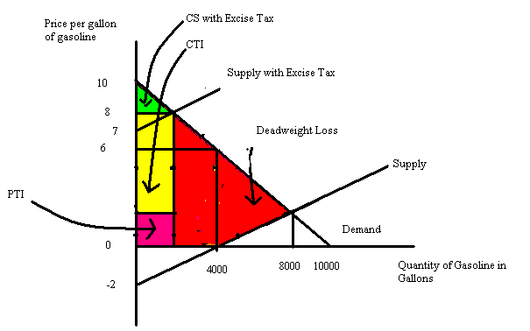

2. Consider the small country of Beachville. It currently has a closed fruit juice market, but its government is considering opening this market to trade. Currently the domestic demand and supply curves for fruit juice in Beachville are given by the following equations where P is the price per gallon of fruit juice and Q is the number of gallons of fruit juice in hundreds:
Domestic Demand for Fruit Juice: Q = 10 – (5/2)P
Domestic Supply of Fruit Juice: Q = (15/2)P
Currently the world price of fruit juice is $2 per gallon of fruit juice.

a. Given the above information, what is the equilibrium quantity and equilibrium price of fruit juice in Beachville? Show how you found your answer.

b. Given the above information, what is the value of consumer surplus (CS)?

c. Given the above information, what is the value of producer surplus (PS)?

d. Given the above information, what would happen to the value of consumer surplus (CS’) if this market opened to trade? Provide both a verbal description of the effect of opening this market to trade as well as a numerical value.

e. Given the above information, what would happen to the value of producer surplus (PS’) if this market opened to trade? Provide both a verbal description of the effect of opening this market to trade as well as a numerical value.

Answer:

a. To find the equilibrium price and equilibrium quantity of fruit juice in Beachville we need to find where the domestic demand curve and domestic supply curve for fruit juice intersect. Thus, 10 – (5/2)P = (15/2)P or P = $1 per gallon of fruit juice. Use this price in either the domestic demand curve or the domestic supply curve to find the equilibrium quantity: thus, Q = 10 – (5/2)(1) = 7.5 or Q = (15/2)(1) = 7.5. But, remember that Q is measured in hundreds of gallons, so the equilibrium quantity of fruit juice in Beachville will be equal to 7.5(100) or 750 gallons.

b. CS = (1/2)($4 per gallon - $1 per gallon)(750 gallons) = $1125

c. PS = (1/2)($1 per gallon - $0 per gallon)(750 gallons) = $375

d. If this market opens to trade, the price of fruit juice in Beachville will increase to the world price; Beachville fruit juice producers will export fruit juice to the world market in order to receive the world price for their product; Beachville consumers will buy less fruit juice as the price per gallon increases to the world price. CS’ in the fruit juice market will decrease relative to its value when the market was closed to trade. To find CS’ we need to determine how many gallons of fruit juice will be demanded domestically if the price per gallon of fruit juice increases to $2 per gallon. To find this value use the domestic demand curve and substitute P = $2: thus, Q = 10 – (5/2)P or Q = 10 – (5/2)(2) = 5 or 500 gallons of fruit juice will be demanded domestically when the price of fruit juice in Beachville is equal to the world price of fruit juice. CS’ = (1/2)($4 per gallon - $2 per gallon)(500 gallons) = $500.

e. If this market opens to trade, the price of fruit juice in Beachville will increase to the world price; Beachville fruit juice producers will export fruit juice to the world market in order to receive the world price for their product. PS’ in the fruit juice market will increase relative to its value when the market was closed to trade. To find PS’ we need to determine how many gallons of fruit juice will be supplied domestically if the price per gallon fruit juice increases to $2 per gallon. To find this value use the domestic supply curve and substitute P = $2: thus, Q = (15/2)P or Q = (15/2)(2) = 15 or 1500 gallons of fruit juice will be supplied domestically when the price of fruit juice in Beachville is equal to the world price of fruit juice. PS’ = (1/2)($2 per gallon - $0 per gallon)(1500 gallons) = $1500.

3. Smurfland is a small, closed economy. In Smurfland the domestic demand and domestic supply of pillows are given by the following equations where P is the price per pillow measured in dollars and Q is the quantity of pillows measured in thousands of pillows:
Domestic Demand for Pillows: P – 20 – Q
Domestic Supply of Pillows: P = 4 + .6Q
The world price of a pillow is $6.

a. What is the equilibrium price and equilibrium quantity of pillows in Smurfland given the above information? Make sure you provide the appropriate units of measurement and not just the numeric values in your answer.

b. If Smurfland opens its pillow market to trade what do you predict will happen? Use a verbal description here and in (c) you can calculate some specific values.

c. Suppose Smurfland opens its pillow market to trade. What will be the quantity of pillows supplied domestically? What will be the quantity of pillows demanded domestically? What will be the level of exports or imports to Smurfland once this market is open to trade? If you get fractional values, don’t worry-just round to the nearest hundredth! (Hint: on this question and the next you will likely find it helpful to sketch a graph to guide your calculations.)

d. Suppose that Smurfland opens it pillow market to trade. How much does total surplus in this market increase by because of this decision? Provide all the steps and reasoning that is necessary to get this answer in the answer you provide.

e. Suppose that Smurfland opens its pillow market to trade but in addition it also implements a tariff so that the price of pillows in Smurfland once this market is open is $7.30. (Hint: you will find it helpful to sketch a graph of the market for pillows in Smurfland once this tariff is implemented.)
i. Given this tariff, determine the quantity of pillows domestically demanded in Smurfland.
ii. Given this tariff, determine the quantity of pillows domestically supplied in Smurfland.
iii. Compare the total surplus in the pillow market in Smurfland between the open economy outcome and the outcome with the described tariff.
iv. Given your answer in (iii) what could possibly justify the implementation of this tariff?
v. Calculate the deadweight loss (DWL) from the implementation of this tariff. Describe why there is a deadweight loss from the implementation of the tariff.

Answer:
a. To find the equilibrium we need to find where the demand and supply curves intersect: thus, 20 – Q = 4 + .6Q or Q = 10,000 pillows. Remember that the quantity is measured in thousands of pillows!

b. If Smurfland opens its pillow market to trade it will import pillows because people in Smurfland will now be able to purchase pillows at the world price which is lower than the closed economy domestic price of pillows. As the price of pillows falls in Smurfland with the opening of this market to trade we can anticipate that the quantity of pillows demanded will increase.

c. The quantity of pillows supplied domestically if this market is opened to trade can be found by substituting P = 6 into the domestic supply equation: 6 = 4 + .6Q or Q = 10/3(1000) = 3333.33 pillows. The quantity of pillows demanded domestically if this market is opened to trade can be found by substituting P = 6 into the domestic demand equation: 6 = 20 – Q or Q = 14(1000) = 14,000 pillows. Since the quantity demanded domestically is greater than the quantity supplied domestically this implies that Smurfland will import the difference: Smurfland’s imports will equal 10,666.67 pillows.

d. I calculated this answer by sketching a graph of this market and noting how opening this market to trade would affect total surplus. This meant that I only needed to calculate the area of one triangle. I have inserted a diagram to explain my thinking on this:
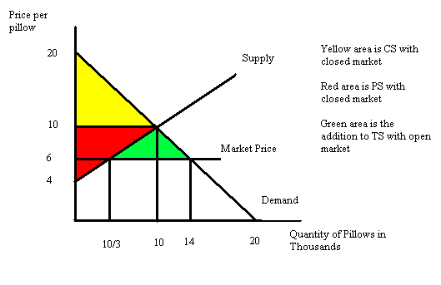
From the diagram I see that opening this market changes total surplus from the sum of the yellow and red areas to the sum of the yellow, red, and green areas. So, opening this market causes total surplus to increase by the area of the green triangle or by (1/2)($10 per pillow - $6 per pillow)(14,000 pillows – 3333.33 pillows) = $21,333.34.

e. The following figure will help you understand the different parts of this answer:

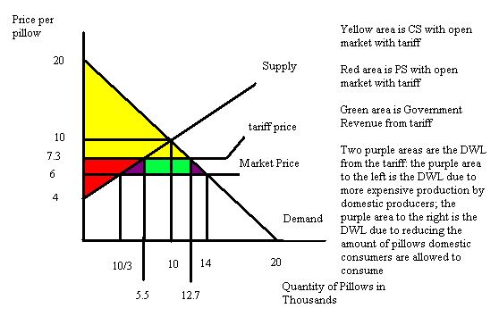
i. To find the quantity demanded domestically with the tariff, substitute P = 7.3 into the domestic demand curve: thus, 7.3 = 20 – Q or Q = 12.7(1000) = 12, 700 pillows.
ii. To find the quantity supplied domestically with the tariff, substitute P = 7.3 into the domestic supply curve: thus 7.3 = 4 + .6Q or Q = 5.5(1000) = 5,500 pillows.
iii. Total surplus with an open economy and no tariff is equal to the following: CS with open economy + PS with open economy = (1/2)($10 per pillow - $6 per pillow)(14,000 pillows) + (1/2)($6 per pillow - $4 per pillow)(3333.33 pillows) = $101,333.33. Total surplus with an open economy and the tariff is equal to the following: CS with the tariff + PS with the tariff = (1/2)($20 per pillow - $7.3 per pillow)(12,700 pillows) + (1/2) ($7.3 per pillow - $4 per pillow)(5,500 pillows) = $89720. Total surplus decreases with the imposition of the tariff.
iv. The implementation of the tariff benefits two groups: a) the tariff benefits domestic producers of pillows in Smurfland by limiting the number of pillows imported into the economy; and b) the tariff benefits the government of Smurfland since it is effectively a tax on foreign producers of pillows.
v. DWL from implementation of this tariff is the sum of two triangles (see the figure). DWL = (1/2) $7.3 per pillow - $6 per pillow)(5,500 pillows – 3333.33 pillows) + (1/2)($7.3 per pillow - $6 per pillow)(14,000 pillow – 12,700 pillows) = $2253.34.

4. Cubville is a small economy and its market for sweaters is currently a closed market that can be described by the following domestic demand and domestic supply curves where P is the price per sweater in dollars and Q is the quantity of sweaters:
Domestic Demand Curve for Sweaters: P = 200 – Q
Domestic Supply Curve for Sweaters: P = 50 + (1/2)Q
Currently the world price of sweaters is $60 per sweater.

a. The government of Cubville has decided to open its sweater market to trade, but at the same time it has decided it must either implement a tariff or a quota such that imports into its market are equal to 60 sweaters. The government of Cubville has asked you to determine what level of tariff will be necessary to obtain this goal. The government will also need a thorough explication of how you determined this tariff and the government has also requested that you provide a graph illustrating the sweater market and this tariff.

b. The government of Cubville has requested that you also provide them with an alternative to the tariff. The government needs to know if they choose to use a quota rather than a tariff, how big does the quota need to be? Remember that the government wants these two potential policies to result in the same outcome. The government of Cubville needs a thorough explication of how you determined this quota and they also need a graph illustrating the sweater market with this quota.

c. If the government of Cubville implements the quota you recommend in (b), what is the maximum that a foreign importer of sweaters will be willing to pay for the right to import a sweater? Explain how you found your answer.

Answer:
a. If the government of Cubville opens this market to trade while restricting its level of imported sweaters to 60, we first need to figure out if this restriction has any impact on this market. Let’s start by determining how many sweaters Cubville would import if this market were open to trade and there was no limit on imports. To do this, let’s plug in P = 60 = world price into both the demand and the supply equations: thus, in the demand equation we have P = 200- Q or 60 = 200 – Q or the quantity demanded domestically is 140 sweaters when sweaters are sold in Cubville at the world price; from the supply equation we have P = 50 + (1/2)Q or 60 = 50 + (1/2)Q or the quantity supplied domestically is 20 sweaters when sweaters are sold in Cubville at the world price. Thus, when this market opens to trade and there is no restriction on the level of imports, the level of imports will be equal to 140 – 20 or 120 imported sweaters. So, from this we can conclude that this restriction on imports will have an effect on this market.

Now we need to figure out what level of tariff will result in only 60 sweaters being imported. We can reflect that the quantity of sweaters supplied domestically + the number of imported sweaters equals the quantity of sweaters demanded domestically when this market is in equilibrium. We can rewrite this idea as follows: Qs + (# of imported sweaters) = Qd. Let’s use the supply and demand equations to find expressions for Qs and Qd: the supply equation is P = 50 + (1/2)Qs and rewriting this in terms of Qs we get Qs =2P – 100; the demand equation is P = 200 – Qd and rewriting this in terms of Qd we get Qd = 200 – P. Using these expressions we can rewrite Qs + (# of imported sweaters) = Qd as (2P – 100) + 60 = (200 – P) or $80 per sweater. So, if the tariff is set so that the price of sweaters increases from the world price of $60 per sweater to $80 per sweater this will result in only 60 sweaters being imported into this market. It will also result in domestic sweater producers producing 60 sweaters and domestic sweater consumers consuming 120 sweaters.

b. Well, this is an easy question. If the government has decided to limit the number of imported sweaters to 60, then the amount of the quota is 60 sweaters. When this limit is imposed on this market it results in the price of $80 per sweater. Read through the explanation in (a) again and make sure you understand how this all works.

c. If you are lucky enough to import one of the 60 imported sweaters that are allowed then you will find that you can sell this sweater for $80 rather than the world price of $60. The maximum you would be willing to pay to sell this imported sweater in Cubville is therefore the difference between these two prices, or $20 per sweater.

5. Tommy recently graduated from college and is now in the process of deciding where he wants to start his career. He has three job offers (!) for similar work and similar future opportunities, but each job offer is in a different city. Tommy has no strong geographic preference and his only goal is to select that job that results in his being financially best off. From his economics class Tommy knows that he needs to be thoughtful when comparing these offers. This is what he knows:
Job Offer #1: is for a job in Toledo that pays $40,000 for his first year of work (for convenience, let’s refer to this as year 2015), guarantees him a 10% increase in his nominal salary for the second year (2016), and a 10% increase in his nominal salary for the third year (2017). After that his nominal salary will be adjusted so that his real salary stays constant.
Job Offer #2: is for a job in Miami that pays $42,000 for his first year of work (for convenience, let’s refer to this as year 2015), guarantees him a 5% increase in his nominal salary for the second year (2016), and a 5% increase in his nominal salary for the third year (2017). After that his nominal salary will be adjusted so that his real salary stays constant.
Job Offer #3: is for a job in St. Paul that pays $48,000 each year for the first and second years (2015 and 2016), and a 3% increase in his nominal salary for the third year (2017). After that his nominal salary will be adjusted so that his real salary stays constant.

a. Let’s start by simply analyzing the nominal values of these three job offers. Given the above descriptions fill out the table below so that Tommy can compare the nominal values of the offers he has. Once you fill out the table rank the options in terms of their nominal values. Show in the table how you computed these answers.

 | Nominal Wage in 2015 | Nominal Wage in 2016 | Nominal Wage in 2017
Toledo
Miami
St. Paul

b. Tommy understands from his economics class that he needs to really consider real salaries rather than nominal salaries in making his decision about which offer to accept. Luckily for him we have data about the CPI projections for the next three years for each of these cities. The table below provides our best estimates of what the CPI for 2015, 2016 and 2017 will be in each of these cities.

 | Projected CPI 2015 | Projected CPI 2016 | Projected CPI 2017
Toledo | 100 | 120 | 130
Miami | 110 | 120 | 130
St. Paul | 120 | 125 | 130

Use this information to complete the following table of real salary values for these three job offers. In the table, you should round your answers to the nearest whole number. Show in the table how you computed your answers. Once you fill out the table rank the options in terms of their real values. Which job offer should Tommy accept?

 | Projected Real Salary in 2015 | Projected Real Salary in 2016 | Projected Real Salary in 2017
Toledo
Miami
St. Paul

c. To drive home the difference between the nominal and real values a bit more. Let’s complete one more table using the data you have been given. Here is the table: make sure you show your work for how you computed your answers.

 | Percentage change in nominal salary from 2015 to 2016 | Percentage change in nominal salary from 2015 to 2016 | Percentage change in real salary from 2015 to 2016 | Percentage change in real salary from 2016 to 2017
Toledo
Miami
St. Paul

Answer:
a.
 | Nominal Wage in 2015 | Nominal Wage in 2016 | Nominal Wage in 2017
Toledo | $40,000 | $40,000*1.10 = $44,000 | $44,000*1.10 = $48,400
Miami | $42,000 | $42,000*1.05 = $44,100 | $44,100*1.05 = $46,305
St. Paul | $48,000 | $48,000 | $48,000*1.03 = $49,440
From the table we can see if we only look at the first year and nominal values that Tommy would rank the options from best to worst as St. Paul, Miami, and Toledo. If Tommy goes to the third year and out into the future using these nominal values we see that he would rank the offers in the following order: St. Paul, Toledo, and Miami. So, over time the relative rankings in nominal terms changes with these three offers.

b.
 | Projected Real Salary in 2015 | Projected Real Salary in 2016 | Projected Real Salary in 2017
Toledo | ($40,000/100)*100 = $40,000 | ($44,000/120)*100 = $36,667 | ($48,400/130)*100 = $37,231
Miami | ($42,000/110)*100 = $38,182 | ($44,100/120)*100 = $36,750 | ($46,305/130)*100 = $35,619
St. Paul | ($48,000/120)*100 = $40,000 | ($48,000/125)*100 = $38,400 | ($49,440/130)*100 = $38,031

Using the values in this table we can see that the job offers in real salary terms in terms of best offer to worst offer are rank as: St. Paul, Toledo, and Miami three years out and into the future after that. Tommy if his only goal is to maximize his purchasing power should accept the job in St. Paul. But, notice that the St. Paul and Toledo offers in real terms are not nearly so far apart as the nominal job offers seemed.

c.
 | Percentage change in nominal salary from 2015 to 2016 | Percentage change in nominal salary from 2015 to 2016 | Percentage change in real salary from 2015 to 2016 | Percentage change in real salary from 2016 to 2017
Toledo | [(44,000 – 40,000)/40,000]*100 = 10% | [(48,400 – 44,000)/44,000]*100 = 10% | [(36,667 – 40,000)/40,000]*100 = -8.3% | [(37,231 – 36,667)/36,667]*100 = 1.5%
Miami | [(44,100 – 42,000)/42,000]*100 = 5% | [(46,305 – 44,100)/44,100]*100 = 5% | [(36,750 – 38,182)/(38,182]*100 = -3.8% | [(35,619 – 36,750)/36,750]*100 = -3.1%
St. Paul | [(48,000 – 48,000)/48,000]*100 = 0% | [(49,440 – 48,000)/48,000]*100 = 3% | [(38,400 – 40,000)/40,000]*100 = -4% | [(38,031 – 38,400)/38,400]*100 = -0.96%

6. Consider the market for a brand of designer jeans for which there are really no close substitutes. Suppose the demand in this market is described by the following equations where P is the price per pair of jeans and Q is the quantity of jeans:
P = 1000 - .8Q for Q less than or equal to 1000 and
P = 250 - .05Q for Q greater than or equal to 1000
What price and quantity should this jean company charge given the above information if the sole goal of the firm is to maximize their revenue? Explain how you found your answer.

Answer:
From our study of elasticity we know that total revenue is maximized at the midpoint of a linear demand curve. In this example however there are two linear segments of the demand curve and so we will need to consider both segments.

For Q less than or equal to 1000, we have the demand curve P = 1000 - .8Q. The midpoint of this line if the line intersected both axes would be (625, $500). Since a quantity of 625 is less than the maximum quantity for this segment (Q less than or equal to 1000) we can use this midpoint to calculate the firm’s total revenue.
TR = P*Q
TR = ($500 per pair of jeans)(625 pairs of jeans)
TR = $312,500

For Q greater than or equal to 1000, we have the demand curve P = 250 - .05Q. The midpoint of this line if the line intersected both axes would be (2500, $125). Since a quantity of 2500 is greater than the minimum quantity for this segment (Q greater than or equal to 1000) we can use this midpoint to calculate the firm’s total revenue.
TR = P*Q
TR = ($125 per pair of jeans)(2500 pairs of jeans)
TR = $312,500

This firm will earn the same revenue if it chooses to produce 625 pairs of jeans and sell them for $500 a pair or if it chooses to produce 2500 pairs of jeans and sell them for $125 a pair.

7. Suppose you are given the demand curve
P = 100 – 2Q
where P is the price per widget and Q is the quantity of widgets.

a. Using the point elasticity of demand concept find the elasticity of demand when Q = 10. Show your work.

b. Using the point elasticity of demand concept find the elasticity of demand when P = 60. Show your work.

c. What do you predict will be the value of the elasticity of demand when P = 50? Explain your answer.

d. Using the point elasticity of demand concept find the elasticity of demand when P = 50. Show your work.

Answer:

a. ε = [-1/slope][P/Q] = (1/2)(80/10) = 4

b. ε = [-1/slope][P/Q] = (1/2)(60/20) = 1.5

c. Since P = 50 is the price associated with the midpoint of this demand curve, one would predict that the value of the elasticity of demand at this price should be one since the midpoint is the unit elastic point of a linear demand curve.

d. ε = [-1/slope][P/Q] = (1/2)(50/25) = 1

8. You know that the elasticity of demand using the arc elasticity formula is
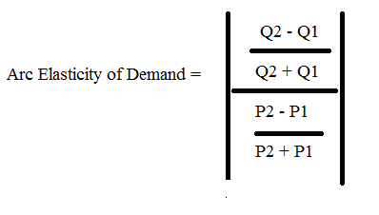
and you know that the point elasticity of demand formula is
Point Elasticity of Demand = [-1/slope][P/Q]

See if you can prove that the arc elasticity formula can ultimately be manipulated to give you the point elasticity formula. Show your work.
Answer:
Rewrite the arc elasticity formula as follows:
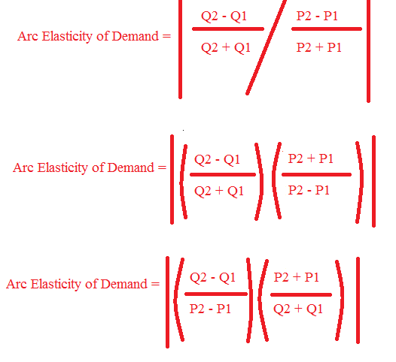
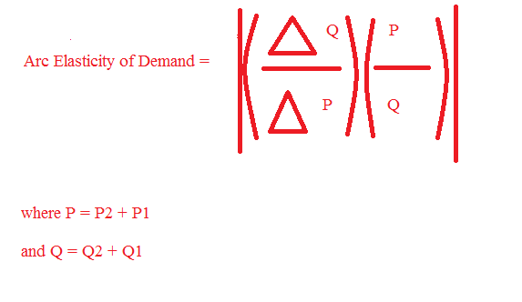
Note that slope = rise/run = (change in Price)/(change in Quantity)
So, (Change in Quantity)/(Change in Price) = 1/slope and since the slope of a demand curve is less than 0, we can replace the absolute value signs with (-1/slope) to get a positive sign for our elasticity of demand measure.
Thus,
ε = [-1/slope][P/Q]

