Economics 101
Summer 2009
Answers to Homework #3
Due June 9, 2009

For this homework you will find it helpful to know the following equations:

1) Standard percentage change formula = [(new value - initial value)/(initial value)]*100
2) Midpoint method percentage change formula = {(new value - initial value)/[(new value + initial value)/2]}*100

1. Suppose that when the price of bicycles is $100, 500 bicycles are demanded and when the price of bicycles is $200, 100 bicycles are demanded.
a. Using the standard percentage change formula (not the midpoint method), what is the percentage change in the price of bicycles if the initial price is $100?
[(500 - 100)/100]*100 = 400 % increase in price
b. Using the standard percentage change formula (not the midpoint method), what is the percentage change in the quantity of bicycles demanded if the initial price is $100?
[(100 - 500)/500]*100 = 80% decrease in quantity demanded
c. Price elasticity of demand is defined as the percentage change in the quantity demanded divided by the percentage change in the price of the good. Using your calculations in parts (a) and (b) of this problem, what is the price elasticity of demand?
Price elasticity of demand = 80%/400% = .2. Note for the price elasticity of demand we take the absolute value of this calculation since demand curves are usually downward sloping.
d. Using the standard percentage change formula, what is the percentage change in the price of bicycles if the initial price is $200?
[(100- 200)/200]*100 = 50% decrease in price
e. Using the standard percentage change formula, what is the percentage change in the quantity of bicycles demanded if the initial price is $200?
[(500 - 100)/100]*100 = 400% increase in quantity demanded
f. Using your calculations from parts (d) and (e) of this problem, what is the price elasticity of demand?
Price elasticity of demand = 400%/50% = 8
g. Are the two measures you calculated in part (c) and part (f) the same? Explain your answer.
No, you get very different measures. In part (c) the price elasticity of demand indicates demand is inelastic since the elasticity measure is less than 1 and in part (f) the price elasticity of demand indicates demand is elastic since the elasticity measure is greater than 1. This difference arises because we are using the standard percentage change formula and this formula's results depend upon the initial value or base that the percentage is based on. The midpoint method eliminates this discrepancy.
h. Suppose the initial price of bicycles is $100. Calculate the price elasticity of demand for bicycles using the midpoint method for calculating a percentage.
Price elasticity of demand = {(100-500)/[(500+100)/2]}/{(200-100)/[(200+100)/2]}*100 = 2
Remember that we take the absolute value of the price elasticity of demand since demand curves are usually downward sloping.
i. Suppose the initial price of bicycles is $200. Calculate the price elasticity of demand for bicycles using the midpoint method for calculating a percentage.
Price elasticity of demand = {(500-100)/[(500+100)/2]}/{(100-200)/[(200+100)/2]}*100 = 2
j. Compare your answers in parts (h) and (i). Are they the same? Explain the significance of your findings.
Using the midpoint method gives us the same values for the price elasticity of demand irrespective of what is our initial point.

2. For each of the following scenarios determine if demand if elastic, inelastic, or unit elastic.
a. Joe can sell 100 shovels if he prices his shovels at $12 or he can sell 130 shovels if he prices his shovels at $10. The demand for shovels is _______________.
To answer these questions you need to compute the total revenues for each scenario: if price decreases and total revenue increases, then demand is elastic; if price decreases and total revenue decreases, then demand is inelastic; and if price decreases and total revenue is unchanged then demand is unit elastic.
a. Demand is elastic.
b. Emily sold lemonade on Tuesday for $.50 a cup and she sold 100 cups. On Thursday she raised the price to $1 a cup and sold 50 cups. The demand for lemonade is _________.
b. Demand is unit elastic.
c. Martin can sell 2000 boxes of detergent if the price is $10 and 1800 boxes if the price is $11. Demand for detergent is __________.
c. Demand is elastic.

3. You are told that the cross-price elasticity of demand of good X for good Y is a negative number. You conclude that good X and good Y are _____________.
Complements

4. You are told that the cross-price elasticity of demand of good A for good B is a positive number. You conclude that good A and good B are _____________.
Substitutes

5. You are told that your income elasticity of demand for potatoes is .1. If your income increases by 10% then the percentage change in the quantity of potatoes you demand is equal to _____________.
1%

6. You are given the following information about production in Smallwood.
 | Quantity in 2008 | Prices in 2008 | Quantity in 2009 | Prices in 2009
Muffins | 100 | $1 | 150 | $2
Bagels | 200 | $2 | 150 | $1
Suppose you are told that the market basket for purposes of calculating the CPI in Smallwood is defined as 20 bagels and 40 muffins.
a. Calculate the CPI in Smallwood for 2008 and 2009 using 2008 as the base year.
Cost of market basket in 2008 = 80
Cost of market basket in 2009 = 100
CPI in 2008 = [Cost of market basket in 2008/Cost of market basket in base year]*100
CPI in 2008 = (80/80)*100 = 100
CPI in 2009 = [Cost of market basket in 2009/Cost of market basket in base year]*100
CPI in 2009 = (100/80)*100 = 125
b. Based on your calculations in part (a), what was the rate of inflation between 2008 and 2009?
Rate of inflation = [(125 – 100)/100] * 100 = 25%
c. Holding everything else constant, recalculate the CPI for Smallwood using 2009 as the base year.
Cost of market basket in 2008 = 80
Cost of market basket in 2009 = 100
CPI in 2009 = (100/100)*100 = 100
CPI in 2008 = (80/100)*100 = 80
d. Based on your calculation in part (c), what was the rate of inflation between 2008 and 2009?
Rate of inflation = [(100 – 80)/80]*100 = 25%

7. Relative to 2006, the inflation rate in Madison in 2007 was 8%. Furthermore, nominal wages in Madison rose 10% during this period.
a. What was the percentage change in real wages in Madison in 2007?
To answer this question you need to organize the data:

Year | CPI | Nominal Wages | Real Wages
2006 | 100
2007
But, you also know that the nominal wage equals the real wage in the base year: so pick a wage for these two cells of your table. I selected 100 since that is an easy number to work with. Thus,
Year | CPI | Nominal Wages | Real Wages
2006 | 100 | 100 | 100
2007
You can now fill in the 2007 cells for the CPI and the nominal wage.
Year | CPI | Nominal Wages | Real Wages
2006 | 100 | 100 | 100
2007 | 108 | 110
Now, you need to find the real wage in 2007 and then compute the percentage change in the real wage rate.
Real wage = [(Nominal Wage)/(Price Index)]*100
Real Wage = (110/108)*100
Real Wage = 101.85
Percentage change in real wage = [(101.85 – 100)/100]*100 = 1.85%
b. Is it possible for the CPI to increase and the nominal wage to increase, but for the real wage to decrease? Explain your answer.
Yes it is possible. If the nominal wage increases but by a smaller percentage than the percentage increase in the CPI, the real wage will decrease.

8. Use the following information to construct the budget line for each individual. Draw the budget line on a separate graph, carefully labeling each axis. Provide an equation in slope-intercept form for each budget line.
a. Income of $100, price of good X equals $20 and price of good Y equals $10
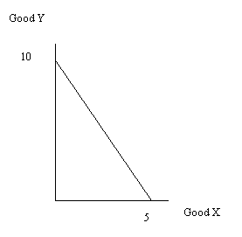
Y = 10 – 2X
b. Income of $100, price of good X equals $20 and price of good Y equals $20
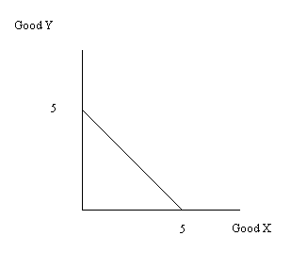
Y = 5 – X
c. Income of $100, price of good X is $10 and price of good Y is $10
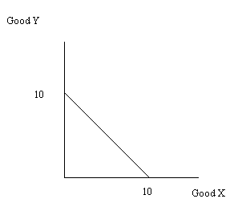
Y = 10 – X
d. Income is $200, price of good X is $20 and price of good Y is $10
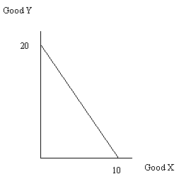
Y = 20 – 2X
e. Circle the right answer. Holding everything else constant, if income decrease this causes the individual’s budget line to (shift in, shift out), (increases, decreases, has no effect on) the y-intercept and (increases, decreases, has no effect on) the slope of the budget line.
f. Circle the right answer. Holding everything else constant, if the price of good X decreases (assume X is measured on the horizontal axis), then the y-intercept of the budget line (increases, decreases, remains the same), the x-intercept of the budget line (increases, decreases, remains the same), and the slope of the budget line (is unaffected, has a smaller absolute value, has a larger absolute value).
g. Circle the right answer. Suppose income doubles and the prices of good X and good Y also double. This will cause the individual’s budget line to (shift out, shift in, be unaffected). The new budget line (is identical to the original budget line, has a smaller slope in absolute value terms than the original budget line, has a larger slope in absolute value terms that the original budget line).

10. Suppose Sarah’s available income to spend on coffee drinks and pizza is $100. Furthermore, suppose the price of coffee drinks is $5 and the price of pizza is $10.
a. Draw Sarah’s budget line on a graph and label it BL1. Measure coffee drinks on the x0axis and pizza on the y-axis.
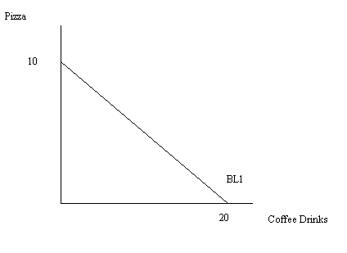
b. Suppose you are told that Sarah maximizes her utility when she consumes 8 pizzas. How many coffee drinks does Sarah consume given this information and all the preliminary information?
We know that Sarah has $100 in income and that she maximizes her utility when she consumes 8 pizzas. But, 8 pizzas cost Sarah $80 and that means she has $20 left over to purchase coffee drinks. Since coffee drinks cost $5, this means that Sarah can afford 4 coffee drinks.
c. Suppose that Sarah’s income remains at $100 but the price of coffee drinks changes to $10 while the price of pizza remains at $10. You are told that Sarah maximizes her utility when she consumes 3 coffee drinks. How many pizzas does Sarah consume when she maximizes her utility given these prices and her income?
Sarah spends $30 on coffee drinks when she purchases three coffee drinks: this leaves Sarah with $70 that she can spend on pizza. Sarah purchases 7 pizzas.
d. Draw a graph illustrating Sarah’s consumption choices when she faces these two different sets of prices. Label the first budget line BL1, the second budget line BL2, her utility maximization point with BL1 as point A, and her utility maximization point with BL2 as point B.
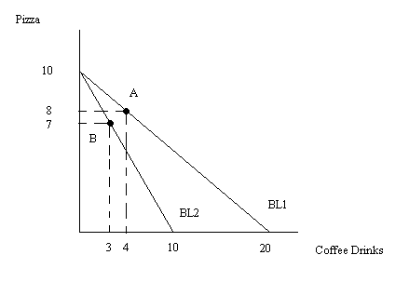
e. Suppose that given these two budget lines you are told that if Sarah had her income adjusted so that she could continue to enjoy her initial level of utility while paying the new prices (those described in part (c)) she would consume 3.5 coffee drinks and 9 pizzas. How much additional income would Sarah need in order to be able to maintain her utility at the initial level while paying the new prices?
We know the new prices: the price of pizza is $10 and the price of a coffee drink is $10. So, if Sarah purchases 3.5 coffee drinks this will cost her $35 and if she purchases 9 pizzas this will cost her $90, for a total of $125. Sarah will need to be compensated an additional $25 in order for her to pay the new prices while still achieving her initial level of utility. Remember that when the price of coffee drinks increases, holding everything else constant, this reduces Sarah’s purchasing power-she will need to have additional income if she is to maintain her original level of satisfaction.
f. What is the substitution effect measured in terms of coffee drinks?
Sarah initially consumed 4 coffee drinks and she reduces her consumption to 3.5 coffee drinks when her income is compensated so that she can maintain her original level of utility while paying the new prices: this implies that her substitution effect is .5 coffee drinks since this is the amount of coffee drinks Sarah gives up simply because of the change in the price of the good.
g. What is the income effect measured in terms of coffee drinks?
To find the income effect we want to compare Sarah’s consumption when her income is compensated so that she can stay on the original indifference curve while facing the new prices to her consumption choice when she faces the new prices but maintains her original level of income. Thus, we will be looking at the change in coffee drink consumption from 3.5 coffee drinks to 3 coffee drinks: Sarah’s income effect is .5 coffee drinks.

11. Use the following information depicting a firm’s short-run production function and cost function to answer this question.
L | K | Q | MPL | FC | VC | TC | AFC | AVC | ATC | MC
0 | 10 | 0 | --- | $100 |  |  | --- | --- | --- | ---
1 |  |  | 80 |  | $20
2 |  |  | 110
3 |  | 250
4 |  | 280
5 |  | 300
a. Fill in the missing cells on the above table.
L | K | Q | MPL | FC | VC | TC | AFC | AVC | ATC | MC
0 | 10 | 0 | --- | $100 | $0 | $100 | --- | --- | --- | ---
1 | 10 | 80 | 80 | 100 | $20 | 120 | 1.25 | .25 | 1.5 | .25
2 | 10 | 190 | 110 | 100 | 40 | 140 | .53 | .21 | .74 | .18
3 | 10 | 250 | 60 | 100 | 60 | 160 | .4 | .24 | .64 | .33
4 | 10 | 280 | 30 | 100 | 80 | 180 | .36 | .29 | .64 | .67
5 | 10 | 300 | 20 | 100 | 100 | 200 | .33 | .33 | .67 | 1
b. At what level of labor usage does this firm experience diminishing marginal returns to labor?
Diminishing returns to an input occurs in the short run when output increases at a diminishing rate when an additional unit of the input is used. This occurs with the third unit of labor: output increases from 80 to 190 units with the hiring of the second unit of labor. This represents additional output of 110 units. But, when the third unit of labor is hired output increases from 190 units to 250 units. Even though output is still increasing, it is increasing at a decreasing rate: the third unit of labor only contributes 60 additional units of output while the second unit of labor contributed 110 units of output.
c. What is the price of a unit of labor?
In the table you are told that the variable costs of production are equal to $20 when one unit of labor is hired: therefore, the cost of a unit of labor is $20.
d. What is the price of a unit of capital?
In the table you are told that the fixed costs of production are equal to $100 when 10 units of capital are hired: therefore, the cost of a unit of capital is $10.
e. As output increases, what happens to this firm’s fixed costs of production? Explain your answer.
In the short run, at least one input is fixed. In this example the fixed input is capital while the variable input is labor. As output increases the firm’s fixed costs of production do not change in the short run since its usage of the fixed input does not change in the short run.
f. As output increases, what happens to the firm’s variable costs of production? Explain your answer.
In the short run, at least one input is variable. In this example the variable input is labor while the fixed input is capital. As output increases this is only possible because the firm hires additional units of labor. As the firm increases its use of labor this causes the firm’s variable costs of production to increase. Thus, as output increases the firm’s variable costs of production also increase.

