Economics 101
Spring 2011
Answers to Homework #3
Due Tuesday, March 1

Directions: The homework will be collected in a box before the lecture. Staple your homework before handing it in. Please place your name, TA name and section number on top of the homework (legibly). Make sure you write your name as it appears on your ID so that you can receive the correct grade. Please remember the section number for the section you are registered, because you will need that number when you submit exams and homework. Late homework will not be accepted so make plans ahead of time. Please show your work. Good luck!

1. AGRICULTURAL INTERVENTION

Use the following to answer parts (a) through (e).

Consider the market for pineapples in a small island nation. The domestic demand curve (in Island Dollars) is P = 60 – 3Q_{D} and the domestic supply curve is P = 10 + 2Q_{S}.

a. What is the market equilibrium price and quantity?

Solution: Set prices equal and solve to get P = $30 and Q = 10

PRICE CEILINGS AND FLOORS:

b. If the government, hoping to help the poor, imposes a price ceiling of $15, what will be the shortage of pineapples in the market? Graph your response.

Solution: Plug P=15 into the supply and demand curves to find that quantity demand at this price is 15 and the quantity supplied is 2.5. The shortage is therefore 15-2.5 =12.5 pineapples.

c. What price floor would yield a surplus of 15 pineapples?

Solution: Solve both equations for quantity to get:
QD=20-P/3 and QS = P/2-5
With the price floor, we know that QS=QD+15
Plug in our equations to get: P/2-5=20-P/3+15
Solving this gives P = 48.

PRICE SUPPORT PROGRAMS

d. Suppose the government price target is $42, which they plan to accomplish by use of a price support program. How many pineapples will the government have to buy with this program, and how much will the program cost the government? Graph your results, and shade the region corresponding to total government cost.

Solution: By plugging P = 42 into the supply and demand curves, we see that quantity demanded is 6 and quantity supplied is 16. The surplus is thus 10 pineapples, which will cost them $420 to buy at the price of $42 a pineapple. Your graph should show the surplus as a horizontal line between the points (Q=6, P=42) and (Q=16, P=42). The total government cost is the rectangle whose top side is the surplus line and bottom is the Q axis.

PRICE SUBSIDY PROGRAMS

e. Suppose the government offers the pineapple producers a $10 subsidy on every unit they sell. Graph the new market supply curve. What will the new market equilibrium quantity and price be with this program? How much does this program cost the government?

At any given quantity, the supplier can afford to sell at $10 less per pineapple than before, since they are now getting the extra money from the government. Thus the new supply curve is shifted down by $10, or
P_{subsidized}=(original supply price)-$10=2Q_{s}
To find the new equilibrium price and quantity, set 60-3Q=2Q which gives Q=12. Plug this into the demand curve to see that consumers pay a price of $24 now. The program costs the government: (subsidy)x(quantity sold) = 10*12=$120

f. What size of subsidy would the government need to provide to attain a target price of $27?

Solution: At $27, consumers will buy 11 units. Suppliers will only produce 11 units at a per unit price of $32. The government thus needs to cover the difference, which is $5 per pineapple.

2. TARIFFS AND QUOTAS

Use the following information to answer parts (a) through (d).

Consider the market for lawnmowers in a small country. The domestic demand curve is
P = 100 – (1/10) Q_{D} and the domestic supply curve is P = 10 + (1/5)Q_{S}.

a. What is the equilibrium market price and quantity, assuming no imports or exports?

Solution: Q=300, P=70

b. If the government opens up the economy to outside trade, and the world price is $60, will the country be importing or exporting lawnmowers? How many lawnmowers will it import or export? Draw this on a graph.

At this price, domestic consumers demand 400 lawnmowers and domestic suppliers produce 250 lawnmowers. Thus 150 lawnmowers will need to be imported to cover the difference between the domestic demand and the domestic supply.

c. Suppose the world price of lawnmowers is $60 and the government opens this market to trade while at the same it imposes a $5 tariff on each lawnmower that is imported. Given this tariff, what will the domestic demand be? Given this tariff, what will the domestic supply be? Given this tariff, what is the government revenue from the tariff? Update your graph to show all these quantities. Also mark the regions that correspond to deadweight loss, domestic consumer surplus, and domestic producer surplus when this market is open to trade and the government imposes a $5 tariff per imported unit.

Solution: Domestic quantity demanded: 350
Domestic quantity supplied: 275
Imports: 75 mowers
Government tariff revenue: $75x5=$375
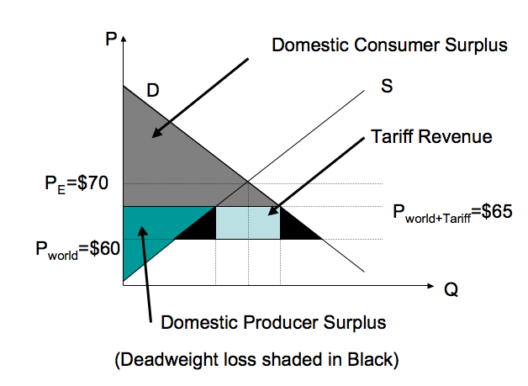

d. Instead of a tariff, the government decides to impose an import quota of 30 lawnmowers. On a new graph, draw the new market supply curve given this import quota.. What’s the new equilibrium price given this import quota? How many mowers are domestic suppliers supplying given this import quota?

ABOVE THE WORLD PRICE: Market supply shifts right by 30 mowers or P = (1/5)Q + 4.
BELOW THE WORLD PRICE: Martket supply stays the same
AT THE WORLD PRICE: Market supply is a horizontal line connecting the “above the world price” curve and the “below the world price” curve

Use the original demand curve and the new supply curve to find the equilibrium price with the quota. Solving for the new equilibrium yields a new price of $68, and a quantity traded of 320, 290 of which are produced domestically.

3. Suppose market demand for tires (in millions) is given by the equation Q_{D} = 12 - P. Tires are supplied according to the market supply equation Q_{S} = 2P.

a. Calculate the equilibrium price and quantity, consumer surplus, and producer surplus in the market for tires. Graph your results.

Key: P* = $4/ unit, Q* = 8, CS = 0.5*8*(12-4) = $32, PS = 0.5*8*4 = $16.

b. Suppose the government imposes an excise tax on tire producers of $3 per tire. How does this tax affect the supply and demand curves (write the equations for both curves)?

Key: Demand curve remains the same, the new supply curve in Y-intercept form is P = Q/2 + 3.

c. Compute the new equilibrium price and quantity given the excise tax described in part (b). On a graph show the changes in equilibrium price and quantity due to the imposition of the tax.

Key: the new equilibrium price and quantity are P*=Q*=6. Graph is shown below.

d. Show on a graph the new producer surplus and consumer surplus given the imposition of the excise tax described in part (b). Also show tax revenue and the deadweight loss due to the imposition of this tax.

Key: The graph below answers questions (c) and (d)

e. Calculate the effect of the excise tax described in part (b) on the consumer and producer surplus.

Key: The new CS = 0.5*(12-6)*6 = $18, PS = 0.5*3*6 = $9, both the consumer surplus and the producer surplus are decreased with the imposition of the excise tax.

f. What, if any, is the deadweight loss caused by the tax?

Key: DWL = 0.5*3*(8-6) = $3

g. What is the government revenue when this excise tax is implemented?

Key: Government revenue = 3*6 = $18

h. Who bears the greater economic incidence of the tax, the consumer or the producer?

Key: Consumer tax incidence is $12, producer tax incidence is $6, so consumers bear the greater economic incidence.

i. Assume the original supply curve is unchanged and the original equilibrium price and quantity are the values you found in part (a). But, suppose you don’t know the original demand curve: you just know the equilibrium price and quantity in the market and the original supply curve. Then, if the government imposes an excise tax of $3 per unit in this market and this results in consumers and producers sharing equally the economic incidence of this tax. From this information deduce what the original demand curve equation is. Illustrate your answer in a graph.

Key: You know the supply curve before the tax is P = (1/2)Q and you know the supply curve after the tax is P = (1/2)Q + 3. You also know that the demand curve includes the point (8, 4). In addition you know that the new equilibrium price with the tax must be $1.50 greater than the initial equilibrium price if consumers and producers share the economic burden of the tax. You also know that the new net price is $1.50 less than the initial equilibrium price if consumers and producers share the economic burden of the tax. Use the original supply curve to find the quantity with the tax: P = (1/2)Q where P is the net price. So 2.5 = (1/2)Q or Q with the tax is equal to 5. Now, you can find the demand curve since you know the demand curve contains the points (5, 5.5) and (8. 4). The slope of the new demand curve is -1/2 and the equation for the demand curve is P = (-1/2) Q + 8. Note that the supply and demand curve should have the same absolute value of slope in order for the consumer and producer tax incidence to be equal.

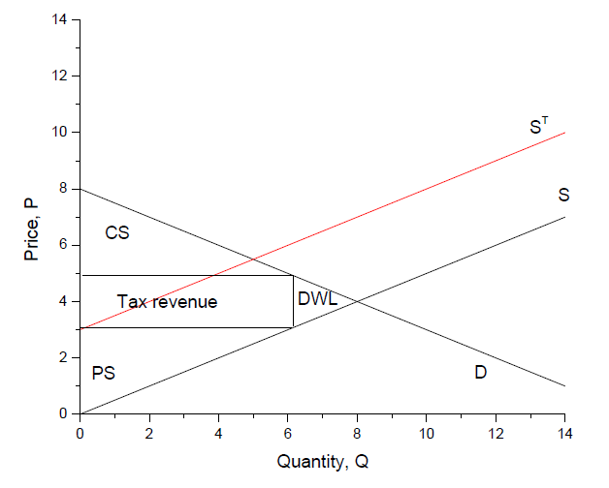
j. Now assume the original demand curve is unchanged and the original equilibrium price and quantity are the values you found in part (a). But, suppose you don’t know the original supply curve: you just know the equilibrium price and quantity in the market and the original demand curve. Then, if the government imposes an excise tax of $3 per unit in this market and this results in consumer tax incidence being less than producer tax incidence. From this information deduce what must be true about the slope of the supply curve relative to the slope of the demand curve. Illustrate your answer in a graph.

Key: Let’s think about a thought experiment on this. You know the initial equilibrium (8, 4) and you know that when a $3 per unit excised tax is imposed in this market that producers tax incidence is greater than consumers tax incidence. Thus, for example if the new price with the tax causes consumption to fall by one unit to 7 units a possible new price with the tax that would cause the tax to fall more heavily on consumers would be $5. This combination (7 units, $5) sits on the demand curve. If the tax causes the price of the good to rise to $5 for consumers then this implies that producers will receive a net price of $2 since $5 minus $2 is equal to the $3 per unit excise tax. Thus, one possible solution to this problem would have the points (8,4) and (7, 2) on the original supply curve. If you use these two points to calculate the supply curve you would get P = 2Q –12. A more general statement would be that the new supply curve must have a slope greater than the absolute value of the slope of the demand curve. Thus, the slope of the supply curve must be greater than one.

4. The accompanying table gives a part of the demand schedule for photo frames in the United States (assume we know that demand is linear).

Price of a 4x6-inch photo frame | Quantity demanded (million)
$12 | 4
$10 | 6
$8 | 8
$6 | 10
$4 | 12

a. Calculate the price elasticity of demand when the price increases from $10 to $12 using a midpoint formula (Hint: according to the midpoint formula, price elasticity of demand between points (Q1, P1) and (Q2, P2) is computed as |^{[(Q2-Q1)(P2+P1)]} / _{[(Q2+Q1)(P2-P1)]}|).

Key: e = 2.2

b. What happens to the total revenue of photo frame producers when prices increase from $10 to $12?

Key: The total revenue decreases from $60 to $48 million

c. Repeat exercises (a) and (b) for a price increase from $6 to $8.

Key: e = 7/9. The total revenue increases from $60 to $64 million

d. What price should the producers of photo frames set in order to maximize total revenue?

Key: if you compute the total revenue for each combination of price and output given in the table, you’d find that the highest revenue of $64 is achieved at the P = 8. For a linear demand curve total revenue is maximized at the midpoint of the demand curve.

e. Based on the answers you have obtained for the questions a-c, how can you explain your finding in part (d)?

Key: for prices under $8 the demand is inelastic, and in this part of the demand curve a price increase results in an increase in total revenue. For prices above $8 the demand is elastic, and in this part of the demand curve a price increase results in a decrease in total revenue. When price equals $8, demand is unit elastic, and at this point the total revenue reaches its maximum.

f. Suppose the demand for photo frames increases so that 4 more photo frames are demanded at any given price. As price increases from $10 to $12 what is the new price elasticity? How does it compare to the elasticity from (a)?

Key: The new demand equation is Q = 20 – P, and the new price elasticity as price increases from $10 to $12 is e = 11/9 > 1. This means that the change now occurs in the elastic part of demand curve, and the total revenue would decrease as the price increases from $10 to $12.

