Economics 101
Homework #3 Answer Key
Fall 2008

Q1. Elasticity
I. Price Elasticity of Demand: Amy’s demand for cheesecakes is Q_{d} = 90 – 4P.
- At price P = 20, what is the price elasticity of demand? Hint: Use the point elasticity of demand formula to calculate this elasticity. ε_{p} = __8__. Is it elastic or inelastic at price P = 20? ___Elastic___

Solution: ε_{p} = 8. It is elastic at price P = 20 since ε_{p} = 8 > 1
$\begin{aligned}Q_{d}=\text{90}−4P⇒P=−14Q_{d}+\text{45}2 \\ P=\text{20}⇒Q_{d}=\text{90}−4(\text{20})=\text{90}−\text{80}=\text{10} \\ ε_{p}=\frac{1}{\left|\text{slope}\right|}\left(\frac{P}{Q}\right)=\frac{1}{\left|−14\right|}×\left(\frac{\text{20}}{\text{10}}\right)=8\end{aligned}$
- Calculate the price elasticity as the price moves from P₀ = 20 to P₁ = 15 by using the mid-point price elasticity formula (hint: this is the same formula as the arc elasticity formula). ε_{p} = ___3.5___
Solution: ε_{p} = 3.5
$\begin{aligned}Q_{d}=\text{90}−4P⇒P=−14Q_{d}+\text{45}2 \\ P_{0}=\text{20}⇒Q_{0}=\text{90}−\text{80}=\text{10} \\ P_{1}=\text{15}⇒Q_{1}=\text{90}−\text{60}=\text{30} \\ ε_{p}=\left|\frac{\frac{Q_{1}−Q_{0}}{Q_{1}+Q_{0}2}}{\frac{P_{1}−P_{0}}{P_{1}+P_{0}2}}\right|=\left|\frac{\frac{\text{30}−\text{10}}{\left(\text{30}+\text{10}\right)2}}{\frac{\text{15}−\text{20}}{\left(\text{15}+\text{20}\right)2}}\right|=\left|\frac{\frac{\text{30}−\text{10}}{\text{30}+\text{10}}}{\frac{\text{15}−\text{20}}{\text{15}+\text{20}}}\right|=\left|\frac{\frac{\text{20}}{\text{40}}}{\frac{−5}{\text{35}}}\right|=\frac{\frac{1}{2}}{\left|−17\right|}=\frac{7}{2}=3\text{.}5\end{aligned}$
- Calculate the total revenue (TR) at P = 20 and P = 15 separately. When P = 20, TR = __$200___; when P = 15, TR = __$450__. Does the total revenue (TR) increase, decrease, or stay the same when the price decreases from P = 20 to P = 15? __TR Increases___. Use your calculation of the price elasticity of demand at these two different prices to explain the result in the change of total revenue. Since the price is elastic (ε_{p} = 8 > 1) at P = 20, a decrease in price will cause the total revenue to increase.___
- At what price is the price elasticity of demand equal to 1? P = ___11.25___
Solution: P = 11.25
$\begin{aligned}Q_{d}=\text{90}−4P⇒P=−14Q_{d}+\text{45}2 \\ P=\text{20}⇒Q_{d}=\text{90}−4(\text{20})=\text{90}−\text{80}=\text{10} \\ ε_{p}=\frac{1}{\left|\text{slope}\right|}\left(\frac{P}{Q}\right)=\frac{1}{\left|−14\right|}×\left(\frac{P}{Q}\right)=\frac{4P}{Q}=1 \\ ⇒Q=4P\end{aligned}$
Now set the two equations equal:
$\begin{aligned}\left\{Q_{d}=\text{90}−4P | \right.\end{aligned}$
Alternatively, you know with a linear demand curve that the unit elastic point occurs at the midpoint of the demand curve: in this case the unit elastic point occurs when quantity is equal to 45 units and price is equal to $11.25.
- Complete the table below based on Amy’s demand for cheesecakes which is Q_{d} = 90 – 4P.

P | Q_{d} | ε_{p} $\left(\frac{1}{\left|\text{slope}\right|}\left(\frac{P}{Q}\right)\right)$ | TR (= P x Qd)
0 | 90 | 0 |  | 0
5 | 70 | 2/7 |  | 350
10 | 50 | 4/5 |  | 500
11.25 | 45 | 1 |  | 506.25
15 | 30 | 2 |  | 450
20 | 10 | 8 |  | 200
22.5 | 0 | undefined |  | 0

When the elasticity ε_{p} > 1: if the price increases, does the total revenue increase, decrease, or remain unchanged? __Decrease_______.
When the elasticity ε_{p} < 1: if the price increases, does the total revenue increase, decrease, or remain unchanged? __Increase_______.
Solution: When the elasticity is smaller than 1, i.e. demand is inelastic, the total revenue increases as the price increases. When the elasticity is greater than 1, i.e. demand is inelastic, the total revenue decreases as the price increases. Notice that when the elasticity is equal to 1, the total revenue is maximized.
II. Cross-price elasticity of Demand: Amy substitutes cheesecakes for ice cream sometimes, but Amy always drinks coffee when she has a piece of cheesecake.
- The price of ice cream decreases by 10%. As a result, Amy’s demand for cheesecakes decreases from 11 cheesecakes to 9 cheesecakes. What is the cross-price elasticity of demand for Amy for these two goods? Hint: for this calculation just use the % change for price you have been given and then calculate the % change in the quantity demanded using the arc elasticity concept. ε^{cheesecake} _{p ice cream} = ____2_____. From Amy’s perspective, is ice cream a substitute or a complement good for cheesecakes? __Substitute______ Why? Use the concept of cross-price elasticity of demand to explain your answer. The cross price elasticity of demand is 2. Since it is positive, ice cream and cheesecakes are substitutes
Solution: ε^{cheesecake} _{p ice cream} = 2.
$ε_{p}=\frac{\%ΔQ}{\%ΔP}=\frac{{ΔQ}/Q}{\%ΔP}=\frac{\frac{9−\text{11}}{\left(\frac{9+\text{11}}{2}\right)}}{−\text{10}\text{\%}}=\frac{\frac{−2}{\text{10}}}{−\text{10}\text{\%}}=\frac{−\text{20}\text{\%}}{−\text{10}\text{\%}}=2$

- The price of coffee increases by 20%. As a result, Amy’s demand for cheesecakes decreases by 15%. What is the cross-price elasticity of demand for Amy for these two goods? ε^{cheesecake} _{p coffee} = _____– ¾____. From Amy’s perspective, is coffee a substitute or a complement good for cheesecakes? _____Complements_____ Why? Use the concept of cross-price elasticity of demand to explain your answer. _ The cross-price elasticity of demand is – ¾. Since this number is negative, coffee and cheesecakes are complements.
Solution: ε^{cheesecake} _{p coffee} = – ¾.
$ε_{p}=\frac{\%ΔQ}{\%ΔP}=\frac{−\text{15}\text{\%}}{\text{20}\text{\%}}=\frac{−3}{4}$
III. Income elasticity of Demand: Amy got a raise at work, and her income increases by 25%. As a result, her demand for cheesecakes increases by 15%. In the meanwhile, Amy’s demand for jelly decreases by 10%.
- What is Amy’s income elasticity of demand for cheesecakes? __3/5__ ____ What does this income elasticity tell us about Amy’s valuation of cheesecakes (are cheesecakes normal or inferior goods)? Amy’s income elasticity of demand for cheesecakes is 3/5. Since this is a positive number, cheesecakes are normal goods for Amy.
Solution: ε^{cheesecake} _{income} = 3/5.
$ε_{p}=\frac{\%ΔQ}{\%ΔP}=\frac{\text{15}\text{\%}}{\text{25}\text{\%}}=\frac{3}{5}$

- What is Amy’s income elasticity of demand for jelly? ____-2/5____ ____ What does this income elasticity tell us about Amy’s valuation of jelly (is jelly a normal or an inferior good)? Amy’s income elasticity of demand for jelly is
(-2/5). Since this is a negative number, jelly is an inferior good for Amy.
Solution: ε^{jelly} _{income} = -2/5.
$ε_{p}=\frac{\%ΔQ}{\%ΔP}=\frac{−\text{10}\text{\%}}{\text{25}\text{\%}}=−\frac{2}{5}$

Q2. Tariffs and Quotas
The domestic demand and domestic supply curves for MP3 players in a small closed economy are as follows:
Supply:$P=3Q_{S}+2$
Demand:$P=−Q_{D}+\text{102}$
I. Closed Economy (no trade)
- Shade the area of consumer surplus (CS) and producer surplus (PS) of the economy without trade on the graph below. Calculate the value of consumer surplus (CS) and producer surplus (PS) for the MP3 player market in this small closed economy. CS = ___$312.5_____, PS = __$937.5____.
Solution: use $\frac{1}{2}\text{bh}$ formula to calculate the area of CS and PS (Remember that CS and PS are measured in dollars).
CS = $\frac{1}{2}(\text{102}−\text{77})(\text{25})=\frac{\text{625}}{2}=\text{312}\text{.}5$
PS = $\frac{1}{2}(\text{77}−2)(\text{25})=\frac{\text{1875}}{2}=\text{937}\text{.}5$
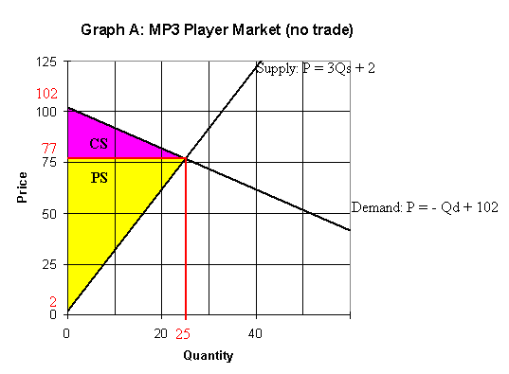
II. Open Economy to Free Trade.
Use the following information to answer question a) ~ d). Suppose that this small closed economy is open to free trade and that the world price is $62 per MP3 player.
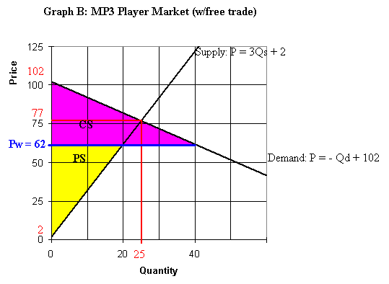

- What is the quantity supplied by domestic producers? _20______
Solution: Plug the P_{World} = $62 into the domestic Supply equation: $P=3Q_{S}+2$
$\text{62}=3Q_{S}+2⇒\text{60}=3Q_{S}⇒Q_{S}=\text{20}$
- What is the quantity demanded by domestic consumers? __40______
Solution: Plug the P_{World} = $62 into the domestic Demand equation: $P=−Q_{D}+\text{102}$
$\text{62}=−Q_{D}+\text{102}⇒Q_{D}=\text{40}$
- With free trade, how many MP3 players will the country import or export? _They will import 20 units__
Solution: At P_{World} = $62, Qd = 40, and Qs_{Dom} =20, there is a shortage of 20 units of MP3 players, and thus we will need an import = 40 - 20 = 20 units of MP3 players to fulfill the excess quantity demanded.
- Shade the area of the consumer surplus (CS) and producer surplus (PS) after the economy opens to free trade on Graph B above. Calculate the value of consumer surplus (CS) and producer surplus (PS). CS_{trade} = _$800__ and PS_{trade} = $600____.
Solution: use $\frac{1}{2}\text{bh}$formula to calculate the area of CS and PS. (Remember that CS and PS are measured in dollars.)
CS_{trade} = $\frac{1}{2}(\text{102}−\text{62})(\text{40})=\frac{\text{1600}}{2}=\text{800}$
PS_{trade} = $\frac{1}{2}(\text{62}−2)(\text{20})=\frac{\text{1200}}{2}=\text{600}$

III. Open Economy to Trade (with Tariff)
Use the following information to answer question a) ~ i). Suppose that the government imposes a tariff of $6 on each imported MP3 player, and the world price is $62 per MP3 player.
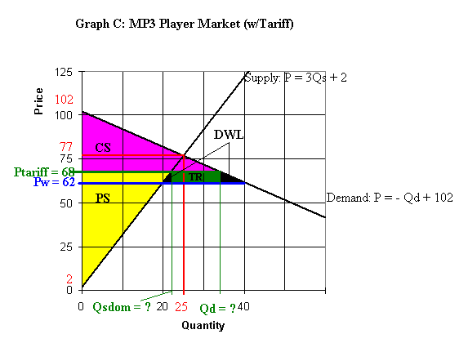

- What is the quantity supplied by domestic producers after the introduction of the tariff? ______22_____________.
Solution: Calculate the P_{Tariff} = P_{World} + Tariff = $62 + $6 = $68. Plug the P_{Tariff} = $68 into the domestic Supply equation: $P=3Q_{S}+2$
$\text{68}=3Q_{S}+2⇒\text{66}=3Q_{S}⇒Q_{S}=\text{22}$
- What is the quantity demanded by domestic consumers after the introduction of the tariff? _________34__________.
Solution: Plug the P_{Tariff} = $68 into the domestic Demand equation: $P=−Q_{D}+\text{102}$
$\text{68}=−Q_{D}+\text{102}⇒Q_{D}=\text{34}$
- How many MP3 players will the country import or export after the introduction of the tariff? They will import 12 units after the imposition of the tariff.

Solution: At P_{Tariff} = $68, Qd = 34, and Qs_{Dom} =22, there is a shortage of 12 units of MP3 players, and thus we will need an import = 34 - 22 = 12 units of MP3 players to fulfill the excess quantity demanded.

- Shade the areas of the consumer surplus (CS), the producer surplus (PS), the total tariff revenue (TR), and the dead weight loss (DWL) after the introduction of tariffs on Graph C above.
- Calculate the value of consumer surplus (CS) and the value of producer surplus (PS) for the MP3 player market after introducing the tariff. CS w/Tariff = __$578____ and PS w/Tariff = __$726____.
Solution: use $\frac{1}{2}\text{bh}$formula to calculate the area of CS and PS.
CS_{Tariff} = $\frac{1}{2}(\text{102}−\text{68})(\text{34})=\frac{\text{1156}}{2}=\text{578}$
PS_{Tariff} = $\frac{1}{2}(\text{68}−2)(\text{22})=\frac{\text{1452}}{2}=\text{726}$
- Calculate the value of total tariff revenue. Tariff Revenue = ____$72_______.
Solution: total tariff revenue = (tariff per unit) (quantity imported) = $\$6×\text{12}=\$\text{72}$.
- Calculate the dead weight loss. DWL = _______$24________.
Solution: DWL is equal to the summation of the two grey triangular areas by using$\frac{1}{2}\text{bh}$formula . DWL =$\frac{1}{2}(\text{22}−\text{20})(6)+\frac{1}{2}(\text{40}−\text{34})(6)=6+\text{18}=\text{24}$
- Rank the consumer surplus (CS) for the three options from the highest to the lowest:
Option 1: the MP3 player market without trade.
Option 2: the MP3 player market with free trade.
Option 3: the MP3 player market with the tariff.
Option 2 (CS_{Trade} = $800) > Option 3 (CS_{Tariff} = $578)> Option 1 (CS = $312.5)

- Rank the producer surplus (PS) for the three options from the highest to the lowest:
Option 1: the MP3 player market without trade.
Option 2: the MP3 player market with free trade.
Option 3: the MP3 player market with the tariff.
Option 1 (PS = $937.5) > Option 3 (PS_{Tariff} = $726)> Option 2 (PS_{Trade} = $600)

IV. Open Economy to Trade (w/Quota)
Use the following information to answer question a) ~ j). Suppose that the government introduces a quota allowing imports of 8 units instead of introducing tariffs. Suppose that the world price is $62 per MP3 player.
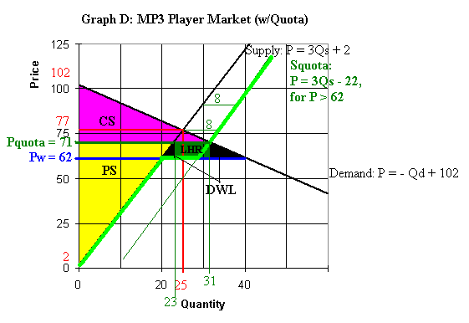
- Mark the new supply curve S^{Quota} with a bold line or a colored line on Graph D after the implementation of the quota. Shade the areas of the consumer surplus (CS), the producer surplus (PS), the license holder revenue (LHR), and the dead weight loss (DWL) after the introduction of the quota on Graph D above.

- What is the quantity demanded by domestic consumers after the introduction of the quota? ____31_______
Solution:
Step 1: Find the new supply curve.
First of all, we need to construct the new supply curve. At the price below P_{World}, no suppliers will import the good since they can simply sell the MP3 players to other countries in the world at P_{World} = $62. Therefore, the quota will only increase the quantity supplied by 8 units by the quota at the price above P_{World} = $62. The new supply curve S Quota is shown as the bolded orange curve on Graph D.
1) P < P_{World} = $62
So, we know, for the price under P_{World} = $62, the supply equation is equal to the domestic supply equation: $P=3Q_{S}+2$
2) P = P_{World} = $62
The supply curve is the horizontal line $P=\text{62}$
3) P > P_{World} = $62
For the price above P_{World} = $62, the importers are willing to import the quantity up to the quota limit = 8. Therefore, the supply equation above P= $62 is equal to: $Q_{\text{SDom}}+\text{Quota}=Q_{\text{SDom}}+8$
The domestic supply function is $P=3Q_{\text{SDom}}+2⇒Q_{\text{SDom}}=\frac{1}{3}P−\frac{2}{3}$
Q^{Quota} = $Q_{\text{SDom}}+\text{Quota}=Q_{\text{SDom}}+8=\frac{1}{3}P−\frac{2}{3}+8=\frac{1}{3}P+\frac{\text{22}}{3}$
$$Q^{\text{Quota}}=\frac{1}{3}P+\frac{\text{22}}{3}⇒P=3Q^{\text{Quota}}−\text{22}$$
Step 2: Find the new equilibrium price and quantity.
By Graph D, we can observe that the demand curve intersect with the new supply curve S^{Quota} at a point above P = $62. Therefore, we shall use the demand curve and the new supply curve S^{Quota} to find the equilibrium point where these two curves coincide.
Supply^{Quota}: $P=3Q^{\text{Quota}}−\text{22}$
Demand:$P=−Q_{D}+\text{102}$
Set them equal, $P=3Q−\text{22}=−Q+\text{102}⇒4Q=\text{124}⇒\text{Qe}=\text{31}$
Plug $\text{Qe}=\text{31}$ back to either of the equation, say demand equation, $P=−Q_{D}+\text{102}$, then we got $\text{Pe}=−\text{31}+\text{102}=\text{71}$
The new equilibrium price(Pe) is $71 and the equilibrium quantity (Qe) is 31.
- What is the quantity supplied by domestic producers after the introduction of the quota? _____23______
Solution: Plug the new equilibrium price Pe = $71 into the domestic Supply equation: $P=3Q_{S}+2$
$\text{71}=3Q_{S}+2⇒\text{69}=3Q_{S}⇒Q_{S}=\text{23}$
- How many MP3 players will the country import or export after the introduction of the quota? ____They will import 8 units after the imposition of the quota_____.
Solution: Since the quota only allows the imports up to the limit of 8 units, the imports will be just 8 units. Let’s check if this is correct. At Pe= P_{Quota} = $71, Qd = 31, and Qs_{Dom} =23, there is a shortage of 8 units of MP3 players, and thus we will need an import = 31 - 23 = 8 units of MP3 players to fulfill the excess quantity demanded.
- Calculate the value of consumer surplus (CS) and the value of producer surplus (PS) for the MP3 player market after introducing the quota. CS w/Quota = ______$480.5______ PS w/Quota = ____$793.5_______.
Solution: use $\frac{1}{2}\text{bh}$formula to calculate the area of CS and PS.
CS_{Quota} = $\frac{1}{2}(\text{102}−\text{71})(\text{31})=\frac{\text{961}}{2}=\text{480}\text{.}5$
PS_{Quota} = $\frac{1}{2}(\text{71}−2)(\text{23})=\frac{\text{1587}}{2}=\text{793}\text{.}5$
- Calculate the value of total license holder revenue (LHR). License Holder Revenue = ______$72______.
Solution: total license quota revenue = (P_{Quota} – P_{World}) (Quota) = $(\$\text{71}−\$\text{62})×8=\$\text{72}$.
- Calculate the dead weight loss. DWL = ___$54_______________.
Solution: DWL is equal to the summation of the two grey triangular areas by using$\frac{1}{2}\text{bh}$formula .
DWL =$\frac{1}{2}(\text{23}−\text{20})(\text{71}−\text{62})+\frac{1}{2}(\text{40}−\text{31})(\text{71}−\text{62})=\frac{\text{27}}{2}+\frac{\text{81}}{2}=\text{54}$
- Rank the consumer surplus (CS) for the three options from the highest to the lowest:
Option 1: the MP3 player market without trade.
Option 2: the MP3 player market with free trade.
Option 3: the MP3 player market with the quota.
Option 2 (CS_{Trade} = $800) > Option 3 (CS_{Quota} = $480.5)> Option 1 (CS = $312.5)

- Rank the producer surplus (PS) for the three options from the highest to the lowest:
Option 1: the MP3 player market without trade.
Option 2: the MP3 player market with free trade.
Option 3: the MP3 player market with the quota.
Option 1 (PS = $937.5) > Option 3 (PS_{Quota} = $793.5)> Option 2 (PS_{Trade} = $600)
- If the government wants to use the quota policy to attain the same equilibrium quantity equal to the domestic quantity demanded under the $6 tariff policy in g), what would be the quantity the government sets for the quota to achieve this goal? ___The government should set the quota at 12 units____.

Q3. Nominal vs. Real Prices: Use the following table to answer the next five questions.
The CPIs below are constructed using Year 1960 as the base year (BY = 1960).
Year | CPI (BY = 1960) | Nominal average salary
1980 | 200 | $10,000
1995 | 300 | $21,000
2008 | 400 | $30,000
2009 | 420 | $32,000

I. What will be the CPI measure in year 1980 if we alter the base year to 2008? 50 .
Solution: $\frac{{\text{CPI}}_{\text{1980}}}{{\text{CPI}}_{\text{2008}}}×\text{100}=\frac{\text{200}}{\text{400}}×\text{100}=\text{50}$
II. What was the increase in the general price level from 1980 to 2008? _____100%______ If the average salary increased at the same rate as the increase in the general price level, given the nominal average salary was $10,000 in 1980, what should the nominal average salary be in 2008? ___$20,000_______.
Solution: Change in price level from 1980 to 2008 =$\frac{{\text{CPI}}_{\text{2008}}−{\text{CPI}}_{\text{1980}}}{{\text{CPI}}_{\text{1980}}}×\text{100}\text{\%}=\frac{\text{400}−\text{200}}{\text{200}}×\text{100}\text{\%}=\text{100}\text{\%}$
If the average salary increased at the same rate as the increase of the price level from 1980 to 2008, the nominal price of the average salary in 2008 should be =$\$\text{10},\text{000}×\left(1+\text{100}\text{\%}\right)=\$\text{20},\text{000}$
III. The nominal price of the minimum wage was $6 per hour in 1980 as well as in 2008. What was the real price of the minimum wage per hour in 1980 using 2008 as the base year? $12 .
Solution:$\$6×\frac{{\text{CPI}}_{\text{2008}}}{{\text{CPI}}_{\text{1980}}}=\$6×\frac{\text{400}}{\text{200}}=\$\text{12}$
IV. Using the above table of information recalculate the CPI using 1980 as the base year (BY).Fill in your answers in the table below.
Year | CPI (BY = 1960) | CPI (BY = 1980)
1980 | 200 | 100
1995 | 300 | 150
2008 | 400 | 200
2009 | 420 | 210

V. Suppose your nominal salary is $60,000 in 2008. You are about to meet with your boss and demand a raise. Given the forecast of the CPI in 2009 in the table above using BY = 1960, what’s the minimum nominal salary you should ask for 2009 in order to maintain the same real wage/purchasing power you get in 2008? $63,000.
Solution: $\$\text{60},\text{000}×\frac{{\text{CPI}}_{\text{2009}}}{{\text{CPI}}_{\text{2008}}}=\$\text{60},\text{000}×\frac{\text{210}}{\text{200}}=\$\text{63},\text{000}$

